Writing a Persuasive Essay
A persuasive essay (also known as the argument essay) has one of two objectives:
- To convince your reader to adopt your point of view
- To convince your reader to take a specific course of action
A good persuasive essay argues one side of a very narrow topic. Although the persuasive essay only addresses one side of the issue, the topic must be debatable. Simply put, the persuasive essay recognizes that there are two sides to every question, but only presents one side to the reader. Still, it's important for you to understand both sides of the debate in order to promote your viewpoint effectively.
Choosing the Topic for a Persuasive Essay
The persuasive essay is an objective composition. In choosing your topic for a persuasive essay, although you should select one about which you feel strongly, be sure that you can find solid evidence that supports your position.
Refrain from choosing a topic where arguments are based on opinion or belief. Don't confuse facts with truths. A "truth" is a majority-held belief or opinion that is unproven and unsubstantiated by fact. Develop your argument using facts, logical reasoning, relevant examples, quotations from recognized experts, and/or statistics.
Avoid arguing indisputable facts. Start your essay draft by proving your thesis. Write the question, your position, and then write a thesis statement that directly opposes your viewpoint. This ensures that you have chosen a debatable question. Examine the other side of the argument and determine whether your evidence is strong enough to disprove the opposing viewpoint. Look for contrasting evidence, mistakes, and inconsistencies in logic.
Define Your Topic
In addition to a statement of the question, your persuasive essay title is also a statement of your position on the question. However, since your essay is objective, your title should be, too. For instance:
- Cable Internet vs. Fios Internet - This is unacceptable since it doesn't state your position.
- Why I Chose Cable Internet Over Fios Internet - This is also unacceptable since use of first person makes it subjective rather than objective and suggests personal choice rather than factual evidence.
- Reasons Why Cable Internet Rules Over Fios Internet - This is acceptable. It defines the topic, objectively states your position, and relates that your argument is based on evidence (reasons).
Introducing the Persuasive Essay
Use your thesis in your persuasive essay introduction. In addition to putting your topic and position into a sentence, the introduction to your persuasive essay should be a clear definition of the points that support your thesis. Present them in the same order that you'll use in the body of your essay to help the reader see that your position is supported in a way that comes to a logical conclusion.
Organizing the Persuasive Essay Body
The easiest way to organize the body of a persuasive essay is to think of your points as pointing towards your conclusion. Each sentence in the body should be closely related to your topic and to the sentence that precedes it.
- Begin each paragraph with a point from your introduction, following the same sequence you presented in the introduction. Support it with your evidence. As you finish each paragraph, examine it as you did the opposing point of view. Look for mistakes, inconsistencies in logic, and truths masquerading as facts.
- Be sure your evidence is specific. Stay away from using broad generalizations and personal opinions. Especially refrain from using words like all (as in all people), always, every, and never.
- Check to see that you have accurately cited any sources you used in examples and quotations.
- Help your reader see the logical progression of your argument by concluding each paragraph with a transitional sentence that leads to your next point.
Before you begin writing your conclusion, check all paragraphs of your essay body to ensure that
- Your evidence is strong and relevant to the point you addressed in the paragraph
- The essay progresses logically to your conclusion
- Both your points and supporting evidence are on topic and focussed towards the conclusion
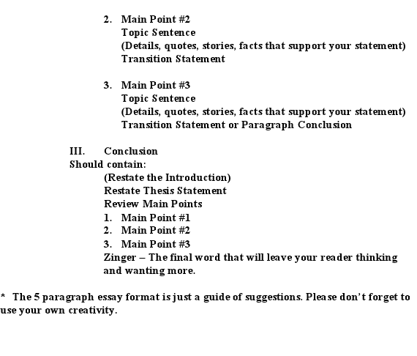
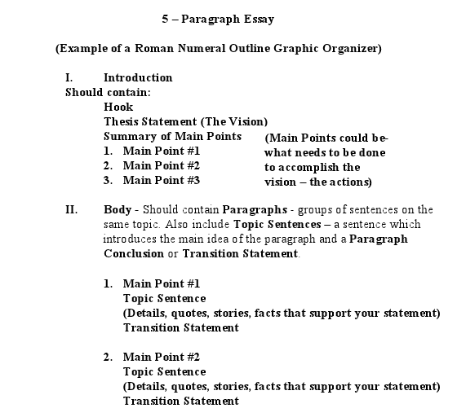
In Conclusion
Redefine your topic and summarize your essay by restating your most powerful evidence, again preserving the sequence of your presentation. The conclusion of your persuasive essay is your last chance to remind your readers of your position and persuade them to accept your point of view. 