|  |  |  |  |  |  |  |  |  |  |  |  |  |  |  |  |  |  |  |  |
| --- | --- | --- | --- | --- | --- | --- | --- | --- | --- | --- | --- | --- | --- | --- | --- | --- | --- | --- | --- |
|  |  |  |  |  |  |  |  |  |  |  |  |  |  |  |  |  |  |  |  |
|  |  |  |  |  |  |  |  |  |  |  |  |  |  |  |  |  |  |  |  |
|  |  |  |  |  |  |  |  |  |  |  |  |  |  |  |  |  |  |  |  |
|  |  |  |  |  |  |  |  |  |  |  |  |  |  |  |  |  |  |  |  |
|  |  |  |  |  |  |  |  |  |  |  |  |  |  |  |  |  |  |  |  |
|  |  |  |  |  |  |  |  |  |  |  |  |  |  |  |  |  |  |  |  |
|  |  |  |  |  |  |  |  |  |  |  |  |  |  |  |  |  |  |  |  |
|  |  |  |  |  |  |  |  |  |  |  |  |  |  |  |  |  |  |  |  |
|  |  |  |  |  |  |  |  |  |  |  |  |  |  |  |  |  |  |  |  |
|  |  |  |  |  |  |  |  |  |  |  |  |  |  |  |  |  |  |  |  |
|  |  |  |  |  |  |  |  |  |  |  |  |  |  |  |  |  |  |  |  |
|  |  |  |  |  |  |  |  |  |  |  |  |  |  |  |  |  |  |  |  |
|  |  |  |  |  |  |  |  |  |  |  |  |  |  |  |  |  |  |  |  |
|  |  |  |  |  |  |  |  |  |  |  |  |  |  |  |  |  |  |  |  |
|  |  |  |  |  |  |  |  |  |  |  |  |  |  |  |  |  |  |  |  |
|  |  |  |  |  |  |  |  |  |  |  |  |  |  |  |  |  |  |  |  |
|  |  |  |  |  |  |  |  |  |  |  |  |  |  |  |  |  |  |  |  |
|  |  |  |  |  |  |  |  |  |  |  |  |  |  |  |  |  |  |  |  |
|  |  |  |  |  |  |  |  |  |  |  |  |  |  |  |  |  |  |  |  |
|  |  |  |  |  |  |  |  |  |  |  |  |  |  |  |  |  |  |  |  |
|  |  |  |  |  |  |  |  |  |  |  |  |  |  |  |  |  |  |  |  |
|  |  |  |  |  |  |  |  |  |  |  |  |  |  |  |  |  |  |  |  |
|  |  |  |  |  |  |  |  |  |  |  |  |  |  |  |  |  |  |  |  |
|  |  |  |  |  |  |  |  |  |  |  |  |  |  |  |  |  |  |  |  |
|  |  |  |  |  |  |  |  |  |  |  |  |  |  |  |  |  |  |  |  |
|  |  |  |  |  |  |  |  |  |  |  |  |  |  |  |  |  |  |  |  |
|  |  |  |  |  |  |  |  |  |  |  |  |  |  |  |  |  |  |  |  |
|  |  |  |  |  |  |  |  |  |  |  |  |  |  |  |  |  |  |  |  |
|  |  |  |  |  |  |  |  |  |  |  |  |  |  |  |  |  |  |  |  |
|  |  |  |  |  |  |  |  |  |  |  |  |  |  |  |  |  |  |  |  |
|  |  |  |  |  |  |  |  |  |  |  |  |  |  |  |  |  |  |  |  |
|  |  |  |  |  |  |  |  |  |  |  |  |  |  |  |  |  |  |  |  |
|  |  |  |  |  |  |  |  |  |  |  |  |  |  |  |  |  |  |  |  |
|  |  |  |  |  |  |  |  |  |  |  |  |  |  |  |  |  |  |  |  |
|  |  |  |  |  |  |  |  |  |  |  |  |  |  |  |  |  |  |  |  |
|  |  |  |  |  |  |  |  |  |  |  |  |  |  |  |  |  |  |  |  |
|  |  |  |  |  |  |  |  |  |  |  |  |  |  |  |  |  |  |  |  |
|  |  |  |  |  |  |  |  |  |  |  |  |  |  |  |  |  |  |  |  |
|  |  |  |  |  |  |  |  |  |  |  |  |  |  |  |  |  |  |  |  |
|  |  |  |  |  |  |  |  |  |  |  |  |  |  |  |  |  |  |  |  |
|  |  |  |  |  |  |  |  |  |  |  |  |  |  |  |  |  |  |  |  |
|  |  |  |  |  |  |  |  |  |  |  |  |  |  |  |  |  |  |  |  |
|  |  |  |  |  |  |  |  |  |  |  |  |  |  |  |  |  |  |  |  |
|  |  |  |  |  |  |  |  |  |  |  |  |  |  |  |  |  |  |  |  |

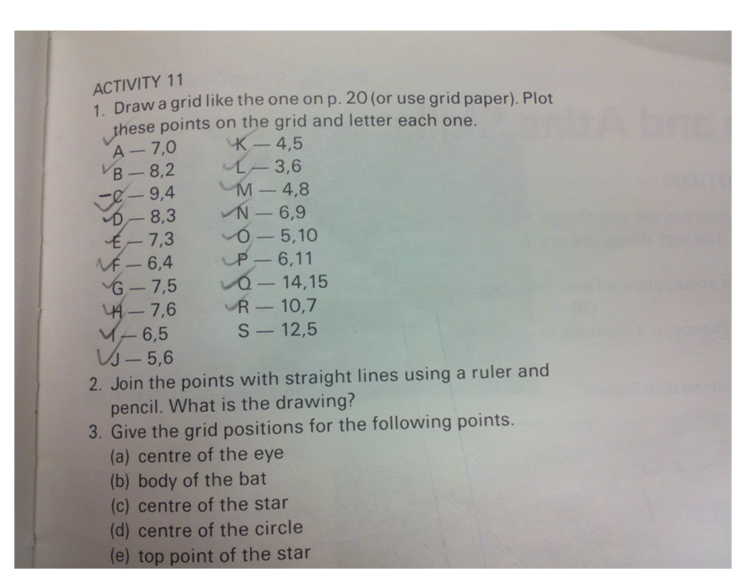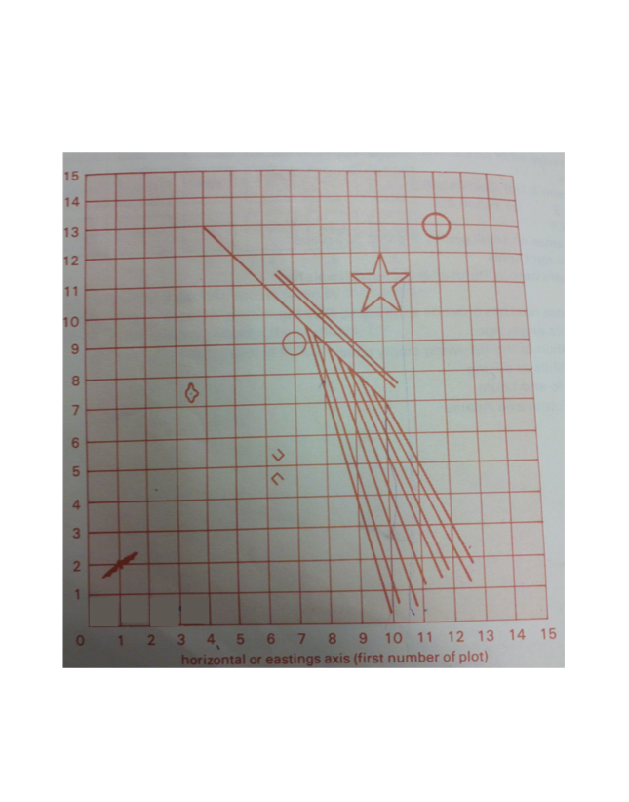

Now, using grid paper, create your own picture and exercise. Make sure you have an answer key. You will need to number your axis points.