https://www.youtube.com/watch?v=qm4-KH0Tv6Q one 5 out wheel offense

How to Coach and Teach the Wheel Man-to-Man Basketball Offense
When it comes to coaching basketball fundamentals, you must consider continuity offenses. For example, most basketball zone offenses involve continuity, floor balance by rotating the ball rapidly from one side of the court to the other while filling the perimeter passing lanes as cutters penetrate into or through the zone defense. It's all about winning hoops, folks!
To the best of my knowledge, the Wheel Offense is the Daddy of all continuous pattern offenses. It was followed by the "Auburn Shuffle" and then, the "Flex Offense" used much, today.
I've have had experience teaching all three basketball offenses in my days of coaching youth basketball. Sometimes they were successful and sometimes not. The biggest fault that I can see with their use is that players get so engrossed in going from point "A" to point "B" they often pass up good scoring opportunities. Many times I've expressed the opinion, "This is for coaches who don't know how to coach." However, this was always in jest. You can take any 2 or 3 of the fundamental eight plays and build your own continuous pattern basketball offense.
By this I mean, they either don't have enough knowledge, nor the time it takes to teach all the fundamentals. Also, some coaches seem possessed in controlling every player's movement each moment of every game. As a result, his players may win a few games, but never rise to their fullest potential.
The wheel man-to-man offense features constant movement. Cuts are made toward and away from the ball by every player with double screens away from the ball.
If you need a good ball control offense, the "Wheel" may be for you. Especially for small teams with balanced scoring and rebounding. It might work, too, with players who do not fare too well at free-lance play.
It certainly is not an offense for teams with poor ball-handling skills, or teams who rely on the scoring or rebounding skills of a single player.
The wheel can be run from many different alignments and is easily started from either the left or right side without altering positions of players. For illustration purposes, a two-guard-front alignment is used; but once set in motion, it becomes a one-guard-front.
The Wheel Continuity Offense  This is probably the daddy of all continuity patterned offenses. Actually it consists of three consecutive plays ran first on one side of the floor, then the other.  Diagram Wheel 1 shows the point initiating the play with a pass to 4 at the wing. Teammate 2 cuts off 5's screen at the high post, looking for a pass from player 4 for the layup.  #5 the high pivot should always open-up toward the ball as he will often be open for a pass and uncontested high percentage shot. | 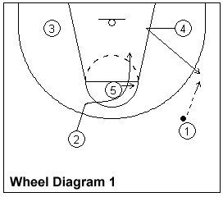
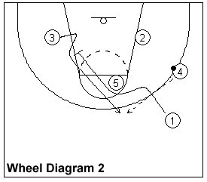 | The Wheel Continuity Offense  The second play is shown on Wheel Diagram 2, which is a screen opposite the ball. The point guard, #1 fakes a give and go and cuts off teammate #5 to set a pick on #3's defender.  #3 is open on the outside for #4's pass back to the top.
The Wheel Continuity Offense  Wheel Diagram 3 illustrates the third play, which is another shuffle, or flex, cut to the basket. Again, the screener which is #2 in this case, always opens-up toward the ball. Often, the screener becomes the open man. Today, you often see the concept of the wheel being woven into the more modern motion offenses. | 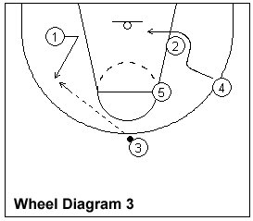
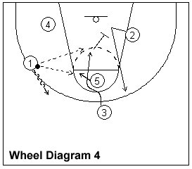 | The Wheel Continuity Offense  Wheel Diagram 4 shows #3 executing the shuffle cut on the left side of the floor. If a scoring opportunity doesn't present itself, player #3 continues on to set a screen for teammate #2.
The Wheel Continuity Offense  Wheel Diagram 5 shows the beginning of the same sequence of plays run on the opposite side of the floor, or #1 could reverse the ball to #2 and run the plays on the right side, again. | 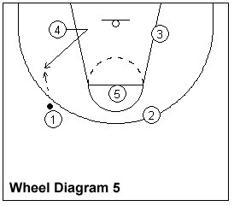

Introduction to the Wheel Offense
Posted on January 30, 2013 by Coach Riches Posted in Basketball Plays, Offensive Philosophy, Team Offence
- 6
- 4
- 5

- 4

The wheel offense is one of the oldest offensive strategies in basketball. It was one of the offensive fore runners for what we know today as motion and continuity offenses. Aspects of the wheel offense can be seen in many modern offensive structures as well as being an offensive system in its own right.

The wheel offense was created by Garland Pinholster, Head Coach at Oglethorpe University in the 1950’s. It was Coach Pinholster’s vision to develop an offense that could be used against both man to man and zone defences. This concept alone would make it more versatile than most offensive sets then and something even in today’s modern coaching landscape, with a multitude of offenses, is very rare. As part of Garland Pinholster’s development of options for the wheel offense various terminal sets and trick plays were also added for greater flexibility in the offense. Coach Pinholster also wanted an offense that could be run with a variety of different players of changeable height and ability.

The wheel offense is a relatively simple and versatile offense, which allows it be used by a wide range of different players with different abilities. Although the offense has been surpassed by more complex offenses that play to the individual strengths of certain players. The wheel offense is still effective for teams who know how to work players into scoring positions which are focused around the individual’s offensive strengths and skill sets.

Some coaches have cited the wheel offense as a solid team building exercise, because it forces all of the five players on the court to rely on each other and work on their offensive skills.

The offense allowed teams without an individual standout talent to work the ball with player movement to get highly efficiency shots. Because of the constant player movement it also created regular mismatches on the offensive end, with it’s frequent cuts often causing the defence to have to switch post players onto perimeter players, and vice versa.

The key strength of the wheel offense is its versatility. To truly uphold the philosophy of the wheel offense system all five players need to be strong shooters, ball handlers, and cutters. That means that the defence does not know where the offensive focal point is. If anyone on the court can shoot and score, all five defensive players have to stay focused for longer, which is demanding even for the most well drilled teams. It is important to note that if your players are not well rounded as part of your strategy, you can still use the wheel offense. Just make sure these players understanding what their offensive options are when they are to use these skills.

As with many motion or continuity offences the wheel offense has a number of disadvantages and as a coach you should be aware of these to avoid them hampering your implementation. The first issue is that the offense can make players focus too much on the pattern of the offense and not enough on making good “reads” from the defensive player in front of them. Players will often revert to running the movement and not the opportunity when they become fatigued both physically or mentally.

Additionally in its original set the wheel offense does not allow a creative offensive player to get isolated. If you have a talented player who can help get you easy baskets, that player would have to break the offensive scheme in order to be effective. So be prepared to add additional play options to allow for this flexibility.

As an older offense, it does not make use of many modern basketball innovations such as screens. Screens and variations to the cuts would make this offense much more effective, but could also make it more rigid, like the Princeton Offense, one of its more complex descendants.

Because the wheel offense uses a number of misdirection and optional trick plays, and relies on frequent cuts, it can be difficult for a man or zone defence to cover. The key will be your team’s ability to guard cutters effectively and this really comes down to drilling the defensive fundamentals like talking on help defence, jumping to the ball and bumping cutters.

With the offense also having a pattern element to it, focus on isolating players with a weakness from the rest of the team. If you know a player is a poor shooter try to have them catch on the perimeter and then deny the passing options hard while containing the dribble. This will disrupt the opposition’s offense and cause the wheel to become unmanageable.
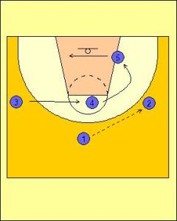
Wheel Offense Standard Diagram 1
In this example of the offense, sets up in a 1-3-1 formation.

The point guard (One) passes to the shooting guard (Two) on the wing to start off the plays movement.

The center (Five) cuts to the weak side of the keyway, while the power forward (Four) replaces to the strong side low post.

The small forward (Three) then flashes to the foul line looking for a pass.

If any of those rotations are open, the shooting guard (Two) can pass to that offensive player.

Just because this play looks simple, does not mean your players are allowed to run only straight cuts or stand in their spots. Sealing, creating a lead and faking should always be encouraged by the offensive players.
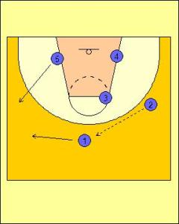
Wheel Offense Standard Diagram 2
If not scoring opportunity presents itself. The shooting guard (Two) passes back to the point guard (One) who dribbles to the weak side of the floor making sure to finish outside the elbow extended.

The center (Five) steps out to receive the ball on the wing.
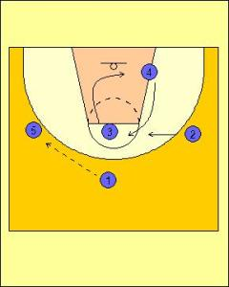
Wheel Offense Standard Diagram 3
The ball is swung to the center (Five). The small forward (Three) and power forward (Four) switch places.

The shooting guard (Two) rotates into the middle lane at the foul line.

If any of those rotations present a scoring opportunity, the center (Five) passes to that player.
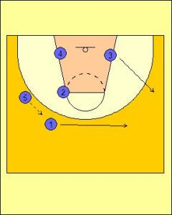
Wheel Offense Standard Diagram 4
The center swings the ball back to the point guard, who dribbles back to the opposite side of the floor. The small forward cuts out to the wing and the entire play resets.

Youth Basketball Play 9 -
"Wheel"

Youth Basketball Play 9 is called "Wheel". This is another simple offensive play that involves a lot of movement by the players.
The nice thing about this offensive play is that all five players stay involved and active. The constant motion by the offensive players forces the opponents to work harder on defense. Good screening and cutting creates many easy scoring opportunities as well!
Youth Basketball Play 9 can be used at any level of competition. This play can be modified to fit your players’ skill level and experience. As your players get comfortable with the basic movements, backdoor cuts can be added.
As always, you must first teach your players the fundamentals of basketball before you can implement an offense. Once your players can perform the offensive fundamentals properly, you can then incorporate those into your offensive strategy.
Check out our drills page for some great ideas on teaching your players the fundamentals of the game.
In addition to Youth Basketball Play 9, you'll find more effective youth basketball plays here.

Youth Basketball Play 9:
"Wheel"

To help you understand the play, please follow the key below.
- 1 = Point Guard
- 2 = Wing
- 3 = Wing
- 4 = Post
- 5 = Post
- Black Dotted Arrow = Pass
- Black Straight Arrow = Player Movement

- The players will start in a 1-3-1 formation.
- 1 will pass to 2 or 3 (2 in this example).
- After passing to 2, 1 will set a screen away from the ball on 3's defender.
- Once 2 has the ball, 5 should establish good low post position and look for a pass and scoring opportunity.
- If 5 does not get a pass from 2, they should move across the lane to the opposite low-post.

- As 5 moves across the lane, 4 should slide down to the ball-side low post position.
- 4 should look for a pass from 2 as they are moving down to the low post.
- As this is happening, 3 should be coming off of 1's screen and then flashing to the free throw line looking for a pass from 2.
- If 3 gets a pass from 2, they should look for a jump shot or drive to the basket.

- If none of the above passes and scoring options are open, 3 should pop out to the top of the key and look for a pass from 2.
- 2 will pass the ball out to 3 to reset the play.

- 2 will pass to 3 who will then pass to 1.
- Players must remember to set up their defender with good fakes and v-cuts. They must come toward the pass to prevent steals by their defender.

- After passing to 1, 3 will set a screen on 2's defender.
- 2 must set up their defender with a good fake and then run them directly into 3's screen.
- 5 will establish good low post position and look for a pass from 1.

- If 5 does not get a pass from 1 in the low post, they should set a screen on 4's defender.
- 4 should set up their defender with a good fake and then run them directly into 5's screen.

- 1 will now have two passing/scoring options.
- 1 can pass to 4 coming off of 5's screen.
- 1 can pass to 2 coming off of 3's screen.
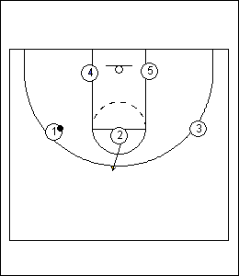
- If 1's pass to 4 or 2 is not open, 2 will pop out to the top of the key to help reset the play.
- Once the ball is reversed from 1 to 2 to 3, you will be back at the starting point of the offense.

*****
Youth Basketball Play 9 is a very simple offensive play - yet it can be so effective when executed properly.
The key to this offense, as well as any other offense, is being fundamentally sound. By drilling your players on the fundamentals first, you are setting them up for success.

