Using quotations properly
Why do we use quotations?
- To Support Your Point-It’s not enough to just explain an idea. Instead, use the actual words—a quote—from the book to help establish an argument.
- To add credibility to your argument-When doing research, writers should bring in the work of other experts in the field to help establish credibility.

Whenever you use quotes you need to credit the author
- The writer should document the sources appropriately depending on the preferred style guide for the paper such as MLA or APA.

Direct Quotes
- Quotes printed word for word exactly as the speaker said them are direct quotes. These words appear inside quotation marks. The attribution word appears outside the quotation marks. The attribution is the phrase that tells who said it, where you got the information.
- Direct quotes are used when a source expresses an opinion.

Examples of Direct Quotes
- “I am thrilled to be representing the great State of Texas at the Free Spirit Conference here in Washington, D.C.,” Susie Spunk, newspaper adviser said. “I owe it all to my talented students.”
- “I’m just glad I didn’t have to spend any more time with my adviser than I did,” said Janie Joker, who added that she enjoyed riding the subways more than she did the conference.

Indirect Quotes
- Information from a source which is not made up of the speaker’s exact words is not placed inside quotation marks. This is an indirect quote, which is a paraphrase or a summary of the meaning of the direct quotation. These still need to be credited to the author however.
Indirect quotes are used to:
- Express a fact stated by the source
- Clarify a quote that is too long, confusing or dull
- Condense the ideas of several direct quotes

Examples of Indirect Quotes
- Essentially an indirect quote paraphrases what someone else said.
- "An indirect quotation reports someone's words without quoting word for word: Annabelle said that she is a Virgo.
- A direct quotation presents the exact words of a speaker or writer, set off with quotation marks: Annabelle said, 'I am a Virgo.'
- Never change the meaning of someone’s quote when you paraphrase it. Misquoting your source will erode your credibility.

Leading into your quote
- You should always introduce your quote and explain it.- don’t just leave it floating
- Introducing quotes with a signal phrase
A signal phrase is a group of words that signals that a quote will be introduced
- According to Dr. Torres, “____________________” (50).
- Dr. Torres states, “__________________________” (35).
- Dr. Torres complicates matters further when he writes that “__________” (56).
- The author demonstrates this concept “________” (4).
*Notice that the page number goes in parentheses followed by punctuation
Some examples of signal phrases with author tags
- According to _________, “…”
- As_______ goes on to explain, “…”
- Characterized by _______, the society is “…”
- As one critic points out, “…”
- ______ believes that “…”
- ______claims that “…”
- In the words of _____, “…”

Examples of words that can help lead into a quote:
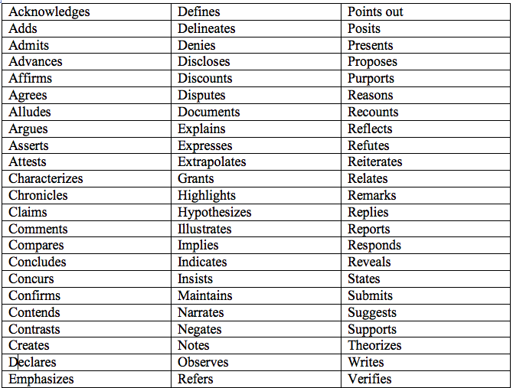

Applying Strategies for Integrating Direct Quotations
When you are quoting text from a prose source and using MLA format:
- Embed the quotation in your text when the quotation is four lines or less in length.
- Set the quotation off from your text (this is called a block quotation) when it is more than four lines in length.
(For other documentation styles, the length may be different. APA counts words rather than line length.)

Less than four lines- integrated
Example:
Henry James’ odd juxtaposition of detail as he describes the respectability of “a cook, a housemaid, a dairywoman, an old pony, and an old gardener” provides a humorous clue as to the Victorian obsession with respectability that may
have influenced the puzzling behavior of one of the key characters in The Turn of the Screw (13).

More than 4 lines- block quotation
The governess’ reference to a popular gothic novel from the period supplies further evidence of her tendency to romanticize her experiences:
IT WAS NOT THAT I DIDN’T WAIT, on this occasion, for more, for I was rooted as deeply as I was
shaken. Was there a “secret” at Bly – a mystery of Udolpho or an insane, an unmentionable
relative kept in unsuspected confinement? (James 29)
Perceptive readers will notice that the governess’ citing of ghosts sometimes occur after she has been reading another novel.
Note: Follow your style-guide conventions for double-spacing text. Single-spacing is used here due to space limitations

More than 4 lines- block quotation
Henry James’ description of the governess provides interesting information for the critic who views the novel through a feminist lens:
The fact to be in possession of was therefore that his old friend, the youngest of several daughters
of a poor country parson, had, at the age of twenty, on taking service for the first time in the
schoolroom, come up to London, in trepidation, to answer in person an advertisement that had
already place her in brief correspondence with the advertiser. (11)
Additional conventions for block quotations:
- Begin the quotation on a new line. Do not add an extra space before it.
- Indent the entire quotation one inch from the left margin.

Applying Strategies for Integrating Direct Quotations
Additional conventions for block quotations:
- Double-space your quote just as you have double-spaced the rest of the paper.
- End the quotation with the appropriate punctuation, and place the parenthetical citation AFTER that punctuation.
Additional conventions for block quotations:
- Do NOT use quotation marks around block quotations.
- If the quotation includes a quotation, preserve the quotation marks just as they appear in the original.
When you are quoting text from a poetry source and using MLA format:
- Include quotations from a single line of a poem in your text.
- Include quotations from two or three lines of a poem in your text, showing separations between lines by using a slash (/) with a space before and after it to indicate the end of each line in the poem.

Integrating Direct Quotations- lines of poetry- one line
Example:
- In Leaves of Grass, the speaker creates a sense of intimacy by claiming to be confessing private thoughts and directly addressing the reader: “This hour I tell things in confidence, / I might not tell everybody but I will tell you” (43).

Integrating Direct Quotations- lines of poetry- two-three lines
- Example:
- In Leaves of Grass, the speaker creates a sense of intimacy by claiming to be confessing private thoughts and directly addressing the reader: “This hour I tell things in confidence, / I might not tell everybody but I will tell you” (43).

Integrating Direct Quotations-more than 3 lines of poetry
If you are quoting from more than two or three lines of a poem, set the quotation off from your text.
Guidelines for spacing and indentation are the same as for a prose quotation.

Punctuating Quotations
- The author’s exact words go inside the quotation marks: “I am super, duper cool.”
- The end punctuation (period, question mark, exclamation point) goes inside the last quotation mark. “Give me the damn money!”
- When the attribution comes after a direct quote, use a comma to separate the quote from the attribution. “Here it is,” replied Bob.
- If a question mark relates to the sentence and not the quote, place it at the end of the sentence outside the quotation marks: What kind of moron says, “I am super, duper cool”?
- Use single quotation marks to indicate a quote inside a quote. “And so I told her, ‘Fix your own tire, Grandma!’”
- Leave off the closing quotation marks at the end of a paragraph if the quote continues in the next paragraph.
- If a quote is a complete sentence, begin it with a capital letter. If it’s not, don’t.
- Use quotation marks to indicate the title of a smaller work, such as an article, essay, short story, song, poem, or speech.
In his essay, “Potatoes are Yummy,” Joe Smith argues that…
- Use italics (or underline) for larger works such as a book, magazine, album, play, film, or long poem.
In her novel, Potatoes are Yucky, Ann Smith argues that…
In her novel, Potatoes are Yucky, Ann Smith argues that…

Using Quotes
- To clarify or modify a phrase within a quote, insert brackets. “Slowly, [Bob] reached for the meat cleaver.”
- Add the word “sic” (meaning thus) in italics within brackets after words that are misspelled or used incorrectly in a direct quote from a printed source. This indicates the quote is exactly like the original source. “Macbeth is a grate [sic] play.”
- To take words out of a quote you must indicate you are doing so by using three dots …
- Original quote- “Lucy, who was crazy, did it.”
- Modified quote- “Lucy…did it.”

Avoid the following mistakes
- Failing to introduce the title of the work and the author.
- Starting a sentence or (paragraph) with a quote. Remember, you need to introduce the quote using a signal phrase.
- Ending a paragraph with a quote. Remember, you need to follow every quote with some of your own commentary or analysis. (This is the bottom piece of bread to your sandwich!)

