Timed Writing Scoring Rubric Name: ________________________
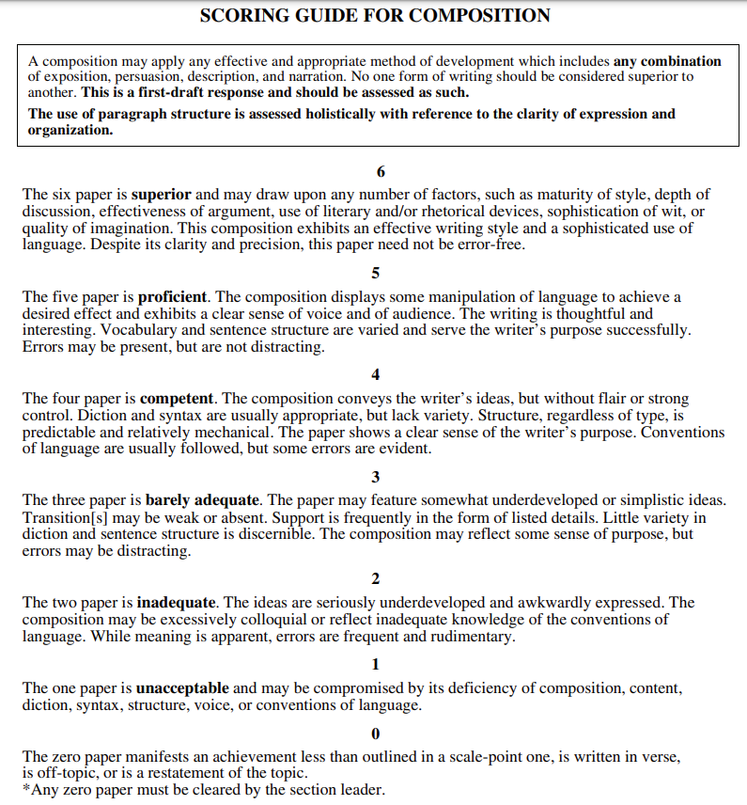
Your timed write should be a multi-paragraph composition on the topic given. In addressing the topic in your composition you can consider all possibilities. You may draw support from the experiences of others or from any aspect of your life, your reading and your experiences. You do not have to agree with the topic. You can use any appropriate method of development including exposition, persuasion, description and narration. This will be marked as a first draft response and grammar will only be considered when it interferes with understanding of the composition. A composition may apply any effective and appropriate method of development and can include any combination of exposition, persuasion, description and narration. All forms are considered equally. The use of paragraph structure is assessed holistically with reference to the clarity of expression and organization.

