The Super-Fantastic Writing Resource Guide

Contents
Adjective Wheels 3
5 Words to Use Instead of “Very” 5
Show Don’t Tell 6
Character Traits 8
Personality Adjectives 10
Body Language 14
Describing Sounds 20
Describing Smells 23
Describing Tastes and Flavours 25
Describing Touch 26
Body Descriptions 27
Sentence Starters 32
Using Higher Level Vocabulary: Fiction Writing 33
Writing Help: Transitions, Connectives, etc 37

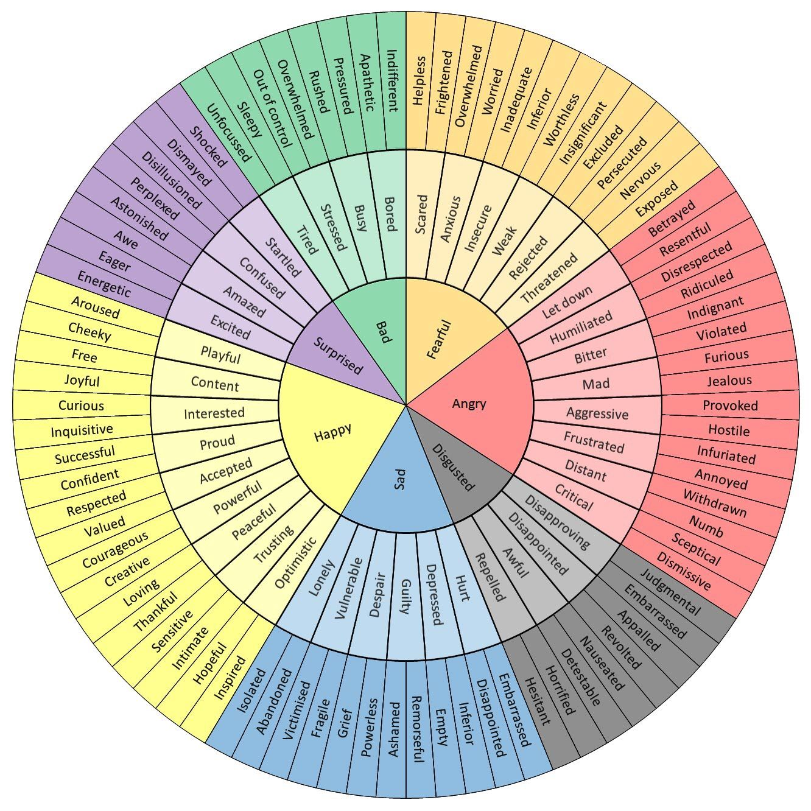

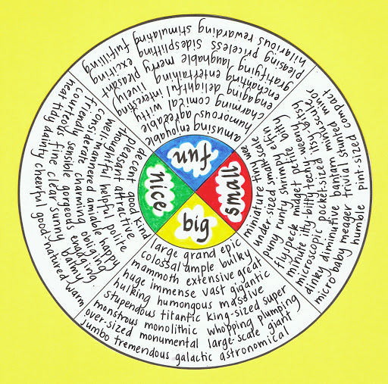

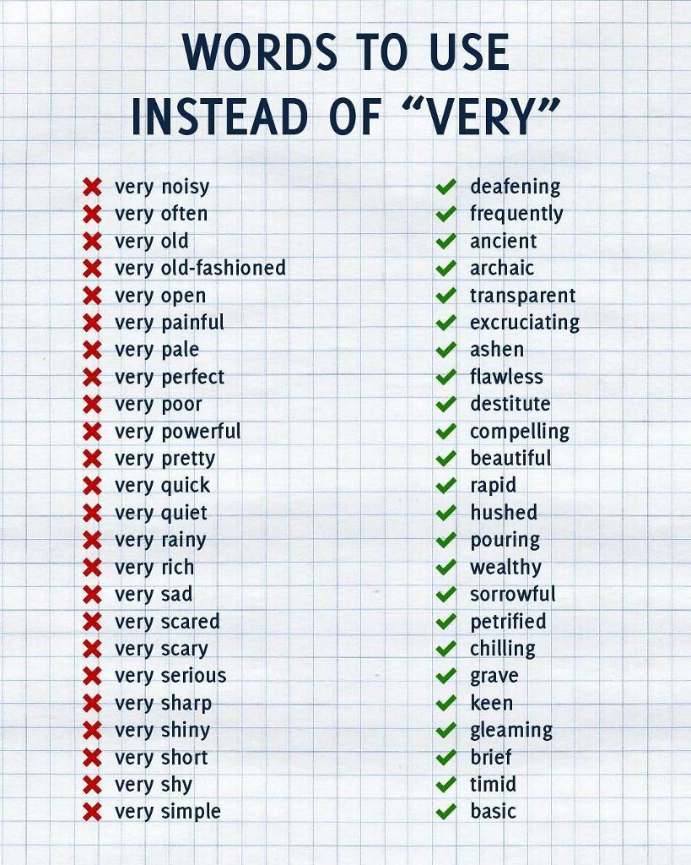

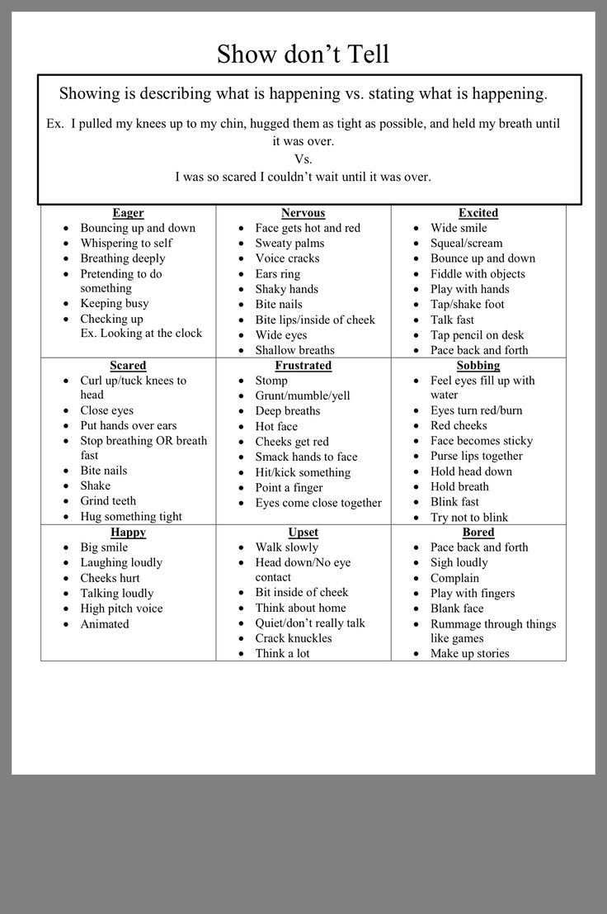

5 Simple Ways To Help Writers Show And Not Tell

- Choose a viewpoint character: It is easier if you are experiencing the scene as one character. If you struggle to write in third person, you can try writing a scene in first person. Use it as practice. You can change the viewpoint later if needed. Often beginner writers use an omniscient narrator without being aware of how much it makes you tell.

- Use the senses: Write a list of what your character sees, hears, smells, touches and tastes. Then write about it without using the words see, hear, smell, touch and taste. By using the senses you force your character to interact with their environment and in so doing, it becomes more of a showing scene.

- Be specific: The more specific you are with your descriptions and actions the easier it will become to show. specificity makes your writing stronger, your images clearer and forces your reader to engage mentally and emotionally.

- Avoid these ‘telling’words: Look out for these words: is, are, was, were, have, had. Look out for the words ‘was and were’, ‘have and had’. Most of the time they are making you tell. Certain verbs can also make you do this. Look at this post on more telling words to avoid.

- Dialogue: This is one of the simplest tools to use. The moment your characters start talking, showing becomes easier. Dialogue means you have an action scene. A scene where things happen. You have movement. You have body language, you have them interacting with their setting. You have a scene that engages a reader.

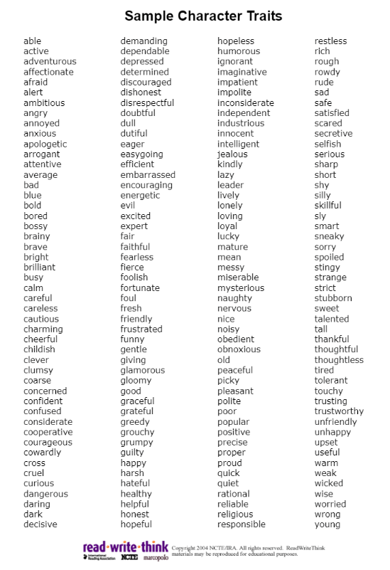
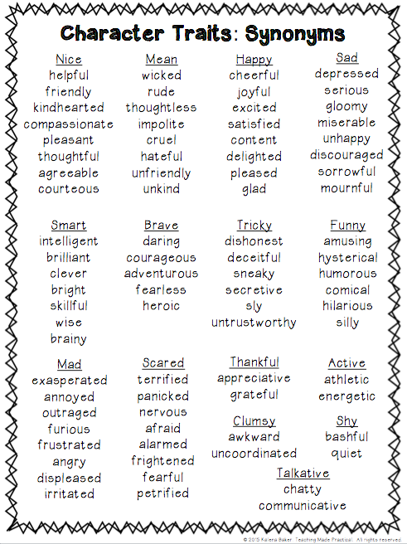

Positive Personality Adjectives

adaptable
adventurous
affable
affectionate
agreeable
ambitious
amiable
amicable
amusing
brave
bright
broad-minded
calm
careful
charming
communicative
compassionate
conscientious
considerate
convivial
courageous
courteous
creative
decisive
determined
diligent
diplomatic
discreet
dynamic
easygoing
emotional
energetic
enthusiastic
exuberant
fair-minded
faithful
fearless
forceful
frank
friendly
funny
generous
gentle
good
gregarious
hard-working
helpful
honest
humorous
imaginative
impartial
independent
intellectual
intelligent
intuitive
inventive
kind
loving
loyal
modest
neat
nice
optimistic
passionate
patient
persistent
pioneering
philosophical
placid
plucky
polite
powerful
practical
pro-active
quick-witted
quiet
rational
reliable
reserved
resourceful
romantic
self-confident
self-disciplined
sensible
sensitive
shy
sincere
sociable
straightforward
sympathetic
thoughtful
tidy
tough
unassuming
understanding
versatile
warmhearted
willing
witty

Negative Personality Adjectives

aggressive
aloof
arrogant
belligerent
big-headed
bitchy
boastful
bone-idle
boring
bossy
callous
cantankerous
careless
changeable
clinging
compulsive
conservative
cowardly
cruel
cunning
cynical
deceitful
detached
dishonest
dogmatic
domineering
finicky
flirtatious
foolish
foolhardy
fussy
greedy
grumpy
gullible
harsh
impatient
impolite
impulsive
inconsiderate
inconsistent
indecisive
indiscreet
inflexible
interfering
intolerant
irresponsible
jealous
lazy
Machiavellian
materialistic
mean
miserly
moody
narrow-minded
nasty
naughty
nervous
obsessive
obstinate
overcritical
overemotional
parsimonious
patronizing
perverse
pessimistic
pompous
possessive
pusillanimous
quarrelsome
quick-tempered
resentful
rude
ruthless
sarcastic
secretive
selfish
self-centred
self-indulgent
silly
sneaky
stingy
stubborn
stupid
superficial
tactless
timid
touchy
thoughtless
truculent
unkind
unpredictable
unreliable
untidy
untrustworthy
vague
vain
vengeful
vulgar
weak-willed

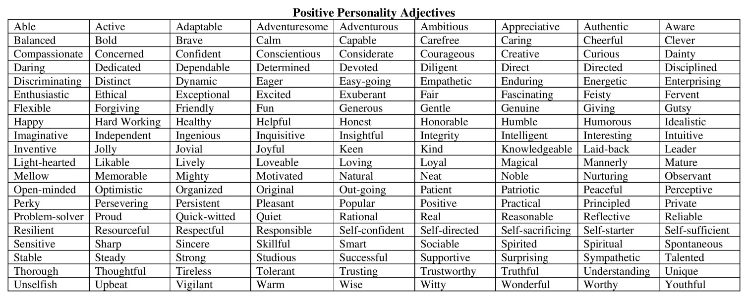

18 Words to Describe Evil People

sadistic: getting pleasure from hurting others
conniving: behaving in a way that secretly hurts others or deliberately fails to prevent others from being hurt
amoral: not following any moral rules and not caring about right and wrong
perverse: showing deliberate determination to behave in a way that most people think is wrong or unacceptable
ferocious: very aggressive or violent
tyrannical: using power or authority over people in an unfair and cruel way
devious: behaving in a dishonest or indirect way, or tricking people, in order to get something
ruthless: determined to get what you want and not caring if you hurt other people
faithless: not loyal: that you cannot rely on or trusts
treacherous: willing to betra trust; intending to harm you while seeming friendly or loyal
bloodthirsty: wanting to kill or wound; enjoying seeing or hearing about killing and violence
perfidious: deliberately dishonest and unablt to be trusted
rapacious: wanting more money or goods than you need or have a right to
vicious: violent and having a desire to cause pain and suffering
savage: aggressive, violent, and causing great harm
degenerate: having moral standards that have fallen to a level that is very low and unacceptable to most people
bigoted: strongly and unfairly hating or refusing to accept members of a group
cold-blooded: showing no feelings or pity for other people

BODY LANGUAGE AND GESTURES
from MASTER LISTS FOR WRITERS by Bryn Donovan bryndonovan.com

she nodded
he bobbed his head
she tilted her head
he cocked his head
she inclined her head
he put his head in his hands
he covered his eyes with a hand
she hid behind her book
she pressed her hands to her cheeks
she raised her chin
he lifted his chin
her hands squeezed into fists
his hands tightened into fists
she clenched her fists
she balled her fists
he unclenched his fists
her arms remained at her sides
his arms dangled at his sides
he shrugged
she gave a half shrug
he lifted his shoulder in a half shrug
she gave a dismissive wave of her hand
she raised a hand in greeting
he waved
she held up her hands
he lifted his hands
she held up her palms
he threw his hands in the air
she brushed her palms together
her rubbed his hands together
she made a steeple of her fingers
he spread his hands
she gesticulated
she fanned herself
he flapped his hands
he waved his hands
she clapped her hands
he snapped his fingers
she held up a finger
she wagged a finger
he pointed
she gestured with a thumb
he jerked his thumb toward…
she extended her middle finger toward him
he gave her the finger
she flipped him the bird
she gave him the thumbs up
he gave him the okay sign
she flashed a peace sign
she drew a finger across her throat
he twirled a finger next to his temple
she gave a mock salute
he pretended to shoot himself in the head
she waggled her hips
he thrust his pelvis
he put his hands on his hips
she rested a hand on her hip
she jutted out her hip
she shoved her hands into her pockets
he jammed his hands in his pockets
she folded her arms
he crossed his arms over his chest
she hugged herself
he wrapped his arms around himself
she rubbed her forearms
she spread her arms wide
she held out her hand
he extended a hand
he shook his head
she turned her face away
he looked away
his breaths quickened
she panted
she was breathing hard
his chest rose and fell with rapid breaths
she took in a deep breath
he drew in a long breath
she took in a sharp breath
he gasped
she held her breath
he let out a harsh breath
she exhaled
he blew out his cheeks
she huffed
he sighed
she snorted
she laughed
he giggled
she guffawed
he chuckled
she gave a bitter laugh
he gave a mirthless laugh
she tittered
he cackled
she rubbed her shoulder
he kneaded his shoulder
he rolled his shoulders
she tensed her shoulders
he massaged the back of his neck
she rubbed her temples
she rubbed her hands on her thighs
she ran her hand through her hair
he threaded a hand through his hair
he shoved his hair away from his face
she toyed with a lock of hair
she played with her hair
she twirled her hair
she wrapped a curl around her finger
she tucked a lock of hair behind her ear
he undid his ponytail
she shook out her hair
she tossed her hair
he buried his hands in his hair
she tugged at her hair
he stroked his beard
he scratched his beard
she tugged at her earlobe
he bit a nail
she chewed on a cuticle
she picked at her nails
she inspected her fingernails
he plucked at the cuff of his shirt
she picked lint from her sleeve
he adjusted the lapels of his jacket
she fiddled with her earring
he twisted the ring on his finger
she played with her cell phone
he tugged at his shirt collar
he adjusted his tie
she smoothed down her skirt
she scratched her nose
he scratched his head
she rubbe3d her forehead
he blotted his forehead with a handkerchief
she slapped her forehead
he smacked his forehead
he facepalmed
she rubbed her eyes
she pinched the bridge of her nose
he held his nose
he slapped a hand over her mouth
she covered her mouth with her hand
he slapped his knee
she pressed her fingers to her lips
he tapped his fingers against his lips
she held her finger up to her lips
he rubbed his chin
she pressed a hand to her throat
she touched her hand to her heart
he pounded his chest
he clutched his chest
he leaned against the wall
she bounced on her toes
he danced in place
she jumped up and down
he tapped his foot
he stomped his foot
her toes curled
she folded her hands in her lap
she drummed her fingers on the table
she tapped his fingers on the table
he slammed his hand on the table
she pounded her fist on the table
she set her pals down flat on the table
he rested his hands on the table
she set her hands on the table, palms up
he leaned back in his chair
she hooked her feet around the chair legs
he gripped the arm of the chair
she put her hands behind her head
he put his feet up on the desk
he fidgeted
she jiggled her foot
he swung his leg
she crossed her legs
he uncrossed his legs
she crossed her ankles in front of her
she stretched out her legs in front of her
he sprawled out
he shuddered
she flinched
he recoiled
he shivered
she trembled
his body shook
she cowered
he shrank back
she huddled in the corner
he pulled away
she jerked away
he turned away
she stilled
he froze
she jolted upright
he stiffened
she straightened
he tensed
he jumped
she jumped to her feet
he stood up
she rose from her seat
she relaxed
he hunched
she slouched
her shoulders sagged
his shoulders slumped
her shoulders rounded
his chest caved
he drooped
she wilted
he went limp
he rolled his shoulders
she sq1uared her shoulders
she clasped her hands behind her back
he puffed out his chest
she thrust out her chest
he propped his chin on his hand
she rested her chin on her palm
he yawned
she stretched
he turned around
she whirled around
he pivoted
she reeled
he staggered
her knees buckled
she stepped away
she drew nearer
he leaned closer
she inched forward
he loomed closer
he paced
she shifted form one foot to the other
she rocked back and forth
he shuffled his feet
he swayed on his feet
she dragged her
she cringed feet
she pumped a fist
he thrust his fists in the air
she punched the air

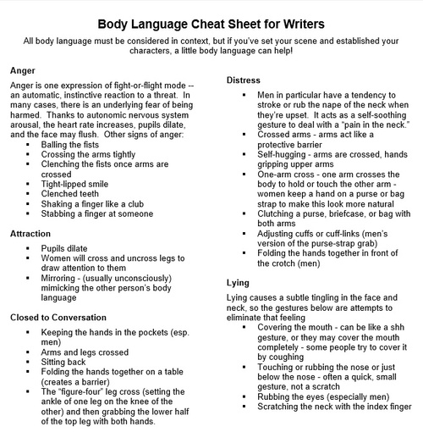
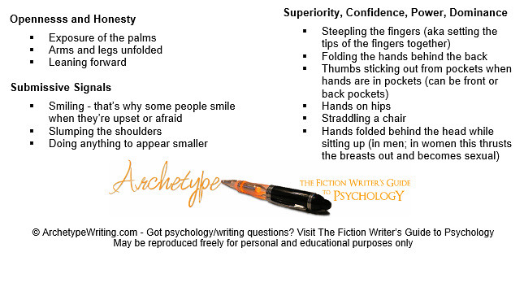
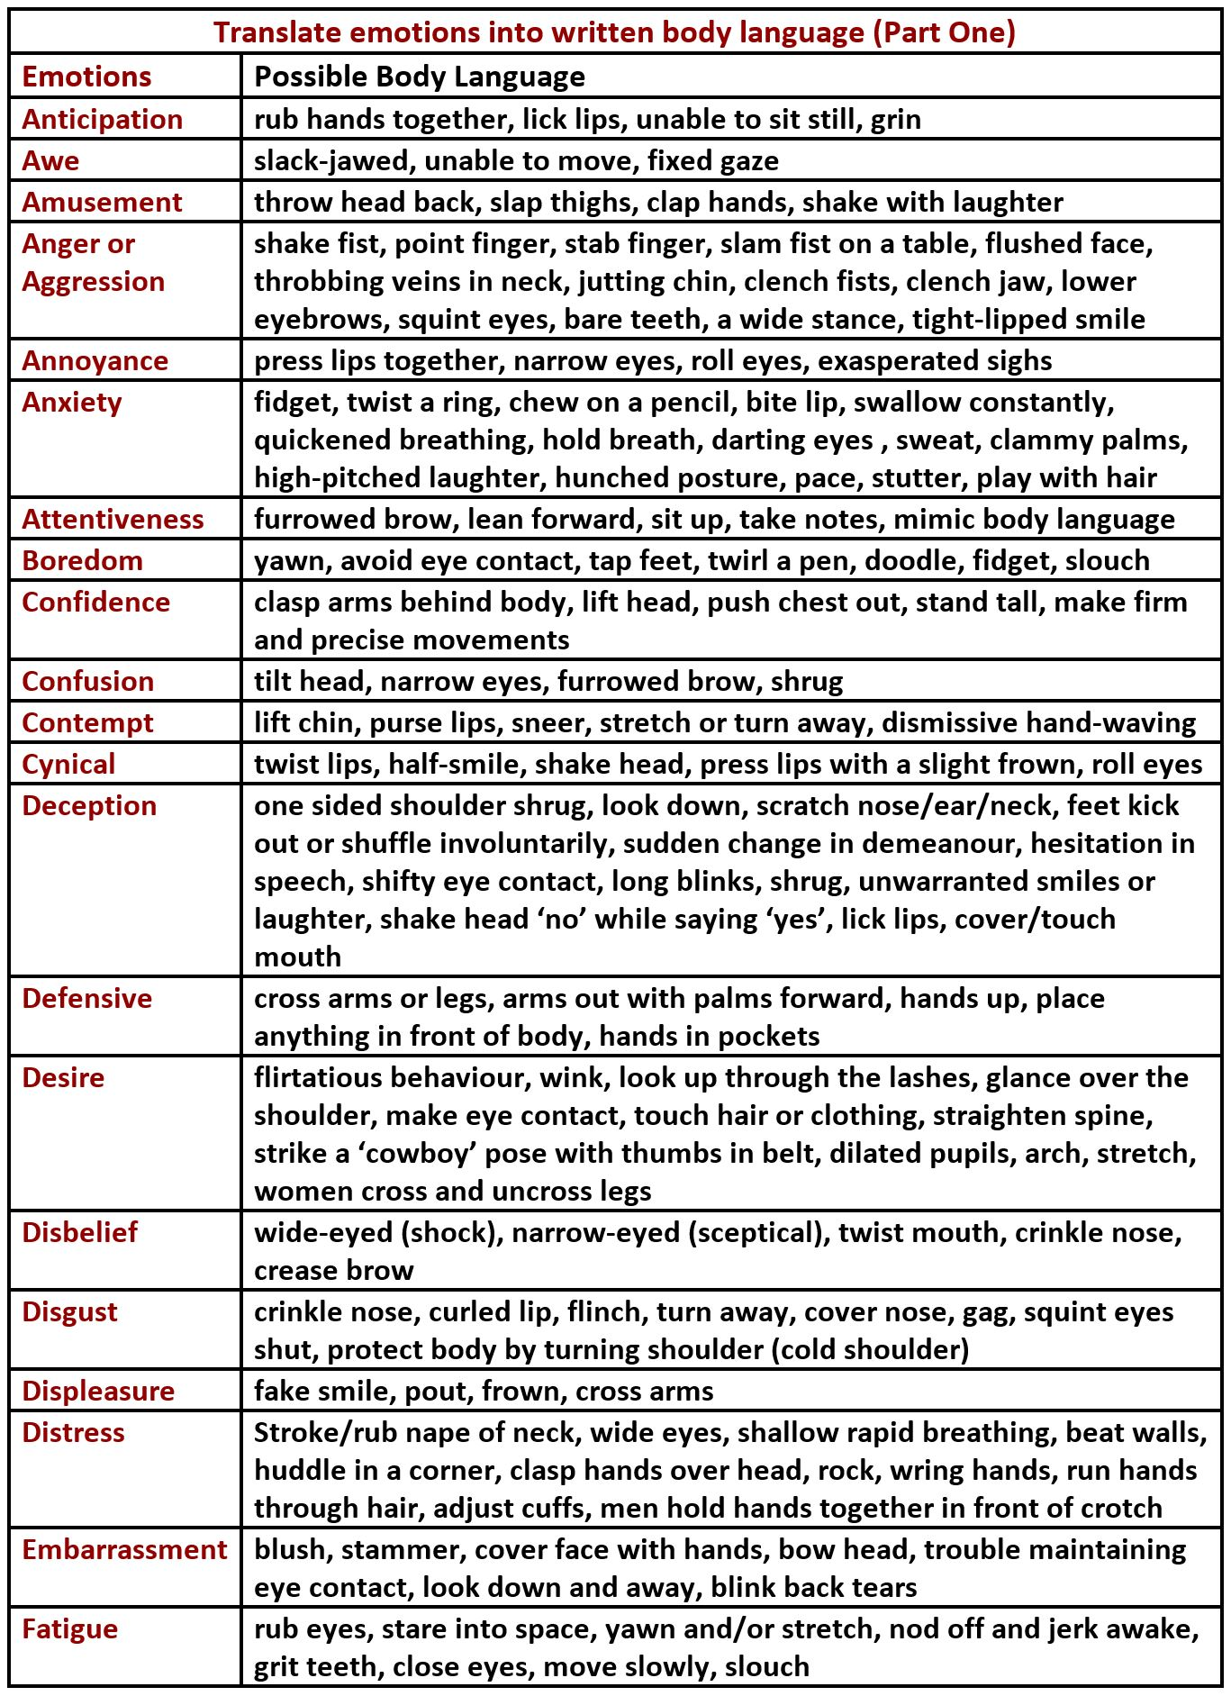
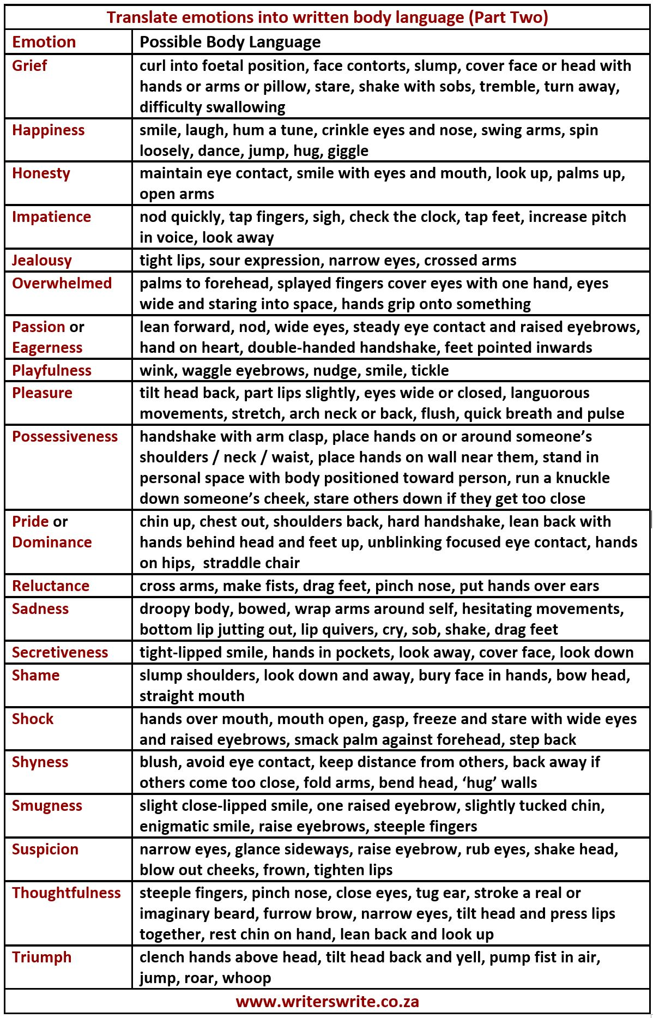

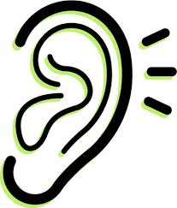
Ways To Describe Sounds

General Words Describing Sounds
- audible – a sound that is loud enough to hear
- broken – a sound that has spaces in it
- emit – to make a sound
- grinding – a sound of one hard thing moving against another
- hushed – a sound that is quiet
- inaudible – a sound that is difficult to hear
- monotonous – a sound that is always the same and never gets louder or quieter, or higher or lower
- muffled – a sound that is not easy to hear because it is blocked by something
- plaintive – a sound that has a sad quality
- rhythmic – a sound that has a clear, regular pattern
- staccato – a sound where each word or sound is clearly separate

Describing Pleasing Sounds
- dulcet – soft and pleasant
- lilting – a sound that has a rising and falling pattern
- listenable – easy to listen to
- mellow – a soft, smooth, pleasant sound
- melodic – beautiful sound
- musical – sounds like music
- pure – a clear, beautiful sound
- rich – a sound that is strong in a pleasant way
- soft – quiet and peaceful
- sonorous – a sound that is deep and strong in a pleasant way
- sweet – a pleasant sound

Describing Noisy Sounds
- at full blast – as loudly as possible
- almighty – used for emphasising how loud something is
- brassy – a sound that is loud and unpleasant
- deafening – a sound so loud you cannot hear anything else
- ear-splitting – extremely loud
- explosive – a sound that is loud and unexpected
- howling – a continuous, low, loud noise
- insistent – a continuous, loud, strong noise
- loud – a sound that is strong and very easy to hear
- noisy – a sound that is full of noise
- percussive – a sound that is short, like someone hitting a drum
- piercing – a sound that is very loud, high, and unpleasant
- pulsating – strong, regular pattern
- raucous – rude, violent, noisy
- resounding – a sound that is loud and that continues for a while
- riotous – lively and noisy
- roaring – a deep, loud noise
- rowdy – noisy and causing trouble
- sharp – a sound that is sudden and loud
- shrill – a sound that is loud, high, and unpleasant
- thundering – extremely loud
- thunderous – loud
- tumultuous – a sound that includes noise, excitement, activity, or violence
- uproarious – extremely noisy

Words That Help You Show And Not Tell Sounds
Many of these words that help you show and not tell are examples of onomatopoeia. These words imitate natural sounds.

- The bees buzzed outside my window.
- The wind sighed.
- The leaves crackled and crunched under his feet.
Use this list to make your writing come alive.
- babble – a gentle, pleasant sound of water as it moves along in a river
- bang – to move, making loud noises
- beep – a short high sound or several short high sounds
- blare – to make a loud and unpleasant noise
- blast – to make a loud sound with a car horn
- bleep – a short high sound or several short high sounds
- boom – to make a deep loud sound that continues for some time
- caterwaul – an unpleasant loud high noise
- chime – a high ringing sound like a bell or set of bells
- chink – a high ringing sound when knocked together, or to make something do this
- clack -to make a short loud sound like one hard object hitting against another
- clang – a loud, metallic sound
- clank – a short, loud sound
- clash – a loud, metallic sound
- clatter – a series of short, sharp noises
- click – a short sound like the sound when you press a switch
- clink – to make the short high sound of glass or metal objects hitting each other, or to cause objects to make this sound
- cluck – to make a short, low sound with your tongue
- crash – a sudden loud noise, as if something is being hit
- creak – if something creaks, especially something wooden, it makes a high noise when it moves or when you put weight on it
- drone – to make a low continuous noise
- fizz – a soft sound that small gas bubbles make when they burst
- groan – a long, low, sound
- growl – a low, unpleasant noise
- grunt – to make a short low sound in your throat and nose at the same time
- gurgle – the low sound water makes when it is poured quickly from a bottle
- honk – to make a loud noise using a horn, especially the horn of a car
- hoot – to make a short loud sound as a warning
- mewl – crying with a soft, high sound
- moan – a long, low sound
- neigh – to make a high loud sound like a horse’s neigh
- peal – if a bell peals, or if someone peals it, it makes a loud sound
- peep – if a car’s horn peeps, it makes a sound
- ping – to make a short high sound like the sound of a small bell
- pipe – to make a very high sound, or to speak in a very high voice
- pop – a sudden noise like a small explosion
- putter – a short, quiet, low sound at a slow speed
- ring – to make a bell produce a sound
- roar – to make a continuous, very loud noise
- rumble – a continuous deep sound
- scream – to make a very loud high noise
- scream – to make a very loud high noise
- screech – to make a loud, high, and unpleasant noise
- scrunch – to make a loud noise like something being crushed
- sigh – a long, soft, low sound
- squeak – to make a short, high noise
- squeal – to make a long high sound
- squee – to make a loud high noise because you are excited or happy
- thrum- to make a low regular noise like one object gently hitting another many times
- thud – a dull sound when falling or hitting something
- thump – to hit against something with a low loud sound
- tinkle – to make a high, ringing sound
- wail – to make a long, high sound
- wheeze – a high sound, as though a lot of air is being pushed through it
- whine – a high, loud sound
- whirr – a fast, repeated, quiet sound
- whisper – to make a quiet, gentle sound
- whistle – to make a high sound by forcing air through your mouth in order to get someone’s attention
- yelp – a short, loud, high sound, usually caused by excitement, anger, or pain
- yowl – a long, loud, unhappy sound or complaint

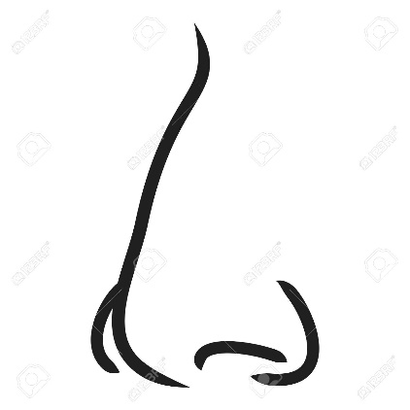
General Words Describing Smells
Use these words that describe smells when you are setting a scene.
- antiseptic – clean or pure smell that is bland an characterless
- aroma – a smell that is strong but pleasant
- comforting – pleasant aroma
- delicate – subtle, faint, smell that is not overpowering
- evocative – a smell that makes you think of something, often something that you experienced in the past
- faint – a smell that is not strong
- fragrance – a sweet or pleasant odour
- heady – strongly aromatic, pungent, rich, intoxicating, spicy, piquant – not a mild smell
- heavy – a sweet and strong smell
- intoxicating – A smell that exhilarates, disorients, or excites
- laden – a literary word that describes a strong smell
- odour/odor – a smell
- odorous – a strong smell
- odourless – with no smell
- piquant – stinging, pungent, an aroma that tickles the nose.
- powerful – a strong smell
- redolent – smelling of something
- reek – to smell strongly and unpleasantly
- scent – a particular smell, especially a pleasant one
- whiff – a slight smell of something

Words That Describe Unpleasant Smells
- acrid – a smell that is strong, bitter, and unpleasant in your nose and throat
- damp – a wet smell
- fetid – an unpleasant smell, usually caused by decay
- frowsty – an unpleasant smell caused by a lack of fresh air
- funky – a strong and unpleasant smell
- fusty – smells old, dusty, or damp
- high – an old-fashioned word that describes a strong flavour and smell
- malodorous – scented, aromatic, redolent, fragrant, stinking.
- musty – unpleasant, stale, and not fresh
- nasty – unpleasant smell
- nauseating – a smell that causes disgust, loathing, or revulsion
- noisome – extremely unpleasant, especially because of being very dirty or having a bad smell
- overpowering – very strong smell
- pungent – a smell that is strong and sharp
- putrid – decaying and smelling very bad
- rancid – rancid food is no longer fresh and has an unpleasant smell
- rank – a strong unpleasant smell or taste
- ripe – a strong or unpleasant smell
- sickly – makes you feel sick
- smelly – an unpleasant smell
- sour – a taste or smell that is no longer fresh
- stale – not fresh or pleasant
- stench – a very bad smell, especially of decay
- stinking – an unpleasant smell
- stuffy – a smell caused by an area with no fresh air in it

Words That Describe Pleasant Smells
- ambrosial – sweet smelling, fragrant, aromatic
- aromatic – perfumed, fragrant, scented, sweet smelling, pungent, usually pleasing
- bouquet – the particular smell of a wine or flower
- delicious – a pleasant smell
- fresh – a pleasant, newly made smell that can be clean, clear, cool, crisp, refreshing, sweet, warm
- fragrant – with a pleasant smell
- perfumed – pleasant to smell because perfume has been added or used, or it has a natural perfume
- rich – a smell that is strong in a pleasant way
- savoury/savory – pleasant to taste – spicy, pungent, flavoursome, and aromatic, salty but not sweet
- scented – a pleasant smell
- sweet – a pleasant smell that is sweet
- tangy – a smell or taste that is strong and bitter in a pleasant way

Words That Smell Like Something
- citrusy – characteristic of citrus fruit in scent
- earthy – smelling like earth
- fishy – smelling like fish
- floral – smelling of flowers
- flowery – a flowery smell reminds you of flowers
- fruity – smelling like fruit
- gamy – having the distinctive fragrance of game (wild meat)
- garlicky – smelling of garlic
- leathery – smells like leather
- lemony – smells like lemon
- medicinal – smells like medicine
- musky – similar to musk in smell
- peachy – similar to a peach in colour, taste, or smell
- smoky – smelling of smoke
- woody – an earthy smell, smelling of wood

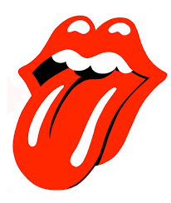
Words To Describe Tastes And Flavours
- acidic – very sour
- astringent – an astringent taste is one that is strong and bitter
- bitter – a strong sharp taste that is not sweet
- bitter-sweet – tasting bitter and sweet at the same time
- brackish – has a slight taste of salt and is therefore not pure
- hot – contains a lot of spices that create a burning feeling in your mouth
- mature – has been left to develop a pleasant strong flavour
- mild – does not have a strong taste
- ripe – has a strong flavour
- robust – has a lot of flavour
- savoury – tasting of salt or spices and not sweet
- seasoned – containing seasonings to improve flavour
- sharp – has a strong and bitter flavour
- sour – with a taste like a lemon
- spicy – has a strong hot flavour
- sweet-and-sour – contains both sweet and sour flavours
- syrupy – thick, sweet, and sticky
- tart – a slightly sour taste
- unsalted – not flavoured with salt
- watery – pale, or not strong

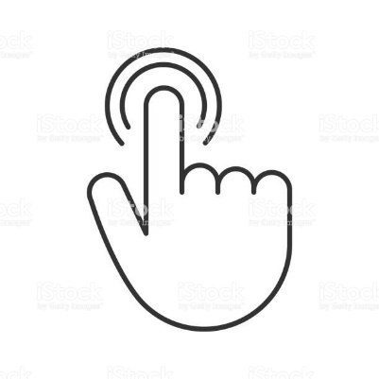
Words To Describe Touch

The ABCs of Touch
- Abrasive, Ample, Angular
- Bald, Barbed, Bendable, Blemished, Blistered, Bloated, Blunt, Bristly, Broken, Bubbly, Bulging, Bulky, Bumpy, Bushy
- Caked, Carved, Chafing, Chapped, Chunky, Circular, Clammy, Clean, Coarse, Cold, Cool, Corrugated, Cratered, Crenelated, Crocheted, Cushioned
- Damaged, Damp, Dehydrated, Dense, Dented, Dirty, Distended, Distorted, Doughy, Downy, Drenched, Dry, Dusty,
- Embossed, Enamelled, Encrusted, Engorged, Engraved, Etched, Even
- Fat, Feathery, Filmy, Firm, Flat, Fleecy, Flimsy, Fluffy, Fluted, Fragile, Freezing, Frigid, Frothy, Furry, Fuzzy,
- Gelatinous, Glassy, Glazed, Glossy, Glutinous, Gnarled, Gooey, Gossamer, Grainy, Granular, Grating, Gravelly, Greasy, Grimy, Gritty, Grooved, Grubby
- Hairy, Hard, Harsh, Hollow, Hot
- Icy, Impenetrable, Imprinted, Indented, Inflated, Inlaid, Inscribed, Ironed, Irregular, Itchy
- Jagged
- Knitted
- Layered, Leathery, Level, Limp, Lined, Long-haired, Loose, Luke-warm, Lumpy
- Malleable, Metallic, Moist, Mosaic, Mushy
- Narrow, Neat
- Oily, Ornamented
- Padded, Patterned, Pleated, Pliable, Pockmarked, Pointed, Pointy, Polished, Pot-holed, Prickly, Printed, Pulpy
- Ragged, Rasping, Razor-sharp, Refined, Ribbed, Ridged, Rigid, Rough, Rubbery, Rusty, Rutted
- Sandy, Saturated, Scalding, Scarred, Scored, Scraped, Scratched, Sculptured, Serrated, Shaggy, Sharp-edged, Sheer, Silky, Slick, Slimy, Slippery, Smooth, Soaked, Soapy, Sodden, Soft, Soggy, Soiled, Solid, Sopping, Spiky, Spiny, Spongy, Springy, Steely, Stiff, Sticky, Stubbly, Stuccoed, Sweaty, Swollen, Syrupy
- Thick, Thin, Thorny, Throbbing, Tiled, Tough, Tweedy
- Unblemished, Unbreakable, Uncomfortable, Uneven, Unyielding
- Varnished, Velvety, Veneered, Vibrating, Viscous
- Warm, Waterlogged, Wavy, Wet, Wide, Wiry, Withered, Woollen, Woven, Wrinkled
- Yielding
- Zigzag

Eyes – General
focus here is on physical descriptions rather than emotional expressions
large  small  narrow  sharp  squinty  round  wide-set  close-set  deep-set  sunken  bulging  protruding | wide  hooded  heavy-lidded  bedroom  bright  sparkling  glittering  flecked  dull  bleary  rheumy | cloudy  red-rimmed  beady  birdlike  cat-like  jewel-like  steely  hard  fringed with long lashes  with sweeping eyelashes  with thick eyelashes

Eyes – Color
Brown is the most common eye color by far. Green is quite rare.
chestnut  chocolate brown  cocoa brown  coffee brown  mocha  mahogany  sepia  sienna brown  mink brown  copper  amber  cognac  whiskey  brandy  honey  tawny  topaz  aquamarine | hazel  obsidian  onyx  coal  raven  midnight  sky blue  sunny blue  cornflower blue  steel blue  ice blue  Arctic blue  glacial blue  crystal blue  cerulean  electric blue  azure  lake blue | denim blue  slate blue / slate gray  storm blue / storm gray  silver / silver gray  chrome  platinum  pewter  smoky gray  ash gray  concrete gray  dove gray  shark gray  fog gray  gunmetal gray  olive  emerald  leaf green  moss green

Eyebrows
arched  straight  plucked | sparse  dark  faint  thin | thick  unruly  bushy  heavy

Skin – Color
amber  bronze  cinnamon  copper  dark brown  deep brown  ebony  honey  golden  pale | pallid  pasty  fair light  cream / creamy  alabaster  ivory  bisque  milk  porcelain | chalky  sallow  olive  peach  rose / rose ruddy  florid  russet  tawny  fawn

Skin – General
Some of these are better for the face, and some are better for other parts of the body.
Lined  wrinkled  seamed  leathery  sagging  drooping  loose  clear  smooth  silken  satiny  dry  flaky  scaly  delicate  thin | translucent  luminescent  baby-soft  flawless  poreless  with large pores  glowing  dewy  dull  velvety  fuzzy  rough  uneven  mottled  dimpled | doughy  firm  freckled  pimply  pockmarked  blemished  pitted  scarred  bruised  veined  scratched  sunburned  weather-beaten  raw  tattooed

Face – Structure
Square|  round  oblong  oval  elongated  narrow  heart-shaped  catlike  wolfish  high forehead | broad forehead  prominent brow ridge  protruding brow bone  sharp cheekbones  high cheekbones  angular cheekbones  hollow cheeks  square jaw  chiseled  sculpted  craggy | jowly  jutting chin  pointed chin  weak chin  receding chin  double chin  cleft chin  dimple in chin  visible Adam’s apple  soft

Nose
snub  dainty  button  turned-up  long | broad  thin  straight  pointed  crooked | strong  Roman  bulbous  flared  hawk

Mouth/Lips
thin  narrow  full  lush  Cupid’s bow | rosebud  dry  rosy  cracked  chapped | moist  glossy  gap between teeth  gleaming white teeth  underbite

Facial Hair (or lack thereof)
clean-shaven  smooth-shaven  beard  neckbeard | goatee  moustache  sideburns  mutton-chop sideburns | stubble  a few days’ growth of beard  five o’ clock shadow

Hair – General
long  short  shoulder-length  loose  limp  dull  shiny  glossy  sleek  smooth  luminous  lustrous  spiky  stringy  shaggy  tangled  messy  tousled  windblown  fine | unkempt  bedhead  straggly  neatly combed  parted  slicked down / slicked back  cropped  clipped  buzzed / buzz cut  crewcut  bob  mullet  curly  bushy  frizzy  wavy  straight  lanky  dry  thinning | oily  greasy  layers  corkscrews  spirals  ringlets  braids  widow’s peak  bald  shaved  comb-over  afro  thick  luxuriant  voluminous  full  wild  untamed  bouncy  wispy

Hair – Color
Black  blue-black  jet black  raven  ebony  inky black  midnight  sable  salt and pepper  silver / silver gray  charcoal gray  steel gray  snow-white | brown  brunette  chocolate brown  coffee brown  ash brown  brown sugar  nut brown  caramel  tawny brown  toffee brown  red  ginger  auburn | copper  strawberry blonde  butterscotch  honey  wheat  blonde  golden  sandy blond  flaxen  fair-haired  bleached  platinum

Body Type – General
tall  average height  short  petite  tiny  compact  big  large  burly  beefy  bulky  brawny  barrel-chested  heavy / heavy-set  fat  overweight  obese  flabby  lean  slim  taut  ripped  Herculean  broad-shouldered  bowlegged | chunky  chubby  pudgy  pot-bellied  portly  thick  stout  lush  plush  full-figured  ample  rounded  generous  voluptuous  curvy  hourglass  plump  leggy / long-legged  gangling  lanky  coltish  lissome  willowy  lithe  sloping shoulders | slender  trim  thin  skinny  emaciated  gaunt  bony  spare  solid  stocky  wiry  rangy  sinewy  stringy  ropy  sturdy  strapping  powerful  hulking  fit  athletic  toned  built  muscular  chiseled

Hands
Delicate  small  large  square  sturdy  strong | smooth  rough  calloused  elegant  plump  manicured | stubby fingers  long fingers  ragged nails  grimy fingernails  ink-stained

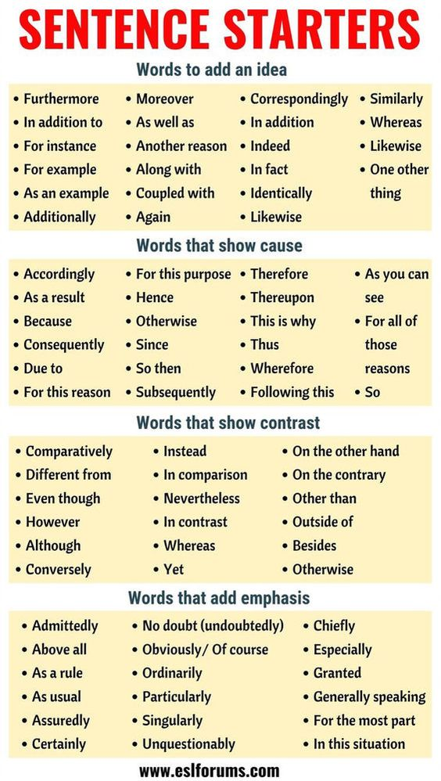

Using Higher Level Vocabulary: Fiction Writing
Try using time connectives, e.g. Meanwhile, Earlier, Later on, Soon, Eventually, After, Minutes later, Finally, In the afternoon …….

Remember connectives may be used as sentence starters.
Try using a verb with an ing ending, e.g.: Laughing, Running, Shouting, Yelling ……..

Furiously
Angrily
Miserably
Sulkily
Despondently

Sadly
Unluckily
Unfortunately
Happily
Luckily
Fortunately
Thankfully

Quickly
Rapidly
Swiftly
Briskly
Hastily
Hurriedly

Carefully
Gingerly
Nervously
Apprehensively
Slowly
Lethargically
Unhurriedly

Suddenly
Without warning
Immediately
Abruptly
Unexpectedly
Instantaneously

explained
elaborated
continued
added
suggested
commented
remarked

moaned
groaned
whined
complained
wailed
snivelled
sighed

shouted
yelled
bellowed
cried
screeched
barked
roared

whispered
murmured
mumbled
muttered
whimpered

argued
insisted
retorted
snapped
asserted
suggested
declared

asked
enquired
questioned
queried
replied
answered
responded

To start sentences
To connect sentences
although
however
because
also
since
when
meanwhile
nevertheless
as so
if or

To replace said

Using Higher Level Vocabulary: Fiction Writing
confident
certain
optimistic
in no doubt
convinced
positive
sanguine

nervous
anxious
apprehensive
worried
tense
uneasy
jittery

big
massive
gigantic
almighty
gargantuan
humongous
enormous

brave
valiant
plucky
bold
fearless
courageous
audacious

quiet
peaceful
tranquil
still
silent
noiseless
calm

busy
lively
crowded
hectic
teeming
swarming
bustling

afraid
frightened
terrified
petrified
terror-stricken
scared witless
panic-stricken

angry
furious
livid
outraged
annoyed
incensed
fuming

ugly
repulsive
grotesque
repugnant
revolting
hideous
vile

beautiful
attractive
handsome
gorgeous
stunning
exquisite
winsome

scary
eerie
spine-chilling
unnerving
sinister
frightening
creepy

grand
stately
impressive
magnificent
regal
splendid
majestic

sad
miserable
dejected
crestfallen
depressed
despondent
heartbroken

happy
ecstatic
euphoric
thrilled
elated
delighted
overjoyed

horrible
unpleasant
nasty
obnoxious
insufferable
disagreeable
loathsome

nice
pleasant
likable
charming
delightful
amiable
good natured

unattractive
ugly
unappealing
unsightly
hideous
disgusting
horrible

attractive
breathtaking
magnificent
awe-inspiring
glorious
spectacular
beautiful

To describe feelings
To describe characters
To describe settings

Higher Level Connectives
although
however
whereas
nonetheless
nevertheless
notwithstanding

consequently
subsequently
as a result of
therefore
hence
ergo
in addition
moreover
furthermore
as well as
also
plus

Bank of High Level Vocabulary
Colours: saffron, indigo, scarlet, azure, emerald, hazel, turquoise, jaundiced, pea green, cyan, magenta, burgundy, cherry, ruby, sapphire, crimson, bloodshot, vermilion, maroon, auburn, chestnut, cobalt, aquamarine, navy, khaki, camouflage, vanilla, , pearly white, antique white, violet, beech, cadet blue, firebrick, tomato, coral, orchid, honeydew, ivory, lemon, peach, plum, gold, lavender, beige, fuchsia.

Dramatic Verbs: snared, disturbed, smashed, blazed, swayed, tormented, straggling, lacerating, plunged, clashed, crackled, penetrated, blistering, jolted, splitting, darted, collapsed, trembled, engulfed, scurried, flickered, twitched, shattered, obliterated, throbbing, shuddered, exploded, oozed, quivered, gushed, raged, toiled, twisting, , writhed, swelled, crept, flapped, collided, pummelled, punctured, dissolved, clenched.

Emotions: apprehension, solemnity, melancholy, underlying guilt, nausea, ennui, jealous, depressed, heartbroken, crestfallen, despondent, anxiety, vexed, morose, confused, hostile, ecstatic, elated, hatred, shame, contempt, pity, envy, benevolence, boredom, restlessness, bewilderment, awe, humiliation, suspicious, impatient, panic-stricken, disbelief, exasperation, resentment, defiance, curiosity, expectation, remorse, exhilaration,

Adjectives: rigorous, merciless, relentless, arduous, rigid, vile, deformed, jagged, serrated, furtive, repulsive, monstrous, intolerable, distinct, prodigious, perilous, ghastly, vast, transparent, ruinous, obscure,

Words to create an interesting character: mute, hesitant, aloof, prodigious, insolent, dispassionate, timid, bashful, surreptitious, indifferent, detached, unapproachable, intriguing, negligent, irresponsible, isolated, irritable, impudent, compelling, edgy, cantankerous, evasive, deceitful, fiery, impulsive, fervent, introverted, eccentric, callous, amoral, immoral, fickle, sentimental, compassionate, eager, inquisitive, indecisive, naïve, infatuated, affectionate, threatening, vicious, unpredictable, cynical, pessimistic, impertinent,

Adjectives for describing food: bittersweet, acidic, peppery, spicy, tangy, sweet, flavoursome, fruity, bitter, sour, salty, sapid, citrus, appetising, sharp, sugary, insipid, bland, stale, watery, succulent, unpalatable, savoury, lukewarm, tingle, aftertaste,

Sound Nouns: click, whisper, hush, silence, tiptoe, creak, tap, thud, knock, din, tone, resonance, vibration, ring, toll, chime, echo, scream, thump, yell, bawl, screech, wail, yelp, roar, shriek, bang, shout, uproar, babble, clunk, tick, inaudible, rattle, plod, hum, whirr, rev, crunch, beep, rumble, squeak, clatter, snore, bleep, yawn, snorted,
TRANSITION WORDS
To improve your writing you need to make sure that your ideas, both in sentences and paragraphs, stick together or have coherence and that the gap between ideas is bridged smoothly. One way to do this is by using transitions - words or phrases or techniques that help bring two ideas together. Transitional words and phrases represent one way of gaining coherence. Certain words help continue an idea, indicate a shift of though or contrast, or sum up a conclusion. Check the following list of words to find those that will pull your sentences and paragraphs together.

For continuing a common line of reasoning:
consequently
clearly, then
furthermore
additionally
and
in addition
moreover
because
besides that
in the same way
following this further
also
pursuing this further
To change the line of reasoning (contrast):
however
on the other hand
but
yet
nevertheless
on the contrary
For opening a paragraph initially or for general use:
admittedly
assuredly
certainly
granted
no doubt
nobody denies
obviously
of course
Clearly
to be sure
true
undoubtedly
unquestionably
generally speaking
in general
at this level
in this situation
For the final points of a paragraph or essay:
finally
lastly
Transitional chains, to use in separating sections of a paragraph which is arranged chronologically:
first... second... third...
generally... furthermore... finally
in the first place... also... lastly
in the first place... pursuing this further... finally
to be sure... additionally... lastly
in the first place... just in the same way... finally
basically... similarly... as well
To signal conclusion:
therefore
this
hence
in final analysis
in conclusion
in final consideration
indeed
To restate a point within a paragraph in another way or in a more exacting way:
in other words
point in fact
specifically

Sequence or time
after
afterwards
as soon as
at first
at last
before
before long
finally
first... second... third
in the first place
in the meantime
later
meanwhile
next
soon
then

The primary reason | It is apparent that ... | Conventionally,.. | These factors suggest ... | Previously,...
A major factor | Foundational to all this is ... | Another significant point is ... | The incident exemplifies... | For that reason...
Of major concern | Customarily, ... | In particular, ... | The traditional interpretation is ... | Prior to this, ...
The general consensus is ... | The statement presupposes... | The example demonstrates ... | Until now, ... | Another argument is ...
The evidence supports ... | The point maintains that ... | Historically,... | In the same way,... | In direct contrast is ...

It’s absolutely vital | It begs the question | That prompts the question,... | … needs further clarification | Moving on,...
considering …, we should ... | Looking ahead,... | Considering the implications | There are two sides to this issue... | Having said that, ...
In any case,... | Ordinarily speaking, ... | Another essential point worth considering is ... | Notably, the idea of ... | It is uncommon that...
Notwithstanding, the idea ... | By the same token, ... | For the most part,... | Looking at it from a different viewpoint, ... | As a rule, … or  Barring …, or  Save for ...

All things considered, ... | By and large, ... | In closing, ... | As has been noted, ... | In brief, … or  Briefly,
On balance, ... | On the whole, ... | With this in mind,... | In the long run, ... | In summary,...

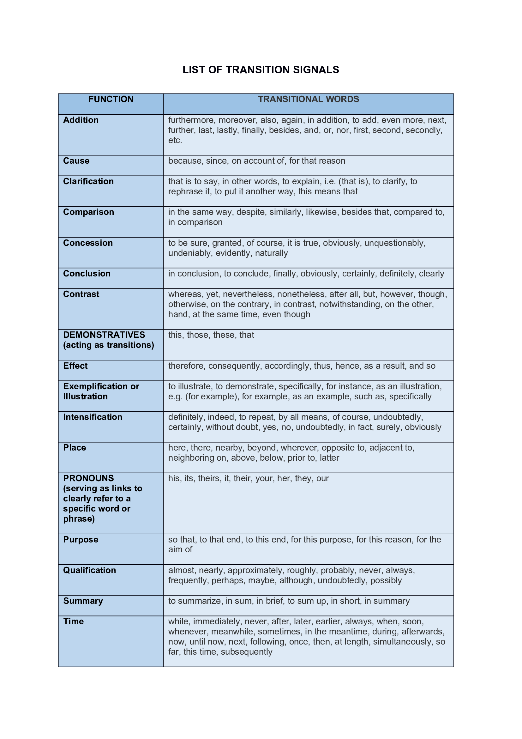
Illustration: Thus, for example, for instance, namely, to illustrate, in other words, in particular, specifically, such as.
Contrast: On the contrary, contrarily, notwithstanding, but, however, nevertheless, in spite of, in contrast, yet, on one hand, on the other hand, rather, or, nor, conversely, at the same time, while this may be true.
Addition: And, in addition to, furthermore, moreover, besides, than, too, also, both-and, another, equally important, first, second, etc., again, further, last, finally, not only-but also, as well as, in the second place, next, likewise, similarly, in fact, as a result, consequently, in the same way, for example, for instance, however, thus, therefore, otherwise.
Time: After, afterward, before, then, once, next, last, at last, at length, first, second, etc., at first, formerly, rarely, usually, another, finally, soon, meanwhile, at the same time, for a minute, hour, day, etc., during the morning, day, week, etc., most important, later, ordinarily, to begin with, afterwards, generally, in order to, subsequently, previously, in the meantime, immediately, eventually, concurrently, simultaneously.
Space: At the left, at the right, in the center, on the side, along the edge, on top, below, beneath, under, around, above, over, straight ahead, at the top, at the bottom, surrounding, opposite, at the rear, at the front, in front of, beside, behind, next to, nearby, in the distance, beyond, in the forefront, in the foreground, within sight, out of sight, across, under, nearer, adjacent, in the background.
Concession: Although, at any rate, at least, still, thought, even though, granted that, while it may be true, in spite of, of course.
Similarity Or Comparison: Similarly, likewise, in like fashion, in like manner, analogous to.
Emphasis: Above all, indeed, truly, of course, certainly, surely, in fact, really, in truth, again, besides, also, furthermore, in addition.
Details: Specifically, especially, in particular, to explain, to list, to enumerate, in detail, namely, including.
Examples: For example, for instance, to illustrate, thus, in other words, as an illustration, in particular, after all, even, indeed, in fact, or course, specifically, particularly, to demonstrate
Consequence or Result: So that, with the result that, thus, consequently, hence, accordingly, for this reason, therefore, so, because, since, due to, as a result, in other words, then.
Suggestion: For this purpose, to this end, with this in mind, with this purpose in mind, therefore.
Sequence: again, also, and, and then, besides, finally, first…second…third, furthermore, last, moreover, next, still, too
Cause and effect: accordingly, as a result, because, consequently, for this purpose, hence, so, then, therefore, thereupon, thus, to this end, due to, for the reason that, since, finally
Place: above, adjacent to, below, beyond, closer to, elsewhere, ,far, farther on, here, near, nearby, opposite to, there, to the left, to the right
Summary, Repetition, or Conclusion: as a result, as has been noted, as I have said, as we have seen, as mentioned earlier, in any event, in conclusion, in other words, in short, on the whole, therefore, to summarize, briefly, in brief, overall, given these facts, hence, in conclusion, summing up, to put it briefly, to sum up, so, therefore, thus, to conclude
For continuing a common line of reasoning: Consequently, clearly, then, furthermore, additionally, and, in addition, moreover, because, besides that, in the same way, following this further, indeed, also, pursuing this further, in fact, in the light of the… it is easy to see
To change the line of reasoning (contrast): however, on the other hand, but, yet, nevertheless, on the contrary
For opening a paragraph initially or for general use: admittedly, assuredly, certainly, granted, no doubt, nobody denies, obviously, of course, to be sure, true, undoubtedly, unquestionably, generally speaking, in general, at this level, in this situation
For the final points of a paragraph or essay: finally, lastly
Transitional chains, to use in separating sections of a paragraph which is arranged chronologically:
first…second…third
in the first place…also…lastly
further…finally
to be sure…additionally…lastly
same way…finally
basically…similarly…as well
generally…furthermore…finally
in the first place…pursuing this
in the first place…just in the
To signal conclusion: therefore…this…hence...in final analysis…in conclusion…in final consideration…indeed
To restate a point within a paragraph in another way or in a more exacting way: in other words…point in face…specifically
Sequence or time: after, afterwards, as soon as, at first, at last, before, before long, finally, first…second…third, in the first place, in the meantime, later, meanwhile, next, soon, then
To indicate a purpose or reason why: for fear that, in the hope that, in order to, so, so that, with this in mind

