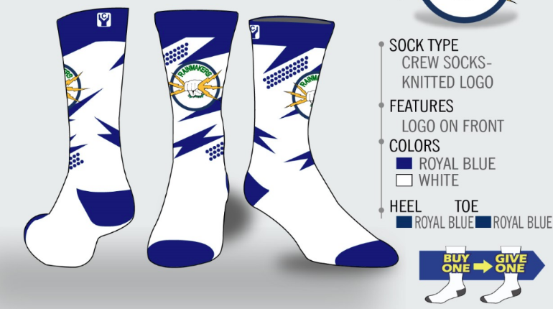
Player Name: _______________________
Charles Hays Secondary School-
Sr Girls Basketball Rainmakers Sock Order form
Cost per pair is $20
Socks are one size fits all ( 7-13 )

Name of person ordering | Contact information | # of socks | Total $ collected
Address:
Home #
Cell #
Address:
Home #
Cell #
Address:
Home #
Cell #
Address:
Home #
Cell #
Address:
Home #
Cell #
Address:
Home #
Cell #
Address:
Home #
Cell #
Address:
Home #
Cell #
Name of person ordering | Contact information | # of socks | Total $ collected
Address:
Home #
Cell #
Address:
Home #
Cell #
Address:
Home #
Cell #
Address:
Home #
Cell #
Address:
Home #
Cell #
Address:
Home #
Cell #
Address:
Home #
Cell #
Address:
Home #
Cell #
Address:
Home #
Cell #
Address:
Home #
Cell #

