“Side Bet” by Will F Jenkins p. 84

Questions and Assignments- Answer all of these questions in full sentences. (see example) If the question asks for an opinion then you must give a reason, an example and an explanation, with support. Use quotes from the story if
It is appropriate to do so.

Example: Question: Do you think the title of the story is appropriate?

Answer: I think the title of the story is appropriate because
Reason: the story is about a bet between a man and a rat.
Example: For example, the man makes a bet with a rat about who will survive.
Explanation: Since the winner of the bet is decided at the end of the story, in terms of
who survives it is a good title.

Questions

- How does the story start?
- Describe the setting of the story. What features stand out?
- Why do you think the author showed the setting in so much detail?
- Who was the bet between and what was it about?
- What had happened to the man on the island?
- When did the man first become aware of the rat?
- Why didn’t he like the rat? Describe some things the rat does that causes the man to hate it.
- Do you think the man is right to hate the rat? Why or why not?
- Describe the island the man is on. Why would it be difficult to survive there? Be specific.
- Why was the man trapped? Why did he have little hope of rescue?
- How much did the man have to survive on?
- How does the man try to take care of the problem with the rat?
- When did the man become convinced that he had lost the bet? What was the prize the rat was meant to collect?
- Why did the man start the fire?
- How was the man rescued? Explain why this was ironic. (look up what ironic means in the dictionary)
- Why is the man jealous of the rat?
- Why does our feeling towards the rat shift from hatred to sympathy? In other words, why do we feel sorry for the rat at the end?
- In what unusual way does the man pay his debt to the rat?

Assignments:
Activity #1- Create/draw pictures of character(s) or scene(s) from the story for 15 details. You have to have a chart with all 15 details, sentences with a reason, example and explanation for each of the 15 details, and a picture for each of the 15 details you have selected.

- Pick the character(s) and/or scene(s) you want to draw or create. In total you will need to have 15 details between all of the pictures of characters and/or scenes you draw.
- Make a chart that lists the details you have chosen to include in your pictures, the quote or description from the story that made you choose that detail, and the page number you got it from. (see example)

Detail | Quote/description | Page #
1. Big | ``The rat was huge.`` | 85
2. etc.
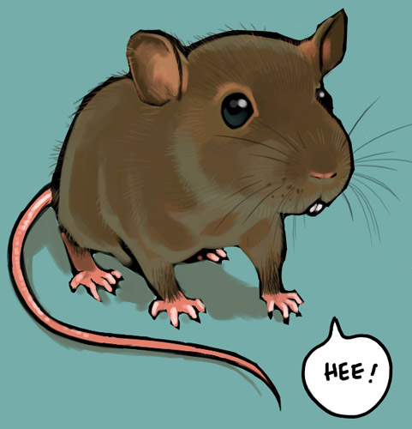
- Picture –Make sure you label the picture with
the number from the chart for each detail.

1

- For each detail you must explain what the detail is, where you got it from, and why you put it where you did. (see example)

Example- I drew the rat so it was as big as a cat because in the story, on pg. 85 it said ``the rat was
huge.``Since a normal size rat would be about the size of a squirrel I thought that making the rat
look as big as a cat would make it seem huge.

Activity #2-Creative writing assignment: Follow all the writing steps. You need a rough and good copy. (see example from The Most Dangerous Game for help)

Creative assignment

Write a diary from the perspective of the rat about what happened, how it felt about it and why. (1-2 pages)

