ROUTES
&
ROOTS
- 1. WHAT ARE YOUR ROOTS?-CULTURAL HERITAGE-VILLAGES/CITIES/ ANCESTORS
- 2. WHAT WAS YOUR ROUTE? (parents/grandparents/ancestors)
- 3. HOW DID YOU GET TO PRINCE RUPERT?
- 3. FAMILY- PARENTS, SIBLINGS, GRANDPARENTS- EXTENDED FAMILY

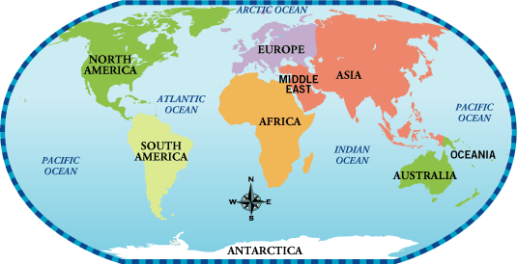

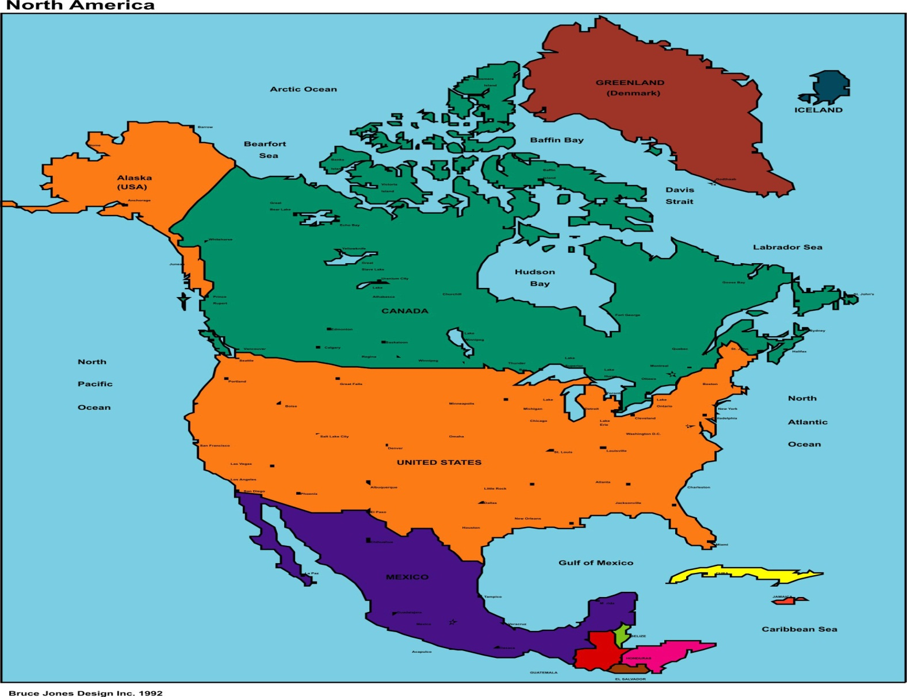
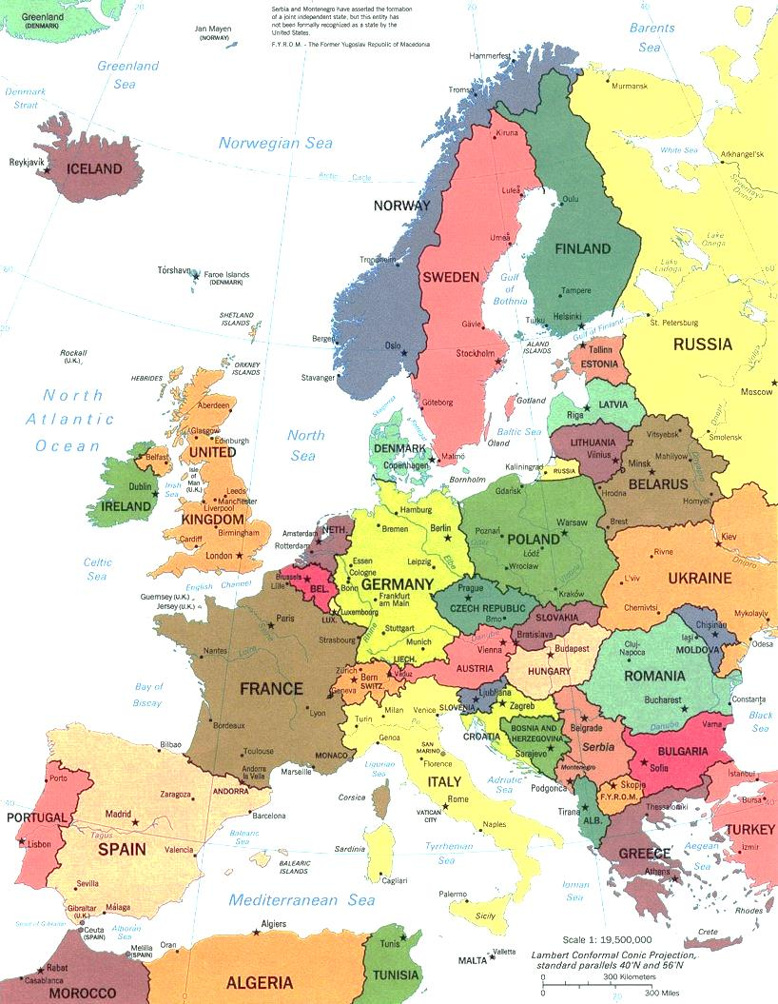

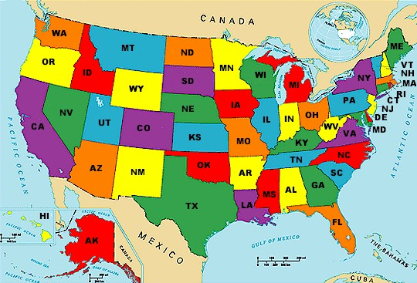
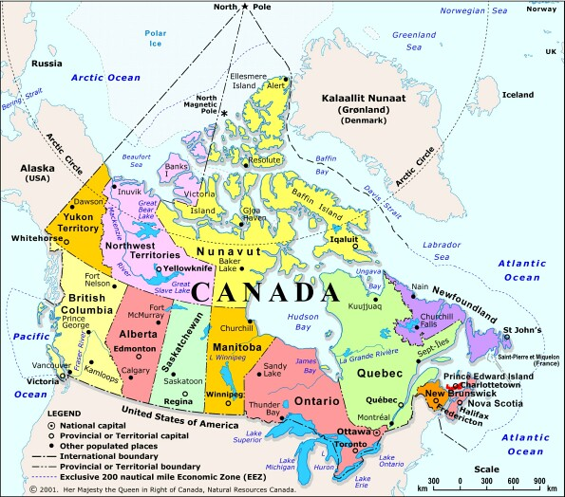

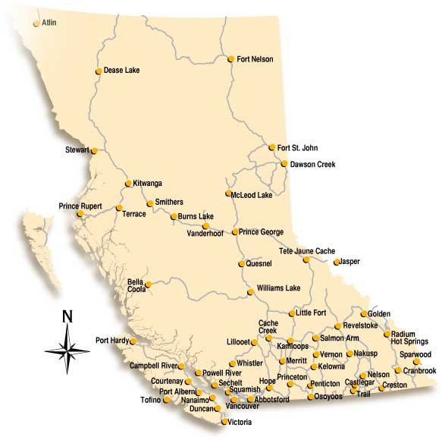
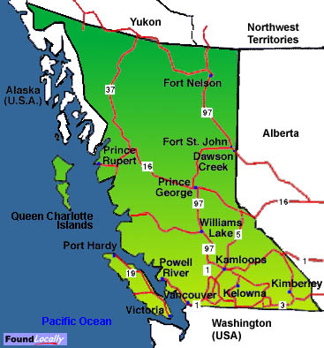
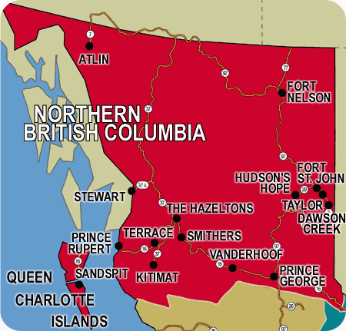
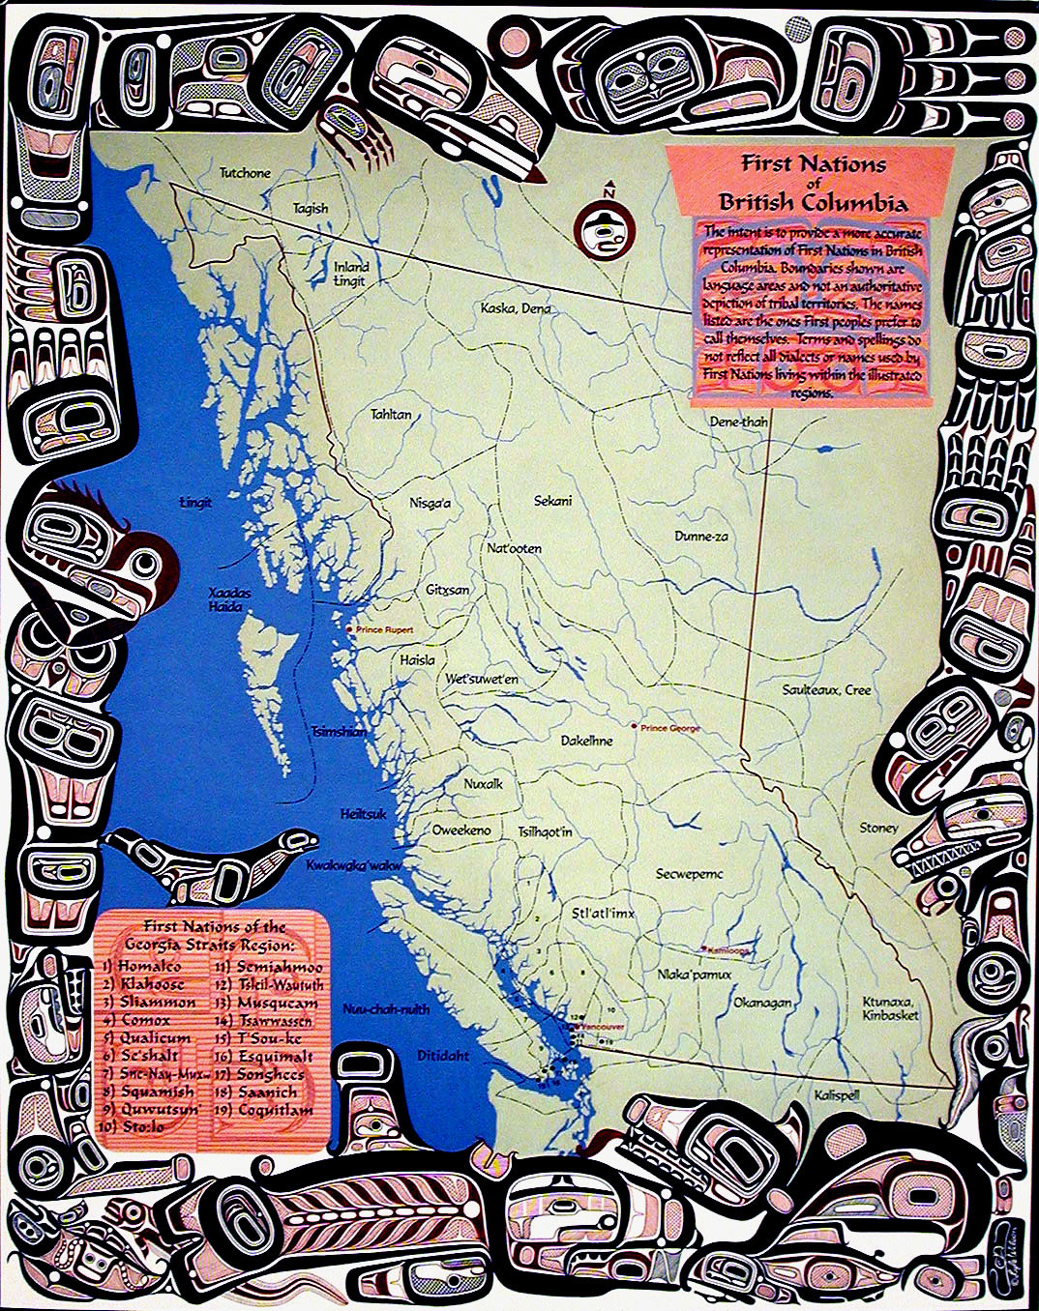
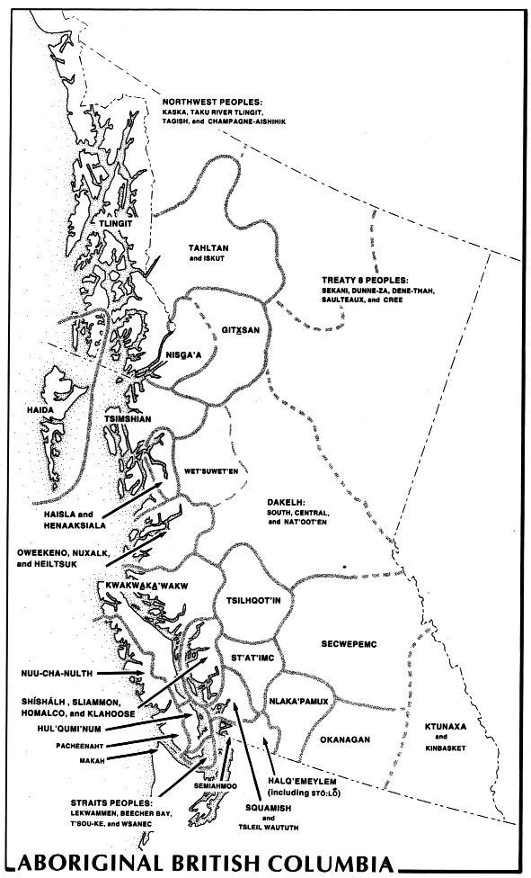
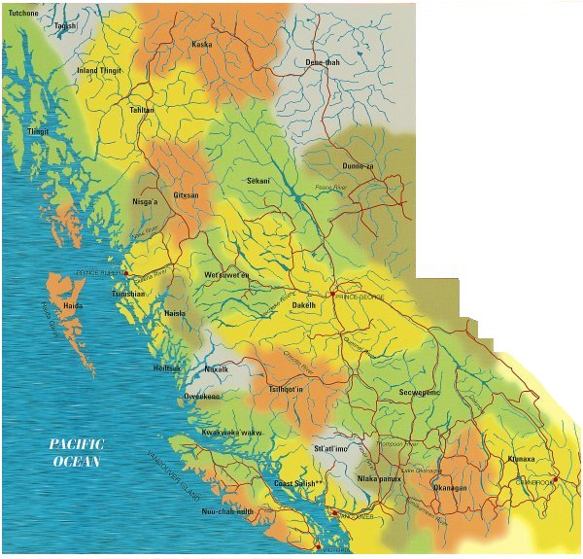

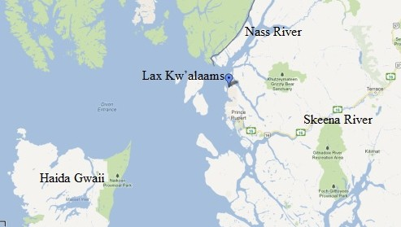
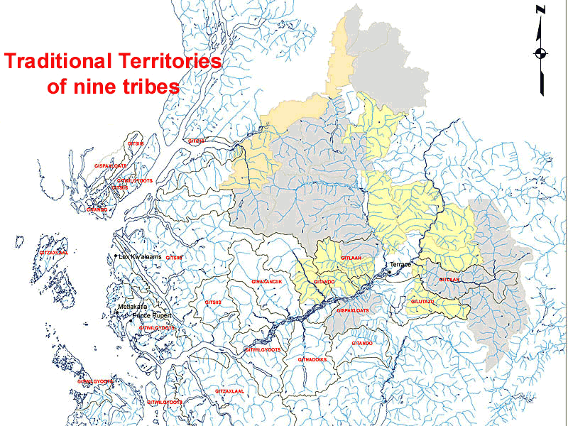
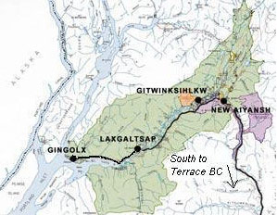

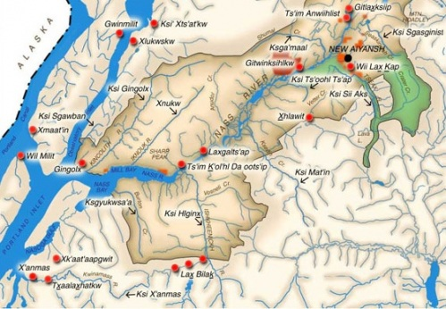

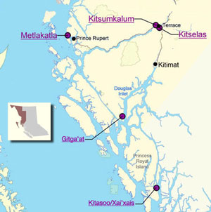

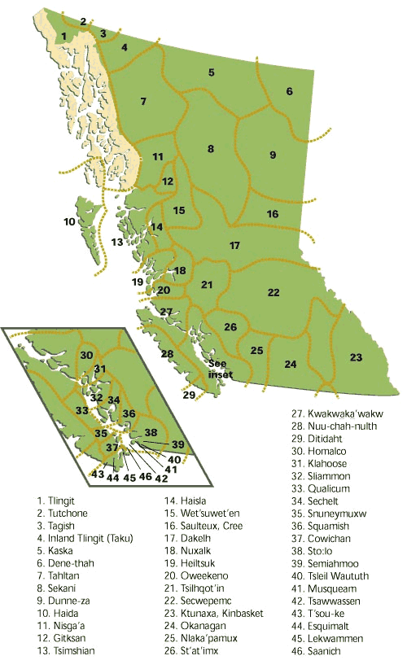
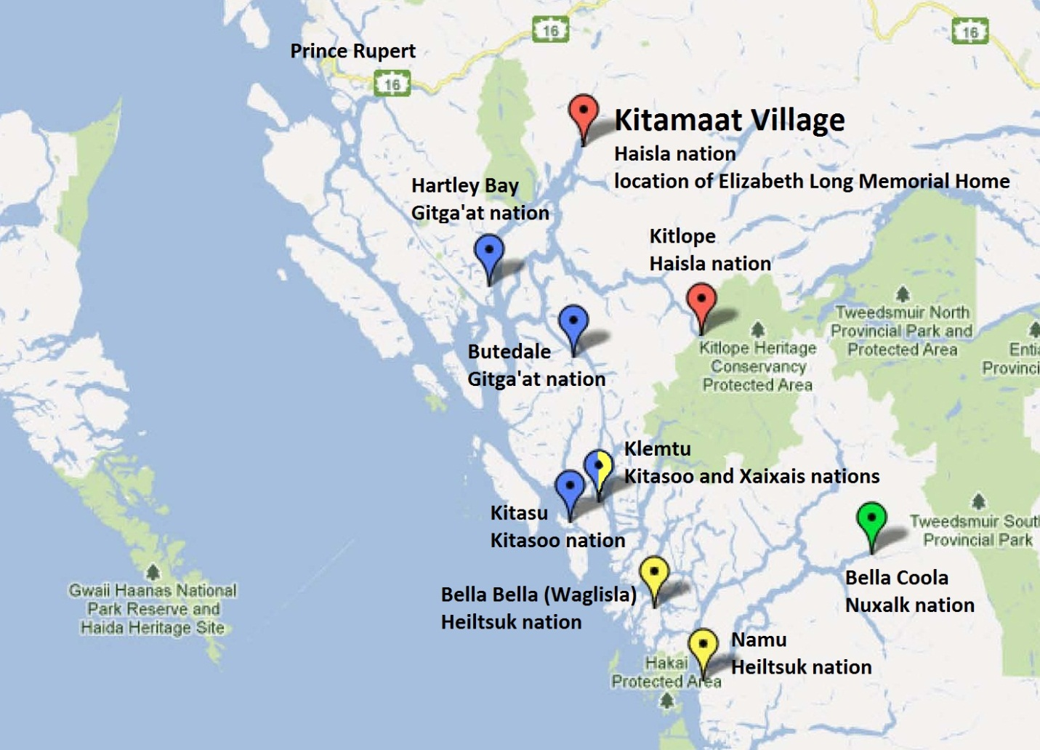
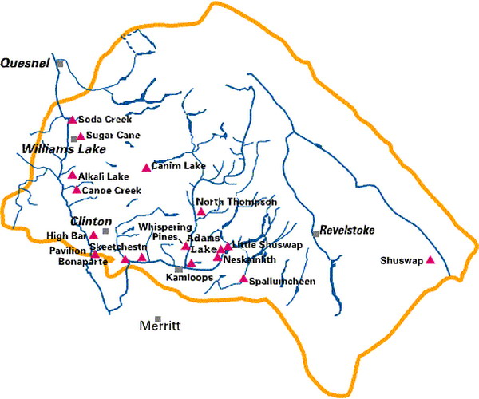
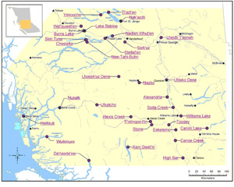

- Writing assignment:
- Answer the following questions in a couple of paragraphs.
- What is your ethnic/cultural background? What does it mean to you? Is it important? Why or why not? What do you know about your background? What would you like to learn? Why is it important to know about your background? Why do you think it is important for people in Canada, regardless of their ethnic or cultural background to know about the history of first nations people in Canada?

