Practicing latitude and longitude
- Label the equator, the prime meridian, the tropic of cancer, the tropic or Capricorn, the arctice circle and the Antarctic circle on the map.
- Give the latitude and longitude coordinates for the following letters on the map:
- A  - B  - C  - D  - E  - F  - G  - H | - I  - J  - K  - L  - M  - N  - O
- Identify the number that corresponds to the following coordinates on the map.
- 26 N 176 E  - 60 N 110 W  - 45 S 170 E  - 40 N 95 W  - 45 S 15 W  - 10 S 65 W  - 5 S 14 W  - 75 N 35 W  - 20 S 133 | - 20 N 10 E  - 50 N 84 E  - 60 N 123 E  - 10 S 33 E  - 20 S 52 E  - 70 S 52 E

- Place a Star on the following points of latitude and longitude. Label each with the small case alphabet letter corresponding to the question. For example, your first start would be labelled a.
- 66.5 N 150 W  - 66.5 N 80 E  - 0 N 0 E  - 10 N 90 W  - 23.5 N 100 W  - 23.5 N 110 E  - 23.5 S 180 W  - 23.5 S 80 E  - 20 S 40 W | - 40 S 140 W  - 40 S 140 E  - 66.5 S 90 W  - 66.5 S 60 E  - 80 S 0 E  - 70 S 170 E

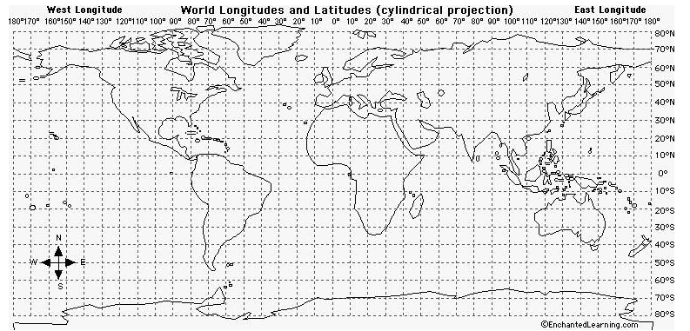
4
L
O
N
M
K
J
I
H
G
F
E
D
C
B
A
15
12
14
13
11
100
2
9
7
6
5
3
8
1

