Practice review test continued
- Name all the provinces and territories, as well as their capitals.
Province/Territory | Capital
1 | A
2 | B
3 | C
4 | D
5 | E
6 | F
7 | G
8 | H
9 | I
10 | J
11 | K
12 | L
13 | M

- On the map below label the provinces and their territories using the numbers and letters from #1
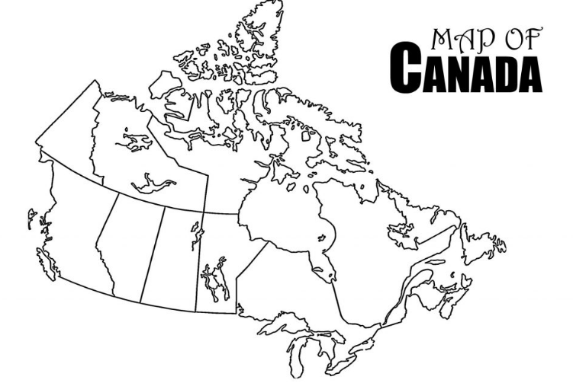

3. Name the 7 continents and the 5 oceans below.
Continents | Oceans
1 | A
2 | B
3 | C
4 | D
5 | E
6
7

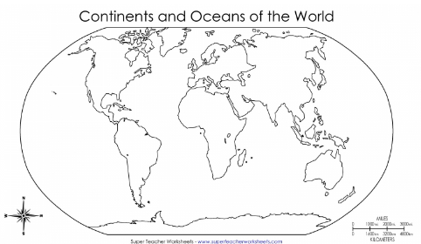
4. Label the continents and oceans on the map below using the information from #3.

