English First Peoples Poetry Anthology Booklet and Presentation project
In this project we are going to be reading poems based on different shared aboriginal experiences. You will be expected to find poems/songs by first nations people and about first nations experiences. You will also be writing poems of your own to express themes about first nations peoples and your own experience as a first nations person. At least one of the poems you create will have to be a song, using a drum, combining the traditional method of expressing these ideas and the modern. You will use these poems to create a poetry anthology booklet with these poems. In this booklet you must complete the requirements for the grade you wish to receive. Your booklet must have the following:
For a passing grade (C-)- To pass everyone must complete the following at a minimally acceptable level.
- A title page with the title of your anthology, illustrations relating to the poems you have picked/written, your name, and your class on it.
- At least 7 examples of poems and/or songs you like. (they must include words and/or lyrics)
- At least 7 different types of subject poems written by you using the types of poetry we have looked at.
- One of the poems you have chosen or created in #2/#3 must be used to create a drumming song to present to the class.
- For each poem you must explain why you chose or wrote the poem.
- For each poem you must include at least one visual to represent the images in the poem.
- For each poem you must summarize what the poem is about and what you think the theme of the poem is, as well as explain how the theme is shown in the poem.
- You must complete the poem questions for at least one poem.
- You must present one of your poems to the class from your booklet and explain the visual, the summary, and the theme of the poem.
- You must also present the song/poem you have used/created for drumming.
For a C grade-You must complete all requirements for C-, at a C level, as well as these additional requirements.
- An additional two examples of poems for #2, and #3(9 of each),, 2 visuals per poem in #5, and one more set of poem questions for #8.
For a C+ grade-You must complete all of the requirements for C-/C, at C+, as well as these additional requirements.
- An additional three examples of poems for #2, and #3(10 of each),, 3 visuals per poem in #5, and one more set of poem questions for #8.
For a B grade- You must complete all requirements for C-/C/C+, at a B level, as well as these additional requirements.
- An additional four examples of poems for #2, and #3(11 of each),, 4 visuals per poem in #5, and one more set of poem questions for #8.
- You must create a visual representation of your poem. This can be done with a collage or series of pictures that represent images in your poem.
  - You must also show your visual representation of the poem to the class, explaining how you came up with these images from your poem.
  - You must identify two poetic terms used in your poem and why they are examples of that term, and how they are used by the poet in the poem.
For an A grade- You must complete all requirements for C to B, at an A level, as well as these additional requirements.
- An additional five examples of poems for #2, and #3 (12 of each), 5 visuals per poem in #5, and one more set of poem questions for #8.
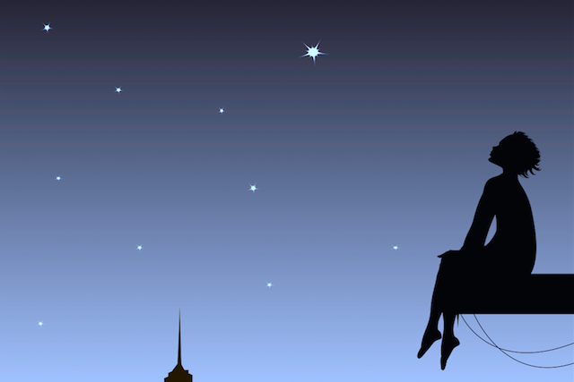
- You must do #12 from the requirements for a B grade but you must identify three poetic terms for b.
Title Page Example

POETRY ANTHOLOGY BOOKLET
Poems that Inspire Me

NAME
ENGLISH FIRST PEOPLES 11/12
PERIOD

Poem questions (All answers must have reason/examples and explanations where
necessary. They must also be written in full sentences.)
- What is the title of the song/poem?
- Does the title suit the song/poem? Explain your answer.
- What is the song/poem about?
- What is the theme of the poem? Explain your answer.
- How do you know the poem is about this? Give 2 reasons with examples and explanations.
- Why do you think the poet wrote this song or poem?
- What are two things this poem made you think about and why?
- What is one part of the poem you found interesting and why?
- What is one part of the poem you didn’t like and why?
- Overall did you like or dislike this poem. Explain 1 reason why.
- On a scale of 1-10 what would you rank this song/poem ? Give 2 reasons for your answer.
- What is one thing that the poet could have done to improve the poem ? Explain how it would have been improved.
- Would you recommend this poem to others? Why or why not?
- Find 5 poetic devices in the poem. Write the line of poetry they are found in, (only as much as necessary to show the device) and explain why it is an example of that device. (just as you did for Casey at the Bat)

Example of How to Create a page for each poem in your anthology booklet
A Time To Believe by B.J. Morbitzer  To believe is to know that  every day is a new beginning.  Is to trust that miracles happen,  and dreams really do come true.  To believe is to see angels  dancing among the clouds,  To know the wonder of a stardust sky  and the wisdom of the man in the moon.  To believe is to know the value of a nurturing heart,  The innocence of a child's eyes  and the beauty of an aging hand,  for it is through their teachings we learn to love.  To believe is to find the strength  and courage that lies within us  When it's time to pick up  the pieces and begin again.  To believe is to know  we are not alone,  That life is a gift  and this is our time to cherish it.  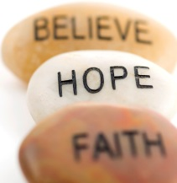  To believe is to know  that wonderful surprises are just  waiting to happen,  And all our hopes and dreams are within reach.  If only we believe. | Poem: A Time to Believe  Poet: B.J. Morbitzer  Topic: Motivational poem  - I chose this poem because it talks about what it means to believe in something and I think that you must believe in what you are doing to be motivated to do something. For example, if a person believe they can make the world a better place, by improving the environment, for instance, then they are more likely to be motivated to take action to accomplish their goals.  - This poem is about the power of believing. It gives examples of what it means to believe in something, and how we can reach our dreams if we believe in something. The theme of this poem is that if you believe in something enough you will have the power to make your hopes and dreams come true. For example, it talks about how when people believe, they can “trust that miracles happen” and they can “find the strength and courage that lies within.” Since belief allows for us to imagine the possibilities in life, it helps us succeed in fulfilling our hopes and dreams.  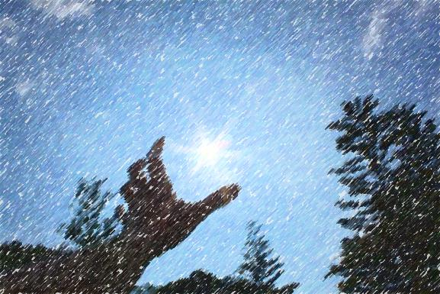
Some poems you can read to choose from to put in your Anthology or to give you ideas of what to write your poems about (There are many others and you do not have to pick from this list. The key to the choice is that they have to be by First Nations poets/songwriters and about first nations experiences.)

Place poems- Connection to home Connection to the land-
Dreaming in Indian- pg. 15- Fried Bologna and Rice
Dreaming in Indian Pg. 20/21- Home poems
Dreaming in Indian Pg.73- The power of the land
Voices of the First Nations- p.83- The reason why I am afraid even though I am a fisherman
Anthology of Canadian Native Literature pg. 38/39 –Shadow River/The Corn husker/The Song my Paddle sings
Anthology of Canadian Native Literature pg.178- Coyote Trail

History remembered poems
Dreaming in Indian p. 23,
Dreaming in Indian p. 25- NDN lady
Dreaming in Indian p.27- Lakota Thunder
Dreaming in Indian p.56-Indian Giving
Dreaming in Indian p.57 Shapeshifter gets a job offer
Dreaming in Indian Pg.105- Medicine War Love
Voices of the First Nations- p. 59- Rocks
Voices of the First Nations- p.70- Sahaquakegick
Anthology of Canadian Native Literature pg. 48 The Lilloets
Anthology of Canadian Native Literature pg.187 I want to dance in Wild Indian Black Face

Lived Experience- Poverty/Abuse/Addiction/Loss of Culture/Racism
Dreaming in Indian p.45 My Reality (sexual abuse)
Dreaming in Indian p.62/63 Poverty
Anthology of Canadian Native Literature pg. 47- Tyee Big Chief- (loss of language)
Anthology of Canadian Native Literature pg. 49- Christmas at the Mission (res school)
Anthology of Canadian Native Literature pg. 107- I lost my talk
Anthology of Canadian Native Literature pg. 107- MicMac Hieroglyphics
Anthology of Canadian Native Literature pg. 108- Shawnawdithit
Anthology of Canadian Native Literature pg. 122-Jacob
Anthology of Canadian Native Literature pg. 130 Joseph’s Justice
Anthology of Canadian Native Literature pg. 180-Raced out to write this up (racism)
Anthology of Canadian Native Literature pg.181- One way to keep track of who’s talking
Anthology of Canadian Native Literature pg. 182- Coyote Columbus Cafe
Anthology of Canadian Native Literature pg. 189-Exercises in Lip Pointing
Anthology of Canadian Native Literature pg. 192-196-How to write about white people/Saskatchewan Indians were dancing/I shoulda Said something political/Me tonto along
Anthology of Canadian Native Literature pg.212- Heritage/Howling at the Moon
Anthology of Canadian Native Literature pg.215- I am not in charge of this ritual
Anthology of Canadian Native Literature pg. 220- the apocalypse will begin
Anthology of Canadian Native Literature pg.229- History Lesson
Anthology of Canadian Native Literature pg.231- Indian Woman
Anthology of Canadian Native Literature pg.234- Threads of Old Memory/Fire Madness/Wind woman/Keepers words
Anthology of Canadian Native Literature pg.246- Shake ‘n Bake/Zen Indian/ He told me/Four songs for the Fifth Generation/Post-Oka Kinda Woman/

Healing /Resilience
Dreaming in Indian Pg.74-Music is the Medicine
Dreaming in Indian Pg.119- Weaving Dreams
Voices of the First Nations- p.161 God of the Fiddle Players
Voices of the First Nations- p.241 Just remember
Anthology of Canadian Native Literature pg. 106- Today’s Learning child (resilience)
Anthology of Canadian Native Literature pg.217 if I ever heard/my sweet maize
Anthology of Canadian Native Literature pg.224 Replanting the heritage tree
Anthology of Canadian Native Literature pg.327- Waking up/Journey towards possibilities
Anthology of Canadian Native Literature pg.333- Waking up/Journey towards possibilities
Walking both sides of an Invisible border

Pride in Who you are/Culture/Wisdom of Elders/Learning from Elders

Voices of the First Nations- p.127 A visit in Mid- Summer
Voices of the First Nations- p.110 Our Elder- My Nokomis Speaks
Voices of the First Nations- p.150 Our Elder- The Crow Hop
Anthology of Canadian Native Literature pg. 114- I am Canadian

Other poems/songs to consider looking for

