Oolichan Field trip make up work
Read the information below. Using it and the information from the fill in the blanks, write a paragraph about why Oolichans were important to First nations people and the ecosystem.

Eulachon, a small type of smelt, were also caught and preserved. They were called "candlefish" because they contained so much natural oil that when dried, they could be burned like a candle. Eulachon oil was not only a food product but also a valuable trade commodity. Eulachon fishing rights were highly prized by the Tsimshian and Kwakwaka’wakw peoples. Other groups such as the Haida and Tlingit had no access or rights to eulachon fishing and would seek oil from those who had a surplus. (Eulachon trade routes were known as "grease trails.")
The fishing areas were so important that jurisdiction was closely monitored; kinship groups held exclusive rights that could be passed down as private property. Two main techniques were used to preserve fish: drying and smoking. Eulachon were pierced by sticks threaded through the gill and mouth and were hung on drying racks (figure 3). With good weather and the right combination of wind and smoke, the fish could cure in about five days.
Eulachon oil, rich and nutritious and a natural source of iodine, was consumed with almost every meal as a seasoning or flavouring agent and was also used for trade with other groups. The fish were allowed to spoil or "ripen" before rendering the oil. Afterwards, they were placed in a vat or a pit filled with water which was heated up to the boiling point. Most of the oil would then rise to the top and be skimmed off and placed into containers. In early times, the oil was stored in "bottles" made from kelp bulbs; later, glass bottles were used. Ingenious fishing techniques and their accompanying tools developed over time, as they were enhanced, modified or discarded depending on their effectiveness and the availability of materials.
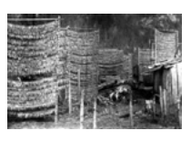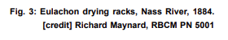
Oolichan facts: Answer the following questions using information from the information given.
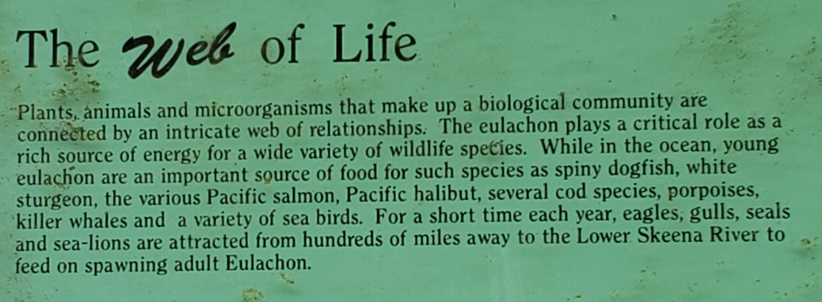
The Web of Life
Oolichan play a critical role as a rich source of ________________ for many wildlife species. Oolichan are an important source of food in the ocean for (name 3 species) _____________________________, ___________________________________ and _____________________________________________. Each year ____________________, __________________________, ___________________________ and __________________________________ come from hundreds of miles away to the Lower Skeena River to feed on spawning adult Oolichan.
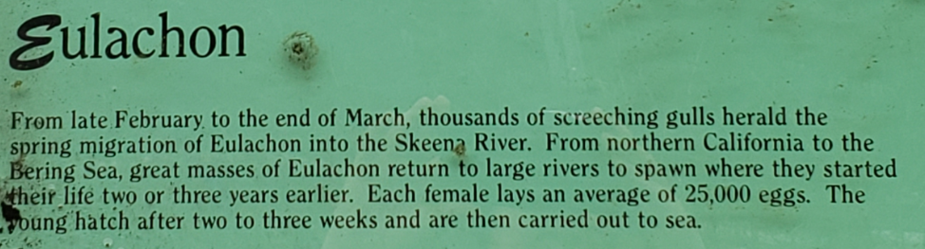

Eulachon
The spring migration of Oolichan into the Skeena River happens from late _________________________ to the end of _______________________. They travel from northern ____________________________ to the Bering Sea returning to large rivers to ___________________ where they started their life 2 or 3 years earlier. Each female lays an average of ______________________ eggs. The young hatch after ___ to ___ weeks and are then carried out to ______________________.
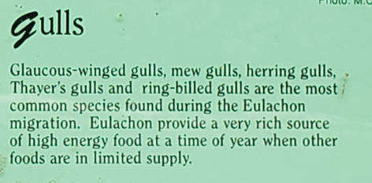
Gulls
The most common species of gulls during the Oolichan migration are ______________- winged gulls, ___________ gulls, _______________ gulls, _________________ gulls and ring-___________________ gulls. Oolichan provide them with a high energy food when other foods are in limited ______________.

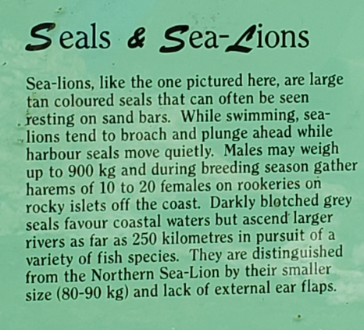
Seals and Sea-Lions

Male Sea-Lions weight up to ______ kg and during beeding season they have ________________ of 10-20 females. Seals and Sea-Lions go up large rivers as far as ________ km in pursuit of various fish species including oolichan. Seals are distinguished from Sea-lions by their ____________ size and lack of external __________ flaps.

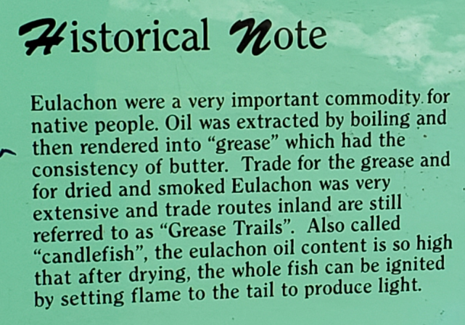

Historical note
Oolichan were a very important _________________________ for Indigenous peoples. The oil was extracted by boiling and then rendering it into _________________________ that had the consistency of butter. Trade for the grease, as well as dried and smoked oolichan was very extensive and trade routes were called ____________________ Trails. Oolichan are also called ____________________ because their oil content is so high after drying that that whole fish can be _____________________ by setting flame to the tail to produce light.
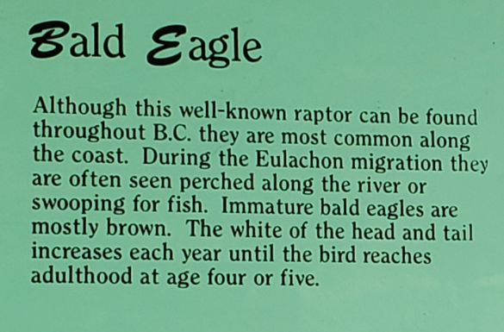
Bald Eagle
Eagles are most common along the _____________ of BC. During the oolichan __________________ they can be seen perched in the trees and swooping down for fish. Immature bald eagles are mostly ___________________. While the white of their head and tail increases every year, their heads become the most white at ______________________ when they turn _________________________ or _____________________.

