Most Dangerous Game activity alternate
“Side Bet” by Will F Jenkins p. 84

Assignment:
Activity #1- Create/draw pictures of character(s) or scene(s) from the story for 15 details. You have to have a chart with all 15 details, sentences with a reason, example and explanation for each of the 15 details, and a picture for each of the 15 details you have selected.

- Pick the character(s) and/or scene(s) you want to draw or create. In total you will need to have 15 details between all of the pictures of characters and/or scenes you draw.
- Make a chart that lists the details you have chosen to include in your pictures, the quote or description from the story that made you choose that detail, and the page number you got it from. (see example)

Detail | Quote/description | Page #
1. Big | ``The rat was huge.`` | 85
2. etc.
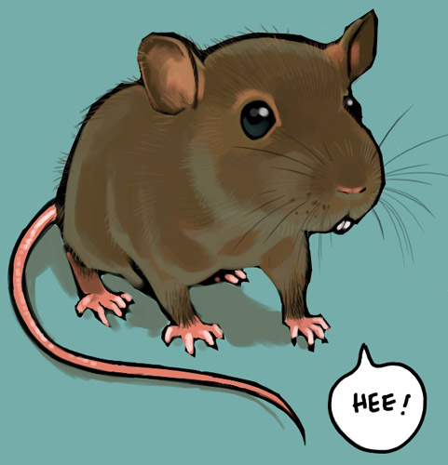
- Picture –Make sure you label the picture with
the number from the chart for each detail.

1

- For each detail you must explain what the detail is, where you got it from, and why you put it where you did. (see example)

Example- I drew the rat so it was as big as a cat because in the story, on pg. 85 it said ``the rat was
huge.``Since a normal size rat would be about the size of a squirrel I thought that making the rat
look as big as a cat would make it seem huge.

