Basketball Defense - Match-up Zone Defense
A good man-to-man defense looks like a zone away from the ball (help-side defense)... see Basic Defense. The match-up zone resembles what we years ago called a "switching man-to-man", where defenders switch freely with one another, so that your defensive big men stay down low and your quick guards are on the perimeter.
This discussion also reminds us that "a good zone looks like a man-to-man, and a good man-to-man looks like a zone."
As in any aggressive man-to-man defense, pressure the ball at all times, front the low post, deny the passing lanes, and give help on inside penetration.
Now let's look at some defensive sets and how to match-up. You can create your own match-up rules so long as your players all understand and know the coverage patterns. In the diagrams below X = defense, O = offense.
2-1-2 Match-up Zone  Refer to Diagram A.  Here your 2-1-2 match-up faces a 1-3-1 offense. You see in the diagram how your defensive players match up with the offense. X1 takes the point (O1), and X2 gets the right wing player (O2), while X3 comes out to pick up the left wing (O3)  Refer to Diagram B.  The 2-1-2 match-up zone faces a 3-out, 2-in offensive set. The coverage pattern is identical to that in Diagram A, except that X5 will drop down to the low block and pick up O5. | 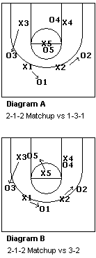

One guard defensive front match up zone (1-3-1 and 1-2-2 sets).  By using either the 1-3-1 or 1-2-2 set, you may be able to force the offense out of their usual 1-3-1, or 3-out, 2-in offense and into a 2-1-2 set.  Refer to Diagram C. (1-3-1 match-up zone vs 2-1-2 offense) X1 picks up the guard to his right and X2 gets the other guard. X3 drops down to get the player in his/her corner and X4 gets the opposite corner. X5 has the middle.  Refer to Diagram D. (1-2-2 match-up zone vs 2-1-2 offense) Again X1 and X2 pick up the two guards (O1 and O2) and X3 gets the wing-corner (O3) on his side. X4 picks up the opposite corner (O4) and X5 moves up to defend the high post (O5). | 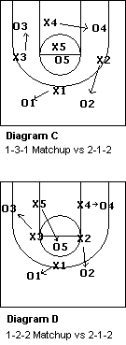

Match-up zone vs 1-4 Stack Offenses  Refer to Diagram E.  Here's how to match up against the 1-4 stack offense. X2 should play the gap between O2 and O4, and X3 plays the gap between O3 and O5. Both of these defenders can try to deny the pass to the wing and help when the ball gets to the post player at the elbow. If X2 (or X3) gets beaten by the back-cut, then X4 (or X5) must recognize this and pick up the cutter, while X2 (or X3) slides over to pick up the post player (O4 or O5) that was vacated by the switch.  Refer to Diagram F.  Here's how to match up against the 1-4 low stack offense. X2 should again play the gap between O2 and O4, and X3 plays the gap between O3 and O5. Both X2 and X3 can attempt to deny the pass to the two offensive players they are gapping. X4 and X5 three-quarter front the two low post players. X1 plays good man-to-man defense against the point guard (O1). | 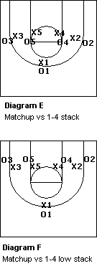

So far, so good...
Look at Diagrams G and H below. How are you going to defend these cuts? In Diagram G, when the cutter (O2) moves away from the ball (to the weak-side), X2 can stay with and bump the cutter, and deny the pass, and then switch with X4 once O2 moves to the corner. Now X2 has O4 and X4 has O2. In Diagram H, this is a more threatening situation with the cutter moving ball-side. Here it might be easiest just to have X2 stay with O2 man-to-man all the way to the ball-side corner. Now, X1 and X3 may need to slide one position leftward as the offense rotates back around to the other side. In other words, after the ball-side cut, X2 is now on the right wing (X3's former position), X3 is on top on the right (X1's former position) and X1 now has the left top spot (X2's former position). However you do it, you must have a solution for these cuts, and must drill them thoroughly in practice so everyone under- stands what to do.
The other option, which is even more simple, is to have just one rule... once the initial match-ups are done (on that particular offensive possession by the opponent) and you have affected the offense's basic set, everyone plays man-to-man, using the concepts of on-ball, deny and help-side defense (see Man-to-Man Pressure Defense).
Refer to Diagrams G and H... you must have a solution for defending these offensive cuts.
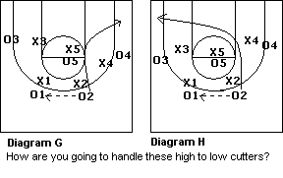

Match-Up Defense 101: Teaching, Implementing A Swarming Match-Up Zone Defense
By Andy Wood, Former Head Boys Coach, Blanchester High School, Blanchester, Ohio
THE PREMISE OF a match-up zone defense is to manipulate the opponent into executing its zone offense versus — for all intents and purposes — a man-to-man defense.
Zone offenses are predictable. Teams will, for example, almost always attack a 2-3 zone with either a 1-3-1 or a 1-2-2 offensive attack.
A match-up defense essentially eliminates the opponent’s arsenal of set plays, cutters, etc., by switching all player movements. It’s also versatile and can work from any defensive alignment that you choose (2-3, 1-3-1, 1-2-2, 3-2, etc.).
Though the match-up appears to be a zone, each of the five defenders are always be responsible for an individual offensive player, applying man-to-man defensive principles.
Defenders in the match-up are responsible for a designated man, contrary to zone responsibilities, in which defenders are assigned to defend a pre-determined area.
X1 Sets The Tone. X1 is the most important defender on the floor. This player’s defensive actions dictate the defensive assignments of the other four defenders.
Automatically Switch On Screens. If an offense attempts to screen the match-up, the defenders should automatically switch.
Jam Cutters. All cutters must be jammed so that their timing and movements are severely disrupted.
Communicate! Defenders Must Talk To One Another. Communication is critical in making the match-up defense successful. Any time an offensive player cuts through the “match-up” area, all five defenders must talk to one another and determine new assignments.
Deception Is Key. The foundation of the match-up defense is to show a zone defensive look while playing man-to-man principles.

Basically, 1) Have a player declare ball at all times (I prefer point zones for this reason) 2) "5 Rule" their are five of them and five of us so Which one is yours? 3) "Skip rule" : the quickest player to the ball calls ball and the others match up and 4) "Runner or Cutter Rule" : Follow that player to the paint, let your teammates know and guard the nearest player to free a teammate. I have two change ups to the last rule but we switch most of the time.

Mike Deane's Matchup Zone Rules
There are however, a lot of rules that you need to establish for how your matchup zone will function in the different scenarios, such as what to do with cutters, screens, etc...
Guard Movements:
When the ball is in the middle, play normal M2M principals, defenders must travel on air time. Guards have to cover perimeter- they must cover 3 guards,
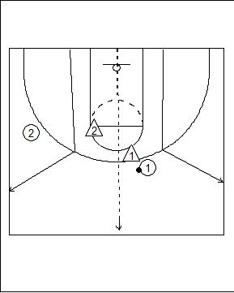
If the ball is in the outside 3rd, deny all back pass. Guards play the ball as if there is no help when they are guarding the ball. Must move on the air time- jump back to help. On closing out it's 2 steps towards the ball, then close out,
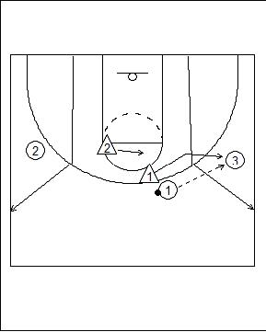
Forward Positions:
They cover everything from middle of the lane to the block, to opposite short corner. They play on the baseline side of the offensive player. Forwards work in a pair with the guard on their side. On the reversal of the ball, 3 covers the wing, like a 2-3 zone slide. It's like a bump,
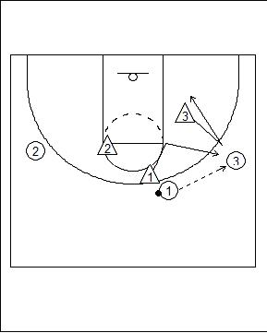
On the bump 3 must pick up anybody who is in his area. If there is a player in the corner, he guards him.
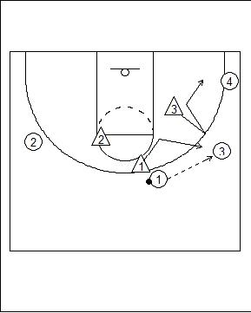

If there is a post player on the block 3 must cover him and bump the other weak side defender off the block,
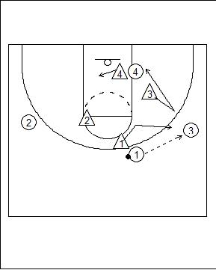
Skip Pass:
Skip pass back to the top, 2 takes the ball, 1 is in help, and 3 bumps back to help side- help must have 1 foot on the basket line,
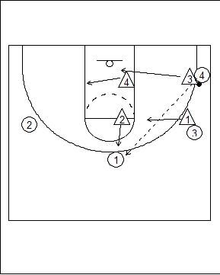

Center Position:
5 covers block to block, and high post. Ball enters paint, everybody drops to the level of the ball. 5 plays on the high side of every body,
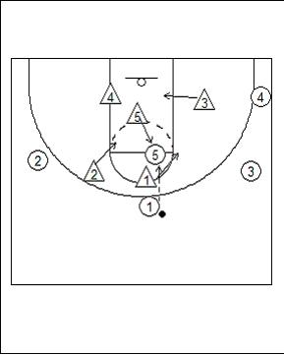
High/Low Interchange:
4 takes 2 steps with 5 then yell high post and cover 4 on the low side,
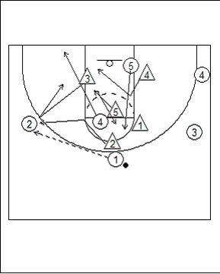

Baseline Runner:
The defenders bump the runner from defender to defender,
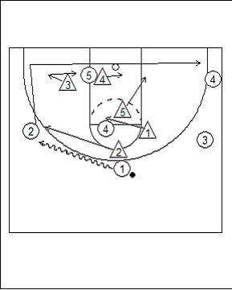
Summary:
Matchup zones are a great disruptor defense in that they mask what your intentions are. It can throw the other team's offense off a little bit as they try to adjust to whether you are running a M2M or a zone. However, there are a lot of rules that you need to install that are very specific and cover very specific situations, such as how to defend certain kinds of cuts and screens. In my opinion, I would not install a matchup zone in any team lower than Varsity, I just think the complexities of it are more than a freshman or JV team can handle. Plus they should be focusing more on their fundamentals such as stance, ball-you-man, etc... anyways, before they learn the intracacies of a matchup zone.
If you're seriously thinking of going with the matchup zone this season, then you should check out Mike Deane's DVD on Inside Out Matchup Zone. To discuss this and many more of your favorite basketball topics, head over to the X's and O's of Basketball Forum to talk with other coaches from around the world.

A Matchup Zone Rule Scheme Deconstructed
Posted by bruchu Labels: Zone Defense
I can across some notes the other day that outlined the rules for a matchup zone defense, they were created I believe by a high school coach and posted on the X's and O's forum. It can be run out of any formation (1-3-1, 2-3, 3-2, 1-2-2, etc...) and in my opinion, is probably easy enough to implement for any M2M or zone team. The idea of the matchup zone is play as much zone, but by covering a man at the same time. So without further delay, here they are:
P = point
L = takes first player to the left of P
R = takes first player to the right of P
M = matcher, takes any player right R or left of L on lowside
C = center, M2M in the paint on high side
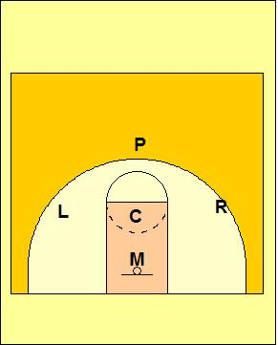
Defining who guards who depends on who P guards. The matchup is framed around P and everyone else falls in line. Obviously, this matchup is easier with odd man fronts (1-3-1, 1-2-2) because the P is always up top. But it works with a 2-3 as well, depending on which side the offense usually brings the ball up on (right-hand, left-hand), P will play the appropriate side. The P does not have to matchup on the ball either.

Basic Switches:
As you've probably gathered, this matchup zone is based on the idea of constant switching, through the concept of bumping defenders. On all screens, cuts, and cut and replace, the defenders communicate and bump each other to maintain the formation. So, unlike a straight zone, each defender has a man to cover, but also a general area. As players without the ball move, the defenders move as well (all while also watching the ball), when you check moves outside of your area, you must bump him to your fellow defenders. Communication is key, you must communicate or the defense breaks down. Screens and cuts work the same way. There are 2 basic switches, on the perimeter and in the paint.
On the perimeter, any screen or cut is played the same way, with the ball and without. You move with your check until you reach another defenders area, then bump your check to the other defender. You wait until the other defender calls release before finalizing the switch.
In the paint, C is M2M and covers mostly the high side. M is on the low block running the baseline covering any right or left of R and L respectively. If the offense lines up with 2 high posts,
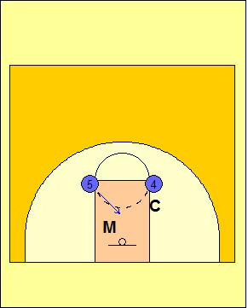
The M should get anyone going low. If the posts run an X cut, C and M call your basic switch each time with C taking the high, M taking the low.

Weakside Wing to Strongside Corner:
OK, so now that we have the basic screens/cuts figured out, time to go over the more complicated ones. The weakside wing cutting into the middle looking for a quick hit, then cutting to the corner. L is on helpside defense. M is strongside post. As O3 cuts, L follows to the middle of the post. L must communicate the switch, and M looks to switch and yells release for L to cover O5 in the post,
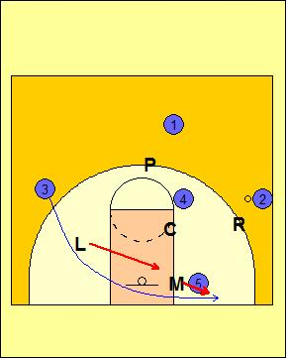
As the offense overloads, the defense reacts to the cuts, and each defender is once again matched up with a offensive player. M must take anyone on the baseline left or right, so obviously M must be very athletic. C stays with O4 whereever O4 goes, except if O4 goes to the low post, then C and L would quick switch,
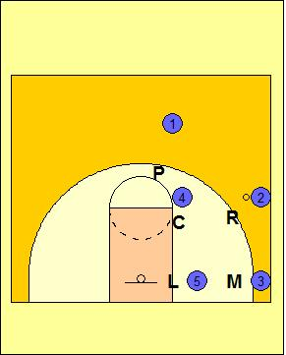

Point Loop Cut to Strongside Corner:
A very common cut in zone offenses is the point loop cut. Slightly tricky here, but again, with good communication, it should work seamlessly. O1 passes to the wing, and cuts straight down the middle. P follows O1 into the paint. At this point, O1 approaches L's area so L drops down to replace P. L follows O1 through as O1 exits the paint. At this point, L calls switch and M takes O1 to the corner yelling 'release' for L to take O5,
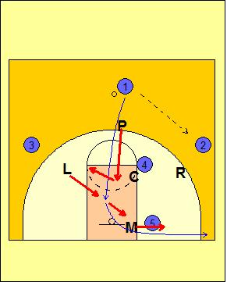
So, you are back in almost the same as the weak to corner cut above. P has moved into helpside now checking O3. If O3 moves up to the point, P follows him up to the point,
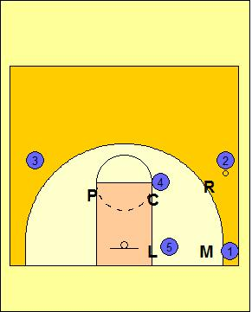

Strongside Wing to Weakside Wing:
The last cut is the hardest one to cover because of the amount of off-ball movement. O2 cuts across the lane to opposite lane with the perimeter players cutting to fill. O2 passes to O4 in the corner and basket cuts. L follows into the lane but R drops down to cover as well and replace L. As O1 and O3 move, P moves with O1,
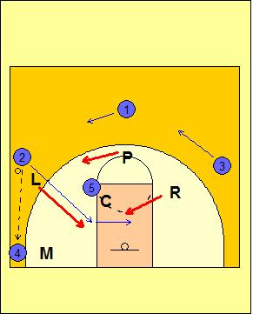
R calls 'release' and takes O2 to the weakside wing. L must sprint back to the strong side wing, taking O1 this time. Bumping P back to the top to take O3. All the while, if O5 drops down to the strongside post, O5 follows,
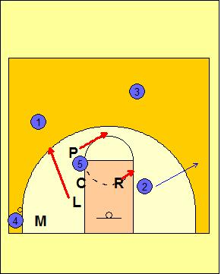
Final Thoughts:
Teams that scout you may resort to offenses that use a lot of cutting, like an X-zone offense. If your players get crossed up, you can always use a in-game call like base to go straight M2M or straight zone. Additionally, players should always be instructed to protect the paint first, then look to pickup their check afterwards if they get lost momentarily.

2-3 Match Up Defense
Our match-up zone defense is a combination of the 2-3 zone that is taught by Fred Litzenberger at the University of Oregon and the Point and Talk defense taught by Don Meyer at Northern State University. This defensive scheme is our secondary defense but our basic principles remain the same…. communicate to your teammates, pressure the ball and help and recover.

Our 12 points of an effective Match-Up Zone Defense
- You must use both man to man and zone defensive principles.
- Each man has area responsibility and man responsibility.
- Each player must use man-to-man defense, area defense, and help defense.
- Two defensive men must constantly defend three offensive men.
- Offensive alignment will dictate defensive alignment.
- Defensive players adjust to both the men and the ball. Neither has priority. Both are of equal importance.
- Each defensive player checks the ball, a man, and “part of the other four.”
- “Communication” is more important for the back three players than for the guards.
- The key to the front line defense (guards) is “movement and adjustment.”
- The key to the back line defense (center and forwards) is “communication and adjustment.”
- To be effective in the match-up zone one man must consistently and effectively defend two—two defend three—three defend four—and four defend five.
- Key word is still “adjust.”
Why should a team play a zone defensively? A team should look to play a zone if their opponents can’t attack it consistently, you can’t guard the opponent man-to-man, you need to control an excellent penetrating guard, and finally, you can sandwich or front and back the post player.
The rules of our match-up are simple and go hand in hand with our other defensive schemes.

Match-Up Rules
- Continually point to your man and talk to your teammates.
- Guard someone: don’t have two defensive players on the same offensive player.
- Defense takes the shape of the offense’s alignment.
- Keep bigs in and smalls out.
- The post player comes out in emergencies only…as when the offense has five players along the perimeter or if we have to defend an excellent perimeter shooter.
- Help side defenders straddle the weak side lane line. The offense will screen away and will send offensive players away so in our Match-Up, we assume all offensive players are good shooters.
- Guards dig into the post to help force the ball back out onto the perimeter.
- Switch everything to keep bigs in and smalls out…however, we don’t switch the dribble.
- Pressure every shot without fouling: change or alter the shot.
- Only guard to the “arc”. This allows us to protect the paint and high post area while giving help in the post.
- Do not deny passes out to the perimeter, but do pressure the ball.
- Block Out, Pursue, Chin the Rebound, Outlet…”BOPCRO”

