Morris and his wife Esther went to the state fair every year, and every year Morris would say, 'Esther, I'd like to ride in that helicopter. 'Esther always replied, 'I know Morris, but that helicopter ride is 50 dollars and 50 dollars is 50 dollars.'
One year Esther and Morris went to the fair, and Morris said, 'Esther I'm 85 years old. if I don't ride that helicopter, I might never get another chance.' Esther replied, 'Morris that helicopter is 50 dollars and 50 dollars is 50 dollars.'
The pilot over heard the couple and said, 'folks I'll make you a deal. I'll take the both of you for a ride; if you can stay quiet for the entire ride and not say a word I won't charge you! but if you say one word, it's 50 dollars.'
Morris and Esther agreed and up they went. The pilot did all kinds of fancy manoeuvres, but not a word was heard. He did his dare devil tricks over and over again, but still not a word. When they landed, the pilot turned to Morris and said, 'by golly, I did everything I could to get you to yell out, but you didn't . I'm impressed!'
Morris replied, 'well I almost said something when Esther fell out, but, you know, 50 dollars is 50 dollars!'

Discussion Director
- What do you think about Esther telling Morris not to ride every year because it costs $50?
  - Because she is only thinking short term
- Would you have listened to Esther? Why or why not?
  - It depends- but if we were well off I wouldn’t because I wanted to go
- Did you think the story was funny? Why or why not?
  - Yes- even though I don’t think its funny that someone would be let to fall out of the helicopter I imagined her with a bungee- ironic- teach her a lesson about being so stingy

Literary Luminary
'well I almost said something when Esther fell out, but, you know, 50 dollars is 50 dollars
-because its ironic- he learned the lesson but not the way she wanted him to
-

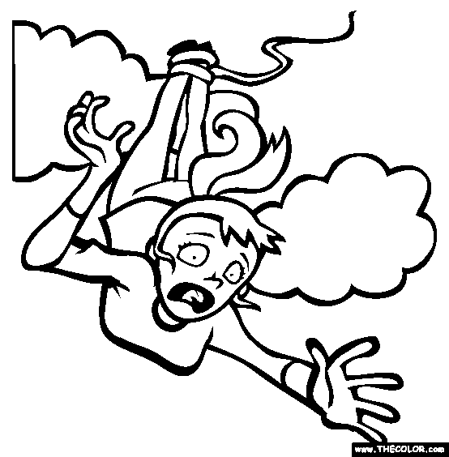
Artful Adventurer
I chose this picture because I think Esther would be scared falling out of the helicopter. I picked a picture where she was tied to a bungee cord because I don’t think the pilot or Morris would have intentionally hurt her- but Morris might have wanted to get even and the pilot was trying to make his money

Connector
'Esther I'm 85 years old. if I don't ride that helicopter, I might never get another chance.'
-people give up on chances- life is short
Character Captain
Esther- cheap- $50 comment
Esther- bossy-$50 comment
Esther-scared- not willing to ride in helicopter
Vocabulary Enricher
Manoeuvres- The pilot did all kinds of fancy manoeuvres, but not a word was heard.
Definition- a movement or series of moves requiring skill and care:
Impressed- When they landed, the pilot turned to Morris and said, 'by golly, I did everything I could to get you to yell out, but you didn't . I'm impressed!
Definition- make (someone) feel admiration and respect:

Term Treasure hunter-irony- a state of affairs or an event that seems deliberately contrary to what one expects and is often wryly amusing as a result
The ending is ironic because Morris acts the way Esther has been acting at the end at Esther’s expense which is unexpected.

