|  |  |  |  |  |  |  |  |  |
| --- | --- | --- | --- | --- | --- | --- | --- | --- |
| |  |  | | --- | --- | | **Label the Earth's Oceans** | [**Continents Quiz**](http://www.enchantedlearning.com/geography/continents/quiz.shtml)[**Oceans**](http://www.enchantedlearning.com/subjects/ocean/) |   Read the definitions, then label the map below.   |  | | --- | | **Definitions** |  |  | | --- | | **Arctic Ocean** - an ocean around the North Pole, bordering northern Europe, Asia and North America. It is the smallest ocean.  **Atlantic Ocean** - an ocean bordering western Europe, western Africa, Antarctica, and eastern North and South America.  **Indian Ocean** - an ocean bordering eastern Africa, southern Asia, western Australia, and Antarctica.  **Pacific Ocean** - an ocean bordering eastern Asia, northeastern Australia, Antarctica, and western North and South America. It is the biggest ocean.  **Southern Ocean** - the ocean bordering Antarctica and extending from 60 degrees latitude. This fifth ocean was recognized by the International Hydrographic Organization in the spring of 2000. |   [oceans map to label](http://www.enchantedlearning.com/label/) | |  | | --- | | **Definitions** |  |  |  | | --- | --- | | **Africa** - a continent that crosses the equator. It is south of Europe and is bordered by the Atlantic and Indian Oceans.  **Antarctica** - the continent that surrounds the South Pole of the Earth.  **Asia** - a continent in the Northern Hemisphere. Asia is attached to Europe (and east of it).  **Australia** - a continent, an island, and a country in the Southern Hemisphere.  **equator** - an imaginary line that divides the Earth into Northern and Southern Hemispheres. | **Europe** - a continent in the Northern Hemisphere. Europe is attached to Asia (and west of it).  **North America** - a continent in the Northern Hemisphere; it is north of South America. It is bordered by the Atlantic and Pacific Oceans.  **North Pole** - the point that is the farthest north on Earth.  **South America** - a continent that is mostly in the Southern Hemisphere. It is bordered by the Atlantic and Pacific Oceans.  **South Pole** - the point that is the farthest south on Earth. |     [continent map to label](http://www.enchantedlearning.com/label/) |
| |  |  | | --- | --- | | **Label Canadian Provinces and Territories** | [**Quiz**](http://www.enchantedlearning.com/school/Canada/Mapquiz.shtml) |   Read about the Canadian provinces and territories, then label the map below.   |  |  | | --- | --- | | **Alberta** - a province in southwestern Canada, between British Columbia and Saskatchewan.  **British Columbia** - a province in southwestern Canada, by the Pacific Ocean.  **Manitoba** - a province in southern Canada, between Saskatchewan and Ontario, bordering Hudson Bay.  **New Brunswick** - a province in southeastern Canada that is east of Quebec and west of Nova Scotia.  **Newfoundland and Labrador** - a province that is northeast of Quebec.  **Northwest Territories** - a territory in northern Canada between the Yukon and Nunavut.  **Nova Scotia** - a province in southeastern Canada that is east of New Brunswick. | **Nunavut** - a territory in northern Canada east of the Northwest Territories, bordering the Arctic Ocean and Hudson Bay.  **Ontario** - a province in southern Canada between Manitoba and Quebec, bordering Hudson Bay.  **Prince Edward Island** - an island province just north of New Brunswick and Nova Scotia.  **Quebec** - a province in southern Canada, east of Ontario, bordering Hudson Bay.  **Saskatchewan** - a province in southern Canada, between Alberta and Manitoba.  **Yukon Territory** - a territory in northwestern Canada, by the Pacific Ocean and Alaska. |   [Label Canadian Provinces Map](http://www.enchantedlearning.com/label/) | 1.___________________________________________ 2________________________________________________  3.___________________________________________ 4________________________________________________  5.___________________________________________ 6________________________________________________  7.___________________________________________ |

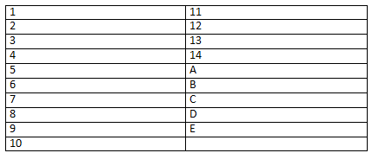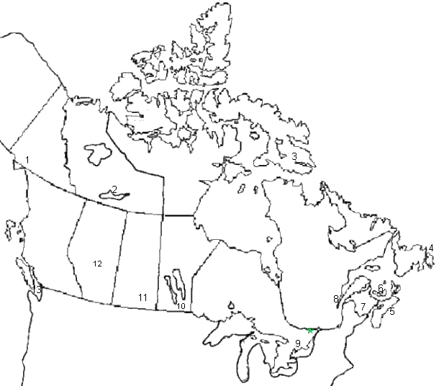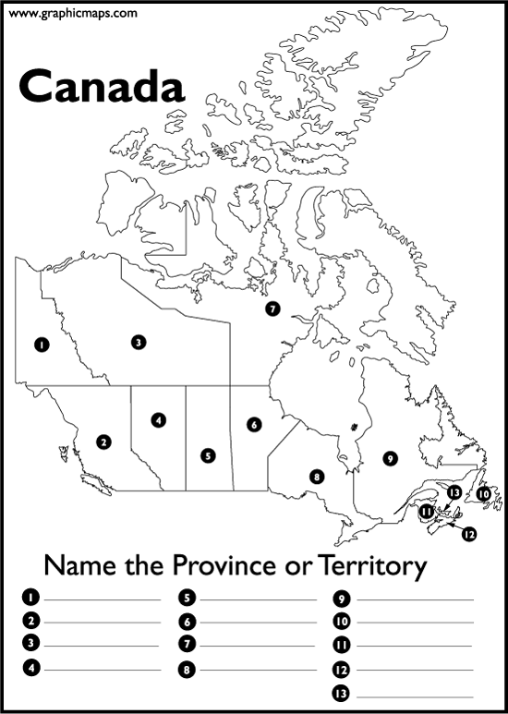

Identify the capitals of the provinces and territories of Canada as well as the name of the Great Lakes.

B

E

D

10

5

2

1

14

8

C

A

13

12

1111

9

6

7

4

3