What is a seed drill, what was it used for?

A Seed drill was a kind of sowing device that accurately planted seeds of different crops in the soil and covered them. Before the introduction of the seed drill, the common practice was to plant seeds by hand. Besides being wasteful, planting was very imprecise and led to a poor distribution of seeds, leading to low productivity.

Picture of the inventor- Jethro Tull

[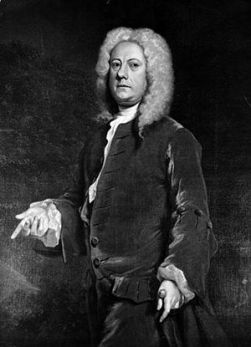](http://en.wikipedia.org/wiki/File:Jethro_Tull_(agriculturist).jpg)

Who invented the seed drill? When and where was it invented?

While [Jethro Tull](http://en.wikipedia.org/wiki/Jethro_Tull_(agriculturist)) is widely thought of as having invented the seed drill, the Sumerians actually used a single-tube version, and by the 2nd Century BC, the Chinese were using a multi-tube seed drill. The first known European seed drill was attributed to Camillo Torello and patented by the Venetian Senate in 1566. A seed drill was described in detail by Tadeo Cavalina of [Bologna](http://en.wikipedia.org/wiki/Bologna) in 1602 In [England](http://en.wikipedia.org/wiki/England), the seed drill was further refined by [Jethro Tull](http://en.wikipedia.org/wiki/Jethro_Tull_(agriculturist)) in 1701 in the [Agricultural Revolution](http://en.wikipedia.org/wiki/British_Agricultural_Revolution).

**THE seed drill**

How does a seed drill work?

A seed drill is formed from loading a bunch of seeds in a number of tubes that allowed seeds that were planted to keep certain distances from each other to allow better growth of the seeds planted.

The seed drill employed a series of runners spaced at the same distance as the ploughed furrows. These runners, or drills, opened the furrow to a uniform depth before the seed was dropped. Behind the drills were a series of presses, metal discs which cut down the sides of the trench into which the seeds had been planted, covering them over with dirt.

Picture of a seed drill

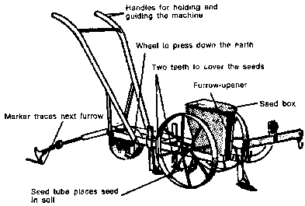

Why was the seed drill an important invention and what impacts has the seed drill had on society and the way they people live now?

The Seed drill was an important inventions because farmers back then were very exhausted whenever they planted their seeds in spring. Not only that, despite the fact that there was so much time spent on the seeding process, it was really inefficient. Before the seed drill was invented, farmers had to plant the seed by hand. This method was also inaccurate and the seeds weren’t distributed equally, which led to poor production speed. Using seed drills made the work almost 8 times more efficiently than if it wasn’t used.

The invention of the seed drill dramatically improved germination. This innovation permitted farmers to have precise control over the depth at which seeds were planted. This greater measure of control meant that fewer seeds germinated early or late, and that seeds were able to take optimum advantage of available soil moisture in a prepared seed bed. The result was that farmers were able to use less seed, and at the same time experience larger yields than under the broadcast methods. The result of this was that less people were needed to seed the land, so there was a decrease in needs for slaves. Also, because more crops were grown, more people were able to get their hands on foods, and more families didn’t have to starve. The government was also able to get more taxes which profited the entire nation. In addition, many people were put out of work and had to find new jobs, which gave a work force for inventions and factories in the Industrial Revolution. The invention of seed drill impacted our modern society hugely because of improved food production and because of the many agricultural machines that were developed as a result of the seed drill.