INDIGENOUS ACTIVITIES YOU SHOULD TRY THIS WINTER
Posted by MUSKRAT Magazine
Date: December 03, 2014
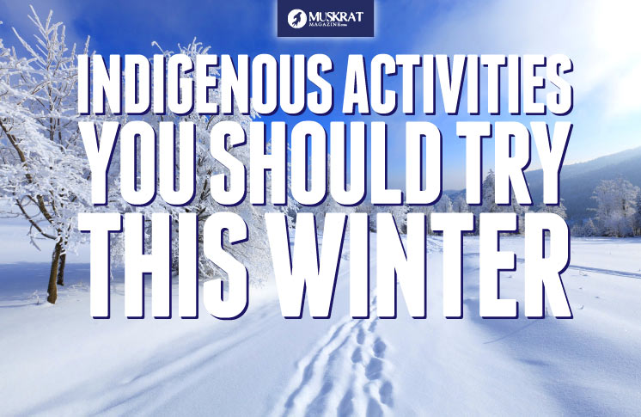
Here are some fun winter activities that are each rooted in Indigenous traditions!
The cold winds are blowing into TOronto, and the rest of the Northern hemisphere of Turtle Island has been under a blanket of snow for weeks now, which means one thing: WINTER IS JUST ABOUT HERE! Winter can be long and hard, but it doesn’t mean we can’t have fun! Here are some fun winter activities that are each rooted in Indigenous traditions. Let us know what some of your winter traditions are!

1. Snowshoeing
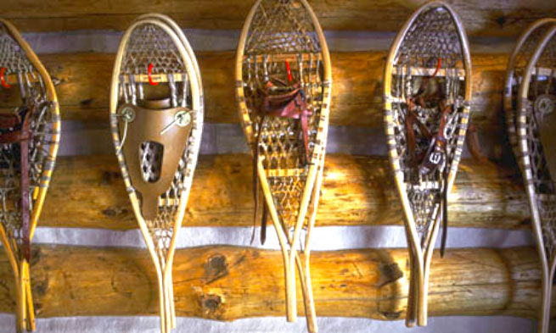
Indigenous ancestors have used snowshoes to traverse deep snowy terrain from time immemorial. Today snowshoeing has also become a recreational activity that is a part of Canadian culture. It is an excellent way to get fresh air and exercise when the days are short and the snow is deep!

2. Tobogganing
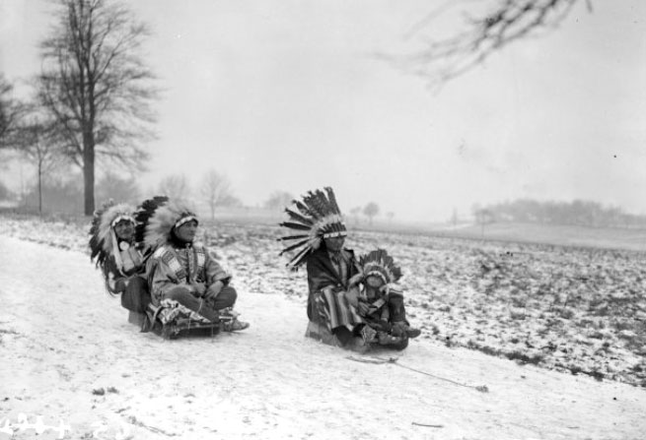
The toboggan appears to have etymological roots in the Maliseet/Mi’kmaq language, however there are also references found relating to Cree and Innu. One thing that is certain is that Indigenous ancestors have used this form of transport across Turtle Island. Today, tobogganing is a quintessential winter activity enjoyed by people of all backgrounds.

3. Ice Fishing
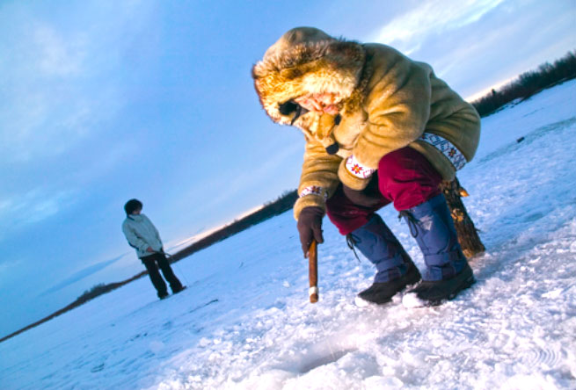ALASKA STOCK IMAGES/National Geographic
Before we had grocery chains and global food resources our people had to get their own sources of protein during the winter months. Bring out your fishing rods from the summer and put them to use this winter. Have fun meeting new people on the lake.

4. Hand Games
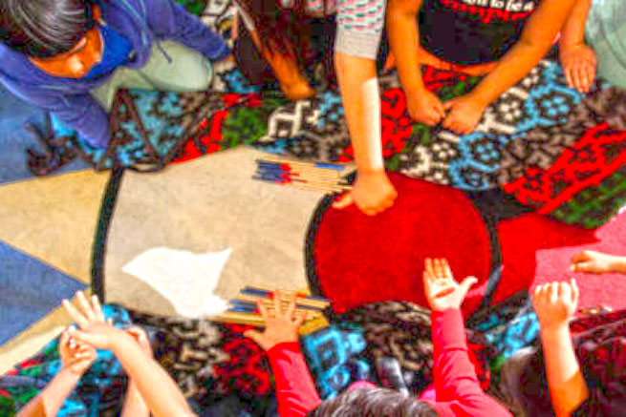
You don’t need to travel hundreds of kilometres to make a night of hand games. Pull out your drum sticks and blankets and invite your friends and family over for a night of singing, laughing, and …[fun].

5. Make your own Igloo
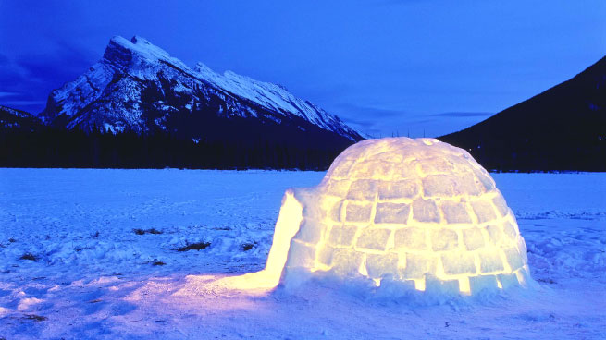
Igloo is Inuktitut and was the traditional winter home of Inuit people of Canada and Greenland. Spend a weekend with your family creating a home from scratch with natural resources our land has to offer.

6. Learn your Language in Winter
Take your Elders out for a winter walk. Winter gives a great opportunity to learn the names of winter animals and plant life in your Native language. The winter owls, rabbits, wolves, coyotes, mice on the snow, deer and moose make out a great start to learn your language.

7. Storytelling
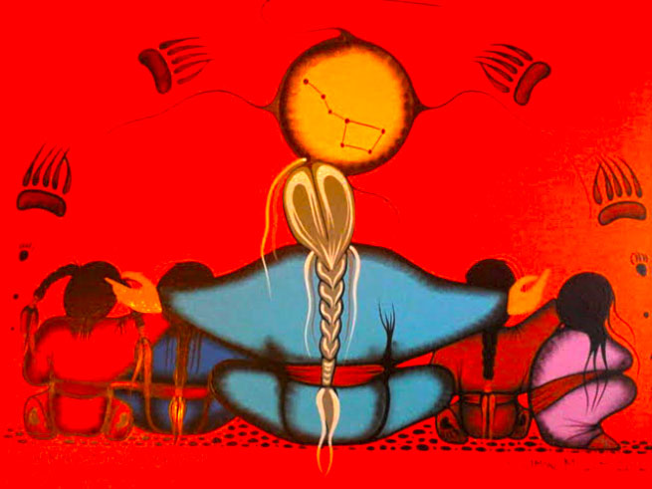Painting by: Simone Mcleod, Sharing Stories of Ojiig
Winter is also a time to share stories about our tricksters, cosmos, and communities. Traditionally storytelling was important during the long nights of the winter months as a form of entertainment and passing down oral history to all those in the community. As the sun fades from our days the stories from the Elders come out.

8. Attend a Round Dance
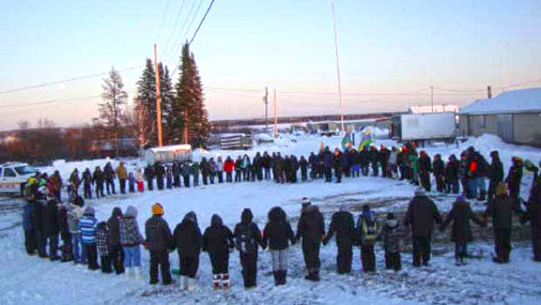
Pow-wow season ended with summer but don’t retire your dancing moccasins and your drums. Head to a round dance this winter. You can usually find one happening every weekend during the winter months. Contact your regional First Nation or Friendship Centre to get the 411 on round dances near you. [Around here you might be able to join a local drumming or dance group- Check with your local band office and on community facebook pages.]

9. Learn to make Bannock
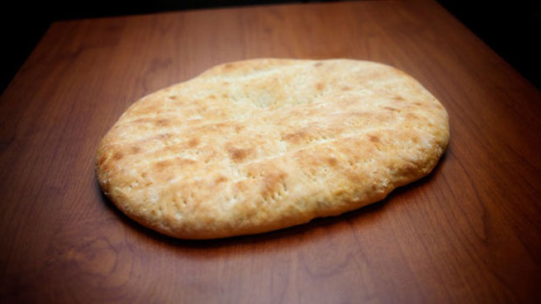
Winter is the best time to learn how to make bannock. This time of year our bodies need the carbs to keep ourselves warm and you also need something to dip into your stew. You have enough time to spend indoors to perfect your baked and fried bannock.

10. Learn to play the Fiddle
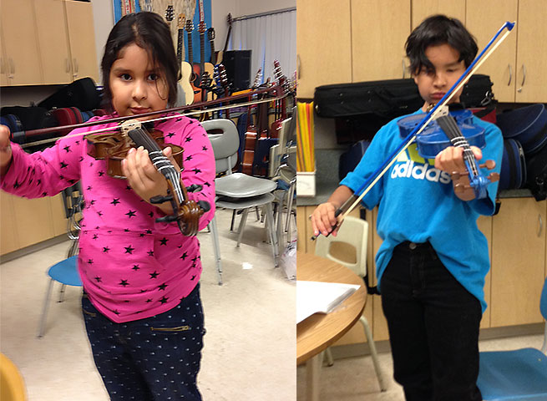
During the cold months of winter Métis people often would play the fiddle, jig and sing to keep warm. Learning the fiddle will have your family dancing and singing around you and keeping you warm.

