Haida Tattoo
For centuries, body modification has been practiced by cultures around the globe including groups on the Northwest Coast such as the Haida. Haida cultural traditions included such body modification as cutting apertures for labrets, ear-rings or pendants, nose ornaments as well as tattooing during the pre-contact period. The tattoo marks themselves were indicative of status, spiritual devotion and decoration. Haida tattoo artist Greg Williams explains that “[t]attooing is new, but it is very, very old. Tattoos have been a part of our culture for thousands of years, our people put our crests on their bodies.” For the Haida, body art and adornment were a means for individuals to express their participation as part of a social unit, a moiety, or a lineage. In this sense, tattoos put a persons identity and spiritual connections on display through the use of crest figures and/or guardian spirits.

More
Haida Tattoo Gallery
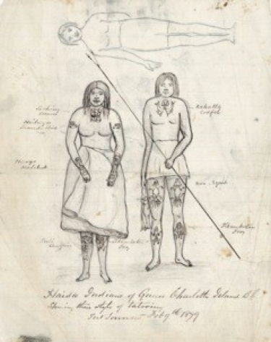
Haida People with tattoos. Sketch by James G. Swan, 1879.

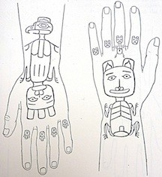
Hand Tattoos
The designs used for tattooing were usually acquired through heredity, and were crests of the bearer dependent on their lineage. The Haida, a linguistically distinct group with a complex class and rank system, consists of two main clans or moieties: Eagles and Ravens. Each of these divisions has rights to different crests, which include a number of figures derived from animal and mythological sources. Therefore, particular figures which constitutes a family name or connection will be represented in tattooing on a part of the body.
The history of how tattoos first came to the Haida is different for both the Eagles and Ravens. In Eagle tradition, it is said that Djila´qons, the ancestress of the Eagle clan, was the start of all tattooing. Djila´qons is described as wearing a hat that is surrounded by frogs and carrying a cane. She is also said to have a painted face and tattoos of laughing geese on her shoulders. It is also believed that when the Low-Ground-People, who are members of the Raven family, raised the Grease-House at Cumshewa was when tattoo marks were first introduced to the Haida. Although this second story is more vague then the first, each oral history provides a unique insight to the spiritual nature of tattooing.
Tattooing for the Haida is traditionally linked to the potlatch. A potlatch is a form of ceremonial feasting at which guests are called to witness important events and where wealth is redistributed. Most importantly, the potlatch is an event filled with symbolism and rich with singing, dancing, and displays of wealth and rank. Potlatches are most often held to celebrate important events such as the completion of a house or the receiving of an honorific name. It was also common for parents to host small potlatches on several occasions in their children’s lives such as when a child receives a name, when a child receives ear and nose piercings and if of high rank, when the child was tattooed. Traditionally at these events, tattoos were well displayed as men were completely naked, and women wore a skirt that fell to the knee. Early European observers of the potlatch have related that the people who wanted to be tattooed all stood in a row while a song was sung, and that relatives would select individuals to receive the honour. As mentioned above, song and dance are both integral to potlatches, and in 1913, John Wesley recorded the ‘Tattooing Song’ (belonging to the Gakyaals Kiigawaay, the Skedans Raven Clan), which was sung to all of the people receiving tattoos during a house building potlatch.
Photographer Edward S. Curtis recorded the most detailed account of the Haida tattooing rituals that took place during the celebration of the completion of a house. The children of the builder himself and the children of other families were all honoured at the cost of ten blankets each for their tattooing. During the dance, those who were going to be tattooed would stand in a row while everyone in attendance sang, and from that row individuals would be selected by relatives to receive the honour of being tattooed. The house chief would then assign the task of tattooing to young men who were skilled professionals or in some cases the chief himself would tattoo some individuals.
It is curious why Curtis did not photograph tattooed people despite the fact that there were still many older individuals with body tattoos when he photographed them at Masset and Skidegate just prior to the first World War. Perhaps both men and women were hesitant to reveal their tattoos due to the missionaries instructing them to cover as much of their bodies as possible. Florence Edenshaw Davidson told Margaret Blackman that her artist father, Charlie Edenshaw, had “no clean skin” as he had tattoos on his hands, arms, legs, chest and back, but that he always wore a long-sleeved shirt to hide them from public view.
Originally, sharp thorns, fish spines or bones were used for tattooing. Later, as copper became more readily available, the tattooing implements were made of the metal and featured three needle points – the middle point of the three being the longest – which were attached to a handle. The handles were made of flat strips of ivory or bone, or from thin strips of wood that were of various widths. There have been many different observations as to the types of materials used for pigments. Pigments that left a bluish tint on the skin were said to have been made from the charcoal of alder or buckbrush. Black pigment was made of magnetite, gunpowder, india ink or powdered charcoal. Red pigment was said to be made from Chinese vermilion or hematite.

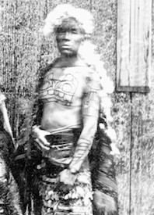
Chief Xana in Masset, 1881. Photograph by E. Dossetter.

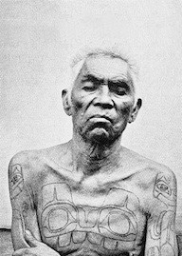
Portrait of Chief Xana showing his chest and arm tattoos from W.H. Collison's "In the Wake of the War Canoe". Photographer uncredited.
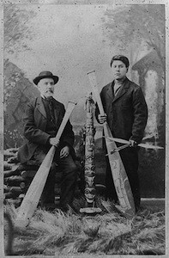
James G. Swan and Johnny Kit Elswa. Spencer & Hastings Studio, 1883.

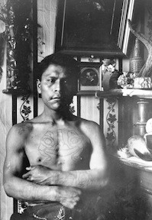
Johnny Kit Elswa showing his arm and chest tattoos. A.P. Niblack, 1886. Smithsonian.
First, the design was drawn onto the person to be tattooed in a dark pigment. The design would then be pricked in with the needles, and then more pigment would be rubbed into the design in order to achieve the desired hue. Rarely did the chiefs do the tattooing themselves instead they would hire skilled tattoo artists to perform the work. For men, tattoos were generally placed on the chest, the upper back between the shoulders, upper and lower arms, and the front of thighs and lower legs. For women, the chest, the shoulders, the forearms, hands and lower leg were tattooed. Curtis notes that even the shins, feet and wrists were sometimes tattooed. In Skidegate, in 1883, James G. Swan made note of and drew a picture of a man named Sca-na-yune, who had a Scana (killer whale) tattooed on each of his cheeks. Most observations, however, did not include seeing facial tattoos, but facial painting was common during ceremonies.
While conducting a geological survey, G.M. Dawson visited Haida Gwaii in 1878, and he commented that tattooing was quite common amongst the Haida people up until more recent times. Children were being raised without such personal adornment as tattoos likely due to the presence of church missionaries who placed shame on this and many other Haida traditions. Due to this negative view brought by the missionaries, scholars like Bill McLennan, curator of the Museum of Anthropology at the University of British Columbia, think that it is likely that the designs that were once tattooed on Haida men and women eventually evolved into bracelet designs. Celebrated artist and carver Jim Hart, a descendent of Charles Edenshaw and the current Chief 7densuu (Edenshaw), explained that Haida women were uncomfortable when newcomers stared at their tattoos, so they decided to create bracelets with the designs rather than have the tattoos on their skin. A once treasured practice transitioned into a new form of art in which Haida people could proudly display their crests on their person.
John R. Swanton was the earliest visitor to Haida Gwaii to have made many sketches of Haida with detailed drawings of their tattoos. He also photographed Haida men with tattoos displayed on their chests and arms. Both Swan and Swanton were able to record some of the tattoo designs from Haida men and women who visited them. Among those people was the wife of Charles Edenshaw, Isabella Edenshaw, who was noted by her daughter Florence Davidson as having been tattooed during a potlatch that her grandfather held. She recalls her mother as having a tattoo of a long dogfish on one leg, a grizzly bear on the other, and a quarter moon and lady on each arm done in red and blue ink. Florence also noted that Isabella’s tattoos are included in J.R. Swanton’s plate of tattoo drawings. Artists such as John Cross, John Robson and Charles Edenshaw helped both Swan and Swanton record the tattoo designs. The collected ledger drawings, journal entries and personal accounts from the 1800‘s provide us with much information about traditional tattooing practices amongst the Haida. Artists, such as Bill Reid, have referred to old crests and tattoo designs for their contemporary pieces. During his ‘Haida Phase’, Reid would use inspiration from these drawings for the designs of personal adornments.
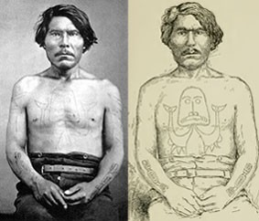
Chief Gitkun (Kitkun) with codfish chest tattoo, and salmon on lower arms. Left: A.P. Niblack photo. Right: J.G. Swan sketch.

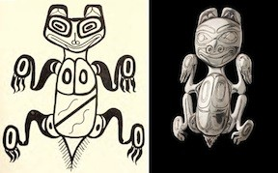
Left: J.G. Swan sketch. Right: Bill Reid Haida Bear Brooch, 1955, Kenji Nagai photo.

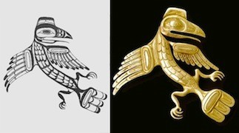
Left: Charles Edenshaw Raven design. Right: Bill Stannis Raven Brooch ca. 1954, Bill McLennan photo.
Today, K’aaju G’aaya (Greg Williams) is the first formally trained tattoo artist to practice on Haida Gwaii in decades. He feels privileged to once again tattoo crests on to the bodies of Haida people, and looks forward to one day opening his own tattoo shop in Skidegate. The people who experienced traditional Haida tattooing in their youth have all passed away. Giidaahlgudsliiay (Susan Williams) passed away in 1970 at the age of 109 years, and was one of the few remaining Haida who had been tattooed in the traditional way in her youth. Maggie Yeltatzie was another of the last people tattooed, and had received tattoos on her hands, but wore gloves to cover them because she was ashamed. These people provided a link to a time when Haida people were still actively practicing a cultural tradition despite missionary resistance, although the effects of their negativity towards these practices show in the shame felt by some of the people who were tattooed.

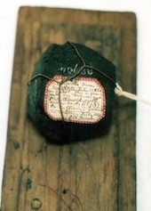
Lump of Magnetite for Pigment © Lars Krutak, 2002.

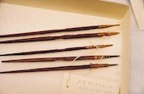
Five Cedar Batons © Lars Krutak, 2002.

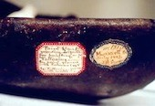
Stone dish used to mix the tattoo pigment © Lars Krutak.

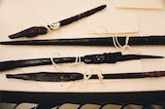
Set of carved cedar brushes © Lars Krutak.
Special thanks to Lars Krutak for his permission to use these images. www.larskrutak.com
In July of 1883, Swan collected a tattooing kit from Masset, Haida Gwaii. Over a hundred years later, tattoo anthropologist Lars Krutak, while working at the Smithsonian Institute’s National Museum of Natural History, uncovered this authentic Haida tattoo kit. This hand-poking kit consisted of five cedar batons for skin-pricking, a lump of magnetite for pigment, a paint-grinding stone and a set of cedar brushes that were elaborately carved with crest figures. Some of the brushes were even still impregnated with pigment. This unique discovery has grabbed the attention of the Old Masset Repatriation Committee, who have expressed an interest in creating replications of these original tools.
https://www.sfu.ca/brc/online_exhibits/haida_tattoo.html

