Facts about Sasquatches
Source: https://www.britannica.com/topic/Sasquatch
What is a Sasquatch?
• Sasquatch is a large hairy humanoid that some believe to live in the northwestern United States and western Canada.
• The name comes from Salish se’sxac, meaning “wild men.”
• Sasquatch is also known as Bigfoot, and it appears to represent the North American counterpart of the Himalayan region’s mythical monster, the Abominable Snowman, or Yeti.
Where is Sasquatch said to live?
• Sasquatch is said to live in the northwestern United States and western Canada. Sightings have been claimed in forested areas.
How is Sasquatch usually described?
• Sasquatch is normally described as a bipedal primate that is anywhere from 6 to 15 feet (2 to 4.5 metres) tall.
• It is often said to give off a foul smell and either moves silently or emits a high-pitched cry.
• Alleged Sasquatch footprints have measured up to 24 inches (about 60 cm) long.
Who was the first person to claim a Sasquatch sighting?
• Some people credit the British explorer David Thompson with the first discovery of Sasquatch footprints, in 1811. Since then, several photographers and videographers have claimed to have seen Sasquatch, although none of their purported evidence has been verified.
Is Sasquatch real?
• Since the first alleged finding of Sasquatch footprints, in 1811, several people have claimed to have found such footprints or to have seen Sasquatch, and some have provided purported documentary evidence. However, scholars and scientific researchers have pointed out that no investigator has produced a physical body or other verifiable evidence, and they do not recognize Sasquatch’s existence.

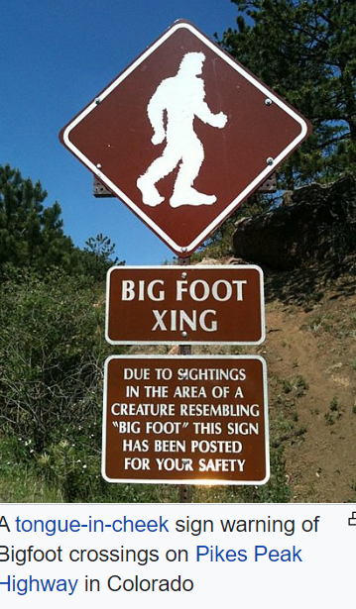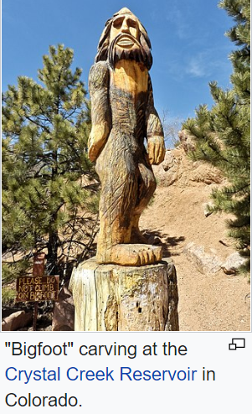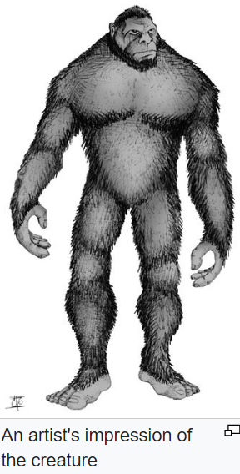
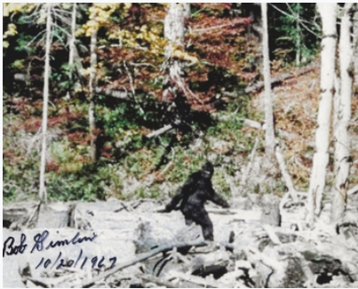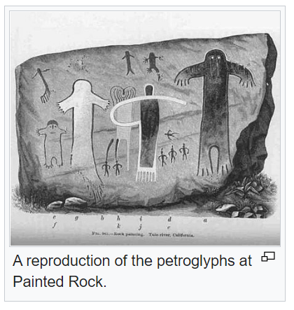
Source: https://en.wikipedia.org/wiki/Bigfoot

Description

- a large, muscular, bipedal ape-like creature
- some say roughly 1.8–2.7 metres (6–9 ft), and others say as tall as 3.0–4.6 metres (10–15 ft)
- covered in black, dark brown, or dark reddish hair
- a human-like face,
- broad shoulders,
- no visible neck,
- long arms,
- eyes of the creature to "glow" yellow or red at night
- smells like a skunk that had rolled around in dead animals and had hung around the garbage pits
- enormous footprints as large as 610 millimetres (24 in) long and 200 millimetres (8 in) wide.

History
Indigenous and early records

- Many of the indigenous cultures across the North American continent include tales of mysterious creatures living in forests, long before contemporary "Bigfoot" reports.
- On the Tule River Indian Reservation in California, petroglyphs created by a group of Yokuts at a site called Painted Rock are alleged by some to depict a group of Bigfoots called "the Family".
- The local tribespeople call the largest of the glyphs "Hairy Man" and they are estimated to be between 500 and 1000 years old.
- most cultures have accounts of human-like giants in their folk history, expressing a need for "some larger-than-life creature
- Each language had its own name for the creature featured in the local version of such legends.
- Many names meant something along the lines of "wild man" or "hairy man", although other names described common actions that it was said to perform, such as eating clams or shaking trees
- Chief Mischelle of the Nlaka'pamux at Lytton, British Columbia told such a story to Charles Hill-Tout in 1898; he named the creature by a Salishan variant meaning "wild-men", se'sxa, or "Sasquatch".
- Members of the Lummi tell tales about creatures known as Ts'emekwes. The stories are similar to each other in the general descriptions of Ts'emekwes, but details differed among various family accounts concerning the creature's diet and activities.
- Some regional versions tell of more threatening creatures: the stiyaha or kwi-kwiyai were a nocturnal race, and children were warned against saying the names so that the "monsters" would not come and carry them off to be killed
- The Iroquois tell of an aggressive, hair covered giant with rock-hard skin known as the Ot ne yar heh or "Stone Giant", more commonly referred to as the Genoskwa

Sightings

- About one-third of all claims of Bigfoot sightings are located in the Pacific Northwest,
- Sightings predominantly occur in the northwestern region of Washington, Oregon, Northern California, and British Columbia. Other prominent areas of supposed sightings include the rural areas of the Great Lakes region and the southeastern United States.
- According to data collected from the Bigfoot Field Researchers Organization's (BFRO) Bigfoot sightings database in 2019, Washington has over 2,000 reported sightings, California over 1,600, Pennsylvania over 1,300, New York and Oregon over 1,000, and Texas has just over 800.[59] The debate over the legitimacy of Bigfoot sightings reached a peak in the 1970s, and Bigfoot has been regarded as the first widely popularized example of pseudoscience in American culture.[60]

Other names for Sasquatch

- Many regions have differentiating names for the creatures
- In Canada, the name Sasquatch is widely used although often interchangeably with the name Bigfoot
- The United States uses both of these names but also has numerous names and descriptions of the creatures depending on the region and area in which they are allegedly sighted
- These include the Skunk ape in Florida
- Grassman in Ohio,
- Fouke Monster in Arkansas
- Wood Booger in Virginia,
- the Monster of Whitehall in Whitehall, New York
- Momo in Missouri,
- Honey Island Swamp Monster in Louisiana
- Dewey Lake Monster in Michigan
- Mogollon Monster in Arizona
- the Big Muddy Monster in southern Illinois
- and The Old Men of the Mountain in West Virginia.
- The term Wood Ape is also used by some as a means to deviate from the perceived mythical connotation surrounding the name "Bigfoot
- Other names include Bushman, Treeman, and Wildman

