English 9 –Poetry Anthology Booklet and presentation
In this project you will be creating a poetry anthology booklet about poems/songs you like/enjoy. In this booklet you must complete the requirements for the grade you wish to receive. Your booklet must have the following:
For a passing grade (C-)- To pass everyone must complete the following at a minimally acceptable level.
- A title page with the title of your anthology, illustrations relating to the poems you have picked/written, your name, and your class on it.
- At least 5 examples of poems and/or songs you like. (they must include words and/or lyrics)
- At least 5 different types of subject poems written by you using the types of poetry we have looked at.
- For each poem you must explain why you chose or wrote the poem.
- For each poem you must include at least one visual to represent the images in the poem and explain why.
- For each poem you must summarize what the poem is about and what you think the theme of the poem is, as well as explain how the theme is shown in the poem.
- You must complete the poem questions for at least one poem.
- You must present one of your poems to the class from your booklet and explain the visual, the summary, and the theme of the poem.
For a C grade-You must complete all of the requirements for C-, at a C level, as well as these additional requirements.
- 6 examples of poems for #2, and #3, 2 visuals per poem in #5, and 2 sets of poem questions for #7.
For a C+ grade-You must complete all of the requirements for C-/C, at C+, as well as these additional requirements.
- 7 examples of poems for #2, and #3,2 visuals per poem in #5, and 3 sets of poem questions for #7.
For a B grade- You must complete all of the requirements for C-/C/C+, at a B level, as well as these additional requirements.
- 8 examples of poems for #2, and #3,3 visuals per poem in #5, and 4 sets of poem questions for #7.
- You must create a visual representation of your poem. This can be done with a collage or series of pictures that represent images in your poem.
  - You must also show your visual representation of the poem to the class, explaining how you came up with these images from your poem.
  - You must identify two poetic terms used in your poem and why they are examples of that term, and how they are used by the poet in the poem.
For an A grade- You must complete all of the requirements for C-/C/C+/B, at an A level, as well as these additional requirements.
- 10 examples of poems for #2, and #3, 4 visuals per poem in #5, and 5 sets of poem questions for #7.
- You must do #12 from the requirements for a B grade but you must identify three poetic terms for b.

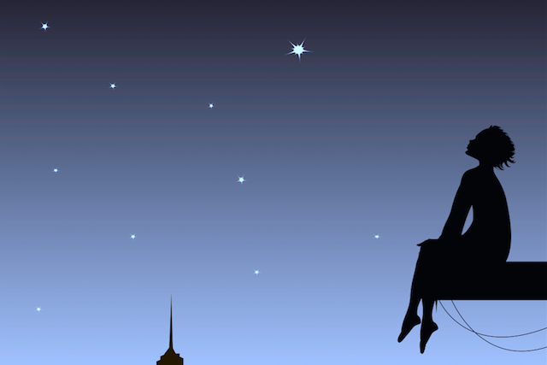
Title Page Example

POETRY ANTHOLOGY BOOKLET
Poems that Inspire Me

NAME
ENGLISH 9
PERIOD

Poem questions (All answers must have reason/examples and explanations where
necessary. They must also be written in full sentences.)
- What is the title of the song/poem?
- Does the title suit the song/poem? Explain your answer.
- What is the song/poem about?
- What is the theme of the poem? Explain your answer.
- How do you know the poem is about this? Give 2 reasons with examples and explanations.
- Why do you think the poet wrote this song or poem?
- What are two things this poem made you think about and why?
- What is one part of the poem you found interesting and why?
- What is one part of the poem you didn’t like and why?
- Overall did you like or dislike this poem. Explain 1 reason why.
- On a scale of 1-10 what would you rank this song/poem ? Give 2 reasons for your answer.
- What is one thing that the poet could have done to improve the poem ? Explain how it would have been improved.
- Would you recommend this poem to others? Why or why not?
- Find 5 poetic devices in the poem. Write the line of poetry they are found in, (only as much as necessary to show the device) and explain why it is an example of that device. (just as you did for Casey at the Bat)

A Time To Believe by B.J. Morbitzer  To believe is to know that  every day is a new beginning.  Is to trust that miracles happen,  and dreams really do come true.  To believe is to see angels  dancing among the clouds,  To know the wonder of a stardust sky  and the wisdom of the man in the moon.  To believe is to know the value of a nurturing heart,  The innocence of a child's eyes  and the beauty of an aging hand,  for it is through their teachings we learn to love.  To believe is to find the strength  and courage that lies within us  When it's time to pick up  the pieces and begin again.  To believe is to know  we are not alone,  That life is a gift  and this is our time to cherish it.  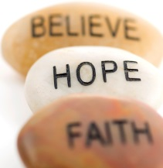  To believe is to know  that wonderful surprises are just  waiting to happen,  And all our hopes and dreams are within reach.  If only we believe. | Poem: A Time to Believe  Poet: B.J. Morbitzer  Topic: Motivational poem  - I chose this poem because it talks about what it means to believe in something and I think that you must believe in what you are doing to be motivated to do something. For example, if a person believe they can make the world a better place, by improving the environment, for instance, then they are more likely to be motivated to take action to accomplish their goals.  - This poem is about the power of believing. It gives examples of what it means to believe in something, and how we can reach our dreams if we believe in something. The theme of this poem is that if you believe in something enough you will have the power to make your hopes and dreams come true. For example, it talks about how when people believe, they can “trust that miracles happen” and they can “find the strength and courage that lies within.” Since belief allows for us to imagine the possibilities in life, it helps us succeed in fulfilling our hopes and dreams.

Poetic Scavenger Hunt-Ms. Ashley

Using the lyrics provided, as well as those found in songs in the movie, find as many examples of the following poetic devices as you can. Different devices are worth different amounts of points and some devices have a maximum amount you are allowed to use. You can do this individually, with a partner or with a group, however the number of points needed needs to be multiplied by the number of people. Maximum of 3 people in a group. There will be prizes for 1st, 2nd and 3rd place after Christmas. You need to put your names on your scavenger hunt when you hand it in.

When you find an example you must write down the following:

- The name of the poem or song.
- The actual line of poetry the poetic term is used in
- The name of the poetic term used in that line of poetry
(if there’s more than one term used in one line it can count for each - but be sure to list all poetic terms found)
4. You get 100 bonus points if you can find at least one example of each of the terms.
5. If you are incorrect you lose 5 points for each incorrect answer. (you might want to find extras just in case you are wrong on
some)
6. You must get the following # of points for the following grades:
E = 25 points
D = 50 points
C- = 100 points
C = 120 points
C+ = 140 points
B- = 160 points
B = 180 points
B+ = 200 points
- = 220 points
A = 240 points
A+ = 260 points
A++ = 300 points
Simile: 5 points each
Metaphor: 5 points each
Assonance: 5 points each
Consonance: 5 points each
Allusion: 5 points each
Alliteration: 5 points each
Personification: 5 points each
Irony: 15 points each
Cliché: 5 points each
Hyperbole: 5 points each
Onomatopoeia: 5 points each
Oxymoron: 5 points each
Symbol: 10 points each
Pun: 15 points each
Invertex syntax: 10 points each
Slant rhyme: 10 points each

Example:

From the song: Jingle Bells

Line of poetry-“Jingle Bells, Jingle Bells”
Terms used - alliteration, assonance, consonance, allusion, onomatopoeia
Tips for writing poetry to make it rhyme or fit syllable counts

When writing poetry that rhymes the following ideas might help:

1. Use the Alphabet- consonants , then double consonants
2. Use the Thesaurus- change the words- use synonyms or similar words
3. Write what you’d like to say-look for words that fit (raw line)
4. Change the order of what you’re saying to change the end word
5. Add adjectives, adverbs, descriptions
6. Delete words
7. Add words
8. Change words- make them shorter or longer

