List of combined sentences
He wears a red, puffy engineer’s hat that has a small brim and has the letter M on it.
He wears a long sleeved red shirt underneath blue button-up overalls with straps that are held on by yellow circular buttons.
He has white gloves on his hands, with a narrow band on his wrist.
He has shiny bronze shoes on his feet.
He has a pale round face and has wide, oval shaped blue eyes with curved thick eyebrows.
He has big round ears that stick out from his face, a big round nose and a wide, curvy symmetrical moustache that covers his top lip.

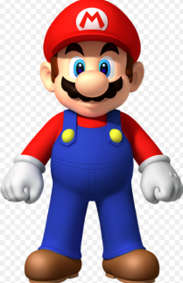

Writing your rough copy of your paragraph

In terms of physical appearance, Mario, in the Super Nintendo Game Mario Brothers is very interesting. He has a pale round face and has wide, oval shaped blue eyes with curved thick eyebrows. He has big round ears that stick out from his face, a big round nose and a wide, curvy symmetrical moustache that covers his top lip. He wears a red, puffy engineer’s hat that has a small brim and has the letter M on it.
He wears a long sleeved red shirt underneath blue button-up overalls with straps that are held on by yellow circular buttons. He has white gloves on his hands, with a narrow band on his wrist. He has shiny bronze shoes on his feet.

Physically, Mario, in the Super Nintendo Game, Mario Brothers is very intriguing. He has a pale round face and wide, oval- shaped blue eyes, with arched bushy eyebrows. His face has cute round ears that stick out, with a large bulbous nose and a broad, curvy moustache that covers his upper lip. In terms of clothing, he wears a cherry-red, puffy engineer’s hat that has a tiny brim with the letter M on it. He also wears a long sleeved candy-apple red shirt, underneath royal blue button-up overalls, with straps held on by bright yellow spherical buttons. He wears white gloves on his hands, with a narrow strip on his wrist. The shoes on his feet are a shiny copper-bronze . As one can see, Mario has a fascinating look.

