Current Events Write Up Criteria -Ms. Ashley

You must fill this out on your own paper. All answers must be written in full sentences and then put into paragraphs. See example below. You should bring in a copy of the article or a link to it on the internet. You will be expected to present your current event to the class.

1.Name of Article - ie. The name of the article was…

2.Date ie. It was written/heard on (month/day/year)…
3.Source:(Where you got the story from) ie. The source of the story was …(name of publication, and other information such as page#, television station, radio station, etc)
4.Type of News ( local /regional /provincial /national /international )(all that are relevant) ie. This news would be considered ______ because…
5.Summary- (be to the point but be sure to include all relevant details)
- What was the article about? (topic of story)
- What happened? Ie. What happened is that…
- Who/What was involved? Ie. The people (other) involved were….
- Where did it happen? Ie. This news event occurred….
- When did it happen? Ie. This took place…
- How did it happen? Ie. This event happened because…
- How does/could it affect people? What impacts will it have? Ie. This event affects people because… Its impacts include…
h) Why is it important / newsworthy? (give reason/example/explanation) Ie. It is important because…. It is
newsworthy because…
- Any other items that people would find interesting from the article that you haven’t already mentioned? Ie. Other interesting facts about this story are…

Current events sample write up paragraph

The name of the article was ” Alien Invasion in Prince Rupert?” It was written by Ima Journalist on Oct. 3, 2016 and the source of the story was The Northern View on page 3. This news would be considered local, national and international because what happened could potentially impact people all over the world, as well as in Prince Rupert. The article was about a few people who claim to have seen UFO’s in and around Prince Rupert over the weekend. What happened was that several people in the Prince Rupert area reported sightings of UFO’s to the RCMP over the weekend. These included several Prince Rupert Citizens, who have yet to be named for safety reasons. These sightings took place in several locations around Prince Rupert including the waterfront, city hall, the movie theatre, and Charles Hays Secondary school on both Saturday Oct 1, and Sunday Oct. 2. The RCMP have speculated that the UFO’s could perhaps have been drones, being used by students and citizens as a prank to fool people. However, they are investigating the possibility that the sightings could have been real. The impacts on people from what has happened will depend on what really happened. Should these sightings be the result of people playing pranks most likely there will be little long term impacts other than warning people of the potential dangers of scaring others and making sure all the laws regarding flying drones were followed. If, however, these sightings cannot be explained as practical jokes, then the impact could be very far reaching, as it will require investigation of the possibility of what other reasons there could be, including possible alien life forms visiting earth. This article is important and newsworthy because it isn’t often you get people seeing UFO’s in Prince Rupert, and if it is true then interest in the Prince Rupert area will definitely grow as people search out the truth. One interesting fact about this story not already mentioned was that the RCMP actually captured one of these UFO’s but no details have been released yet.

Current events Scrapbook requirements
- You will be expected to keep a current events scrapbook/journal section in your binder. In this journal you will include the following:
  - You current event write ups (minimum of 1 write up per week starting this week)-written in paragraph form. (see example given)
  - It should include a journal entry from each week’s presentations of current events that summarizes the main news stories that were covered and your thoughts about them. (in other word- Why are they important? Newsworthy? Interesting? What did you think about them?) (see example below)

Current events presentations Oct. 7, 2016
Summary of current event | My thoughts on what happened
Name of presenter-Ima Student  Name of article- “Charles Hays considers banning cellphones”  -CHSS is planning on discussing the possibility banning cell phone use in class. Meetings between the teachers have begun and students are upset. | I think this is not a good idea. Not everyone misuses their cell phone and we shouldn’t have them taken away because a few people don’t use them right. This article is important because people should know they are considering this and do something about it.
Continue for all presentations given

  - Pictures/clippings of articles or headings/ other relevant items of interest from important news stories each month throughout the term. You should have a minimum of 10 per month. (see example below- only has 8)
September 2016 Current Events Scrapbook page(s)
September 5, 2016 (Monday)
An asteroid is named in honour of Freddie Mercury on what would have been his 70th birthday. (from Queen)
Bayer Buys Monsanto in Cash Deal
September 14, 2016

North Korea Tests Nuclear Warhead
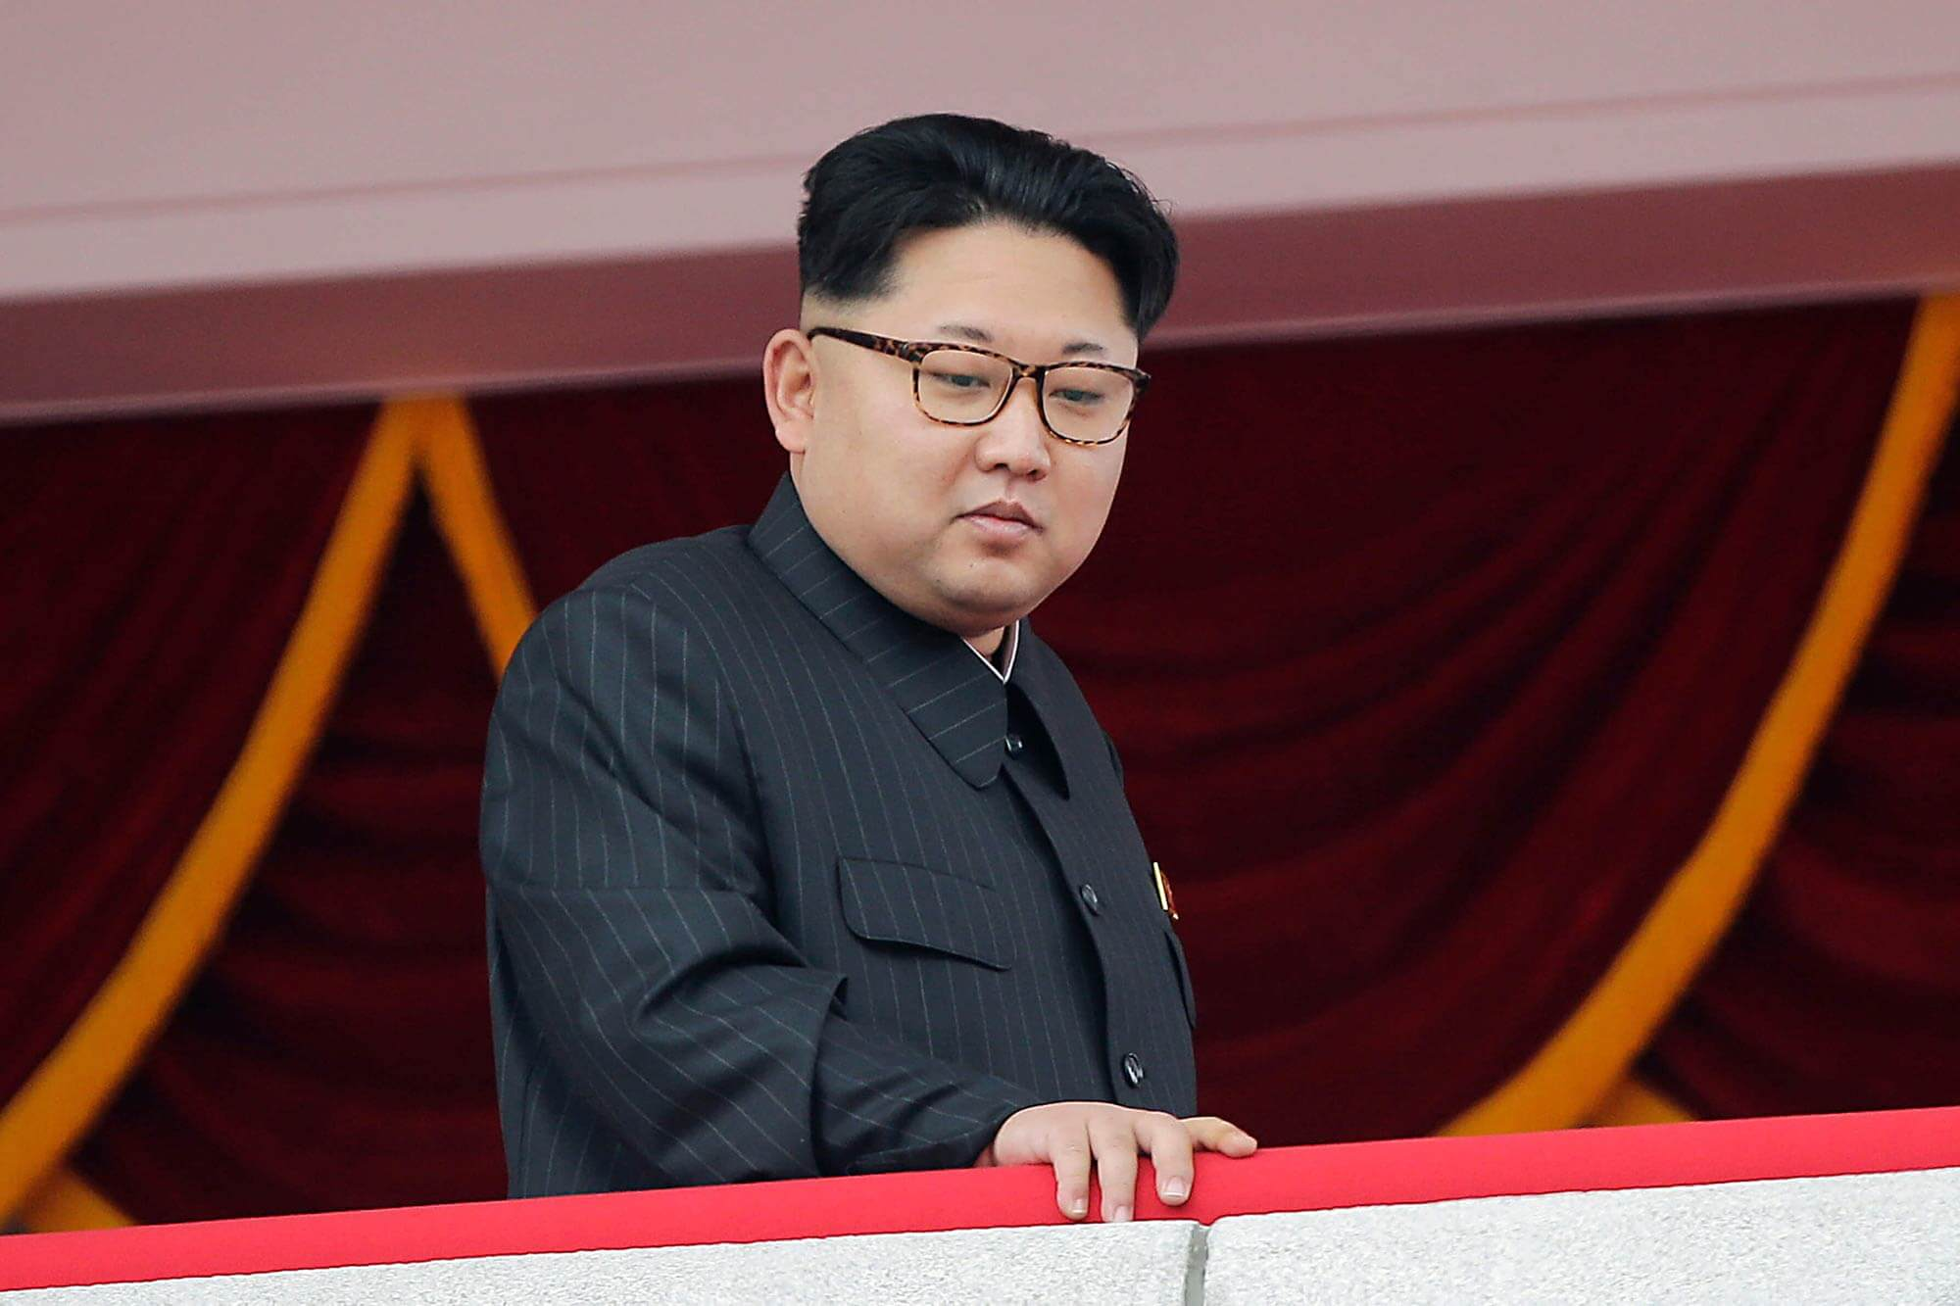
Friday, September 9, 2016,

Government Drops Chlorine Bomb in Aleppo, Syria-Sept. 2, 2016
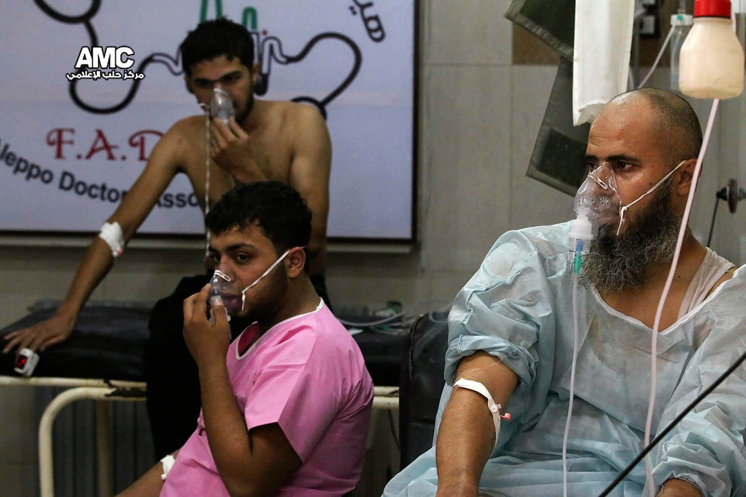

Tuesday 27 September 2016 16.32 BST

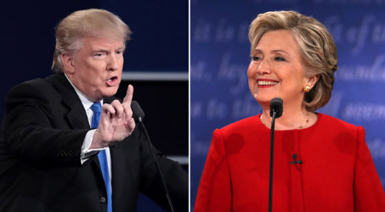

Trump loses cool

while Clinton stays

calm during first

presidential debate

."
September 2, 2016 (Friday)
Residents of the American state of Florida prepare for the impact of Hurricane Hermine.. A state of emergency is declared in 51 of the 67 counties in the state.

September 2, 2016 (Friday)
Samsung Electronics recalls all Galaxy Note 7 smartphones that have fire-prone batteries, and halts sales in 10 markets.
Pope Francis Canonizes Mother Teresa
-Sept. 4, 2016

- You will be expected to present a summary of your current events write ups to the class at least twice a month. (The presentations will happen every Friday or last day of the week. ) You must present a current event that has happened in the past two weeks.
- During current events you will be expected to ask relevant questions, make relevant comments and generate discussion.
Current Events Evaluation
- Your current events journal will be checked for completion periodically and will be evaluated at the end of each term against the learning outcomes.
- Your current events presentation will be evaluated each time you present against the relevant learning outcomes.
- Your questions/comments during current events presentations and the discussions generated will be marked against the relevant learning outcomes.

