Tourism Prince Rupert- Promotional video Assignment
In this assignment you need to imagine you have been hired by Tourism Prince Rupert to create a promotional video to attract tourists to Prince Rupert, and let them know some things they can do and see while in Prince Rupert. In groups you will be expected to take video clips to edit later into a 1-2 minute promotional video. You will need to pick places to represent the types of businesses and/or places of interest listed below to focus on in your video and create segments that represent each section in your video. You will also need to create a script of what to say and take videos and photos to put into your video. The video should focus on the Cow Bay Area to the Salt marsh area and can include anything within that area. You will need to include at least one or more element of the travel pledge (see on back) in your video as well as some Ts’msyen language (Sm’algyax), history, and/or culture. You will need to make it creative, interesting and informative.
You will need to do the following on our field trip.
• Decide on the businesses and/or places of interest you are going to include in your video under these categories (write them down)
- Things to do (pick 1 or 2) _____________________________________________________________________

- Places to shop (pick 1 or 2)____________________________________________________________________

- Places to eat (pick 1 or 2) _____________________________________________________________________

- Places to stay (pick 1)________________________________________________________________________

- Places of Interest (Pick 1 or 2) _________________________________________________________________
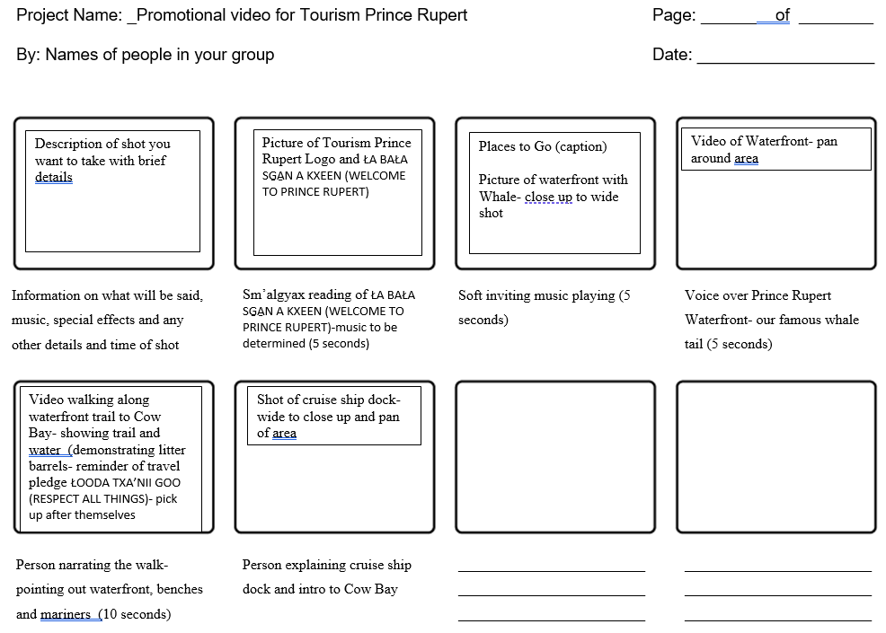
• Plan a rough outline of how you will shoot the segments using the story board template that includes details as shown in the example, as well as who will film and appear in these sections. You also need to write down whose phone the segments are filmed on.

TRAVEL PLEDGE
ŁOODA TXA’NII GOO (RESPECT ALL THINGS)
Consider how your visit can benefit or impact our community by reading and committing to our travel pledge.
CONSIDER YOUR IMPACT
ŁA BAŁA SG̱A̱N A KXEEN (WELCOME TO PRINCE RUPERT)
As a visitor to Prince Rupert, we invite you to consider the impact your visit will make on our local environment, people, and culture by committing to the pledge below. Sustainable travel and tourism is possible if we follow the principles of respect for ourselves, respect for others, and respect for the land.
HAGWIL YAAN (WALK SLOWLY)
When you visit us on Kaien Island (Kxeen), we invite you to take your time. Extend your visit to enjoy all that our community has to offer. Take the time to learn about Ts’msyen culture and history. Engage with locals and learn about our community and natural landscape, treading lightly wherever you go.
ŁOOMSK (RESPECT)
Travel with respect, in all stages of your visit: respect for yourself as a visitor, respect for others you will meet, and respect for the land and animals you will see while visiting.
ŁOODIS LP’NUUN (RESPECT YOURSELF)
Recognize the intersection of your history with the millenia of knowledge and culture that you will meet in Prince Rupert. Engage in meaningful, respectful conversations about local culture and share your stories with locals in an open, respectful manner.
ŁOODA SILA GYEDN (RESPECT OTHERS)
Respect the privacy of local residents and their access to community amenities. Have respect for our local Indigenous People and allow space for them to access Prince Rupert’s natural resources and engage in cultural ceremonies without disruption. Wear your mask when requested and practice social distancing to help limit the spread of COVID-19 to our community. Support local businesses and buy directly from local artists.
ŁOODA TXA’NII GOO (RESPECT ALL THINGS)
Respect the natural environment around Prince Rupert. Do not approach native wildlife, whether on land or in the sea – stay quiet and observe from a distance. Do not take anything from the natural landscape, such as driftwood, shells, or fishing artifacts. Clean up and remove any garbage you bring, or find, while visiting. Leave no trace.
ADA GYILKS AMA NIISGN (TAKE CARE OF YOURSELF)
Take the time to research your trip and be prepared for the landscape, weather, and limitations of visiting a small remote community such as Prince Rupert. Carefully read all signage and do not tread where it is not safe, whether due to wildlife, landscape, or other dangers.

