Assignment: Read the following two articles “Blood Reserve Rocker ‘Johnny Rains’” and “First Nations Art Adorns Miller’s First Canuck Mask.” Compare and contrast how the two artists in these articles, Johnny Rains and Ray Bishop, have combined their traditions and customs with modern times and how this helps first nations traditions live on. You must use specific support for your opinions from both articles in your answer. Your answer must be a minimum of 1 ½ -2 pages (approximately 3-4 paragraphs in length).

Blood Reserve Rocker ‘Johnny Rains’
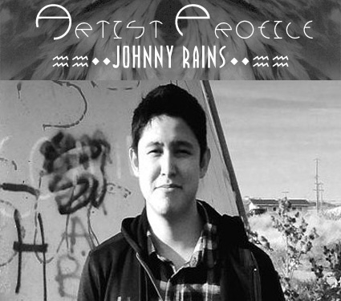
Johnny Rains is a young rocker from the Blood Reserve. He is a singer, song writer, lead guitarist, and founder of ‘The Johnny Rains Band’. Read more below about Johnny Rains below and don’t forget to rock on!
Johnny Rains is generally known as John Scout, a youth singer, song writer, lead guitarist and founder of the Johnny Rains Band. Born and raised in the city of Lethbridge, Alberta, John later moved in with his family on his late grandfathers ranch on the Blood Reserve. John graduated from Cardston High School in 2010.
“In my earlier years at school, I learned that working is the key to success and that practise makes life easier. In elementary, I remember one summer, my grandpa Leo encouraged me to join mutton¹ busting contests at the Kainai Fair & Rodeo, as well as in Cardston and Fort Macleod. I did and won trophies. That rodeo career didn’t last long. In my junior high years, I changed my career to skateboarding, in which I enjoyed and became good at crafting the technique to jump and flip a tiny board. I won awards in contests at the Lethbridge Skate park. My mentor at that time was pro skateboarder Roger Brumsma. In my earlier years, my grandmother Elizabeth, gave me a guitar for Christmas. At four years of age, I learned many Garth Brooks songs which I lip sang. Since that day, thanks to grandma, I never did put my guitar down, many careers came and went, but my love for music grew and is what I do best today”, John remarks in an interview with Blood Tribe Communications Magazine.
John enrolled in band classes throughout his elementary and junior high years where he was trained in both strings and percussion. Vocals and electric guitar training were completed at home with his father. His high school years were filled with performing at numerous community events and talent contests where he developed his natural ability as a performer. The Johnny Rains Band completed its first independent EP titled “RAINS - Be With You” with a release party on April 23, 2011. “This first album is in dedication to my late grandfather, Leo Day Chief, for courageously battling cancer until February 13, 2011. My grandpa wanted me to participate in the Aboriginal Peoples Choice Music Awards or rather wanted me to look further than reserve life. He did not realize that it takes discipline and focus. My goal for 2011, was to honour my grandfather with winning awards or recognition of my music as an ideal way of letting him go. With this in mind, I began to work quickly for the 6th Annual Aboriginal Peoples Choice Music Awards. My first time sharing my music was a result of the first round of voting at a competition for the APCMA. I didn’t get discouraged; instead I worked harder. I was recognized in my own province as a senior youth role model and went on to win an Alberta Aboriginal Youth Achievement Award for Walking The Red Road Category. Since my loss, I have dedicated my music career in support of the Canadian Cancer Society, as well as, a mentorship for the Youth Suicide Prevention Program.”
John learned the history of Indigenous Peoples of Canada in the Kainai Studies Degree Program. John has since been accepted to the University of Lethbridge Bachelor of Fine Arts Program for September 2012. “Graduating from high school is one of the many keys to success that opens doors for future opportunities and accomplishments” says John.
JOHN’S MESSAGE:
“DON’T BE AFRAID TO EXPRESS YOURSELF. WHEN YOU HAVE SOMETHING TO SAY, WRITE, OR SING SHARE YOUR GIFTS,
YOU WILL BE AMAZED AT WHAT YOU COULD DO” MOVE FORWARD, EVEN IF IT MEANS TAKING TINY STEPS . . . THE ACCOMPLISHMENTS ARE ACHIEVED IN THE STRIDES AHEAD.

¹ older sheep

First Nations Art Adorns Miller’s First Canucks Mask
By Lachlan Macintosh On September 4, 2014 · 3 Comments
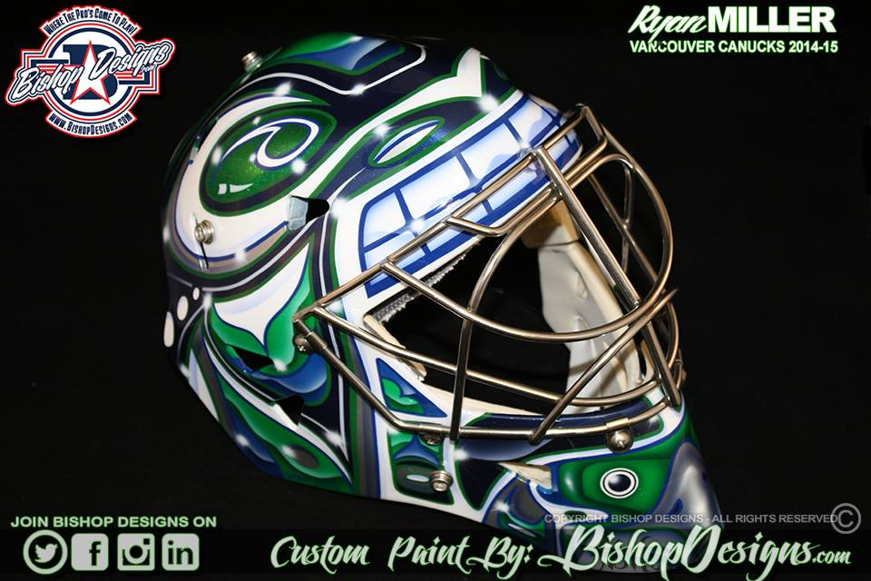
At end of last season, the Vancouver Canucks were left holding the bag after a disappointing season saw them on the outside of the playoff picture looking in for the first time in five years. The Canucks organization started to address what they believed to be issues surrounding the club, and one of those issues was between the pipes. Enter Ryan Miller.
After being traded to the St. Louis Blues from the Buffalo Sabres at the trade deadline in an effort to bolster an already stellar Blues team, Miller struggled to find his game and St. Louis lost in the first round of the playoffs to the Chicago Blackhawks. However, Miller’s three-year contract with the Canucks is an opportunity for the US Olympian to put last year behind him and to do so with conviction. Miller’s newest mask is designed and painted by Ray Bishop of Bishop Designs, and features the First Nations Art that is so famous in this part of the world.
When we talked to Bishop, he said Miller “asked me to come up with a design that would have more of an iconic feel to it (similar to the buffalo style mask we have done so many of in the past), but using the logo elements from Vancouver.” While the blue, green, and white are unique to the Canucks, the characters and style of the mask art are omnipresent in the First Nations art and culture of British Columbia.
The orca head that dominates the mask, with eyes and nostrils atop the mask, and large bared teeth above the cage of Miller’s new helmet is a classic character among totem poles in the Pacific Northwest. So is the small eagle that rests on the chin of the mask. “It is simply a native tribal design pattern that I found to be recurring in most of the references I pulled to aide me in designing Ryan’s new look,” said Bishop.
The orca is a symbol of luck, compassion, and family in First Nations culture. Most often portrayed as a powerful and aggressive figure, the orca protects the people from sea monsters. Well, without much luck last year the Canucks finished outside the playoffs and here’s hoping that Miller can protect the back of the net from the onslaught of pucks. The eagle is another strong character seen as having the closest relationship with the creator, seamlessly moving between the human and spirit worlds. We imagine management and fans will settle for Miller seamlessly moving from post to post!
As for the back of the mask, It’s Miller Time! The classic slogan sits above the “Matt Man” illustration, an homage to Miller’s late cousin who passed away from complications from a bone marrow transplant …. Bishop, an artist from Michigan, has captured the art of the First Nations beautifully on this new mask. Miller has also given a tip of the cap to British Columbia’s oldest inhabitants. The unique design is sure to capture the attention of fans and players everywhere!

Having created masks for Miller in Buffalo, Bishop also put together the St. Louis Blues mask worn by Miller last year. You can visit Bishop Design’s website, follow Ray and Co. on Twitter and/or Instagram, and Like his Facebook page. Check out some more close ups of Miller’s new lid below!

TAGGED WITH → Ray Bishop • Ryan Miller • Vancouver Canucks
http://ingoalmag.com/masks/first-nations-art-adorns-millers-first-canucks-mask/

