Indigenous Christmas Ornaments Activity
All Artwork in each ornament was created by Gitxsan Artist Michelle Stoney and is being used with permission.
These are only to be used for educational purposes and not for profit.
Materials needed:
- Glue/staples- to join the two sides of the ornaments together and to help decorate their ornaments
- Paper, ribbon or string to attach to the ornaments so they can be hung on a tree.
- Crayons, pencil crayons or felts to colour the ornaments.
Optional materials:
- glitter or other decorations to decorate the ornaments
- Cotton balls or similar to stuff the ornaments
Activity Instructions:
- Print out ornament colouring pages for students. They will need 2 copies of each page if you want them to have all the ornaments.
- Have students colour and decorate their ornaments
- Have students cut out ornaments. (see pic 1)
- Have students cut one of the following for an ornament holder: (see pic 2)
  - A piece of string about 15 cm long or
  - A piece of ribbon about 15 cm long or
  - A piece of paper that is about 2 cm wide and 15 cm long.
- Have students take two cut out copies of the same picture (they can be different if they want) and their ornament holder. Place these on their desk. (see pic 3)
- Take one of the pictures. Place it on the table so the picture can’t be seen. (see pic 4)
- Take the ornament holder and fold it over so the two ends are at the top of the ornament and the rest is in a loop that will hold the ornament. (see pic 5)
- Using glue or a stapler have them join the ornament holder to the one side of the ornament. (see pic 6)
- If they want to stuff their ornament they can put a cotton ball on the inside and glue it to the paper. (see pic 7)
- Next place the other side of the ornament picture side up on top and attach it all together and the ornament should be finished. (see pic 8)

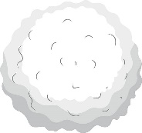
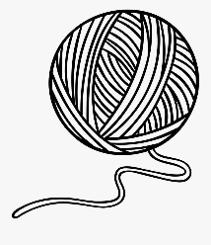
Pic 8
Pic 7
Pic 6
Pic 5
Pic 4
Place picture side down
Pic 3
Pic 2

(15 cm approx.)
Pic 1
[Grab your reader’s attention with a great quote from the document or use this space to emphasize a key point. To place this text box anywhere on the page, just drag it.]

