Module 1
Apr 1 1999 coast guard enacted legislation
Jan 15 1999 competency regulations enacted-canada shipping act
Required as of sept 15, 2009
Less than 12- less than 10 hp no pwc
12-16- less than 40-no pwc
16+ no restrictions
If supervised must have competency card
Compliance notice must be on propelled (or designed to be) and for licensing boats
Info on compliance notice- gross load capacity, safe engine limit, max # adults
Small vessel regs- more than 10 hp must be licensed- lasts 10 years
Criminal code- must offer assistance
Canada shipping act- required to help (distress)
If you lend boat- you and lendee responsible
Canada shipping act- small vessel regs, collision regs, vessel operation restriction regs, charts and nautical publications regs, competency of operation pleasure craft regs, contraventions act
Criminal code
Small vessel- safety equip (careless operation)- construction, safe operating, safety equipment, required maintenance, registration/licensing
Charts/nautical-largest scale map of area- required pubs/docs for area
Vessel operation regs- speed
Contraventions act- power to enforce- speed, safe operation, no equip
Collision regs- rules for navigation, right of way,look out
Criminal code- assistance, unsafe/dangerous operation, false emergency, towing regs, unseaworthy
Boating/alcohol- criminal, fines, boater fatigue quadruples affect of alcohol

Module 2-
Buoyant heaving line- 15 m
Small vessel regs-bailing device required if >12 m need two buckets
- 9 meters- need anchor-small vessel regs
- Manual propelling device needed
> .5 m freeboard must have reboarding device

Module 3
Criminal code requires seaworthy boat
Weight of boat should not exceed 80% of trailers weight capacity
Need mandatory closed loop safety chains
Gross towing weight is the maximum weight you can tow –inclues weight of craft, engine, trailer, fuel and equipment
Attaching trailer- balance it, fasted tongue, lock it, safety chain, tie downs,
5-10% of total loaded weight should be on tongue
Before launching- visual check, remove tiedowns, unplug lights, ensure drain plug in, winch connected, test motor start up,
Back into until 2/3 submerged- turn off vehicle- emergency brake, attach winch line- remove drain plus- attach ilghts
Might be exempt from required pubs/docs if you are under 100 tons and powered by oars or you have substantial knowledge
Should know how to use a compass, plot a course, locate and reference navigational aids

Light winds are defined as “Winds with a wind speed less than 12 knots (22 km/h)” and water surface conditions that are calm or have waves up to 1.5 m in height
Moderate winds are defined as “Winds with a wind speed of 12 to 19 knots (22 to 35 km/h)” and water surface conditions that are rough with waves from 1 to 3 m in height. Inexperienced operators or vessels under 6 m in length should not operate during such conditions.
Strong winds are defined as “Winds with sustainedwind speeds in the range of 20 to 33 knots (37 to 61 km/h).” Water surface conditions during a strong winds advisory are very rough with waves 3 to 6 m in height. Turn on all navigation lights and attempt to cross waves at a 45° angle until sheltered waters are found. Reduce speed and proceed with caution, keeping a look-out for approaching boats and floating debris. If wind and wave conditions make it difficult to proceed, attempt to anchor your vessel until the storm subsides.

Gale winds are defined as “Winds with a continuous speed of 34 to 47 knots (63 to 87 km/h)”. Water surface conditions during a Gale Warning are extremely rough with waves 6 to 9 m in height keep passengers low in the boat and near the centerline. If your boat is taking on water, pump out bilges to keep the boat high in the water. Signal distress if needed.

Storm winds are defined as “Winds with a continuousspeed of 48 to 63 knots (89 to 117 km/h). Water surface conditions during a storm warning are extremely rough with waves over 8 m in height. immediately signal distressand need of assistance

1/3 rule- out/back/reserve
Fuel- don’t overfill, during daylight, don’t smoke- gas explosive
When fueling- must be moored, shut down motor, passengers off, extinguish open flames, close doors, windows, shut off electrical equipment, fire extinguisher ready, gas nozzle at rim of filler pipe, open all doors eindows once refueling complete, if you have a ventilation blower- use for 4 min before starting engine, rechcck for smell, start motor

Refueling portable container- moored, motor off, extinguish flames, disconnect fuel line, approved tank, check for leaks, proper mix of fuel, place tank bank, reconnect fuel line- recheck for leaks, start motor

Fueling pwc- shut down engine, disembark, extinguish flames, visually check gas separation for water- remove water before refueling, turn fuel selctor switch to off,premix gas and oil before refueling, fill tank, tighten fuel filler cap, check for vapours, turn fuel selctor switch to on- restart engine

Module 4

Keep away from pwc intake valve- jet thrust nozzle can cause severe injury
Approach dock at 30=45 degree angle when returning- no brakes- requires time to stop
Pwc needs throttle to steer- no neutral or reverse-must shut down close to dock-remove engine shut off cord

Being on water can impede your judgemetn
Heat stroke- nausea, vomiting, fatigue, weakness, headache, muscle cramps dizziness- cool victim, remove clothing, apply cool water to skin, fan victim, ice packs under arms/groin

Collision regulations –operator responsible for choosing a safe speed
Trim- angle of boat in water- properly trimmed- gunwales parallel to water
To plane- accelerate slightly to regain horizontal trim
Minimum of 75 m required to stop from full throttle with pwc

Boats should cross wakes at a 45 degree angle, pwc operators should cross wakes at a 90 degree angle
Operating in bad weather- caution, lookouts, look and listen, navigation lights, stop engines, use radar

Setting an anchor- inboard end of enchor line attached to boat, outboard end attached to anchore- lower over bow until it reaches bottom, let boat drift rearward- let out 8-10 times more anchor line than depth of water- securely fasten- once anchor is set choose two fixed landmarks- continually check to make sure you aren’t drifting, if anchoring overnight- use all round white light- no green or red light

If setting anchor amongst other boats- first craft into anchorage havs right of swing- allow for this- anchor clear

Red/white flag or blue and white flag- diver down- collision regulations- operators take early and substantial action to stear clear

Non power boats have right of way
Wake- displacement of water
Wash disrupted water behind boat
Universal speed limit within 30 m of shore- 10 km h

Canada shipping act –must report any discharge of pollutant from your vessel that occurs if it is prohibited
To clean boat of invasive species- hot tap water- 40 degrees, high pressure 250 psi, dry for at least 5 days
Must have noise muffling device within 5 km of shore

Exiting in water- shut off engine- take note of hazards, enter feet first unless you know there are no hazards

Boarding boat from deep water- engine off, use ladder or go to back of boat and use propeller-caviation plate
Boarding pwc- right according to instructions- swim to stern- use grab hand and pull yourself on- don’t board from side- make sure engine is off
Cannot tow afeter dark

Module 5

Collision regulations govern navigation rules
Stand-on craft
Boats with the right-of-way are called “stand-on craft”. Stand-on craft are able to maintain their speed and Course when approaching another vessel.
Give-way craft
Boats that do not have the right-of-way are called “give-way craft”. Give-way craft must take early and substantial action to steer clear of the stand-on craft, altering their speed and direction to avoid a collision.
Several factors determine which craft has the right-of-way:
- The type of craft you’re operating
- The type(s) of craft(s) you’re approaching
- The position and direction from which other boat(s) are approaching
- The type of waterway on which you’re operating

Approaching non power craft- give way craft- steer clear- slter speed and course
Head on- no one has right of way- steer to starboard- early action to steer clear- one short blast with sound signaling device
Boat approaching from left you are stand on craft- have right of way- maintain course and speed- vessel approaching from port should give signal blast
Boat approaching from right- you are the giveway craft- steer clear- alter speed and course- give a signal
Overtaking- give way craft- steer clear- pass either side- if you can should go to starboard
2 blasts for overtaking on port- 1 blast for overtaking on starboard

Sound signaling- over 12 meters- one blast when leaving dock
Bakcing up 3 short blasts-
Don’t understand intentions- 5 blasts
Vessel at anchor during poor visibility- signal rapidly for 5 seconds in intervals of not more than one min
Sailboats use one long blast followed by two short during poor visibility-every 2 min
Power boats sound one long every two min and two long blasts every min when stopped during poor visibility

Sailboat navigation
Right-of-way rules for vessels propelled by the wind are based on:
- The direction of the wind
- The position of the mainsail
- The position of the sailboat in relation to other boat traffic
A sailboat moves when wind blows into the mainsail. The windward side is the direction from which the wind is blowing. One way to determine the windward side is to note the position of the sailboat’s “mainsail” (its large main sail). The windward side of the sailboat is opposite to the side on which the mainsail is being carried.
Forexample
If the mainsail is to the right side of the sailboat, then the left (port) side of the vessel is considered to be the windward side (as in the illustration shown above). In this example, the wind is blowing from the port (left) side into the mainsail and “pushing” the mainsail to the starboard (right) side.
A pleasure sailing vessel with the wind on its port side is the give-way craft (B) and must take early and substantial action to steer clear of any sailing vessel with the wind on its starboard side (A).
What does this mean to you?
This means that a sailboat with the wind on the port side (port tack) should keep out of the way of a sailboat with the wind on the starboard side (starboard tack).If operating a power boat in the vicinity, you should anticipate that the sailboat with wind on its port side will alter its Course to starboard to avoid the other sailboat.
If two pleasure sailing vessels have the wind on the same side, the sailing vessel to the windward side is the give-way craft (B) and must take early and substantial action to keep well clear of the leeward vessel (A).
What does this mean to you?
This means a boat sailing Downwind (“behind” the other sailboat) must alter its Course to avoid a boat sailing upwind on the same tack. If operating a power boat in the vicinity, you should anticipate that the boat sailing Downwind will alter its Course to avoid the other sailing vessel.
If a sailboat operating with wind on its port side (B) cannot determine with certainty where the wind is approaching another sailing vessel, it must take early and substantial action to change direction and keep well clear of the other vessel (A)
The Collision Regulations require that all smaller pleasure craft less than 20 m in length (including sailboats) must give right-of-way to larger, less manoeuvrable vessels. This is one of a few instances in which a powered vessel has the right-of-way over non-powered vessels.
preventing collisions at sea and the Canadian modifications upon the high seas and in all waters connected therewith and navigable by vessels as described in the Collision Regulations Rules 1 and 2 and the Canada Shipping Act
When traveling to the United States by sea or inland waterway, Canadian citizens are required to present a single document that complies with the Western Hemisphere Travel Initiative (WHTI).
The navigation lights you are required to display depend on the following:
- The size of your craft
- Whether it is sail-driven or power-driven
- Whether it is underway or at anchor
Power-driven pleasure crafts must exhibit a forward masthead light, sidelights and a sternlight.
Many small boats (such as bow riders and runabouts) typically have a white light affixed to the top of a light pole that can be placed at the stern of the craft. When underway, this all-round light functions as a combined masthead and sternlight, and must be visible in all directions, mounted higher than the boat structure, cockpit or any other obstruction.
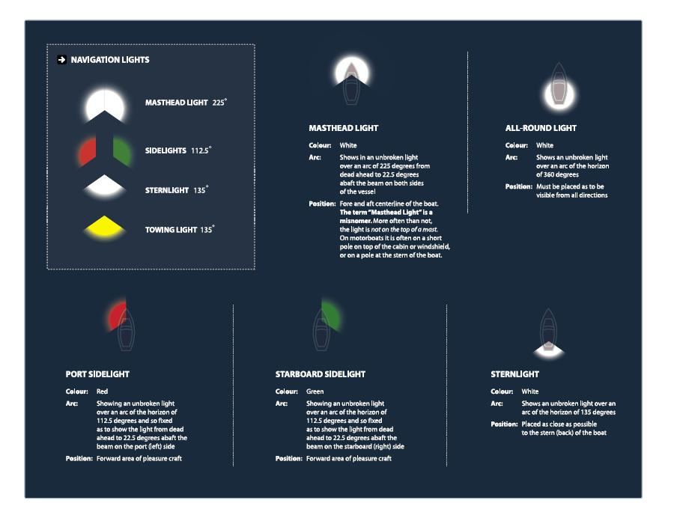

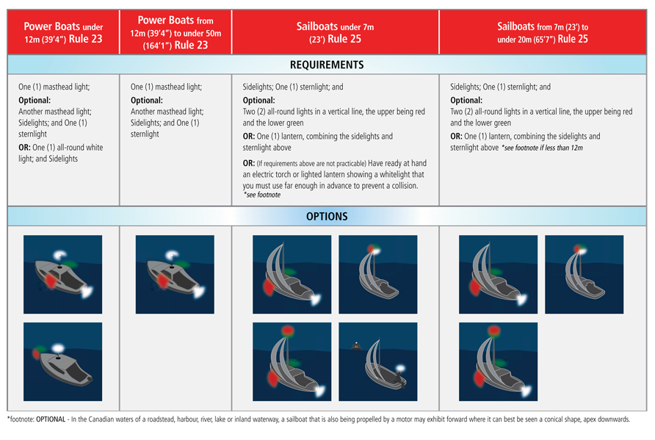

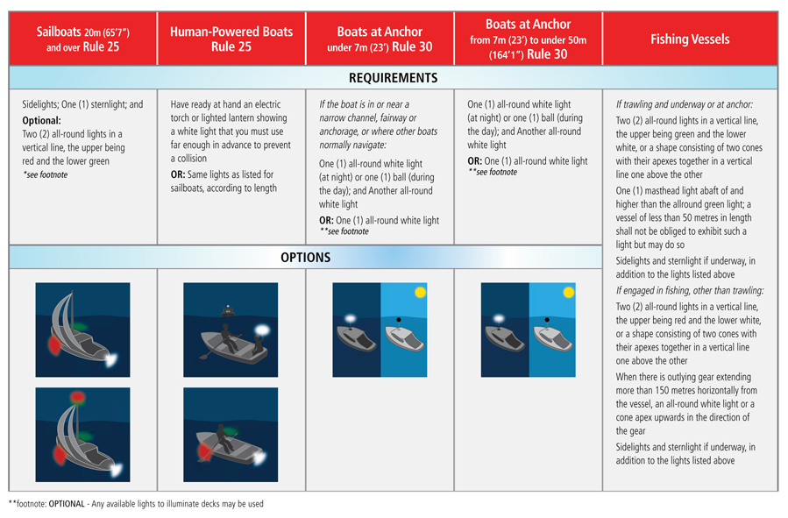
You should steer well clear of a vessel with a Blue Flashing Light.

When towing
If towing another vessel from your stern you must show:
- Sidelights and a sternlight
- A yellow towing sternlight
- Two masthead lights in a vertical line
If being towed, you must exhibit:
- Sidelights and a sternlight
- A diamond shape
- If you do not have sidelights you must exhibit two Aids to Navigation, one each at Fore and Aft
Vessels being pushed
When using a power-driven vessel to push another vessel Ahead or tow alongside, you must exhibit:
- Two masthead lights in a vertical line, sidelights and a sternlight
- If you meet a vessel and see a green, red and white light, you are approaching another power-driven vessel head-on. In this situation neither vessel has the right-of-way. Both operators must take early and substantial action to steer well clear of the other vessel. Both operators should reduce their speed and steer to starboard.

- If a green and white light is visible, then another craft is approaching you from the port (left) side. In this situation, you are the stand-on craft and should maintain your speed and Course. The other craft should take early and substantial action to steer well clear of your craft.
- If a red and white light is visible, then another craft is approaching you from the starboard (right) side. In this situation you are the give-way craft and must yield right-of-way. You should take early and substantial action to steer well clear of the other craft. Reduce your speed, change direction and pass at safe distance behind the other boat.
Green light go-boat approaching port red light stop-boat approaching starboard

If only a white light is visible, you are approaching another craft from behind. You are the give-way-craft and must take early and substantial action to steer well clear by altering your Course and passing at a safe distance on the starboard (right) or port (left) side.
What else does a white light indicate?
If you see only a white light, it can generally indicate one of three things:
- You are approaching another craft from behind
- You are approaching a non-powered craft
- You are approaching a craft that is at anchor

Operators should always control their speed when in the vicinity of a lock. When approaching a lock you should:
- Identify and adjust for water currents and other boat traffic
- Be aware of and operate according to any posted navigational aids (markers and buoys)
- Identify and adjust for adverse weather conditions such as high wind
- Be prepared for oncoming traffic as boats exit the lock
- Wait for any instruction from the lockmaster or waterway personnel.
- Proceed slowly (maximum speed limit is 10 km/h) and with caution into the lock. Have crew members posted at the Bow and stern of the boat with mooring lines ready to use.
- Use the vertical “drop cables” affixed to the walls of the lock to secure your Bow and stern. Your boat’s mooring lines should be wrapped loosely around the lock’s drop cables allowing for upward or downward movement of your craft. Never tie your vessel lines to the drop cables.
- Once positioned, turn off all engines, cease from using any fuel-burning appliances, and refrain from smoking. Turn on your engine ventilation system. Do not leave your mooring lines unattended.
- Once the water level within the lock has reached the proper elevation, the opposite end of the lock will open. The lockmaster will instruct you when to start your engine and when to proceed.
- Proceed with caution. Never block the entrance to the lock from other boats that may be entering or exiting

Remember
When approaching a blind turn always keep to the right side of a river. Power-driven craft and sailboats less than 20 m in length must give way to less manoeuvrable crafts while navigating on a river.
If two vessels approach each other in a narrow channel where tide, river flow, or underwater features create dangerous currents, then the vessel going downstream is automatically afforded the right-of-way
You should always keep to the starboard (right) side of a channel, particularly when approaching oncoming traffic or entering a blind turn. Power-driven craft and sailboats less than 20 m in length must give way to less manoeuvrable crafts operating in a canal or shipping lane. Keep in mind that large vessels, such as commercial ships, are often restricted in their ability to manoeuvre in narrow channels, and pleasure craft operators should steer well clear.
There are a number of activities that are prohibited while in a canal:
- No excessive noise between 11 PM and 6 AM
- No mooring a vessel to a navigational aid
- No fishing within 10 m of a lock or from a bridge that passes over a navigation channel
- It is illegal to dive, jump, scuba-dive, swim or bathe within 40 m of a lock gate or dam

You should avoid crossing traffic lanes but, if obliged to do so, cross at right angle to the general direction of traffic flow. If navigating near a shipping lane or near the termination of a shipping lane you should use caution, avoid the lane with as wide a margin as practicable. Always avoid anchoring in a shipping lane or near its termination. To increase your visibility to larger vessels in or near a shipping lane you should stay in groups with other small boats if possible.
Buoys serve four main functions:
- Provide Warnings
- Provide Information
- Mark underwater hazards
- Provide a system for navigation
There are three styles of floating buoys used on Canadian waterways:
- Light Buoys: Light buoys are typically the largest of all floating buoys and have a light fixture affixed to the top of the buoy.
- Spar Buoys: Spar buoys are also called “pillars” and are common on smaller waterways. They have a cylinder shape and are typically smaller than light buoys.
- Cans: Cans are wider than spar buoys and are typically used as lateral system and bifurcation buoys.
- The Lateral System is a system of red and green buoys used to mark preferred safe routes. The Lateral System also includes fairway buoys, isolated danger buoys and day beacons.
- The Cardinal System consists of yellow and black buoys that indicate safe routes by the cardinal compass points.
- A Range is a series of two buoys that, when aligned along a sight path, indicate the safest route for navigation.
- Special Purpose Buoys may be yellow or white in colour and are used to mark dangers such as (but not limited to) racecourses, underwater structures, pipelines, etc

- F1 pattern (single flashes in 4 second intervals); or
- Q pattern (quick single flashes one second apart)
right-hand side of your boat when upstream.

Part of the lateral system, bifurcation buoys indicate the junction of channels:
- Port-Junction bifurcation buoys are green in colour with a red horizontal band at the midsection. Port-junction buoys mark the junction of two channels and should be kept on the port (left) side of the vessel when navigating upstream.
- Starboard-Junction bifurcation buoys are red in colour with a green horizontal band at the midsection. Starboard-junction buoys mark the junction of two channels and should be kept on the starboard (right) side of the vessel when navigating upstream.
Fairway buoys are used to mark the entrance to a channel, the centre of a shipping channel, or a safe approach to land. Vessels should keep the fairway buoy on the left (port) side whether proceeding upstream or downstream.
Fairway buoys are identified by the following:
- Red and white in colour, divided vertically with one side red and the other side white
- Will have a ball shaped top-mark
- May be equipped with a white light that flashes in a Mo(A) sequence – One short flash, followed by one long flash repeated 10 times per minute
An isolated danger buoy is used to mark an isolated hazard or obstruction such as a rock, shoal, or sunken island. The buoy will be moored on, or above, an isolated danger that has navigable (i.e. safe) water all around it. You should refer to a marine Chart to determine the features of the isolated danger (i.e. size, depth, exact location etc.) and should navigate well clear of the marked danger.
Isolated danger buoys are identified by the following:
- Black in colour with a wide red band at the midpoint
- A top-mark consisting of two black balls
- May be equipped with a white light that flashes in a FL(2) sequence – a two flash sequence repeated every 4 seconds
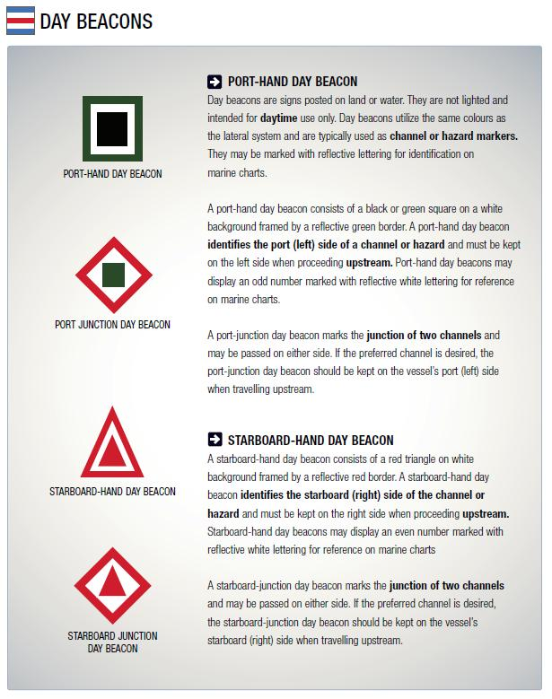
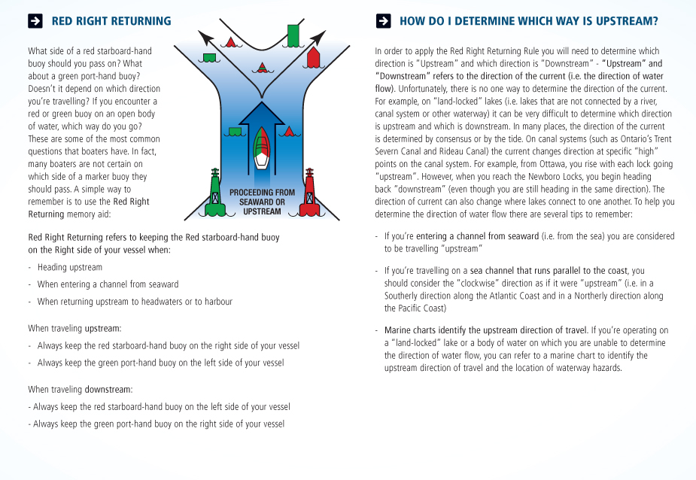
Red right return

The cardinal buoy system consists of yellow and black buoys that are used to assist boaters in identifying the location of safe water

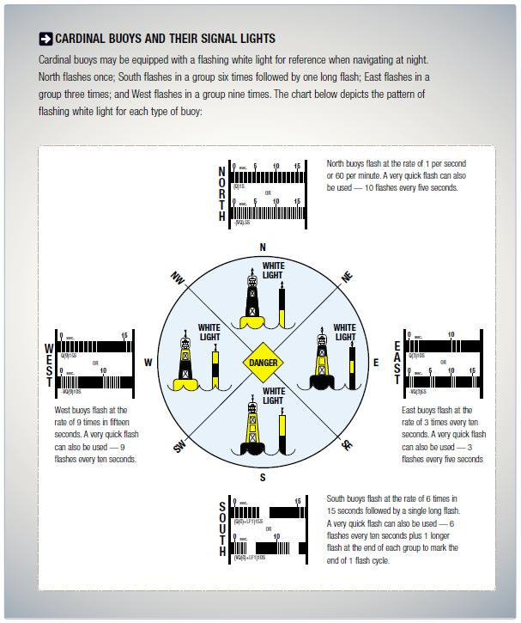

Ranges are typically used to guide larger vessels through a channel. Ranges consist of two or more markers, permanently affixed at a significant distance from each other. Ranges are constructed so that there is an upper marker and a lower marker. The lower marker is constructed near ground level at the shore while the upper marker is attached to a tower, located behind the lower marker.
One navigates through the channel by maintaining a Course that keeps one marker aligned top and bottom with the other. When the two markers are lined up vertically, the boater is on the recommended Course.

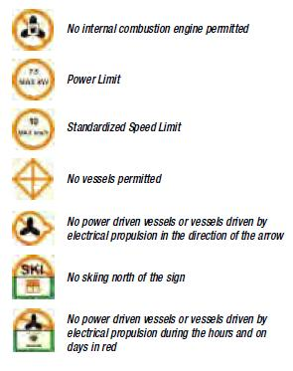
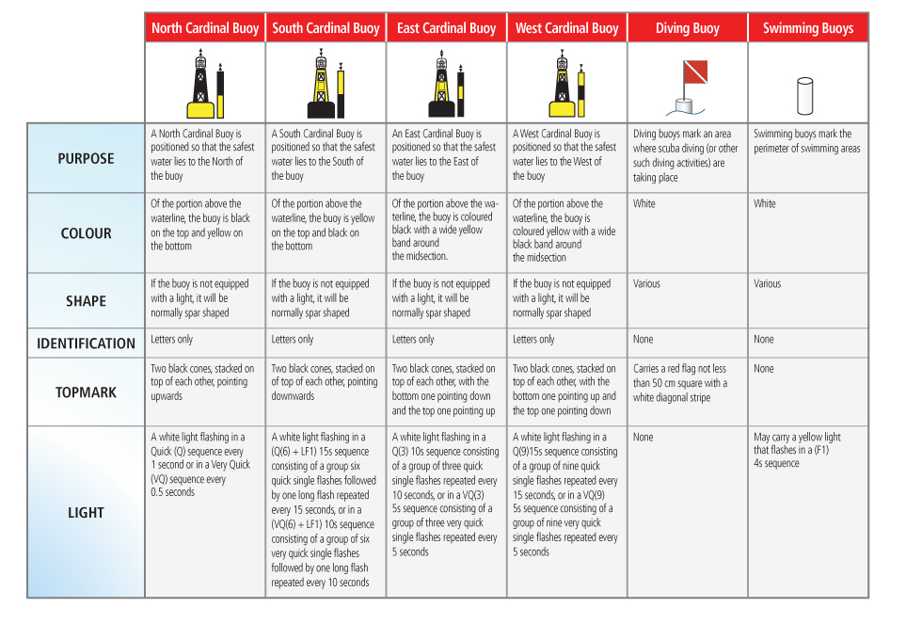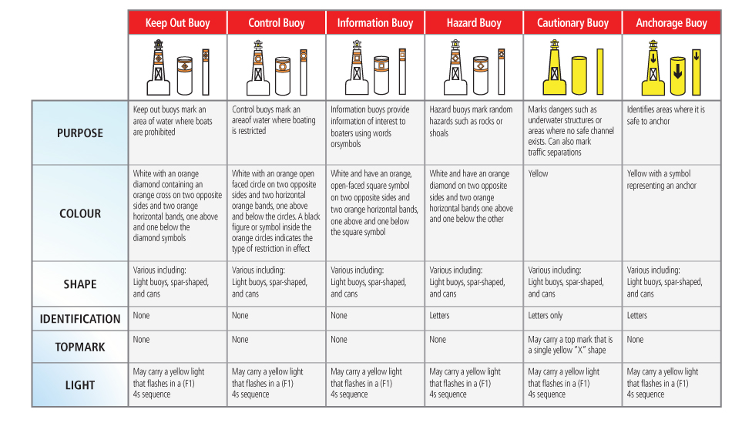

Small vessel regulations require that certain boats carry an emergency kit

If your craft has run Aground:
1. Immediately shift the motor to neutral
2. Ensure that everyone is wearing a PFD or Lifejacket
3. Visually and/or verbally confirm that all passengers are present and accounted for
4. Determine if there are other craft in the vicinity that may offer assistance
5. Determine if there is any danger of being hit by other boat traffic
6. Inspect the hull and equipment for any damage. Check for rising or accumulating water in the hull
7. If the hull is undamaged, assess your Course of action:
- Is it possible to dislodge the craft from its
- obstruction?
- Is it necessary to lighten the craft by removing
- equipment and passengers?
- Is it possible that passengers may be able to
- push the craft off the obstruction?
- Is it possible to use the reverse thrust of the engine to free the craft from the obstruction?
8. If necessary, signal your need for help using a recognized distress signal

If your craft has capsized:
- Ensure that everyone is wearing a PFD or Lifejacket
- Visually and/or verbally confirm that all passengers are present and accounted for
- Determine if there are other craft in the vicinity that may offer assistance
- Determine if there is any danger of being hit by other boat traffic
- If you and your passengers are far from shore or unable to reach shore, stay with your craft. If your craft is not fully submerged, climb onto the overturned hull. This will help you retain energy, increase your survival time in cold weather/water conditions, and increase your visibility to other boaters. However, only re-board the capsized vessel if it is still afloat, seaworthy, and safe to do so. If it is appropriate to leave the craft, swim to shore and immediately get assistance once you’ve reached shore
- If necessary, signal your need for help using a recognized distress signal

A boat is “swamped” when it fills with water from over the side. Swamping can be caused by large waves coming over the gunwales or transom of your boat if it has been overloaded. If your boat has been swamped or is sinking:
- Ensure that everyone is wearing a PFD or Lifejacket
- Visually and/or verbally confirm that all passengers are present and accounted for
- Determine if there are other craft in the vicinity that may offer assistance
- Determine if there is any danger of being hit by other boat traffic
- Attempt to stop any hull leaks or flooding if possible
- If you cannot stop your craft from sinking, immediately swim to safety
- Signal your need for help using a recognized distress signal
You are required to take certain actions if you have been involved in a collision:
- You are required to stop and identify yourself, your vessel, your home port, and your ports of origin and destination to the other craft
- You are required to assist the crew of the other vessel if it safe to do so
- If damage exceeding $1,000 has occurred, or the seaworthiness of either vessel has been compromised, you are required by law to file an accident report with the local authorities
- If serious injury or death has occurred, you are required by law to report the collision to the local law enforcement agency
If circumstances (such as an onboard fire) dictate that you and your passengers need to abandon ship, do the following:
- Ensure that you and your passengers are wearing a PFD or Lifejacket
- If time permits, signal your need for assistance with a radio, Flare, horn, or flashlight
- If possible, jump to the windward side of the boat (the boat will drift away from you)
- Once in the water swim well clear of the boat
- Visually and/or verbally confirm that all passengers are present and accounted for
First, you should sound an alarm notifying your passengers and other boaters of the situation and call for help:
- Shout “Help - Person Overboard!”
- Assign another passenger to keep a visual contact of the person overboard and continuously point to the person’s location.
- Immediately throw the person a buoyant item such as a PFD or Lifejacket. This will help the person stay afloat and mark their position in the water (in the event that they become submerged or if attempting to rescue under reduced visibility).
Second, you should assess the situation and your readiness:
- Are you wearing a PFD or Lifejacket?
- Do you have the proper emergency equipment on hand and readily accessible?
- How panicked is the overboard person?
Third, you should remain calm and determine which overboard rescue technique to use:
- Reaching Assist (such as an oar, paddle, pole, or piece of clothing)
- Buoyant Heaving Line
- Life Buoy

When rescuing a person overboard:
- Carefully manoeuvre the craft turning the bow into the wind.
- Once in position, shut down the engine to avoid injury (such as a propeller strike) or accidental movement.
- Once you have retrieved the person using one of the techniques described below, move to the side of the boat keeping your weight low and instruct the victim that you’re going help him/her out of the water.
- Use a re-boarding device (such as a portable ladder) to assist the victim up and over the side of the boat. In a small boat recover the victim over the stern as it is typically the lowest part of the craft. A heavy rope, chain or cable secured at both ends and draped over the side (almost touching the water) can also be used as a makeshift step if necessary.
Remember the following when rescuing a person who has fallen overboard:
- Position your craft downwind from the victim. He or she will drift towards your boat.
- Don’t panic. Keep a calm head and consider your course of action.
- Don’t jump into the water. If the victim is panicking and thrashing in the water he or she may grab hold of you and pull you under.
- Practice the emergency recovery techniques described in this section and ensure your passengers become familiar with the equipment, techniques and movement of the pleasure craft necessary to perform a successful rescue.
Using a Reaching Assist:
- Move to the side of the boat keeping your weight low and instruct the victim that you’re going to help him/her out of the water
- Using the reaching assist pull the victim to the side of the boat
- Using a re-boarding device assist the victim up and over the side of the boat
Using a Buoyant Heaving Line:
- Ensure the inboard end of the buoyant heaving line (the end without the float) is secured to the boat
- Throw the line so it lands behind the victim
- Slowly pull the line towards you so the victim is able to grab onto it
- Pull the victim to the side of the boat
Using a Life Buoy:
- Ensure the lifebuoy is secured to the boat with a line
- Throw the life buoy so it lands behind the victim
- Slowly pull the line towards you so the victim is able to grab onto it
- Pull the victim to the side of the boat
Hypothermia is a drop in core body temperature, caused by prolonged exposure toabnormally low temperatures. Hypothermia can be caused by:
- Immersion in cold water
- Exposure to cold air and wind while in water soaked clothing
- Prolonged exposure to low water and air temperatures
- Hypothermia sets in when core body tempurature drops below 35.0 degrees Celcius

1-10-1 is a simple way to remember the first three phases of cold water immersion and the approximate time each phase takes.
1- Cold Shock: An initial deep and sudden gasp followed by hyperventilation. Cold Shock will pass in about 1 minute. During that time concentrate on avoiding panic and getting control of your breathing. Wearing a lifejacket during this phase is critically important to keep you afloat and breathing.
10 - Cold Incapacitation: Over approximately the next 10 minutes you will lose the effective use of your fingers, arms and legs for any meaningful movement. Swim failure will occur within these critical minutes and if you are in the water without a lifejacket, drowning will likely occur.
1- Hypothermia: Even in ice water it could take approximately 1 hour before becoming unconscious due to Hypothermia. You should understand the techniques of how to delay hypothermia, self rescue and calling for help in order to increase your chances of survival.
Cold water can also paralyze your muscles instantly - making it extremely difficult to put on a Lifejacket or PFD.
It is important to remember that cold water shock can occur throughout the year, even during warm summer months when water temperatures can remain lower than outside air temperatures.
If suffering from hypothermia, the victim’s core body temperature drops Below normal levels resulting in weakened muscular functions, reduced co-ordination and slowing of mental functions.
A person suffering from hypothermia will exhibit progressive symptoms including:
1) Early Stage:
- The victim is still conscious
- Shivering
- Slurred speech
2) Intermediate Stage:
- The victim may be irrational, confused and sleepy and will exhibit a lack of co-ordination
- Slow and weak pulse
- Slow respiration
- Shivering exhibited in the early stage will now be slowed or absent
3) Final Stage:
- The victim may lose consciousness
- Weak, irregular or absent pulse
- Weak, irregular or absent respiration
- Wet Suit: Traps and heats water against the body and should be used with a flotation device
- Dry Suit: Remains dry on the inside and should be used with a flotation device and thermal liner
- Survival Suit: Helps retain body heat and works as a full body flotation device
- Immersion Suit: To be used in extreme conditions when abandoning a vessel
- Exposure Coverall: A PFD with thermal protection
Immediate Action
1) Ensure that you are wearing an approved PFD or Lifejacket
2) Assess the victim's current condition: What stage of hypothermia is he exhibiting?
3) Clearly identify yourself to the person and ask him/her to respond
4) Assess what emergency and/or personal items you have onboard that may be used to warm the victim
5) Assess your ability to help the victim:
- - Do you have warm dry items to cover and wrap the person?
- - Will you be able to get the victim to safe harbour quickly?
6) Exhibit a distress signal indicating your need for assistance if necessary
1) Remove the person from the source of cold exposure. (You should use the overboard rescue techniques described on pages 114 & 115 to remove the person from the water if necessary).
2) Provide dry shelter Below Deck if possible. Use a blanket, towel, or article of clothing to keep the victim warm.
3) Attempt to slowly increase the victim’s core body temperature by one or a combination of the following:
- Remove the victim from wet clothing as it can prolong cold exposure and worsen the symptoms of hypothermia - However, only remove wet clothing if you are able to provide a dry covering such as a blanket or a warm environment
- Cover the victim's head and neck
- Wrap the victim in dry blankets or towels
- Cover the victim with an insulating device (such as a reflective heat blanket) and vapour barrier
- Apply dry, warm objects (such as a hot water bottle) that have been heated to 40-45°C
Remember
- If the victim asks for a warm liquid you may provide it to him. However, you should never give the victim alcohol or hot stimulants.
- Do not rub and/or massage the victim’s body or extremities in attempt to warm him up. Doing this may damage nerve endings at the skin and encourage cold blood from the extremities to move to the core of the body.
- You can use you own body to transfer heat to the victim.
- You should always carry a Safety Kit including equipment suitable for cold water and cold weather emergencies.
If you find yourself in cold water, do the following to increase your survival time:
Surviving cold water-Immediate Action
1) Assess the situation:
- Is everyone wearing a PFD or Lifejacket?
- Can you get to shore or safety?
- Are there any boaters who can assist you?
- Are you able to signal or call for help?
2) If you are within 50 m of shore and are able to swim to safety you should do so.
3) If you are injured, there is help close by, or you are farther than 50 m from shore, you should stay where you are.
4) If you are alone and close to a floating object, you should climb onto the object to remove yourself from the cold water and save energy. However, you should only do so if you are able to get most of your body out of and above the water.
5) Immediately signal or call for help if you are able to do so.
Huddle position
If you and your passengers find yourself exposed to cold water, and are unable to swim to shore or climb onto a floating object, you should assume the Huddle Position to increase your survival time:
- Place your arms around each other’s mid to lower back and pull together so your chests are close to each other’s sides
- Intertwine your legs
- Place any children in the middle of the huddle
- Keep unnecessary movements to a minimum in order to conserve energy

If you find yourself alone and exposed to cold water, use the Heat Escape Lessening Position (H.E.L.P.) to reduce heat loss from your core body temperature and delay the effects of hypothermia.
H.E.L.P is performed as follows:
1) Cross your arms tightly against your chest
2) Draw your knees up and against your chest
3) Keep your head and face out of the water

Carbon Monoxide (CO) is a deadly gas you can’t see, smell or taste. CO is produced by anything that burns carbon-based fuel (gasoline, propane, charcoal, oil, etc.), including engines, generators, cooking ranges and heaters. CO spreads evenly throughout an enclosed space and is undetectable. Be aware when swimming from a boat equipped with pontoons. CO buildup can occur between the pontoons of a houseboat or pontoon boats.
CO is inhaled through your lungs and cuts off the oxygen supply to your body and can kill in minutes. Be alert to flu-like symptoms which can include headaches, nausea and fatigue.
Operators of boats with fuel burning appliances such as cooking ranges in houseboats, should be aware of the increased risks of CO poisoning. Swimmers or people being towed closely behind a boat with engines operating are also at increased risk of CO poisoning.
Be sure to protect yourself and others from CO poisoning:
- Use a marine grade CO detector and check its batteries before each trip
- Only idle your engine in well ventilated areas and recognize that winds from the stern can carry CO back on board
- Only heat you boat’s cabin or cook when in a well ventilated area
- Use only fuel-burning engines or appliances that are certified or designed for marine use
- Proper use of ventilation systems and blowers on your craft can reduce the risk of CO poisoning
Treating CO poisoning
- Move to fresh air away from the source of CO
- Seek medical/emergency help immediately
Gas fumes, leaking propane and butane are heavier than air and will flow into the lower portions of your boat. These fumes are hard to remove and are highly explosive.
Be sure to follow these safety procedures when using butane and propane:
- Use fuel-burning appliances only in well-ventilated areas
- Secure gas cylinders, portable appliances and heaters so that unexpected movement doesn’t cause a leak
- Always attend to open-flame heating, cooking or refrigeration systems
- Install fuel burning equipment according to manufacturer’s instructions
When using a fire extinguisher:
- Ensure the extinguisher is suitable for the type of fire you are attempting to extinguish
- Stand at least 1 m from the source of the flame
- Pull the safety pin on the handle of the extinguisher
- Aim at the base of the flames and squeeze the trigger handle
- Spray the base of the fire with a left-to-right sweeping motion
Always remember to:
- Use an extinguisher designed for marine use as it will be more corrosion resistant.
- Use an extinguisher with an external gauge (that indicates the condition of the charge).
- Ensure the extinguisher is inspected and maintained regularly.
- Remember that the fire-fighting material in dry chemical extinguishers can “cake” and lose effectiveness over time. The extinguisher should be turned upside down and shaken at least once per month. C02 type extinguishers should be weighed annually and re-filled when they have diminished to 90% capacity.
- Be aware that CO2 and Halon type extinguishers utilize colourless, odorless gases that displace oxygen. Proceed with caution if using or storing these type of extinguishers in an enclosed area.
Water should never be applied to electrical (Class C) or flammable liquid (Class B) fires - Water will spread flammable liquid fires and will conduct electricity. Also, you should never use water on a grease fire. For marine uses, it is recommended that boaters use fire extinguishers that are approved to extinguish Class A, B and C fires.
Maintenance
A dead fire extinguisher is useless. Monthly inspections are required to keep fire extinguishers in proper working order. When inspecting a fire extinguisher you should:
- Check the gauge to ensure the fire extinguisher is fully charged
- Look at hoses (if so equipped) and replace any cracked or broken hoses
- Inspect the seals at the neck of the extinguisher to ensure they are not cracked or broken
- Weigh extinguishers to make sure they meet the minimum weight levels stated on the label - Have fire extinguishers recharged if they contain less than 90% of their rated capacity
Distress signals
You can use your hands to signal distress: Slowly raise and lower outstretched arms from above your head to each side of your body in repetition.
You can use a portable horn or whistle to signal distress by continuously sounding in one minute intervals. You can also signal SOS by sounding three short blasts, then three long blasts, followed by three short blasts.
Other sound signalling devices
You can signal distress by continuously sounding a fog-signalling device. You may also use a gunshot or other explosive sound-emitting device fired at one minute intervals
A watertight flashlight can serve as an effective distress signal at night or during periods of reduced visibility. To signal distress with a flashlight, flash SOS - Three short flashes, then three long flashes, followed by three short flashes.
A watertight flashlight can serve as an effective distress signal at night or during periods of reduced visibility. To signal distress with a flashlight, flash SOS - Three short flashes, then three long flashes, followed by three short flashes.
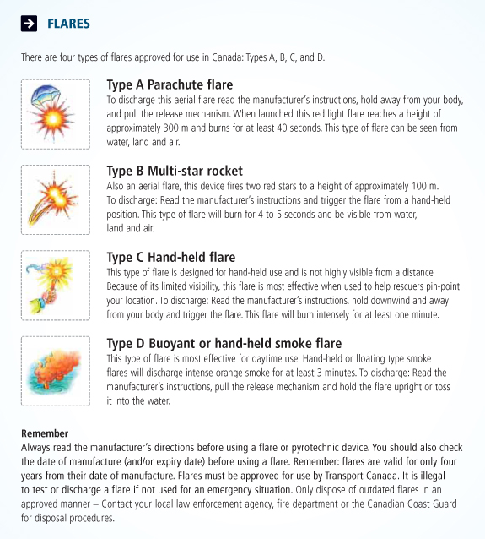

You can use a maritime VHF radio to signal distress:
- Use maritime VHF Channel 16 and repeat “Pan Pan” three times to signal the need for assistance
- Use Channel 16 and repeat “Mayday” three times to signal imminent danger and/or a life-threatening situation
- Once the appropriate distress signal is given, relay the following information:
- The name of your vessel
- Your position
- The nature of the emergency
- The type of assistance needed
Limitations of Cell Phones
While you can obtain search and rescue assistance from the nearest Canadian Coast Guard Marine Communications and Traffic Services (MCTS) centre by dialing *16 or #16 on a cell phone, a cell phone is not a good substitute for a marine radio – a maritime VHF radio is generally the best way of sending a distress alert.
- Cell phones can lose reception or get wet and damaged
- Calling from your cell phone does not alert nearby vessels that you are in distress
- Some cell signals cannot be traced back to your location by rescuers
- Not all cell providers offer the *16 and #16 service
You must obtain a maritime VHF/ROC Certificate to transmit using a maritime VHF radio in Canada. Courses and exams are administered by the Canadian Power & Sail Squadrons.
Code flags can be used to signal distress. Use either of
the following:
- The International Signal for Distress: Code flag “N” (November) flown above Code Flag “C” (Charlie)
- A square flag with a ball (or item resembling a ball) above or Below it
- A Distress cloth: a piece of orange-coloured material displaying a black square, identifiable from the air.
- You can also discharge a dye marker in the water around your vessel. The dye marker will colour the water around your vessel signalling your need for assistance.
- An Emergency Position Indicating Response Beacon (EPIRB) sends a distress signal via satellite to a monitoring center. The monitoring center can immediately dispatch assistance to the signal’s exact location. EPIRBs must be registered with the National Beacon Registry at 1-800-727-9414.
Other types of distress signals can be used to indicate the need for assistance. They are:
- A high intensity white light flashing 50 to 70 times per minute.
- A square shape (or arrangement of items resembling a square shape) positioned on your vessel or in the water near your vessel.
- Controlled flames showing onboard a vessel can also be used to signal distress. During daylight hours, choose a safe flammable substance (such as engine oil in a metal pan) to signal distress. Always use caution when using an open flame on board your craft.

