BOATING IN CANADA RULES AND REGULATIONS
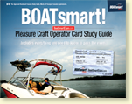

Boating In Canada
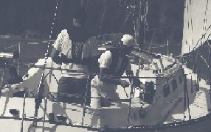
Recreational boating is a pastime that many of us enjoy. In fact, each year over 8 million boaters take to Canada’s waterways. Unfortunately, not all survive. The Canadian Red Cross and the Lifesaving Society of Canada report approximately 200 boating fatalities per year. Sadly, most of these deaths are preventable.
In addition more than 6,000 unreported non-fatal incidents occur every year. Many of these accidents are caused by a lack of basic boating knowledge and skill. By choosing to complete this study guide and obtain your Pleasure Craft Operator Card you have made the choice to increase boating safety and fun for all!
BACK TO TOP

It’s everyone’s responsibility
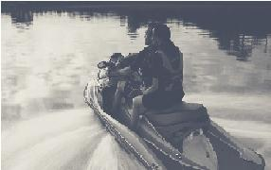
As a boater in Canada, you are expected to understand and obey the rules and regulations that apply on Canadian waterways. By using common sense and operating your craft in a safe and responsible manner, you’ll protect yourself, your passengers and your fellow boaters.
Canadian boat operators should understand and recognize the most common causes of on-water incidents and fatalities:
- Not wearing a Personal Flotation Device (PFD)
- Person overboard (falling overboard)
- Capsizing (sinking, swamping, grounding) and collisions with other vessels
- Operating a vessel while impaired by drugs or alcohol
BACK TO TOP

Operator training and certification
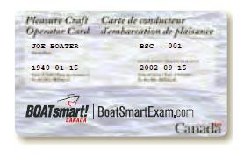
On April 1, 1999 the Canadian Coast Guard enacted the Competency of Operators Pleasure Craft Regulations. These regulations have been phased in over a ten year period and require that operators obtain a Pleasure Craft Operator Card. This law applies to all operators of powered vessels fitted with a motor, including Personal Watercraft (PWCs) and powered sailboats.

OPERATOR COMPETENCY

It’s the law
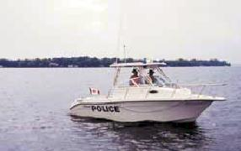
The Competency of Operators Pleasure Craft Regulations were established on January 15, 1999, pursuant to Section 562 of the Canada Shipping Act. The Regulations were set into force on April 1, 1999.
For more information on the Competency of Operators of Pleasure Craft Regulations, please contact:
BOATsmart! Canada
www.BoatSmartExam.com
1-877-792-3926
BACK TO TOP

As of september 15, 2009
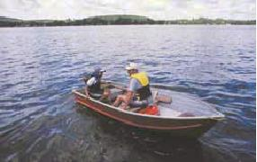
As of September 15, 2009 all operators of motorized vessels are required to carry proof of competency, such as a Pleasure Craft Operator Card, on board at all times. Proof of competency is required for all motorized vessels including Personal Watercraft (PWCs), powered sailboats and small vessels with electric trolling motors. There are no exemptions for motor type, length of boat or age of vessel operator.
Federal law requires your original Operator Card to be carried on board - A photocopy of your Pleasure Craft Operator Card is not acceptable. Replacement cards can be obtained from BOATsmart! Canada by calling toll free 1-877-792-3926 or visiting www.BoatSmartExam.com.
Non-residents
Pleasure craft operator competency requirements apply to all non-residents operating their non-Canadian or foreign-registered craft in Canadian waters for more than forty five consecutive days.
Proof of competency can include a Pleasure Craft Operator Card, approved Rental Boat Safety Checklist, an official Boating Safety Course Completion Card or a recognized Boating Safety Course Certificate issued prior to April 1, 1999.
BACK TO TOP

Safe boater training
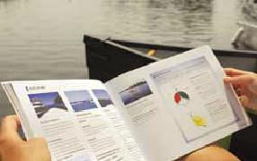
Boaters lacking in experience should take a boating safety course. A boating safety course is a valuable, life-saving tool that will:
- Teach you to be aware of the acts, code and regulations that govern actions on Canadian waterways
- Teach you how to respond in emergency situations
- Ensure you understand your responsibilities as a pleasure craft or PWC operator
- Teach you how to properly and safely operate your pleasure craft or PWC
To learn more about official boating safety courses and to find a course in your community visit www.BoatSmartExam.com or call 1-877-792-3926

COMPETENCY REQUIREMENTS

Proof of competency
You may be asked to provide proof of competency to local law enforcement agencies when operating on your local waterway. Proof of competency can take three forms:
- Proof of having taken a boating safety course in Canada prior to April 1, 1999 or have obtained an approved marine certificate*
- A Pleasure Craft Operator Card issued following the successful completion of a Transport Canada Accredited exam
- A completed rental-boat safety checklist (required for operating any rental boat propelled by an engine)
*If you have completed a boating safety course before April 1, 1999 or have obtained an approved marine certificate and have proof, then your course certificate or approved marine certificate may be accepted as proof of competency. Visit www.boatingsafety.gc.ca or call 1-800-267-6687 to learn more.
What if i don’t have proof of competency?
If you’re stopped by an enforcement officer, and you cannot provide proof of competency, you may be subject to a fine of up to $320.00. Certain provinces, such as Newfoundland, issue summary convictions up to $10,000.00.
BACK TO TOP

Obtaining a pleasure craft operator card
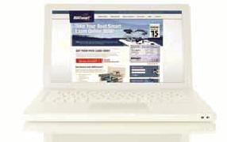
Boaters can obtain their Operator Card by achieving a mark of at least 75 percent on the BOATsmart! Canada Challenge Exam. Once obtained, your Pleasure Craft Operator Card is good for life.
Boaters can take the official exam online at: www.BoatSmartExam.com
For more information on official BOATsmart! Canada testing centres in your community contact BOATsmart! Canada toll free at 1-877-792-3926 or visit www.BoatSmartExam.com
Boaters in Canada are prohibited from operating a recreational vessel unless:
- The operator has proof of competency and proof of age on board
- The person is operating the pleasure craft under the supervision of an instructor
- The operator is not a resident of Canada and who’s pleasure craft is in Canada for less than 45 consecutive days (proof of residency is required)
BACK TO TOP

The operator card exam
The BOATsmart! Canada exam consists of multiple choice questions that are designed to test your boating knowledge and skill.
The exam must be completed within a 75 minute time limit and a passing grade of 75% or greater is required. Although it is strongly recommended, operators are not required to attend a boating safety course before attempting the exam.

AGE AND HORSEPOWER RESTRICTIONS

Age categories
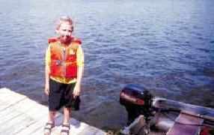
Less than 12 Years of Age
Boaters under 12 years of age that have obtained proof of competency can operate a boat without supervision* so long as the engine is not more than 10 hp. Operators under 12 years of age are NOT allowed to operate a PWC under any conditions.
Between 12 and under 16 years of age
Boaters 12 to 15 years of age that have obtained proof of competency can operate a boat without supervision* as long as the engine is not more than 40 hp. Operators 12 to 15 years of age are NOT allowed to operate a PWC under any conditions.
16 Years of age and older
Operators 16 years of age or older can operate a vessel without supervision and there are no horsepower restrictions. Operators 16 years of age and older are also allowed to operate a PWC provided they have obtained proof of competency.
*Boaters less than 16 years of age can operate any vessel other than a PWC if accompanied and directly supervised in the boat by someone 16 years of age or older.
BACK TO TOP

Supervision provisions
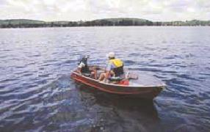
If an operator is accompanied and directly supervised in the pleasure craft by a person 16 years of age and older, the age and horsepower restrictions do not apply. However, any person that is operating the craft must have proof of competency on board.
Operators under 16 years of age are NOT permitted to operate a PWC even if supervised by an adult.
BACK TO TOP

Age and horsepower restrictions
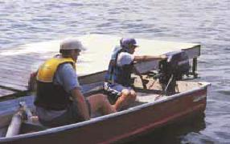
Age and Horsepower Restrictions restrict operators under 16 years of age from operating powerboats with certain size engines. Age and horsepower restrictions apply to three age categories:
- Less than 12 years of age
- Between 12 and under 16 years of age
- 16 years of age and older

VESSEL LICENSING AND REGISTRATION

What is a compliance label?
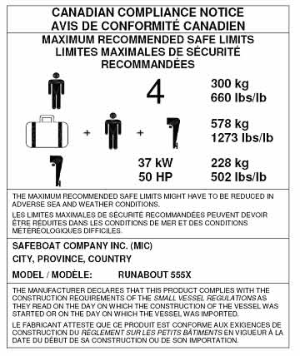
Transport Canada’s Construction Standards for Small Vessels specify how small vessels that are equipped with a motor, are up to 24 m in length and operate in Canada, must be built. A Compliance Notice is a statement from the manufacturer or importer that a vessel is built according to the construction requirements of the Small Vessel Regulations. If you plan to sell, import, build or rebuild such a vessel, you are required to make sure it meets these construction standards. Pleasure craft that meet these construction standards should be equipped with a Compliance Notice. Compliance Notices for pleasure craft up to 6 m in length also have information on recommended maximum safe limits in good weather. Compliance Notices can be a small metal plate or label affixed to the hull of your craft. Examples of Compliance Notices are depicted on this page.
Do I need one?
Canadian boating laws require that a Compliance Notice must be affixed to all pleasure craft propelled (or designed to be propelled) by a motor and that are built in or imported into Canada in order to be sold or operated in Canada, except pleasure craft 24 m and above. Owners of pleasure craft may obtain individual Compliance Notices from the original manufacturer. You also need a Compliance Notice in order to license or register your boat. For more information visit www.tc.gc.ca.
BACK TO TOP

What information is on a compliance label?
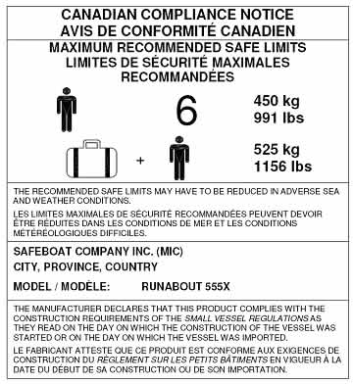
Compliance Notices for pleasure boats less than 6 m in length provide three important pieces of information:
- Recommended Gross Load Capacity: The maximum weight your boat is designed to carry including persons, motor, steering assembly, fuel, all equipment and gear.
- Recommended Safe Limits of Engine Power: Indicates the maximum limit of engine horsepower based on the vessel’s gross load capacity. The maximum engine size is indicated on the Compliance Notice.
- Maximum Number of Adults: The Compliance Label also indicates the maximum number of “equivalent adult persons” that your vessel can safely carry.
The Compliance Notice sets a maximum limit for each of these capacities based on safe operation in fair weather conditions. Loading your craft to maximum capacity may increase the likelihood of injury or emergency if you are forced to operate during adverse conditions. Be aware of and respect the limitations and handling characteristics of your craft. It is extremely hazardous to overload your boat.
Hull identification number
All pleasure craft made in Canada, or imported into Canada after August 1, 1981 (with or without a motor), must have a Hull Identification Number (HIN). A HIN helps to find lost or stolen boats and identify boats that are subject to a recall. A HIN is 12 digits long and no character of the HIN can less than 6 mm (1/4”) in height and width. The HIN must be permanently marked on the outside upper starboard corner of the transom or as close to that area as possible.
BACK TO TOP

Licensing your pleasure craft
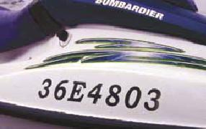
A Pleasure Craft License is the set of ID numbers displayed on your boat which can be used by Search and Rescue personnel to identify your vessel. A Pleasure Craft License is different than a Vessel Registration, which provides proof of ownership (legal title), a unique name and official number for your boat and the right to use your boat as security for a marine mortgage.
The Small Vessel Regulations require that all pleasure craft of all sizes equipped with one or more primary propulsion motors of 10 hp (7.5 KW) or more must be licensed, unless they are registered. The regulation applies to all boats mostly operated or kept in Canada. You can obtain a 10 year license for free from Service Canada. You must renew the license after the 10 year period has expired. If your boat is already licensed, you should make sure that it is in your name and that your contact information is up-to-date.
Transferring ownership
It is mandatory to report a change of name and address to the Service Canada Pleasure Craft Licensing Centre. If selling a pleasure craft, you must transfer ownership by signing the reverse side of your vessel license and providing it to the purchaser. The purchaser is obligated to complete and sign the reverse side of the vessel license and submit it to Service Canada for transfer within 90 days. An owner may operate the pleasure craft for 90 days after the date of change of name or address, if documents establishing the date of change of name or address are on board. Owner information must be kept up-to-date, including name and address changes.
Registering your pleasure craft
There are costs involved in registering your vessel, but if you plan to operate your boat in international waters registering you vessel provides the benefit of proof of ownership, in addition to the benefits noted above. In order to register you will be required to select at least 3 names for your vessel (of which one will be approved), pay a registration fee, complete an application for registry, produce evidence of ownership/title and statement of qualification for vessel registration, as well as have your vessel measured for tonnage. For more information about Pleasure Craft Licensing and registration visit www.boatingsafety.gc.ca or call 1-800-267-6687.

OPERATING RESPONSIBLY

What are my responsibilities?
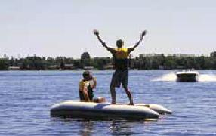
As a Canadian pleasure craft operator, you are expected to know the rules and regulations that govern Canada’s waterways. You are responsible for equipping yourself with the right equipment and for operating your boat in a safe and courteous manner. You are also responsible for ensuring the safety of your passengers and other boaters.
Safe Boating Tip
You are legally responsible for equipping yourself, your passengers and your boat properly. You are also responsible for operating your boat safely and ensuring the safety of those onboard. Boat operators and owners who do not comply with Canadian laws and regulations could be subject to fines and penalties.
BACK TO TOP

Drugs, alcohol and boating
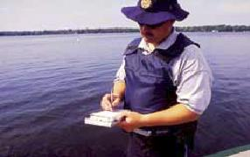
If you drink – don’t drive. The same applies whether you’re driving a car, a boat, a PWC or any other type of motorized vehicle. Consuming alcohol, drugs or other controlled substances can significantly impair your ability to safely operate your pleasure craft. Doing so will not only put your own life at risk, but will also risk the lives of your fellow boaters.
Operating a pleasure craft anywhere in Canada while impaired is an offence under Section 253 of the Criminal Code of Canada. Charges result in a criminal record and, even for the first offence, will result in significant fines. Most provinces have fines from $600 to $2,000 and can restrict your operation of any motorized vehicle for 6 months to 3 years. Offenders can also be sent to prison. In Ontario anyone found guilty of alcohol impairment while in command of a power vessel will lose their automobile driver's licence for a least a year.
Remember: Alcohol, drugs and boating don’t mix.
BACK TO TOP

Using common sense
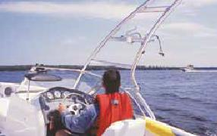
You are required by law to operate your craft in a safe and courteous manner. You should always choose a safe operating speed and use common sense, especially when operating close to shore. Consider the following when operating your craft:
- Your distance from shore
- Water and wind speed conditions
- Visibility conditions
- Local hazards and obstructions
- The amount of boat traffic in the vicinity
- Posted speed limits
- The handling characteristics and capabilities of your craft
- Your level of skill and experience
Almost all boating emergencies are preventable. In fact, most boating accidents are simply the result of a series of smaller things going wrong. Using common sense, such as wearing your personal flotation device instead of stowing it under a seat, can make all the difference.

OPERATING RESPONSIBLY

Instructing your passengers
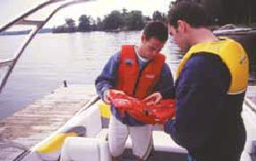
As a boat operator you are responsible for the safety of your passengers. You should explain what their responsibilities and duties are in the event of an emergency, and instruct them on safe behavior while underway.
Instruct your passengers on the following:
- How to operate the craft in case of emergency
- The location of the craft’s emergency kit
- How to rescue a person overboard
- How to properly use an approved PFD or Lifejacket
Be sure that your passengers understand they should:
- Always wear an approved PFD or Lifejacket
- Be aware that the effects of sunlight, motion, waves, wind and sound can impair their judgment
- Keep close to the centreline of the boat and as low as possible when moving around the boat
- Keep hands and feet inside the craft when departing or returning to the Dock
- Refrain from consuming alcohol while onboard
BACK TO TOP

Assisting fellow boaters in distress
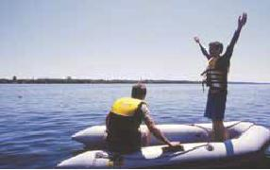
Pleasure craft operators are required by law to come to the aid of fellow boaters in distress:
- When operating your craft you are required to maintain a look-out for signals that indicate a fellow boater is in distress or need of assistance
- If you are involved in a collision, you are obligated by the Criminal Code of Canada to stop and offer assistance to the other boater
- If you identify any persons found at sea and in danger of being lost, your are required by the Canada Shipping Act 2001 to help that person, so long as it doesn’t put your own craft and passengers at risk
BACK TO TOP

Lending your pleasure craft or pwc
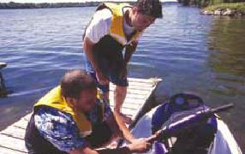
As a pleasure craft owner, both you and the person operating your boat are responsible any time you lend your pleasure craft or PWC. You should ensure that:
- The person borrowing your craft understands boating rules and is a responsible person
- The person borrowing your craft has a Pleasure Craft Operator Card
- He or she is wearing an approved PFD or Lifejacket
You should also review the following:
- Any local hazards or obstructions
- Navigation and right-of-way rules
- The location of safety equipment onboard your craft
- The handling characteristics of your craft

CODE, ACTS AND REGULATIONS

Code, acts and regulations
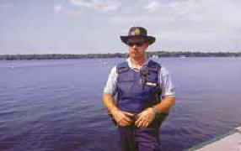
Several major acts and regulations govern pleasure craft operators in Canada and ensure the safe use and enjoyment of Canada’s waterways. Marine acts, regulations and code have the force of law and apply to all pleasure craft operators.
Canada’s boating regulations, acts and code are:
- The Criminal Code of Canada
- The Canada Shipping Act 2001, including the:
  - Small Vessel Regulations
  - Collision Regulations
  - Vessel Operation Restriction Regulations
  - Charts & Nautical Publications Regulations
  - Competency of Operators of Pleasure Craft Regulations
- The Contraventions Act
Violating Canada’s boating laws and regulations could not only cause personal and public injury, but can also result in fines, penalties and imprisonment.
BACK TO TOP

Canada Shipping Act 2001
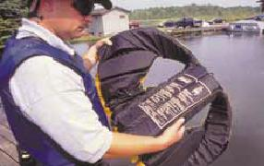
The main provisions for recreational boating in Canada are contained in the Canada Shipping Act 2001 and the Criminal Code of Canada.
Persons visiting from outside Canada and operating power-driven vessels licensed or rented in Canada are required to follow Canadian laws and regulations. When traveling abroad and operating pleasure craft licensed or registered in another country, Canadian citizens are required to obey the laws in the host country.
Boating laws change from time to time. As a safe boater, it’s your responsibility to make sure you have the most current information. Visit www.BoatSmartExam.com for links to the most up-to-date regulations.
The Royal Canadian Mounted Police (RCMP), provincial and municipal police forces and other authorized local authorities enforce the laws that apply to recreational boaters in Canada. Enforcement officers may inspect your vessel and monitor your activities to ensure that you’re carrying the proper safety equipment and operating your craft in a responsible manner.
BACK TO TOP

Canada Shipping Act 2001
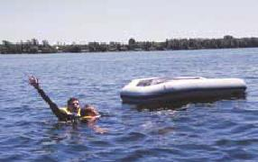
The Canada Shipping Act 2001 establishes a framework of rules and regulations and is the “umbrella” act under which all boating regulations are developed in Canada. It incorporates international and federal laws and regulates all vessels operating on Canadian waterways.
Safe Boating Tip
The Canada Shipping Act 2001 requires every pleasure craft operator to help other boaters in distress, so long as it does not put themselves, their passengers or their craft at risk.

CODE, ACTS AND REGULATIONS

Small vessel regulations
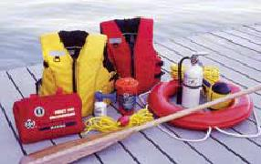
The Small Vessel Regulations outline the minimum mandatory safety equipment that must be aboard your boat, safety precautions to follow before and while boating and construction standards for building a pleasure craft. To be capable of saving your life, and to satisfy the regulations, your pleasure craft’s required safety equipment must be in good working order. As the owner or person entrusted by the owner, you are violating the Small Vessel Regulations if you operate a pleasure craft that does not have all the required equipment on board, or if it is not in good working order. The same applies if you loan it, you should check your vessel and safety equipment before every trip. The Small Vessel Regulations apply to five key areas, including: Construction Standards, Safe Operating Rules, Required Safety Equipment, Required Maintenance and Registration and Licensing.
Safe Boating Tip
The offence “Careless Operation of a Vessel” is part of the Small Vessel Regulations. This means no person shall operate a small vessel in a careless manner, without proper care and attention, or without reasonable consideration for other persons.
BACK TO TOP

Charts and nautical publications regulations
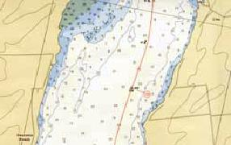
Charts and nautical publications provide the information necessary in order to safely navigate Canada’s lakes, rivers and waterways. Marine charts are a “road map” of Canadian waterways, indicating safe navigation routes, the location of markers, buoys and local hazards. Marine publications and documents include “Notices to Mariners”, “Sailing Directions” and “Tide Tables”. The Charts and Nautical Publications Regulations require that pleasure craft operators have onboard at all times the most recent editions of:
- The largest scale charts for the area that they navigate
- The required publications for the area that they navigate
- The required documents for the area that they navigate
Marine Charts are published by the Canadian Hydrographic Service, Department of Fisheries and Oceans and are available for purchase at your local marine dealer or on the internet.
BACK TO TOP

Vessel operation restriction regulations
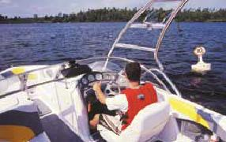
The Vessel Operation Restriction Regulations impose standardized speed limits and shoreline speed zones. The regulations also limit where certain types of boats may or may not be permitted to operate in Canada. Many of the regulations contained within the Vessel Operation Restriction Regulations are local in nature. Boaters should check locally for speed restrictions and Vessel Operation Restriction Regulations for detailed information on speed restrictions.
Boaters are responsible to be knowledgeable of waterway restrictions and to respect the Vessel Operation Restriction Regulations when boating in Canada. Boaters should always abide by both posted and un-posted speed limits and be aware of universal shoreline speed limits that may be in effect. Various provinces including Ontario, Manitoba, Saskatchewan, Alberta and British Columbia, have universal shoreline speed restrictions. These un-posted restrictions require boaters to operate at 10km or less when 30m or closer to any shoreline. Boaters should check locally for speed restrictions and Vessel Operation Restriction Regulations for detailed information on speed restrictions.

CODE, ACTS AND REGULATIONS

Contraventions act
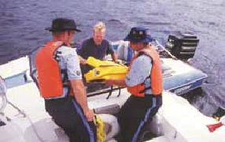
The Contraventions Act enables local authorities to write tickets for offences that result in a fine but not a criminal record. Examples include:
- Disregarding speed limits
- Careless operation
- Operating without the prescribed safety equipment
Typically, fines under the Contraventions Act range between $100 and $200. Fines depend on the type of infraction and the number of violations. You should check with local authorities to determine how the Contraventions Act is applied in your province.
For example
Most local law enforcement agencies have adopted a zero tolerance policy when determining fines when it comes to each person onboard not having a Canadian approved PFD or Lifejacket that is an appropriate fit and in good condition. In participating provinces, this contravention could cost you over $200 for each violation! Fines* for the most common offenses include:
- Operating a vessel in a careless manner: $250
- Speeding: $100
- Boating without your Operator Card: $250
*Not including administrative charges.
BACK TO TOP

Collision regulations
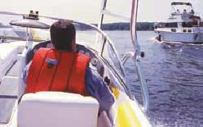
The Collision Regulations stipulate the rules preventing collisions on the high seas and inland waterways. As such, the Collision Regulations govern the following:
- Navigation
- Right-of-way rules
- Look-out rules
Safe Boating Tip
The Collision Regulations, Rule 5 requires that all pleasure craft operators must maintain a proper look-out by both sight and hearing at all times.
BACK TO TOP

Criminal code of canada
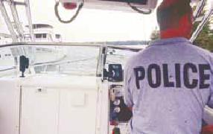
The Criminal Code of Canada enables law enforcement authorities to charge boat operators for criminal offences. For example the Criminal Code of Canada:
- Requires that a pleasure craft operator must stop and offer assistance to another craft when he/she has been involved in a collision
- Prohibits vessels from being operated in a manner that is dangerous to the public
- Prohibits false emergency signals or messages
- Prohibits operators from interfering with marine signals and navigation aids
- Requires that a person other than the operator must keep watch of any person being towed (such as a water-skier)
- Prohibits the towing of water-skiers after dark or before sunrise
- Prohibits the operation of a vessel which is known to be in unseaworthy condition
- Prohibits the operation of a vessel while under the influence of drugs, alcohol or controlled substances

BOATING AND ALCOHOL

Boating and Alcohol
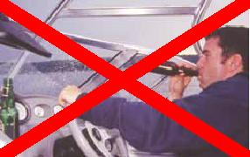
Unfortunately, drinking and boating is still a significant concern on Canadian waterways. In fact, alcohol is a factor in more than 40% of boating related fatalities.
Safe Boating Tip
There’s no excuse: You should never consume alcohol while boating. Always keep the "Water on the Water and the Beer on the Pier!”
Alcohol can have a number of negative effects:
- Diminished judgment and ability to process information - If you are operating a boat, being impaired by alcohol will make you less attentive
- Slower reaction and reflex response times
- Reduced motor skills, peripheral vision and balance, putting you at greater risk of falling overboard
- Poorer depth perception, vision and focus
- Inner ear disturbances, which makes it harder to distinguish the water surface if you fall in
- Accelerated hypothermia, since alcohol lowers the body’s resistance to cold
BACK TO TOP

Boating and alcohol What Are The Risks?
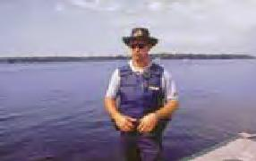
1.Drinking and boating is a criminal offence
Operating a vessel anywhere in Canada while impaired is illegal and is an offence under the Criminal Code of Canada. It is illegal to operate a vessel in Canada with a blood alcohol concentration in excess of 0.08 mg. It is also a criminal offence to fail or refuse to comply with a demand from an enforcement officer to submit a blood sample, which can be punishable by fines and penalties. Enforcement officers have the power to request ID, ask for proof of competency, ask pertinent questions and go on board.
If you’re caught operating a boat while currently prohibited for a previous drinking and boating offence you may be additionally charged. At minimum you can be prohibited from operating a motor vehicle for a minimum of one year for the first offence.
2. Fines and penalties
Convictions, even for the first offence, may result in heavy punishment. Persons who commit an offence are subject to penalties and fines. Not only can you be charged for impaired operation of a vessel, you can also be charged if you are just having a drink while operating a vessel.
3. Consuming alcohol
Provinces and territories have their own rules that determine when alcohol can be consumed or how it can be transported onboard a boat. For example, in Ontario, alcohol can only be consumed under the following conditions:
- On a vessel with permanent sleeping accommodations and permanent cooking and sanitary facilities
- While the boat is at anchor or is secured to the Dock or land
4. Transporting alcohol
It is illegal to transport alcohol on a vessel unless the alcohol is in a container that is unopened and the seal unbroken, or unless the alcohol is packaged in baggage that is fastened closed, or is not otherwise readily available to anyone in the vessel. In a boat, beverage alcohol and alcohol containers must be stored in a closed compartment.
5. Boater fatigue
Boater fatigue is a combination of the hot sun, wind and noise, vibration and boat motion that can quadruple the effects of alcohol on boaters. In other words, the effects of alcohol are up to 4 times greater when on a boat than when on land. Alcohol also slows your swallowing and breathing reflexes, making you more likely to drown if you fall overboard.
6. Alcohol and dehydration
Alcohol contributes to dehydration. Heat and sun can cause boaters to become dehydrated as the body tries to cool itself by sweating. If you’re dehydrated you will feel the effects of alcohol more quickly. Even mildly dehydrated people will absorb alcohol more quickly into their system and will have a higher blood alcohol concentration than a non-dehydrated person. Another concern with dehydration occurs when a person falls overboard: Dehydration causes the body to lose fluids which can lead to stomach cramps while attempting to swim and stay above water. Consuming alcohol and not wearing a Lifejacket or PFD can be a deadly combination.

Summary
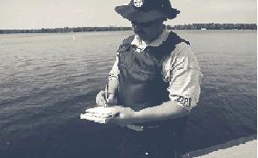
Canadian boating rules and regulations have been implemented to protect the safety of pleasure craft operators and to establish operating and navigation standards to which all boaters must comply. All pleasure craft operators in Canada are obligated to learn and abide by Canadian boating rules and regulations.
Use courtesy and common sense when operating your craft. You should always come to the aid of fellow boaters who need help, so long as you don’t put yourself at risk. By taking the time and care to operate your craft in a safe and responsible manner you’ll reduce the burden on Canada’s search and rescue organizations and increase safe and enjoyable boating for all!
For in-depth information on Canadian boating rules and regulations and text copies of each of legislation please contact the Office of Boating Safety at 1-800-267-6687.

THE BASICS

Who is the “operator”?
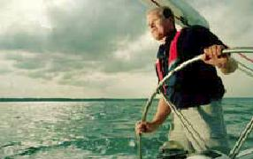
A boat “operator” is considered to be the person who is in control of the pleasure craft and who is responsible for its operation. As a pleasure craft operator you are responsible for yourself, your passengers, your vessel and for the safety of your fellow boaters.
BACK TO TOP

What is a pleasure craft?
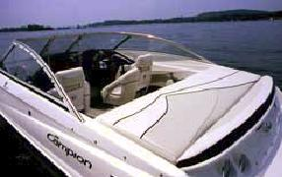
A “pleasure craft” is any vessel, ship, boat or other type of watercraft that is used exclusively for pleasure or recreation.
If the craft carries goods or passengers for hire, payment, reward or profit it is considered to be a commercial craft. Crafts used for commercial purposes are subject to different rules and regulations.
BACK TO TOP

What is a power-driven craft?
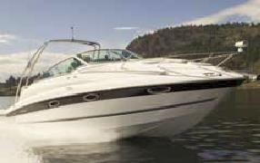
Any vessel propelled by a motor or propelling machinery is considered to be a power-driven craft. This definition includes pleasure sailing craft operating under the power of a motor.
Safe Boating Tip
Boaters are required to know the difference between “power-driven” craft, “sail-powered craft” and “non-powered” craft. Different navigation and equipment rules apply for each type of craft. Navigation rules for each type of craft are covered in Module 5.

THE BASICS

What is a sailing vessel?
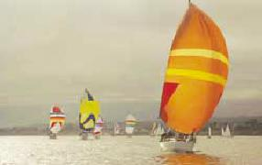
The Small Vessel Regulations defines a pleasure sailing craft (sailboat) as any vessel that is under the power of sail. Sailboats operating with an engine or propelling machinery are considered to be motorized vessels and are subject to the navigation rules and regulations that apply to “power-driven” craft.
BACK TO TOP

What is a personal watercraft?
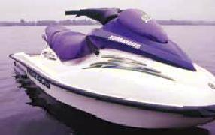
Personal Watercraft (PWCs) are equipped with an inboard engine and are propelled by an internal jet-propulsion system. Because of their size and method of propulsion, PWCs have unique handling characteristics when compared to traditional motorized craft. For example, you cannot steer a PWC unless throttle power is applied.
BACK TO TOP

The hull
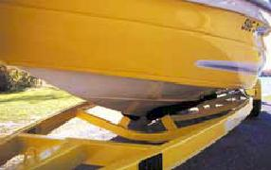
The “hull” is considered to be the portion of the boat that rides both in and on top of the water. The hull does not include any masts, sails, rigging, machinery or equipment. Several types of hulls can be found on both powerboats and sailing craft:
- A Planing Hull is designed to lift (or “plane”) onto the surface of the water as the boat gains speed. Most small powerboats use planing type hulls.
- A Displacement Hull is designed to travel through the water using propulsion. Larger vessels are typically designed with Displacement Hulls because of their size.
- A Pontoon Hull utilizes two or more pontoons to create lift and flotation. Pontoon hulls typically have flat decks and may be fitted with or without a cabin.

BOATING TERMINOLOGY

2.2.1 - Hull styles
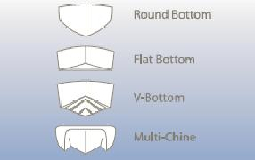
The shape or configuration of a boat’s hull greatly affects its performance. Operators should be able to identify the design of a hull and recognize the unique handling characteristics of each:
- Round-Bottom: Typical to sailboats and canoes, round-bottom hulls are not as stable and tend to “roll” in waves. You should be cautious when loading, entering and exiting a round bottom boat as it may roll easily.
- Flat-Bottom: These vessels are generally designed for slow speeds and calm water. Flat bottom boats tend to be less stable than other hull types in rough water.
- Deep “V” Bottom: The most common type of power-boat hull, these boats move through rough water at higher speeds and have a smoother ride than flat bottom or round bottom boats.
- Multi-Chine Hull: Multi-hull craft, such as catamarans, are very stable but can be more difficult to manoeuvre.
BACK TO TOP

Definitions
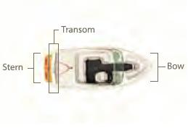
Bow
The forward part or front section of a boat is called the “Bow”.
Stern
The rearward part or rear section of a boat is called the “stern”.
Transom
The “transom” is the stern cross-section of the boat. Port To the left side of the pleasure craft when in the boat looking forward.
Port
To the left side of the pleasure craft when in the boat
looking forward.
Starboard
To the right side of the pleasure craft when in the boat looking forward.
Waterline
In respect of a pleasure craft, means the waterline at the recommended maximum gross load capacity.
BACK TO TOP

Definitions
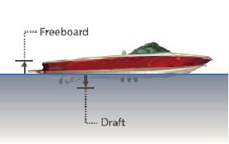
Draft
Draft is defined as the depth of water that a boat needs in order to float freely. A boat’s Draft is measured as the distance from the waterline to the lowest point of the hull. If a vessel is equipped with an outboard motor or stern drive, the Draft is the distance from the waterline to the lowest point on the engine.
Freeboard
Freeboard is the distance from the waterline to the lowest point on the Deck or “topside” of the hull

BOATING TERMINOLOGY

Definitions
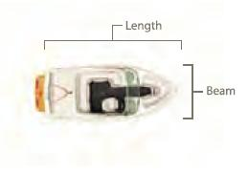
Length
A boat’s length is defined as the distance from the tip of the Bow to the farthest point on the stern (measured in a straight line). If the boat is equipped with a swim platform it is not considered to be part of the boat’s overall length.
Beam
A boat’s Beam is the width of a boat at its widest point.
BACK TO TOP

Outboard engine
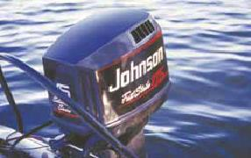
An outboard engine is fixed to the transom (stern) of a boat. The operator steers the craft by moving the entire engine and drive assembly. Outboard engines come in a variety of engine sizes and configurations.
BACK TO TOP

Inboard/outboard engine
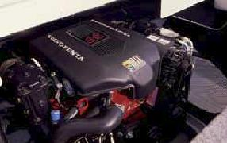
An “inboard/outboard” engine is mounted within the hull of the craft. The lower unit, which consists of the propeller and drive assembly, is mounted on the transom at the stern of the craft. In an “inboard/ outboard” configuration, the operator steers the craft by moving the lower unit left or right.
Inboard engines
An “inboard” engine is one where the motor and a significant portion of the drive assembly are mounted within the hull of the craft. With this design, only the propeller and propeller shaft extend outside the hull. The operator steers the craft by moving a rudder which is affixed at the stern of the craft behind the propeller. Many popular wakeboard style boats use “inboard” engines.

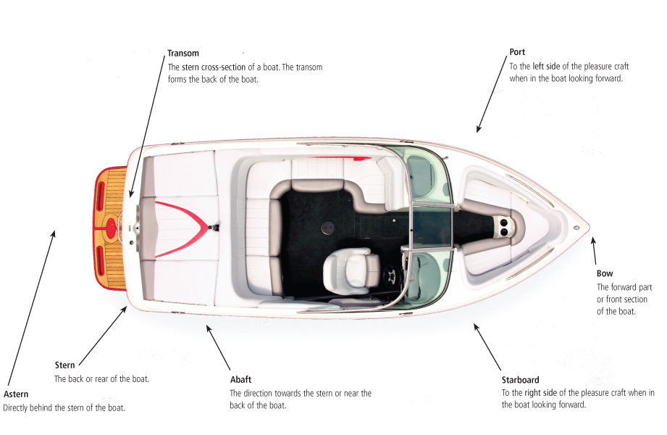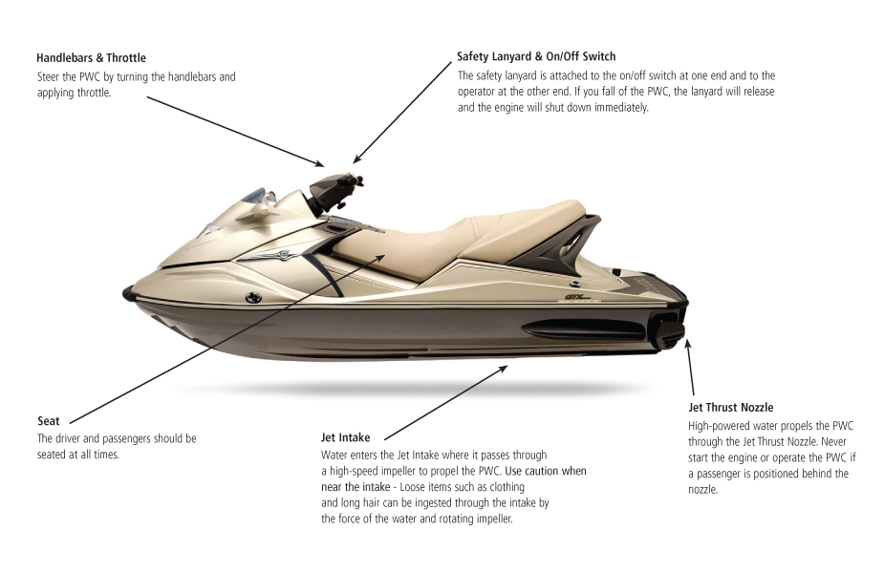PERSONAL SAFETY EQUIPMENT

Safety equipment
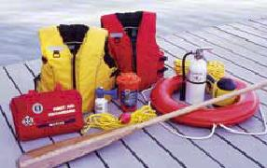
The Small Vessel Regulations require that certain safety equipment be carried onboard at all times. The type of equipment required varies according to the type and size of craft being operated (specific requirements are listed in Appendix A).
The Small Vessel Regulations also require that safety equipment carried on board must be in good working order and be maintained and be replaced in accordance with the manufacturer’s instructions (including maintenance of fire extinguishers to ensure they are fully charged) so that equipment functions properly when needed. All safety equipment should be stored in a location on board the craft where it is readily accessible for immediate use.
There are four types of safety equipment required for operation on Canadian waterways: Personal Safety Equipment; Boat Safety Equipment; Distress Equipment; and Navigation Equipment.
Safe Boating Tip
The right safety equipment provides peace of mind - And if something goes wrong, it can save a life. Make sure your equipment is working properly, is easily accessible and can be operated by everyone onboard.
BACK TO TOP

Personal safety equipment
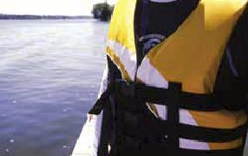
Boaters are required to carry personal safety equipment onboard at all times. This equipment includes:
- Personal Flotation Devices (PFDs) & Lifejackets
- Buoyant Heaving Line
- Emergency Kit
Safe Boating Tip
More than 90 percent of all persons who drown while boating were not wearing a personal flotation device. Remember: Your flotation device only works if you wear it! PFDs should be worn by ALL boaters in and around water - not just when operating or riding in a vessel.
BACK TO TOP

Approved flotation devices
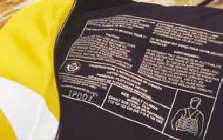
Wearing an approved, properly fitted flotation device greatly reduces the risk of accidental drowning. In fact, Canadian Coast Guard statistics show that boaters wearing an approved flotation device are 5.5 times less likely to drown. Pleasure craft operators and their passengers should wear an approved Personal Flotation Device or Lifejacket at all times while onboard a boat.
There are three main types of flotation devices approved for use in Canada:
- Lifejackets
- Personal Flotation Devices (PFDs)
- Inflatable PFDs
Flotation devices should bear a label or stamp indicating approval by Transport Canada. PFDs can also be approved by the Canadian Coast Guard. The approved status of Lifejackets and PFDs is void if the flotation device has been damaged, altered, or repaired or if the label or stamp indicating approval is illegible. If ripped or damaged, they should be replaced immediately.

PERSONAL SAFETY EQUIPMENT

Lifejackets
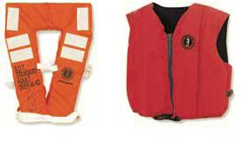
Lifejackets can be found in both “Standard” and “Small Vessel” styles, and are typically bulkier and more uncomfortable than Personal Flotation Devices. Manufactured with increased flotation in the front of the jacket, Lifejackets are designed to turn an unconscious person face up in the water.
- SOLAS (Safety Of Life At Sea) Lifejackets offer the best performance and will turn an unconscious person face up and out of the water in seconds.
- Standard Lifejackets feature a high degree of buoyancy and turning ability but are typically uncomfortable.
- Similar in design, Small Vessel Lifejackets are also designed to turn an unconscious person face up but are not as buoyant and have less turning ability.
All Lifejackets are red, orange or yellow in color and are available in both adult and youth sizes. Lifejackets should be fitted to the size of person wearing the device. Both Standard and Small Vessel Lifejackets are reversible and feature a “keyhole” or “vest” design.
Lifejackets should fit slightly loosely in order to allow water under the front of the jacket so that it can function properly. All zippers, fasteners, buckles and straps should be adjusted to ensure a proper fit. Be sure to choose a Lifejacket that has been approved for use in Canada.
BACK TO TOP

Personal flotation devices
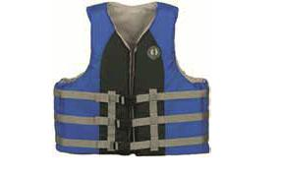
Personal Flotation Devices (PFDs) are more comfortable and less restrictive than Lifejackets. PFDs are designed to keep a person afloat but are NOT designed to turn an unconscious person face up in the water. As such, they are not as safe as
Lifejackets.
PFDs come in keyhole, vest, coat and coverall designs. Child, youth and adult sizes are available and should be fitted to the size of the person wearing the device.
Safe Boating Tip
More than 90 percent of all persons who drown while boating were not wearing a personal flotation device. Remember: Your flotation device only works if you wear it! PFDs should be worn by ALL boaters in and around water - not just when operating or riding in a vessel.
Personal Flotation Devices (PFDs) should fit snugly but not restrict the free movement of arms and legs. Lifejackets should fit slightly loosely in order to allow water under the front of the jacket so that it can function properly. All zippers, fasteners, buckles and straps should be adjusted to ensure a proper fit.
BACK TO TOP

Inflatable pfds
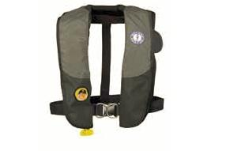
Some PFDs are inflatable – A carbon dioxide cartridge is used to inflate the PFD. Once inflated, the PFD is able to keep a person afloat. Inflatable PFDs are becoming more popular because they allow for unrestricted movement and are more comfortable in hot weather. Inflatable PFDs come in various styles including waist pouches and vests and those that automatically inflate, versus more basic styles that require manual inflation.
Keep the following in mind:
- Inflatable PFDs are only approved for use by persons 16 years or older that weigh more than 36 kilograms
- Inflatable PFDs must be worn at all times while on deck or in the cockpit of an open vessel
- Inflatable must be readily available to persons below deck on vessels equipped with cabins
- Inflatable PFDs are not approved for use on Personal Watercraft (PWCs) or white water activities

PERSONAL SAFETY EQUIPMENT

Making the right choice
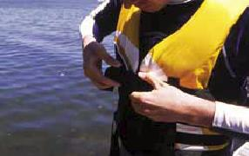
When choosing a PFD or Lifejacket, you should consider the following:
- Choose a PFD or Lifejacket that suits the type of activities for which it will be required
- Check the label or stamp and confirm the PFD or Lifejacket has been approved for use in Canada
- Verify that the PFD or Lifejacket is appropriate for your size and weight
- Check that it fits snugly but allows for freedom of movement
- If purchasing a PFD or Lifejacket for another person, ensure that it meets the criteria for that person
Safe Boating Tip
If you are in a smaller open vessel (such as a small fishing boat), other boaters may find it difficult to see you. Choosing a brightly coloured flotation device will help make you more visible to others.
BACK TO TOP

Children’s pfds and lifejackets
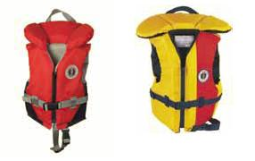
Many Lifejackets, although certified for use, may not properly protect a child and/or float them face up. Choose a PFD or Lifejacket that has been specifically designed for use by children to ensure their safety.
A children’s PFD / Lifejacket should have the following:
- A label or stamp indicating that it has been approved for use in Canada
- An extra large collar to support the child’s head
- A safety strap that fastens between the legs to prevent the jacket from slipping over the child’s head
- A grab strap located on the collar
- Reflective material and a safety whistle
Children should be encouraged to wear a PFD or Lifejacket at all times - both on the boat and when they are near the water. Be sure that children understand how to properly fit and use their PFD or Lifejacket.
The PFD or Lifejacket should always be properly fitted to the child. Never try and make do with a flotation device that is “close” to the right size and never purchase a larger size than appropriate in the hope that the child will “grow into it”.
Safe Boating Tip
A child's head is heavier than his/her body, and this uneven weight distribution means he/she will not float well in a face-up position and may panic easily. Also, diapers, when wet, will adversely affect the performance of flotation devices.
Remember
A PFD or Lifejacket should never be used as a substitute for adult supervision.
BACK TO TOP

Testing pfds and lifejackets
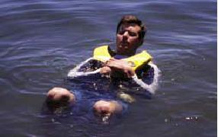
PFDs and Lifejackets should be tested for buoyancy at the start of each season and on a regular basis throughout the season. To test a PFD and/or Lifejacket, perform the following procedure:
- Put on and properly fit the PFD or Lifejacket
- Wade into chest deep water
- Bend your knees and float onto your back
- Ensure the PFD or Lifejacket keeps your chin above the water and permits proper breathing
Safe Boating Tip
Even though your flotation device has a label indicating that it is approved for use in Canada you should still test it - even if it is new. By testing your flotation device on a regular basis you’ll be sure it will keep you afloat when you need it most.
Children should also test their PFDs and/or Lifejackets to ensure proper fit and buoyancy. Have your child follow the same procedures as above in a controlled environment under parental supervision.

PERSONAL SAFETY EQUIPMENT

Proper care and maintenance
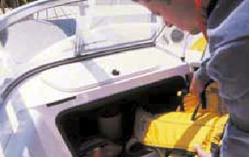
PFDs and Lifejackets are designed to save lives. As one of the most important pieces of safety equipment onboard your craft, they should be maintained and cared for as follows:
- PFDs & Lifejackets should never be used as cushions, bumpers or Fenders. They may become damaged and less effective in an emergency.
- PFDs & Lifejackets should be air dried out of direct sunlight and away from a direct heat source.
- When not in use PFDs & Lifejackets should be stowed onboard your craft in a dry, well ventilated area.
- Store PFDs & Lifejackets in a location that is easily accessible by both the operator and passengers - and never in the proximity of gasoline or chemicals.
- Inspect your PFDs & Lifejackets regularly. If ripped or damaged, they should be replaced immediately.
BACK TO TOP

Cleaning pfds and lifejackets
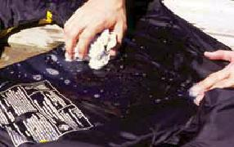
Keeping your flotation device clean will prolong its useful life and save you money. To clean a PFD or Lifejacket:
- Use mild soap and water
- Rinse thoroughly
- Never dry-clean or use strong detergents, gasoline, or chemicals/solvents
- Air dry out of direct sunlight and away from direct heat sources
BACK TO TOP

Putting on a flotation device in the water
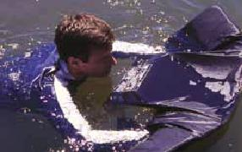
Practice the following procedure for putting on your flotation device while in the water:
- Find a supervised area in which to practice the procedure
- Spread the flotation device open with the inside facing up and out of the water and the neck facing towards you
- Extend your arms through the arm openings
- Lift your arms above your head
- Lie backwards and pull the flotation device around your upper body
- Fasten the zipper, straps, buckles and/or ties to ensure a snug fit
Remember
Although you should know the procedure for putting on a PFD or Lifejacket in the water, it is highly recommended that you wear an approved PFD or Lifejacket at all times while onboard your pleasure craft. If you find yourself in an emergency situation while not wearing a PFD or Lifejacket, you may be putting yourself at risk of injury or death.

PERSONAL SAFETY EQUIPMENT

Buoyant heaving line
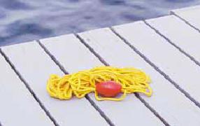
A Buoyant Heaving Line is equipped with a buoy or float at one end. It is designed to be thrown to a person who has fallen overboard or is in the water and in need of help:
- The Small Vessel Regulations require that Buoyant Heaving Lines be at least 15 m in length and be appropriate to the size of your vessel.
- Some Buoyant Heaving Lines are light and therefore can be difficult to throw longer distances. You should practice throwing a Buoyant Heaving Line before an emergency situation arises.
- Using a water safety throw equipped with a throw container (a weighted plastic shell at one end) will enable you to throw the line with less difficulty and ensure it does not become tangled. Choose a water safety throw that has an integrated handle, is brightly coloured and easy to grasp.
- A Buoyant Heaving Line should be readily accessible in case of emergency.
BACK TO TOP

Emergency kit
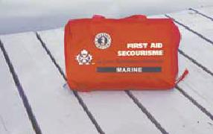
Pleasure craft operators should carry an emergency safety kit onboard at all times. The kit should be stored in a watertight plastic bag and be easily accessible in case of emergency. The kit should include:
- Emergency rations
- Drinking water
- A First Aid kit
- Waterproof matches
- A waterproof flashlight
- A knife
- A whistle
- Dry clothing

BOAT SAFETY EQUIPMENT

Boat safety equipment
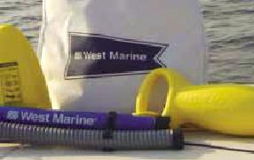
You are required to carry boat safety equipment on your vessel at all times. Different sizes and types of boats are required to carry different equipment. Refer to Appendix A for a complete list of required equipment for your craft. Boat safety equipment includes:
- Bailing Devices
- Manual and Electric Bilge Pumps
- Anchor
- Manual Propelling Devices (Oars / Paddles)
- Axe
- Repair Kit
- Life Ring
- Fire Extinguisher
- Re-boarding Device
Safe Boating Tip
Would you be able to find your boating safety equipment in an emergency? It’s a good idea to store all your safety equipment in a duffle bag or container. Keeping it together and accessible ensures you’ll find it when you need it most!
BACK TO TOP

Bailing device
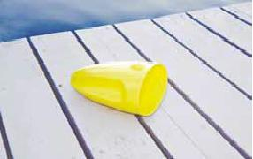
A bailing device is used to remove water from inside a boat:
- Bailing devices are usually home-made plastic or metal scoops
- A bailing device can be made from cutting the top off a bleach bottle
- The Small Vessel Regulations require that bailers have a volume of at least 750 ml and an opening that is at least 65 cm2 in area, and be made of plastic or metal
- Purpose-built bailing devices can also be purchased from your local marine retailer, and are more effective than home-made devices
Buckets
If operating a powered craft 12 m in length and longer, you are required to carry a minimum of 2 buckets each with a 10L minimum capacity. If operating a powered craft over 20 m in length, you are required to carry a minimum of 4 buckets, each with a 10L minimum capacity. Buckets can be used to fight fires and dispel water from your craft, and should be fitted with a lanyard of sufficient length to reach the water from the location in which it is stored.
BACK TO TOP

Manual and electric bilge pumps
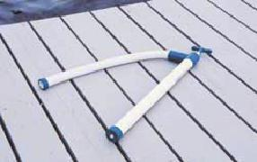
Manual Bilge pumps
Similar in look to a bicycle pump, a manual Bilge pump utilizes a pumping chamber, a water intake hose (or chamber) and a discharge hose to dispel water. If using a manual pump, you must ensure the discharge hose is long enough to reach from the bilge to over the side of your boat.
Electric Bilge pumps
Some pleasure craft are fitted with electric Bilge pumps. Typically located in the engine compartment and controlled from the pleasure craft’s Cockpit, electric Bilge pumps are designed to remove water from the hull of a vessel. Certain models are equipped with an automatic switch and turn on automatically if the water level in the Bilge begins to rise. Even if your vessel is equipped with an electric Bilge pump, you should always carry a manual pump or bailing device as a back-up.

BOAT SAFETY EQUIPMENT

Anchor
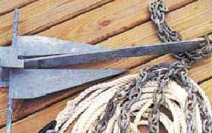
If operating a pleasure craft 9 m in length or longer you are required to carry an anchor. An anchor can be used to secure your boat in case of a breakdown or anchorage due to poor weather.
Anchors are available in various styles and types:
- “Fisherman” anchors are a non-burying type with one arm that penetrates the bottom.
- Fluke anchors have two large flat services that bury into the bottom and once set well can provide a significant amount of holding force.
- Plough anchors function like a farmer’s plough and typically work well in all types of bottoms, although they are harder to set.
- “Bruce” or Claw anchors are popular for small boats and are similar in design to plough anchors but set more easily. They also tend to not release easily due to changes in wind and tide.
Choosing the right anchor depends on the size and weight of your boat and the characteristics of the waterway bottom (i.e. sand, rock, mud). Boaters should refer to manufacturers' recommendations for anchor styles and weights. Larger anchors are recommended for adverse conditions and those equipped with a shackle pin should have a locking device.
The Small Vessel Regulations require that an anchor be fitted with at least 15, 30 or 50 m of cable, rope or chain in any combination. The length depends on the size of your vessel.
Remember
The inboard end of the Anchor Line should be securely fastened to the Bow of your craft. The outboard end of the Anchor Line should be securely fastened to the anchor.
BACK TO TOP

Manual propelling device
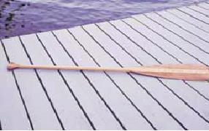
Manual propelling devices, such as oars or paddles, can be used to manoeuvre your craft in the case of a breakdown. Most vessels are required to carry paddles or oars with oar locks. If operating a vessel less than 8m in length you may use an anchor with a minimum of 15 m of rope, cable or chain in place of a paddle or manual propelling device.
BACK TO TOP

Axe
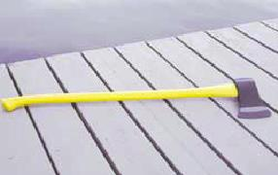
Those operating large vessels (longer than 12 m in length) must carry at least one axe onboard at all times. An effective fire-fighting tool, an axe can be used to chop into a wall that is concealing open flames. An axe can also be used to cut a towline in an emergency. A vessel that sinks while it is being towed can bring down the towing vessel along with it. An axe can be used to cut the tow line and prevent the towing vessel from sinking.
Spiked axes are preferred and should be readily accessible in case of emergency. Do not leave an axe exposed to the elements.

BOAT SAFETY EQUIPMENT

Repair kit
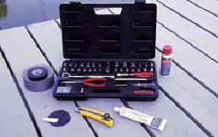
Although not considered to be mandatory equipment, boaters should always carry a repair kit including essential tools and spare parts. Tapered wooden plugs, underwater sealing compounds, patch kits and duct tape can all be used to stop hull leaks. In addition, a basic toolset including wrenches, sockets and driver, spare nuts and bolts, cotter-pins and spare spark plugs should be carried onboard at all times. Ensure that tools and spark plugs are the appropriate size for your craft.
BACK TO TOP

Life ring
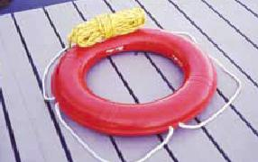
A life ring (sometimes called a life buoy) is a circular shaped device that can be used to rescue a person who has fallen overboard.
The ring must be circular in shape, have an outside diameter of either 610 mm or 762 mm, and carry a sticker indicating that it has been approved by Transport Canada. A life ring must be at attached to a line of at least 15 m in length and be appropriate to the size of your vessel. To be approved, a life ring must have no tears, perforations or rot and the gridlines must be secure and in good condition.
BACK TO TOP

Re-boarding equipment
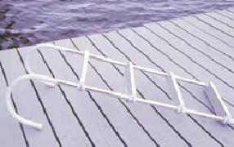
A re-boarding device, such as a ladder, is designed to allow easy re-boarding of your vessel from the water. The Small Vessel Regulations require that all craft carry an effective re-boarding device if the freeboard of the craft is greater than 0.5 m.
Suitable re-boarding devices include:
- A portable ladder
- A built-in transom or swim platform ladder
- A sling
- A rope
- A qualified re-boarding device cannot be part of the propulsion unit
- Re-boarding devices should be appropriate to the size of the vessel

DISTRESS EQUIPMENT

Fire extinguisher
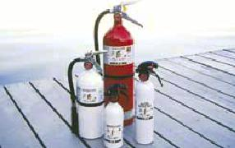
Fire extinguishers are required onboard any vessels with a motor and any one of the following:
- Closed compartments where portable fuel tanks may be stored
- Closed living and cooking spaces
- Permanently installed fuel tanks
- Enclosed engine compartments
Though not all motorboats are required to carry a fire extinguisher, it is highly recommended that a fire extinguisher be carried on all boats. Boaters should mount a fire extinguisher in an easily accessible location where it can be quickly retrieved in case of emergency.
Safe Boating Tip
Fire extinguishers must be approved by the Underwriters Laboratories of Canada (ULC), the Underwriters Laboratory (UL), or the US Coast Guard (USCG).
BACK TO TOP

Requirements
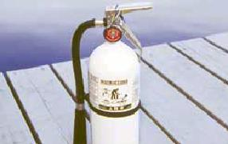
Extinguisher Rating System:
Fire extinguishers are rated using a system of letters and numbers:
- Class A: Designed for use on combustible solid materials such as wood and paper
- Class B: Designed for use on combustible liquid fires including gas, oil and grease
- Class C: Designed for use on electrical fires
The number preceding the letter designation identifies the size of fire the extinguisher is capable of putting out. For example, a Class 3 extinguisher can extinguish a larger fire than a Class 2 extinguisher, and so on.
The Small Vessel Regulations require that Class BC extinguishers be used on pleasure craft in Canada. However, the use of a Class ABC fire extinguisher is recommended. Ensure that the fire extinguisher you choose meets the requirements for the size and type of your craft. (See “Required Safety Equipment”). Even if your craft is equipped with an automatic extinguishing system, you must carry the required portable extinguishers.
SAFE BOATING TIP
Fire extinguishers must be approved by the Underwriters Laboratories of Canada (ULC), the Underwriters Laboratory (UL), or the US Coast Guard (USCG).
BACK TO TOP

Flares
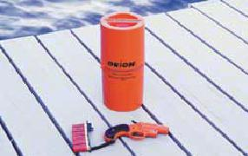
Flares and pyrotechnic devices are used to signal distress and need of assistance.
You may be required to carry certain types of Flares onboard depending on the size and type of craft and the body of water in which you are operating. For example, you are required to carry Flares if operating in any ocean or if operating in a waterway where you may be farther than 1 mile from shore.
You are not required to carry flares if you are operating on a river, canal or lake on which at no time your vessel can be more than one nautical mile from shore.
Flares should always be stored in a watertight container and located in a cool, dry area easily accessible in case of emergency.

DISTRESS EQUIPMENT

Using flares
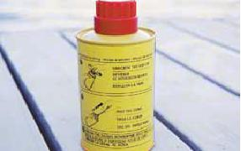
All flares and pyrotechnic distress signals must be approved for use by Transport Canada and are valid for only four years from their date of manufacture. Flares or other pyrotechnic devices are explosive – they should always be used with caution and kept out of the reach of children. Always follow the manufacturer’s instructions located on the packaging or casing before using a Flare or pyrotechnic device.
It is illegal to test or discharge a Flare if it is not being used for an emergency situation. Only dispose of Flare in an approved manner – Contact your local law enforcement agency, fire department or the Canadian Coast Guard for disposal procedures.
Safe Boating Tip
Always check the date of manufacture and read the manufacturer’s instructions before using a flare.
BACK TO TOP

Types of approved flares
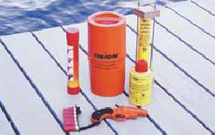
There are four types of flares approved to signal your need for help:
1) Type A: Parachute Flare
- Easily seen from water, land and air
- Must emit a red light
2) Type B: Multi-star Flare
- Easily seen from water, land and air
- Must emit a red light
3) Type C: Hand-held Flare
- Not as easily seen from afar but effective for marking your position
- Must emit a red light
4) Type D: Smoke Flare
- Highly visible during daylight hours
- Must give off orange smoke
BACK TO TOP

Watertight flashlight
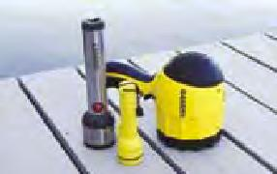
Most vessels are required to carry at least one watertight flashlight onboard at all times. In an emergency, a flashlight can be used as an illuminating device or to send a distress signal. Batteries must be in good condition in order for the flashlight to be recognized as an approved piece of boating safety equipment.
Safe Boating Tip
You can signal distress or your need for help by flashing SOS - Three short flashes, then three long flashes, followed by three short flashes. In addition, a watertight flashlight qualifies as navigation lights on non-powered vessels as wells as sailboats less than 7m in length.

NAVIGATION EQUIPMENT

Sound-signalling devices and appliances
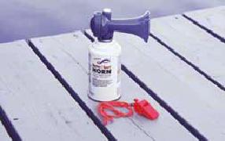
Sound-signalling devices serve several important functions:
- To signal distress or your need of assistance
- To alert other boats of your position in poor visibility
- For navigation purposes
Boaters should be aware that various sound signals exist to attract attention and indicate a vessel’s intention which can include altering course to port and starboard; departing a dock; using astern propulsion; when at anchor and during periods of restricted visibility, such as fog and snow. For more information on various sound signals please see Module 4, 5 and 7.
The Small Vessel Regulations require that all vessels carry some form of sound-signalling device such as a whistle or horn. Approved sound-signalling devices and appliances must be audible for a minimum of 0.93 km.
Types of sound-signalling devices include:
- Mechanical (floatless) whistle
- Horn
- Portable compressed-air horns
- Bell
Pleasure craft less than 12 m in length are required to carry at least one sound-signalling device or other means of making an efficient sound signal. Refer to Appendix A to determine the type and quantity of sound-signalling devices and appliances required for your size of craft.
Safe Boating Tip
It’s good practice to attach a Fox 40 floatless whistle to your PFD or Lifejacket and those of your passengers. By doing so, you’ll be able to signal for help if you become stranded in the water.
Sound-Signalling Devices vs Appliances
A sound-signalling device can be a pealess whistle, compressed gas horn or an electric horn. Pleasure craft 12m or greater in length must have a fitted whistle which is considered to be a sound-signalling appliance. Boats over 20m must also be fitted with a bell. Check the Collision Regulations for the technical standards these appliances must meet. The bell may be replaced by other equipment having the same respective sound characteristics, provided that manual sounding of the prescribed signals shall always be possible.
BACK TO TOP

Navigation lights
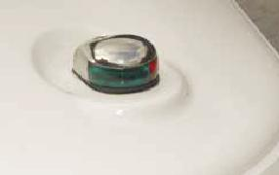
Navigation lights are essential for operating during periods of restricted visibility or at night. Navigation lights make your craft visible from all angles and must be displayed one hour prior to sunset and remain on until one hour after sunrise. Navigation lights should also be exhibited during periods of reduced visibility such as during fog or heavy rain conditions.
Non-powered craft
If your craft is unable to display navigation lights and you are operating during nighttime (or during a period of reduced visibility), then you must have a watertight flashlight, lantern, or spotlight (emitting a white light) ready for use in order to signal your location to other craft, and prevent a collision.
Safe Boating Tip
Before heading out on the water, check the condition of your flashlight and its batteries. Make sure you’ve got fresh batteries and your flashlight is ready to use!
BACK TO TOP

Passive radar reflector
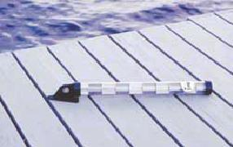
A passive radar reflector is a metallic device that is used to identify the position of your boat to other vessels equipped with radar. A radar reflector must be mounted on vessels that are less than 20 m in length and are constructed of non-metallic materials (such as fibreglass). The passive radar reflector should be mounted or suspended at least 4 m above the waterline.
A passive radar reflector is NOT required if:
- You are operating on a waterway where no other vessels are using radar
- It is impractical to mount on your vessel
- Traffic conditions are limited
- You are operating during daylight hours
- You are operating in good weather conditions and calm waters
- If the use of radar reflector is not essential for safe operation of your craft
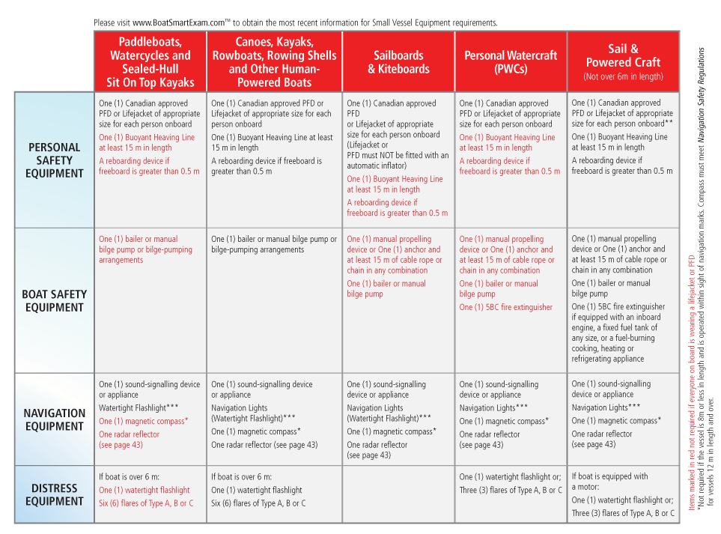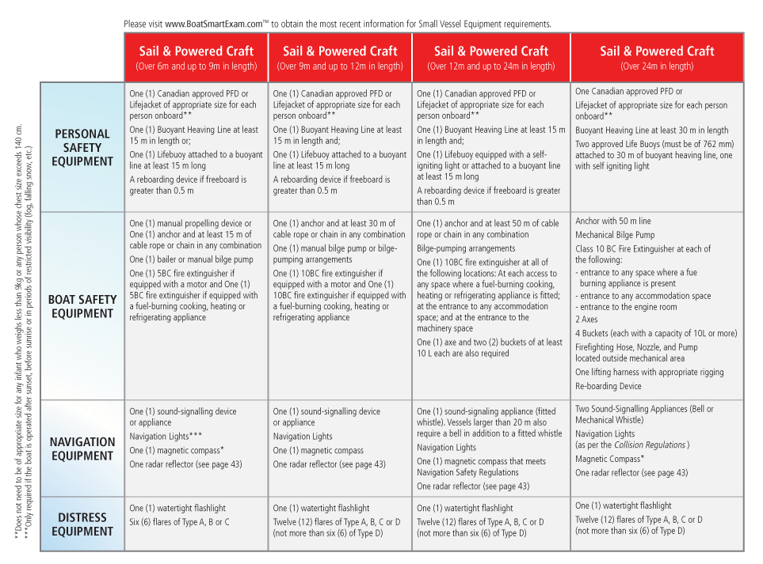BoatSmartExam.com / Study Guide / Module 2 Boating Basics Terminology and Equipment - Summary
You're logged in as: Anna Ashley

STUDY GUIDE COMPLETED
MODULE 2 BOATING BASICS TERMINOLOGY AND EQUIPMENT COMPLETED

SUMMARY

2.10.1 - Summary
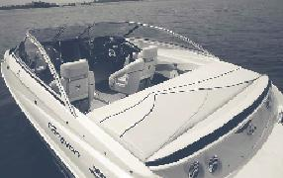
Being familiar with your boating safety equipment and knowing how to use it properly are the first steps in boating safely.You should be able to recognize the different types of craft that operate on Canada’s waterways and understand the limits and handling characteristics of each.
Having the required safety equipment onboard at all times will enable you to respond effectively in emergency situations. Be sure to maintain and store safety equipment properly so it is readily accessible and working properly when you most need it. Always wear an approved PFD or Lifejacket and ensure your passengers do the same.
Remember: Carrying the right safety equipment is not only the law, it can save your life!

MAINTENANCE

Maintaining your craft
There’s nothing more enjoyable than a day on the water. Don’t let it get spoiled by a breakdown. As a responsible boater, you should always plan Ahead. Take care to properly maintain your vessel and equipment. You should also inspect your boat and equipment on a regular basis and become familiar with basic repairs. Doing so will ensure your safety and
that of your passengers.
Being properly prepared and maintaining your equipment will also alleviate unnecessary burden on search and rescue organizations such as the Canadian Coast Guard. You’ll also save time and money by reducing the chance of costly breakdowns.
Remember
The Criminal Code of Canada requires that you maintain your boat and equipment in seaworthy condition. It’s the law.
BACK TO TOP

Pre-season maintenance
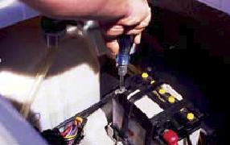
Use the following as a checklist for pre-season maintenance:
- Check the hull and Bilge for any damage includingcracks and leaks
- Check the condition and operation of the outdrive, including:
- Shafts
- Propellers
- Prop
- Nuts and pins
- Check the operation and condition of all systems including:
- Fuel, electrical and cooling systems
- Check the condition of hoses and lines and replace worn, broken or cracked lines
- Check the condition of the throttle control
- Check all electrical connections - Clean and tighten any corroded or loose connections
- Check the condition of all navigation lights
- Inspect and clean the engine’s flame arrestor with soap and water
- Check and replace engine oil if necessary
- Check and replace air and fuel filters if necessary
- With the engine running, check the operation of all gauges and alternator for charging capacity
- Check the condition of the battery. (A fully charged battery should hold its charge for 24 hours)
If unfamiliar with maintenance procedures, you should take your boat to an authorized marine dealer for service.
BACK TO TOP

Winterization and storage
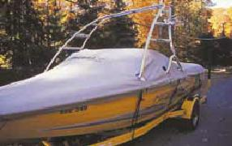
When preparing to winterize your craft be certain to read your owner’s manual. If you are unsure of the appropriate winterization procedure for your type of boat, visit your local marine dealer for advice and service. The following is an overview of winterization and storage procedures:
- Use an environmentally-friendly marine detergent or algae remover to clean the hull of your craft. Empty the Bilge of any excess water and clean it using soap and water (or a marine-grade Bilge cleaner). Cleaning the hull and bilge will remove any dirt, oil, fuel or marine life that may damage the hull over prolonged exposure.
- Drain and flush the engine’s cooling system.
- Drain the engine’s fuel system.
- Clean (or replace) the fuel filter.
- Remove the spark plugs and fog the engine cylinders with a rust inhibitor.
- Lubricate all moving parts.
- Clean off any excess grease, lubrication, dirt or marine life.

TRANSPORTING YOUR CRAFT

Transporting your boat
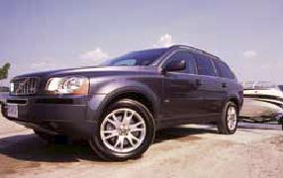
Transporting your boat safely isn’t difficult - It’s a matter of choosing the right towing equipment, using common sense when loading and unloading your craft and knowing the techniques for driving safely with a trailer.
When choosing a trailer there are a few things you should consider. Be sure to select a trailer that will properly support the weight and size of your boat. Your trailer must also meet provincial and local laws with respect to licensing, registration and operating lights.
Safe Boating Tip
Towing and launching your boat safely takes both patience and know how. Be familiar with the proper techniques for safe towing, and practice driving and backing up in a controlled environment before out on the road.
BACK TO TOP

Choosing a trailer
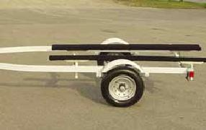
First assess which style of trailer best suits your needs:
Bunk style
A bunk style trailer uses two or more bunks (typically constructed from wood) to hold and support the weight of the craft. Bunk style trailers are best used for small boats and PWCs. However, bunk style trailers can be difficult to use on shallow boat ramps. The bunks must be fully submerged in order to properly launch or retrieve your craft.
Roller style
A roller style trailer uses a series of rollers to hold and support the weight of the craft. Roller style trailers can be used for all types and sizes of craft with well constructed, deep-V fibreglass or welded aluminum hulls. Roller style trailers are easier to use on shallow boat ramps.
BACK TO TOP

The right choice
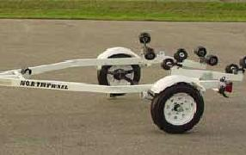
Once you have determined which style of trailer is right for your needs, consider the following:
- Is the width and length of the trailer suitable for the width and length of your craft?
- Is the weight capacity of the trailer suitable for the weight of your craft? The weight of the boat (including the engine and all fixed equipment) should not exceed 80% of the trailer’s weight capacity. The remaining 20% of load capacity should be reserved for equipment and fuel.
- Do all the operating lights work properly?
- Are the wheel bearings properly greased and able to operate smoothly?
- Does the coupler (located at the front end of the trailer) match the size of your vehicle’s hitch ball?
- Is the trailer equipped with mandatory “closed-loop” safety chains?

TRANSPORTING YOUR CRAFT

Additional considerations
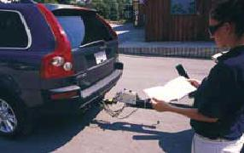
Vehicle capacity
The towing capacity of your vehicle should be considered before trailering any craft. Check your owner’s manual to determine the manufacturer’s recommended gross towing weight for your vehicle. The gross towing weight is the maximum weight you can safely tow and includes the weight of the craft, the engine, the trailer, and all fuel and equipment that is loaded in the boat. The maximum gross trailer weight and the tongue load should not exceed that specified by the vehicle’s manufacturer.
Trailer brakes
Every provincial jurisdiction has its own laws pertaining to trailer brake requirements. For example, some provinces allow towing up to 50% of the net weight of the tow vehicle before brakes are required. Check with local and provincial authorities to determine if your trailer needs to be fitted with trailer brakes.
Trailer hitch
In order to use a trailer, your vehicle must be fitted with a trailer hitch. The hitch should be installed by a reputable dealer and should be suitable for both your vehicle and size and type of trailer. Ensure your hitch is equipped with a ball that matches the size of coupler on your trailer.
BACK TO TOP

Towing your craft
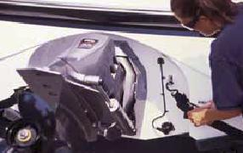
Attaching the trailer to your vehicle:
- Before attaching the trailer to the vehicle, ensure that the trailer is properly balanced (See “Weight Distribution and Driving” current page).
- Position the vehicle or trailer so that the hitch ball is directly below the trailer’s coupler and lower the trailer.
- Securely fasten the tongue latch and lock the trailer coupler using a cotter pin or lock.
- Using tie down straps, securely fasten the boat to the trailer.
- Attach the winch cable and/or winch safety chain to the Bow eye of the boat (if so equipped).
- Ensure that the trailer’s safety chains are securely fastened to the hitch. Chains should be long enough to accommodate tight turns but short enough so that the tongue of the trailer cannot touch the road if it becomes dislodged from the hitch.
- Fasten the trailer’s lighting harness to your vehicle.
BACK TO TOP

Weight distribution and driving
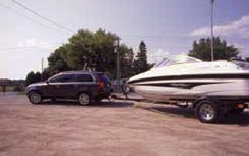
Establishing a proper hitch weight is essential for safe trailering. As a rule of thumb, 5-10% of the total loaded weight should be on the tongue. Too light of weight will result in "fish-tailing" (swaying from side to side). Too much tongue weight could exceed the trailer hitch specifications and may affect the handling or your vehicle. Adjust the tongue weight by shifting equipment in the boat, or move the position of the winch on the trailer (which will position the boat closer to the front or farther to the rear of the trailer). Depending on the trailer, the axles may also be moved to adjust weight
distribution.
Always be aware of the added length and weight of the trailer when driving:
- Accelerate slowly
- Turn using a wider radius to allow for the trailer
- Drive at a slower speed than normal
- Allow for greater braking distance
- Use extra caution if driving conditions are impaired by environmental factors such as high wind, heavy rain, fog or icy conditions

TRANSPORTING YOUR CRAFT

Launching your craft
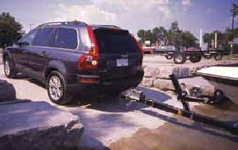
When launching your boat:
1. Make a visual check of the launch area:
- Is the ramp deep enough to launch your craft?
- Are there any overhead wires or obstructions?
2. Remove all tie-down straps and unplug the trailer lights from your vehicle
3. Ensure the Bilge drain plug is properly installed
4. Put all gear and safety equipment onboard the craft
5. Ensure the winch is connected to the Bow of the craft
6. Attach a Bow and stern line to the craft
7. Slowly back the trailer into the water until the motor becomes submerged
8. Test the operation of the motor by starting it and allowing it to warm up
9. Shut down the motor and continue backing the trailer into the water until the boat begins to float
10. Use the Bow and stern lines to guide the boat off the trailer - Remove the vehicle from the ramp
BACK TO TOP

Loading your craft
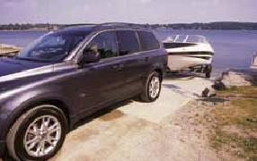
- Secure the boat at the Dock
- Back the trailer into the water until it is two-thirds submerged
- Turn off your vehicle and engage the emergency brake
- Position the boat on the trailer using the Bow and stern lines - Do not drive your boat onto the trailer
- Attach the winch line to the Bow-eye of your boat
- Pull the boat up onto the trailer using the winch
- Ensure the boat is properly seated and balanced on the bunks or rollers
- Once the boat is in position, lock the winch and attach the winch’s safety chain (if so equipped)
- Remove your vehicle and trailer from the ramp
- Once parked, attach the trailer lights and ensure they are working properly
- Remove the boat’s Bilge drain plug
- Secure the boat using tie-down straps (secure to the transom) before departing
BACK TO TOP

Trailering Tips
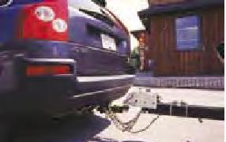
1 Weight distribution
All trailers tow best when they are level. Because most of the weight on a trailer is over its axles, a boat will generally sit level without gear in it. When loading gear, be sure to distribute weight evenly and secure gear so that it will not shift during driving.
2 Safety chains
Trailers are equipped with safety chains that attach the tongue to the trailer hitch. When attaching the trailer to your vehicle you should cross the chains to form a cradle. If the coupler becomes dislodged from the hitchball, it will drop into the cradle and not drag on the pavement.
3 Driving with a trailer
Keep in mind that you’re driving a vehicle that’s much longer and heavier than it was before. You’ll notice reduced acceleration, longer stopping distances, and blind spots in your mirrors. When driving with a trailer you’ll also have to use a much wider turning radius. The wider turning radius becomes evident when rounding sharp corners. Your trailer will not turn in the same arc as the tow vehicle. You’ll need to make a much wider swing to avoid curbs, road signs etc. Also be aware of the extra length required when changing lanes or passing. Watch your mirrors closely to make sure there’s enough room to move over, and always use your indicators.
4 Braking
Give yourself plenty of braking room when towing, especially on downhill grades. Always remember to keep your distance. Look farther ahead than usual and anticipate your and others’ actions. When towing, your stopping distance will increase significantly. Don’t tailgate. Also be aware that after retrieving a boat from the launch ramp the trailer brakes will be wet, temporarily reducing their effectiveness.
5 Backing up
Backing up a trailer can be challenging. The best advice is to plan ahead and limit the amount of backing up you will have to do. Leave yourself plenty of room, and if you have to turn while backing up, back to your left side (driver’s side) if possible. This way you’ll be better able to see the trailer’s movements.
Remember: The trailer will go in the opposite direction of the tow vehicle when backing up.
Techniques for Backing Up
Place one hand at the bottom of the steering wheel. Watch your mirrors. Move slowly. If you want the trailer to move right, move your steering hand to the right. If you want the trailer to move left, move your hand to the left. Use your side mirrors to position the trailer. An alternative method is to turn so that you can see through the rear window and watch the trailer. Try both methods and decide which is most comfortable for you.
Always back up slowly
The faster you go, the more difficult it becomes. Another tip to remember when backing up: If the trailer heads in the wrong direction, stop, pull ahead and try again. This is much easier than trying to correct your mistake, which leads to a zigzag
pattern that is difficult to manage.

UNDERSTANDING LOCAL HAZARDS

Knowledge of local waterways
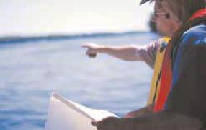
Safe boating is more than just a matter of operating your craft in a responsible manner. Knowing the waterways on which you’re traveling and being able to locate potential hazards is also vital for your safety.
You can refer to a Marine Chart or Nautical Publication to determine the location of waterway hazards for the area in which you will be operating. You can also talk to local operators and marinas who are familiar with the waters to gain valuable insight. Ask about specific hazards that you may encounter and any dangers that should be avoided. You should also determine the location of any ports of assistance in case of emergency.
Operators should check navigational references, such as marine charts, to determine the location of safe harbours or shelter that can serve as safe havens in the event of foul weather. Places of shelter can include marked areas for mooring, bays and docakge areas protected by breakwaters.
BACK TO TOP

Understanding local hazards
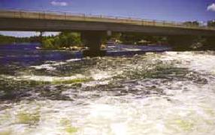
Before out on the water you should familiarize yourself with any local water hazards or dangerous conditions that may impede the safe operation of your craft. Failing to do so could increase the risk of injury or loss of life to you and your passengers.
Local water hazards can include:
- Low head dams
- Rapids
- Currents
- White water
- Tides
- Sudden winds
- Overhead cables
- Underwater cables
- Bridges
- Rapid build-up of high wave conditions
BACK TO TOP

Using marine charts and nautical publications
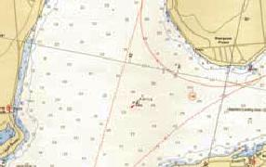
A marine Chart is a map of a body of water. Charts are primarily used to aid in navigation. Charts depict:
- Depth
- Underwater Hazards
- Location and character of charted shipping routes
- Aids to Navigation including lights, buoys and markers
- Traffic routes
- Adjacent coastal areas and landmarks around a body of water
- Navigational hazards
- Places to take shelter in the event of foul weather
The Charts and Nautical Publications Regulations require that operators carry the latest and largest scale versions of the following:
- Local Marine Charts
- The Required Publications and Documents (Such as “Current Atlases” and “Tide Tables”) You may be exempt from these requirements if your vessel is under 100 tons and powered by oars, or if you have substantial knowledge of the local waterway. Marine Charts and Nautical Publications are published by the Canadian Hydrographic Service.

UNDERSTANDING LOCAL HAZARDS

Marine charts and nautical publications
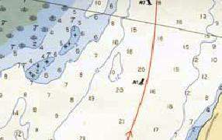
In order to navigate safely on Canada’s waterways, every boater should know:
- How to use a Compass along with marine Charts
- How to plot a Course using a marine Chart
- Positioning methods
- How to locate and reference navigational aids on a marine Chart
- How to properly use his/her electronic navigation equipment
Boaters should refer to marine charts for local hazards that may impede the safe operation of a boat. Boat operators should check Chart #1: Symbols, Abbreviations and Terms to check the meaning of underwater hazard symbols that may be depicted on marine charts. You should also check navigational references and publications (including tide tables) for water levels, times of low, slack and high tides and the direction of water flow. Marine charts and tide tables are published by the Canadian Hydrographic Services (CHS). More information can be obtained from the CHS at www.tides.gc.ca or 1-877-775-0790. If carrying nautical charts on board they must be updated with information from Notices to Mariners available from CHS.
BACK TO TOP

Topographic maps
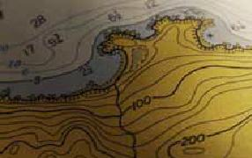
In some cases, topographic maps can be useful to pleasure craft operators. Topographic maps depict natural and artificial features on land and include illustrations of shoreline contours, rocks, elevations and land features or hazards near or above the waterline.
In some instances, such as when a nautical Chart or publication is unavailable for a body of water, topographic maps may aid in the navigation of local waterways. However, topographic maps are intended primarily for use on land by the general public. They do not depict underwater hazards, marine Aids to Navigation, channels or anchorage areas. Topographic maps are published by Natural Resources Canada and other provincial authorities.
BACK TO TOP

Using a compass
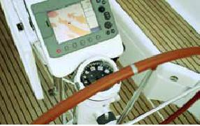
You can use a magnetic Compass to determine your direction and your position on a marine chart. Be wary when using a Compass – A magnetic compass can be affected when in the proximity of metallic and electrical devices and may provide false information.
Certain types of vessels engaged in a foreign voyage may require the use of a magnetic Compass. Please refer to the Navigation Safety Regulations, Part 2-3 for specific requirements.
Using a Marine GPS device
Marine GPS (Global Positioning System) devices can be used to identify your location. Some of today’s systems are able to pinpoint your position to within several feet. Marine GPS devices are becoming a popular tool with boating enthusiasts.
Marine charts and nautical publications now available in electronic format can be used in conjunction with the Marine GPS systems to offer the boater an extremely high degree of navigation certainty. Be sure to familiarize yourself with your Marine GPS system and practice using it before heading out on the water. Marine GPS systems can provide your location - but you should always carry printed marine charts as a back-up in the event your Marine GPS system fails.
Keep in mind that Marine GPS systems may only be accurate to within 30 m and automotive GPS will not provide the information you need on the water.

WEATHER

Local forecasts
Understanding weather and water conditions is vital to boating safely. You should always check the local weather forecast to obtain current, relevant information before out on the water. Operating your vessel without prior knowledge of potential weather hazards may put your vessel and passengers at risk. Local forecasts are available from:
- Local newspaper
- Local radio
- Television weather forecast
- Radiotelephone
- The Meteorological Service of Canada
- www.weatheroffice.ec.gc.ca
VHF?weather forecasts
Environment Canada provides marine weather forecastson the following frequencies:
Atlantic coast and Great Lakes
VHF Channel 21B, 25B and 83B
Pacific coast
VHF Channel 21B and Wx1, 2, 3
Continuous weather broadcast information is availableby telephone at (604) 666-3655 (Vancouver Region)
BACK TO TOP

Wind
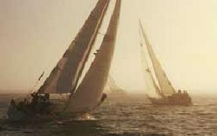
The Meteorological Service of Canada classifies all wind speed and weather warnings in Canada. The service has identified five categories of wind conditions that are defined in terms of their wind speed and the water conditions they create. Wind speed is measured in knots – One knot is equivalent to 1.85 km/h.
PERSONAL WEATHER OBSERVATIONS
In addition to checking the weather before you head out, you can use personal observations to monitor changing weather conditions:
- Keep an eye to the sky: Fog, dark clouds and lightning are obvious indications that bad weather is approaching
- Barometric readings: A rising barometer indicates fair weather, while a falling barometer indicates foul weather
- Pay particular attention to shifts in wind direction and temperature - both indicate that weather is changing
- Be mindful of the West: Foul weather usually approaches out of the West; however storms from the East tend to be more powerful
- Be vigilant of other boaters' movements and monitor radio and weather channels frequently - Ask for recommendations via radio if in unfamiliar waters
BACK TO TOP

Light winds
Light winds are defined as “Winds with a wind speed less than 12 knots (22 km/h)” and water surface conditions that are calm or have waves up to 1.5 m in height. Light wind conditions are suitable for most vessels and those operators with a moderate level of
boating experience.

WEATHER

Moderate winds
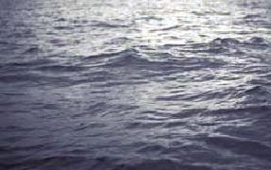
Moderate winds are defined as “Winds with a wind speed of 12 to 19 knots (22 to 35 km/h)” and water surface conditions that are rough with waves from 1 to 3 m in height. Inexperienced operators or vessels under 6 m in length should not operate during such conditions.
Operators of small vessels caught in a moderate winds advisory should attempt to cross waves at a 45° angle until sheltered waters are found. Ensure all passengers are wearing approved flotation devices.
BACK TO TOP

Strong winds and small craft warnings
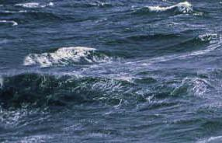
Strong winds are defined as “Winds with sustainedwind speeds in the range of 20 to 33 knots (37 to 61 km/h).” Water surface conditions during a strong winds advisory are very rough with waves 3 to 6 m in height. Environment Canada issues a Small Craft Warning when winds reach such levels. It is not safe to operate a pleasure craft under these conditions.
Operators of vessels caught in a strong winds advisory or small craft warning should take immediate action to ensure their safety. Turn on all navigation lights and attempt to cross waves at a 45° angle until sheltered waters are found. Reduce speed and proceed with caution, keeping a look-out for approaching boats and floating debris. If wind and wave conditions make it difficult to proceed, attempt to anchor your vessel until the storm subsides. Ensure all passengers are wearing approved flotation devices and keep passengers low in the boat and near the centreline.
BACK TO TOP

Gale warning
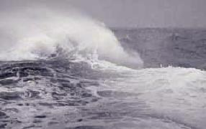
Gale winds are defined as “Winds with a continuous speed of 34 to 47 knots (63 to 87 km/h)”. Water surface conditions during a Gale Warning are extremely rough with waves 6 to 9 m in height. During such conditions, Environment Canada will issue a gterm 2387. It is not safe to operate a pleasure craft under these conditions.
Operators of vessels caught in a Gale Warning advisory should take immediate action to ensure their safety. Turn on all navigation lights and attempt to cross waves at a 45° angle until sheltered waters are found. Reduce speed and proceed with caution, keeping a look-out for approaching boats and floating debris. If wind and wave conditions make it difficult to proceed, attempt to anchor your vessel until the storm subsides.
Ensure all passengers are wearing approved flotation devices and keep passengers low in the boat and near the centerline. If your boat is taking on water, pump out bilges to keep the boat high in the water. Use an approved distress signal (see Module 7) to signal your need for assistance if you are unable to make safe passage.

WEATHER

Storm warning
Storm winds are defined as “Winds with a continuousspeed of 48 to 63 knots (89 to 117 km/h). Water surface conditions during a storm warning are extremely rough with waves over 8 m in height. During such conditions, Environment Canada will issue a Storm Warning. It is not safe to operate a pleasure craft under these conditions.
Operators of Vessels caught in storm warning conditions should immediately signal distressand need of assistance.

USING A TRIP PLAN

What is a trip plan?
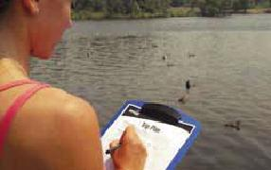
A trip plan is a document that outlines your expected travel itinerary while on the water. A trip plan should be given to a responsible person on shore. In the event that you do not return from your trip on time, a trip plan can be used by search and rescue organizations to help pinpoint your whereabouts.
Safe Boating Tip
Trip Plans (or “Float Plans”) should always be left with a responsible person who knows what to do in case of emergency. Even for a short boating trip, you should let a responsible person know where you will be boating, when you are expected to arrive home and the distinguishing features of your boat.
BACK TO TOP

Preparing a trip plan
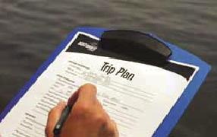
A trip plan should include:
- The name of your pleasure craft
- License number of your pleasure craft
- Type of craft (Power or Sail)
- Size and colour of your pleasure craft
- Type of engine
- Distinguishing features of the pleasure craft
- Your name, address and telephone number
- Number of persons onboard
- Trip description including:
- Time of departure
- Time of return
- Proposed route
- Type of radiophone and channel monitored (if so equipped)
- List of safety equipment onboard including flares, Lifejackets, PFDs and life rafts
- Instructions in case of emergency
Filing a Trip Plan
Where to file
A trip plan should be filed on shore with a responsible person, a marina, or with the local Canadian Coast Guard detachment. The person you file your trip plan with should know what to do in case of emergency.
Changing a trip plan
If you change plans during your trip you should notify the person with whom you’ve filed the plan. Doing so will inform the person of your correct whereabouts and avoid a false alarm or unnecessary emergency actions.
On return
On your return, you must remember to notify the person
or organization with whom you filed the plan and inform
them that you have returned safely. Failing to do so may
result in a false alarm and the launch of a search and
rescue operation.

FUELING YOUR CRAFT

Planning ahead
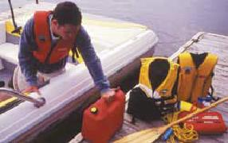
Running out of fuel is the number one cause of boater distress. You should always be sure to plan your requirements and carry enough fuel.
As a general practice you should use the rule of thirds when considering the amount of fuel and oil required:
- One third out
- One third back
- One third in reserve
BACK TO TOP

Safety precautions when fueling
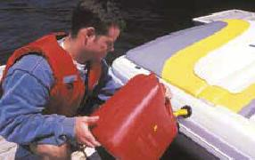
Follow these common sense rules when fueling:
- Always use caution
- Do not overfill or spill fuel - Spilling fuel into the engine or passenger compartment can increase the risk of explosion or fire
- Refuel during daylight hours when an artificial light source is not needed (the electrical Current from the light source can ignite fuel vapours)
- Never smoke while refueling
Remember
Gasoline is highly explosive when mixed with air. Gas vapours will ignite when exposed toflame or spark resulting in destruction of property, serious injury and death. Every boat that has a gasoline engine or uses propane devices must have ignition-protected electrical devices.
This protection prevents sparks from escaping during use. You should only use electrical components that are clearly labelled as ignition protected and never modify or repair marine engines with automotive parts.
BACK TO TOP

Fueling a boat
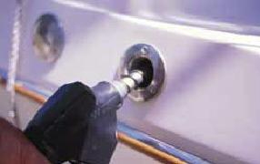
The following procedure is not only recommended for safety – it’s the law. When fueling a pleasure craft equipped with a gasoline or diesel engine, perform the following:
- Ensure your pleasure craft is securely moored to the Dock
- Shut down all motors
- Ask all passengers to disembark the craft and remain on shore
- Extinguish any open flames, including cigarettes and pilot lights
- Close all doors, windows, ports and
- Shut down all electrical equipment
- Have a fire extinguisher available in case of emergency
- Check for leaks and fuel vapours/odors
- When fueling at a pump, keep the gas nozzle against the rim of the filler pipe - This will ensure the pump is grounded and will reduce the risk of ignition due to static electricity
- Never overfill the fuel tank - Be sure to clean up any spillage and securely tighten the filler cap
- Open all doors, windows, hatches and portholes once refueling is complete
- If your pleasure craft is equipped with an enclosed engine compartment, you must operate the ventilation system (blower) for at least four minutes prior to engine start-up
- Re-check for the smell of fuel vapours/odors (do not re-start your engine if excessive fuel vapours are detected)
- Start the motor

FUELING YOUR CRAFT

Refueling a portable tank
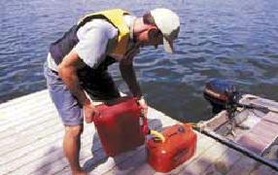
When refueling a portable container:
- Ensure your pleasure craft is securely moored to the Dock
- Shut down all motors
- Extinguish any open flames, including cigarettes
- Disconnect the fuel line and move the tank to the Dock
- Always use a tank that has been approved for use in Canada
- Check the fuel system (including the tank, fuel line, and connectors) for any leaks
- For mixed gasoline: Alternate the addition of gas and oil as the tank is filled - Ensure gas and oil are thoroughly mixed before reconnecting the fuel system to the motor
- Once filled, place the tank back in the craft
- Reconnect the fuel line and re-check for leaks
- Start the motor
BACK TO TOP

Fueling a pwc
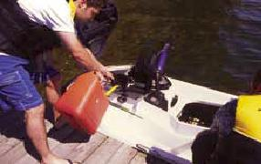
Some additional considerations should be taken when fueling a PWC:
- Shut down the engine
- Ask all passengers to disembark the craft and remain on shore
- Extinguish any open flames, including cigarettes
- Visually check the gas separator for the presence of water - Remove any traces of water before refueling
- Ensure the fuel selector switch is turned to the “OFF” position
- For PWCs requiring mixed gasoline: Always pre-mix gas and oil in an approved portable container before refueling the PWC
- For PWCs equipped with an oil injection system: Ensure the oil tank is full with the approved oil for your craft
- Fill the tank
- Tighten the fuel filler cap, check for fuel vapours
- Turn the fuel selector switch to the “ON” position and restart the engine

USING A PRE-DEPARTURE CHECKLIST

Pre-departure checklist
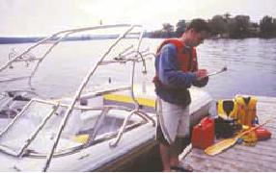
The use of a pre-departure checklist is an excellent way to avoid unsuitable operating conditions (such as bad weather), reduce the risk of breakdown and ensure that you have the right equipment onboard in case of emergency. No matter if you own a boat, or are renting or borrowing a boat, you should always use a pre-departure checklist to ensure your boat is in good working order and properly equipped.
Safe Boating Tip
Why bother using a pre-departure checklist and inspecting your vessel? Because, a few minutes before you leave can save frustration, inconvenience and help you avoid potentially dangerous situations.
Several boating safety organizations, including the Canadian Coast Guard Auxiliary, offer free courtesy checks for pleasure craft to help operators ensure they have the proper safety equipment on board and identify any potential problems.

SUMMARY

Summary
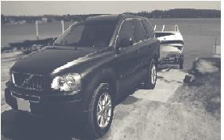
Maintaining your equipment in proper working order will help you avoid emergency situations and reduce your operating costs. You should perform maintenance on your craft and equipment at the beginning of each season and at regular intervals throughout the season. The use of a maintenance checklist is recommended.
Understanding local water hazards and determining local weather conditions before you depart will help you avoid unsuitable operating conditions and potentially life threatening situations. Before out, you should consult marine charts for the waterway in which you plan to operate, and talk to local boaters and marine operators to gain valuable insight.
The Canadian Coast Guard recommends the use of a Trip Plan before out. A Trip Plan is used to identify your vessel and proposed route, and can be a significant aid to search and rescue organizations in an emergency. The use of a Pre-Departure Checklist is also highly recommended.

LOADING PEOPLE AND EQUIPMENT

Loading people and equipment
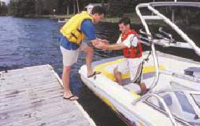
Loading your boat improperly, either by overloading it or distributing weight unevenly, can result in unpredictable handling and may cause your boat to Capsize.
When loading a pleasure craft:
1) Consult the pleasure craft’s Capacity Plate and ensure that:
- Equipment and people do not exceed the “recommended gross load capacity” of the craft.
- The number of people onboard does not exceed “the equivalent number of adult persons” the craft is capable of safely carrying.
2) Ensure each passenger is wearing a properly fitted approved PFD or Lifejacket
3) The operator should board first and then assist each passenger aboard
4) Position equipment and people so that weight is equally distributed and as low as possible throughout the craft
5) Each person should be properly seated and positioned before the next person comes aboard
6) Ensure all equipment is securely fastened and stored properly to prevent uncontrolled shifting once the craft is underway - You should stow gear in lockers that are easily accessible in case of emergency and as low as possible to help stabilize the craft
Safe Boating Tip
Always be sure to load people and equipment so that weight is equally distributed throughout your boat. This will keep your boat “level” in the water, ensure greater stability and reduce the likelihood that your boat could capsize. Be sure to maintain the weight distribution of passengers and load when underway.
BACK TO TOP

Instructing your passengers
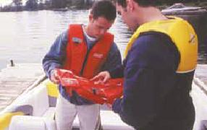
Passengers falling while underway is the leading cause of injury on pleasure craft. In order to maintain a safe operating environment for yourself and your guests, you should instruct your passengers before out.
Familiarize your passengers with your boat and its safety equipment:
- Passengers should be informed of the location of PFDs/Lifejackets and their importance for safety.
- Each passenger should wear a properly fitted, approved PFD or Lifejacket. Instruct passengers on the correct way to put on a PFD/Lifejacket while in the water or on the craft.
- Instruct your passengers to keep their weight as low as possible at all times and hold onto solid objects when moving about the craft. Passengers should always remain as close to the centreline as possible when moving around the craft.
- Show passengers the location of your craft’s Emergency Kit.
- Emergency situations may require your passenger’s co-operation and assistance. Advise passengers on how they may have to react in the event of an emergency.
- Teach passengers how to use vital safety equipment such as buoyant heaving lines and flares. By doing so, you’ll be certain that passengers can respond effectively in the event that you are thrown overboard or are knocked unconscious.
- Instruct passengers to keep hands, arms and legs inside the craft at all times, particularly when approaching or leaving the dock.
- Remind passengers that many factors can affect their reflexes, judgment, and sense of balance while underway. These include the motion of the craft on the water, sunlight, waves, reflections, wind, sound and/or alcohol. Passengers may not be familiar with the effects of these influences and should be advised to take them into consideration.
- Advise passengers of their responsibilities during refueling. Passengers must disembark the craft and extinguish any cigarettes before refueling begins.
BACK TO TOP

Instructions for pwc passengers
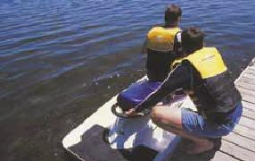
- Advise passengers as to the location of the PWC’s safety equipment.
- Passengers should read and understand the warning labels on the PWC.
- Inform passengers that a PWC is less stable than a traditional vessel and that the PWC will become more unstable as each passenger boards the craft.
- Passengers should keep their weight stable and evenly distributed.
- Advise passengers to keep legs and arms within the craft at all times.
- Remind passengers to keep away from the PWC’s intake grate while the engine is running. Items such as long hair, loose clothing, or PFD straps can become entangled in the moving parts of the jet intake system resulting in severe injury or death.
- Advise passengers that the jet propulsion system is powerful and water and/or debris exiting the jet thrust nozzle can cause severe injury. Operators and passengers should avoid being close to the jet thrust nozzle at the rear of the machine.
- Remind passengers to never place their feet or legs in the water to aid turning.
- Passengers should hold onto the seat strap while underway.

GETTING UNDERWAY

Casting off
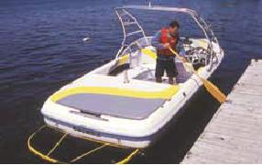
Use the following precautions when casting off:
1. All passengers should be seated properly with their hands and feet inside the boat
2. For crafts equipped with enclosed engine compartments, operate the ventilation system (Blower) for at least 4 minutes before starting the engine.
3. Start the engine:
- PWC operators should ensure the watercraft’s engine shut-off cord (safety lanyard) is securely attached to their wrist or Lifejacket at all times. The engine shut-off cord must be kept from tangling on the handle bars and be free to release if the operator falls off the PWC.
4. Check your surroundings and take into account any obstacles or other craft.
5. Untie all mooring lines and push the craft away from the Dock.
6. As you leave the dock, the stern of your vessel will likely swing back towards the dock. Ensure that you push your craft well clear of the dock at both the bow and stern.
7. Proceed slowly from the dock until it is safe to increase your speed.
8. Fast acceleration may cause passengers to lose their balance. Ensure all passengers and crew are informed before any rapid acceleration occurs.
BACK TO TOP

Returning to the dock
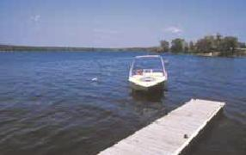
When returning to the Dock:
- Ensure all passengers are seated securely with their feet and hands inside the craft.
- Approach the Dock at a 30 to 45° angle and under a manageable speed.
- Turn your craft slowly as you approach the Dock in order to come to a parallel resting position. If necessary, use reverse to control the position of your craft.
Remember
Your boat does not have brakes and requires a minimum distance to stop. Stopping distance will vary depending on initial speed, load, wind, and water conditions.
PWC operators should remember that as the throttle lever is released to idle position, less directional control is available. You must apply throttle to steer. PWCs that are not equipped with neutral and reverse must be shut down when close to the Dock, or forward thrust will continue to propel the PWC into the Dock.
BACK TO TOP

Disembarking your craft
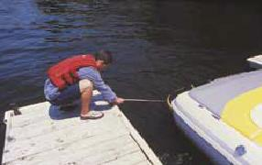
When disembarking:
1. Secure the craft
2. Shut down the motor:
- - PWC operators should remove the engine shut-off cord from the PWC to avoid accidental starting.
4. Securely fasten the craft to the Dock
3. Unload passengers one at a time:
- PWC operators should be aware that as each passenger exits the watercraft it may become unstable. Passengers should attempt to keep their weight distributed as they disembark from the PWC.
4. Never jump from the boat to the Dock

SAFETY UNDERWAY

Safety underway
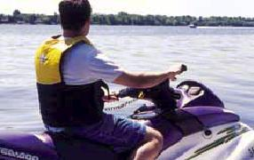
Enjoying Canada’s waterways is one of our greatest summer pastimes. While we all want to have fun and enjoy a day on the water, sharing the waterways with others means operating in a safe and courteous manner.
Safety underway means:
- Understanding and taking into account the effects of being on the water
- Choosing a safe and appropriate speed
- Knowing the proper techniques for reducing risk while operating at high speeds
- Knowing how to operate safely amongst other boat traffic during the day or night and sharing the waterways with others
BACK TO TOP

Effects of being on the water
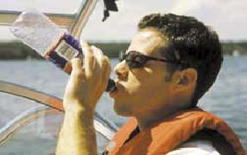
You should remember that certain effects of being on the water can impair your judgement and ability to operate your craft safely. These effects include:
- The motion of your pleasure craft
- Sunlight
- Wind
- Waves
- Sound
- Alcohol and/or controlled substances
These effects (individually or in combination with each other) may impair your balance, sense of coordination, reflexes, response time, eyesight, hearing and judgment. If you find that any of your senses are impaired you should immediately seek a safe harbour and shade yourself from direct sunlight.
Be aware of the effects of being on the water - both on yourself and your passengers. Take steps to reduce these effects by ensuring that you wear appropriate protection from the elements including sunglasses, sunscreen and a visor or hat.
Be well rested when planning to operate your craft for extended periods and ensure that you consume ample liquids (such as water or juice) to keep hydrated. You should never consume alcohol or controlled substances when operating a pleasure craft.
Heat stroke
Heat stroke results from an abnormally elevated body temperature with accompanying physical and neurological symptoms. Heat stroke is a true medical emergency that can be fatal if not properly and promptly treated. Symptoms of heat stroke include nausea, vomiting, fatigue, weakness, headache, muscle cramps and dizziness.
Victims of heat stroke must receive immediate treatment to avoid permanent organ damage. First and foremost, cool the victim. Remove clothing, apply cool water to the skin and fan the victim to promote sweating and evaporation. Apply ice packs under armpits and groin and monitor body temperature and continue cooling efforts until body temperature to 38.3 – 38.8 ºC.

CONTROLLING YOUR PLEASURE CRAFT

Choosing a safe speed
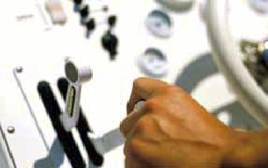
The Collision Regulations specify that it is an operator’s responsibility to choose a safe speed.
Safe Boating Tip
What is a “Safe Speed”? A safe speed is one that allows you to take proper and effective action to avoid a collision. A safe speed will allow you to stop your boat within a safe distance in relation to the prevailing conditions listed below.
Choose a safe speed relative to the following:
- The location and proximity of navigational hazards
- Your distance from shore
- Your distance from other boat traffic (including fishing vessels with trawling nets)
- Activities of others on the water including other vessel traffic
- Water currents and wind conditions
- Weather, water and visibility conditions (such as fog, rain and rough water)
- The manoeuvrability of your vessel
BACK TO TOP

High speed operation
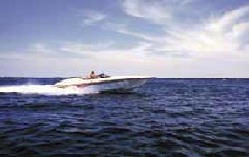
Pleasure crafts operating at high speeds require a greater stopping distance. Operators driving their boats at high speeds should ensure they are able to react effectively in emergency situations, including sudden changes in water, weather and visibility conditions.
Be aware that high-speed operation reduces the amount of time you have to react in an emergency. You should always use caution and be more attentive when operating at high speeds.
Remember
Always operate at a speed that allows you to take effective action to avoid collisions.
BACK TO TOP

Trim
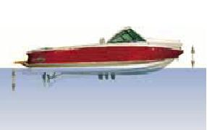
Your boat’s trim is a description of the relative angle of the boat in the water. Too much weight towards the Bow of the boat will cause the front of the boat to plow down into the water. Too much weight towards the stern of the boat will cause the boat to bounce on the water. Either condition can result in poor and uncontrollable handling.
When properly “trimmed”, the gunwales of the craft should be parallel to the water. Trim can be controlled by altering the position of equipment and people in the craft. For craft equipped with power trim, the operator can adjust the trim of the boat by changing the angle of the motor/outdrive or “trim tabs” that are affixed to the transom.
Accelerating and planing
When accelerating, your boat will tend to leave the water and hydroplane onto the surface. Initially, this will lift the Bow of the boat by several degrees and diminish your ability to see over the bow of your craft. To correct this situation, simply accelerate slightly to achieve full plane and your boat will regain a horizontal trim position

CONTROLLING YOUR PLEASURE CRAFT

Controlling a pleasure craft
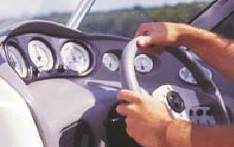
Steering
You should look in all directions (including behind to the stern) before turning your craft. Take note of the position of other boats and their relative speed. Once a safe direction has been established, turn your boat in a predictable manner. You should avoid rapid and unexpected manoeuvres as other boaters will not be able to predict your movements.
Most pleasure craft steer as water passes over the rudder or outdrive and is forced Astern by the propeller. If power to the propeller is cut, the operator can still steer the craft as long as the boat is still moving (coasting) through the water.
Stopping
To stop your craft, pull back on the throttle using a smooth even motion. Your craft will slow to idle speed. To stop your craft completely, move the throttle lever to the neutral position. Always allow for enough distance for your boat to coast to a complete stop.
BACK TO TOP

Steering a personal watercraft
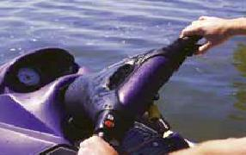
Personal watercraft steer as high-pressure water passes through the craft’s jet-propulsion system. Water is forced through the steering nozzle at the stern of the PWC. The steering nozzle is controlled by the handlebars, which the operator can turn left or right.
Remember
As PWC’s throttle lever is released to idle position, less water is forced through the system, and therefore less steering or directional control is available. If the engine is shut off, all directional control is lost. You need to apply throttle in order to steer a PWC.
BACK TO TOP

Stopping a personal watercraft
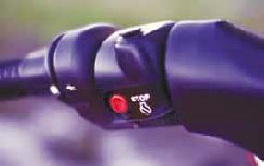
You can stop a PWC by releasing the throttle lever, pressing the stop button, or disconnecting the safety lanyard.
PWCs coast farther and require more distance to stop than traditional pleasure craft. PWC operators should remember that a minimum of 75 m is required to stop from full throttle - Exact stopping distance depends on the type and size of PWC being operated and the
prevailing water and wind conditions.
Never use the PWC’s reverse (if so equipped) to stop. You or your passenger(s) could be unexpectedly ejected towards the handlebars or thrown from the craft.
Remember
Become familiar with the stopping operations of your PWC by practicing in a safe, controlled area. Always leave ample distance between yourself and other craft.

CONTROLLING YOUR PLEASURE CRAFT

Handling rough water conditions
When boating in rough water you should adjust your boat’s speed as appropriate to the water conditions. Slow down and use caution. Adjust your speed so that the Bow of your craft does not become buried in a wave. You should never attempt to jump waves.
If you find yourself in increasingly high seas, you should make way to a sheltered mooring such as a protected bay, cove, or breakwater. If wave and water conditions make it unsuitable to operate safely, immediately set anchor and signal your need for help.
BACK TO TOP

Crossing a wake
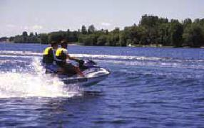
When attempting to cross a wake, you should reduce your speed and alter your Course to cross the wake at a 45° angle. Be aware of traffic that may be in your path as you cross to the other side of the wake. Once you have crossed the wake, resume your speed and Course.
PWC operators should cross the wake at a 90° angle. Doing so will help maintain lateral stability. You should never attempt to jump a wake.
BACK TO TOP

Operating in bad weather
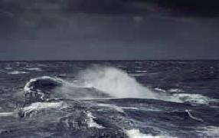
Operating in bad weather is primarily a matter of avoiding collisions. Use the following techniques to avoid collisions in bad weather:
- Proceed with caution: be able to stop in a short distance rather than having to resort to unexpected evasive manoeuvres.
- Place lookouts: if you have passengers onboard, place them near the Bow and stern as effective lookouts - operate with caution during high wave Conditions when other craft may not be visible.
- Look and listen: you and your passengers should “lookout” for other craft and navigational aids by both sight and hearing.
- Navigation lights: use your craft’s navigation lights during periods of restricted visibility to alert other boaters to your position.
- Stop your engines: if you are underway in heavy fog, stop your engines at specific intervals to listen for fog signals from other vessels or Aids to Navigation (marker buoys).
- Use your radar: radar is your best option when Visibility conditions are reduced - if you have a Passive radar reflector it should be displayed during periods of restricted visibility.

CONTROLLING YOUR PLEASURE CRAFT

Anchoring Your Craft
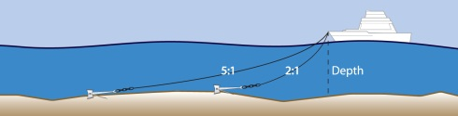
Anchors have several uses:
- In the event of a breakdown
- During severe weather conditions
- An anchor is also useful in non-emergency situations (such as when swimming from the stern or securing for an overnight stay)
Setting the anchor
To set an anchor:
1 Ensure the inboard end of the Anchor Line is securely attached to the pleasure craft.
2 Ensure the outboard end of the Anchor Line is securely fastened to the anchor.
3 Slowly lower the anchor over the Bow or side of the craft until it reaches bottom. Note the distance to the bottom or note the length of rope used for the anchor to reach bottom. Never throw the anchor over the side of the boat.
4 Let the boat drift rearward or operate the engines Astern (in reverse):
- Let out an additional eight to ten times more Anchor Line than the depth of the water and securely fasten the desired length to the boat.
- At only 2:1 and 4:1 depth, the anchor can dig in but there is too much upward pull on the anchor line (rode). At a minimum of 5x depth, the rope lies flat on the bottom and pulls the anchor in deeper (see above illustration).
5 Once the anchor is set, choose two fixed landmarks on the horizon and occasionally check your relative position to ensure that your craft is not drifting. If anchoring overnight, display your craft’s All-round light white light. Do not display your green and red
sidelights.
6 To retrieve the anchor, slowly pull on the Anchor Line, moving the boat forward until the anchor frees itself from the bottom. Bring the anchor onto the craft and fasten securely.
Never secure the anchor to the stern of the craft.
If the wind changes direction, your boat will swing with the stern into the wind - Smaller boats can be easily swamped by waves crashing over the transom. If you are preparing to set anchor in an anchorage among other boats, remember that the first craft into anchorage has the “right of swing”. Always allow for another craft’s right of swing and anchor well clear

SHARING THE WATERWAYS

Sharing the waterways
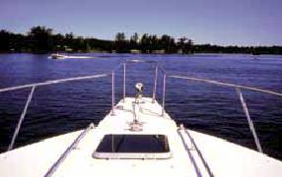
Over 8 million boaters enjoy Canada’s waterways each year. All boaters should be knowledgeable of and abide by the Collision Regulations and use common sense and courtesy while underway.
You should never create a hazard or stress to yourself, to your fellow operators, or to the local habitat:
- Never operate close to swimmers and the personal property of others.
- Ensure that your wake and wash will not cause personal injury, erosion of the shoreline or damage to personal property.
- Use common sense and courtesy when operating close to non-powered craft.
- Reduce your vessel’s wake when passing small non-powered boats. Craft such as canoes, kayaks and rowboats can be easily swamped and capsized by your wake.
BACK TO TOP

Operating near swimmers
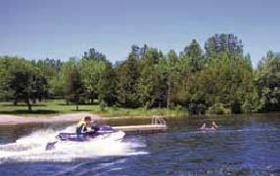
Operating a power boat near swimmers is extremely dangerous and against the law. Always keep well away from designated swimming areas.
Swimming areas in Canada are designated by swimming buoys that are white in colour. However, not all swimming areas may be marked. When operating near shore, keep a look out for swimmers, including those persons engaged in underwater activities such as snorkeling or diving.
Safe Boating Tip
Remember: The sun’s glare can make it difficult to spot swimmers in the water.
BACK TO TOP

Staying clear of divers
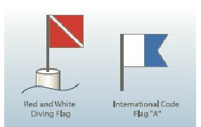
Vessels and persons engaged in diving activities are required to display flags indicating their activities.
The boat from which divers are diving may display the blue and white Code Flag “A” which indicates “I have a diver down: keep well clear at slow speed.” The Collision Regulations Rules 18 and 27 require that all operators take early and substantial action to steer well clear of any vessel that displays a Code Flag “A”.
A floating red and white Diving Flag (carried on the top of a white buoy) marks an area where diving is in progress. Always be sure to keep a look-out for and steer clear of diving flags.
Safe Boating Tip
The red and white Diving Flag marks the general area where diving is in progress.
Keep in mind that it is easy for divers to stray from the area marked by a diving buoy. Always exercise extreme care, slow down and avoid boating in waters frequented by divers.

SHARING THE WATERWAYS

Operating close to non-powerboats
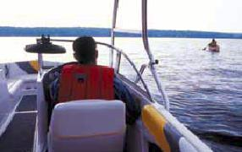
Non-powered craft such as canoes, sailboats, rowboats and sailboards have the right of way – It’s the law. Reduce your speed when operating near unpowered craft and ensure your wake does not create a hazard or irritation to them.
BACK TO TOP

Wake and wash
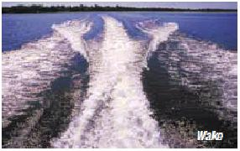
Operators are responsible for the wake and wash of their craft:
- Wake is caused by the boat moving through the water and displacing it
- Wash is the disrupted water following from the stern of the boat and is caused by the motion of the propeller
Safe Boating Tip
Certain waterways can be designated as “No Wake Zones”. No Wake is defined as "The
slowest possible speed required to maintain steerage and ”. Boat speed should not exceed 10 km/h in a “No Wake Zone”.
A number of provinces have adopted a province wide speed limit of 10 km/h within 30 metres of shore. Although not posted, these speed limits are in effect on all inland waterways. Some exceptions apply, such as when towing a waterskier or operating in rivers less than 100 m wide. As of the date of printing, these speed limits apply in Alberta, Manitoba, Saskatchewan, Ontario and British Columbia. Boaters should check with their provincial authorities for more information.
BACK TO TOP

Reducing the effects of wake and wash
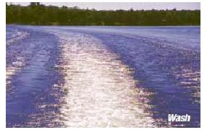
Your craft’s wake and wash can cause damage to the shoreline and can be a danger to smaller craft. When operating your craft be aware of the effects of your wake and wash on the following:
- Swimmers and bathing areas
- Docks
- Wildlife
- Shoreline erosion
- Smaller craft such as fishing boats and canoes
- Unpowered craft
- Water-skiers
- Divers
- Areas of anchorage
- Other anchored or grounded vessels
If operating in or near such areas you should adjust the speed of your craft to reduce the effects of wake and wash. Doing so will ensure that you avoid the risk of personal injury, shoreline erosion and damage to personal property.

SHARING THE WATERWAYS

Environmental responsibility
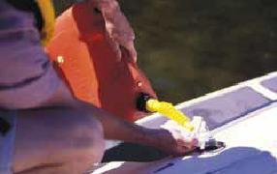
It is illegal to pollute Canadian waterways. Always use caution when refueling and be sure not to spill excess fuel into the water. When operating your craft, be mindful of and respect natural inhabitants and ecosystems. Nesting areas and spawning grounds need to be protected in order for ecosystems to function properly. Always keep well away from undeveloped shoreline areas.
You are prohibited from dumping oil, litter or waste overboard. Even small oil spills may cause serious long-term effects. Waste from marine toilets must be held in a holding tank and pumped out at an approved marine facility. Boaters are also prohibited from dumping bilge water containing oil or other chemicals overboard. You should check your bilge on a regular basis to ensure it’s free of oil, grease and chemicals. If chemical pollutants are found in the bilge use an environmentally friendly absorbent product to soak up chemical waste. You must report to government authorities any discharge of a pollutant from your vessel that occurs, or the probability that such discharge will occur where the discharge is prohibited by the Canada Shipping Act 2001.
Invading Species
In recent years, Canada’s waters have been under threat from aquatic plants, fish and invertebrates (mussels, snails etc.) that originate from other parts of the world, and that have been introduced (accidentally or intentionally) to Canada’s wetlands, lakes and waterways. With no natural predators, high reproductive rates and superior survival capabilities, these “invading species” can rapidly take over Canada’s waterways and wetlands with harmful effects on our native fish, wildlife, habitats and ecosystems. Invading species include Eurasian Water- Milfoil, Purple Loosestrife and Zebra Mussels.
Invading species are spread by recreational boats and watercraft, as well as fishing equipment. Before entering any body of water you should clean your boat to remove foreign species and reduce the likelihood of spreading invading species. Inspect your boat, trailer and equipment. Remove visible plants or animals. Drain water from your boat’s motor, live wells and bilge or transom wells on land and away from any waterway.
Wash and dry your boat, trailer and equipment. Remember that some species can survive out of water. Use one (or all) of the following methods to clean your boat of invading species:
- Rinse with hot tap water (at least 40° C)
- Spray with high pressure water (250 psi)
- Dry your boat and equipment for at least five days before moving to another body of water
Anglers should empty bait buckets on land and consult provincial fishing regulations for information about the use of baitfish. Never release live bait from one body of water to another. Report sightings or obtain information from your local provincial resource agency.
Black Water
Raw, untreated sewage is called “Black Water”. All boats fitted with a marine toilet must be equipped with a holding tank where black water can be stored until it can be disposed of at an approved pump-out station.
Allowing black water to escape into Canada’s waterways is against the law. Serious bacterial infections can occur amongst swimmers, and black water has a negative effect on our environment. Dual systems with “Y” valves (which allow waste to be dispelled from the boat) are illegal and must be retrofitted. Portable toilets are legal only if they are securely fastened to the craft and have a permanent fixture enabling them to be emptied at an approved facility. If you’re planning an extended trip, you should plan to use onshore facilities wherever possible.
BACK TO TOP

Noise pollution
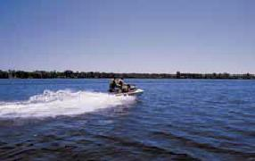
Pleasure Craft are not permitted within 5 nautical miles (9.26 km) of any Canadian shore unless they are fitted with a noise muffling device. A “wet exhaust”, where noise is muffled by cooling water discharged through the exhaust pipe, is not considered a noise muffling device. Operators should check with their local Canadian Coast Guard for any exemptions to this rule.
Boaters should remember that sound travels further on water than on land. Operating continuously in one area disturbs both those on land and on water. Don’t “buzz” around in one area, keep loud music to a minimum and respect those on shore as well as your fellow boaters.

EXITING AND BOARDING FROM DEEP WATER

Exiting into deep water
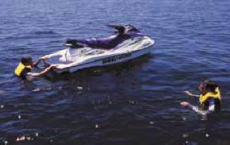
You or your passenger(s) should never exit the craft into the water while underway. To enter the water from your craft, first shut off the engine. Take note of all possible hazards such as rocks, shoals or shallow underwater features. If you are unsure of the area in which you are boating, take caution and enter the water slowly with feet first. Do not dive or jump headfirst unless you are certain there are no hazards or shallow water.
BACK TO TOP

Boarding a boat from deep water
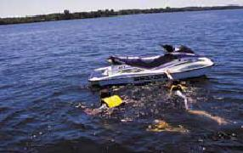
Follow these common sense guidelines when boarding your vessel from the water:
- Ensure the engine is shut off
- If the craft is equipped with a ladder swim to it and pull yourself out of the water onto the boat
- If the craft is not equipped with a ladder, swim or move to the stern of your boat
- Position yourself beside the motor and locate the flat cavitation plate just above the propeller
- Place one hand on the shroud of the motor and one hand on the gunwale of the boat - Place one foot on the cavitation plate - Then use the plate as a step and your arms to help pull yourself up
- When boarding in this manner be surefooted and ask for assistance if necessary - The edges of the cavitation plate are sharp and can cause injury
BACK TO TOP

Boarding a PWC from deep water
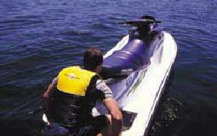
If the PWC has been flipped and is upside down in the water, right it according to the manufacturer’s instructions. (A PWC will not self-right if Capsized). PWCs should be righted in one direction only – check with your owner’s manual and/or warning sticker on the stern of the PWC to determine the proper direction.
To board a PWC, first swim to the stern of the craft. Use the grab handle on the transom or seat to help pull yourself onto the craft. Slowly pull yourself up, placing your knees on the rear boarding platform. Once aboard, move forward onto the seat and attach the safety lanyard.
Always remember the following when boarding a PWC:
- Never attempt to board the PWC from the side. You may cause the craft to flip over on top of you.
- Never attempt to board the PWC when the engine is running. The powerful suction from the jet thrust system may ingest loose items such as long hair, clothing, or the straps of your PFD/Lifejacket resulting in serious injury or death.
- Do not attempt to grab, kneel or stand on the reverse gate (if so equipped) when re-boarding the craft. Damage to the PWC and personal injury may result.
- If waiting for a passenger to board the PWC, never start the engine prematurely. The force of the water exiting the jet thrust nozzle may cause serious injury or death to the passenger.
- Remember that boarding a PWC in deep water can be strenuous. Always practice in chest-deep water and ensure passengers understand proper re-boarding techniques.

TOWING ACTIONS

Towing
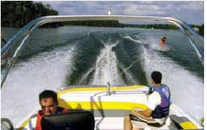
Towing a water-skier, wakeboarder, kneeboarder or other towable device requires the use of a spotter. A spotter is a person who observes the person being towed at all times. The spotter notifies the driver if there is a need for a change in speed and/or direction as indicated by the skier’s hand signals. The spotter can also notify the driver in case of emergency.
The driver should never watch the skier. The driver should always concentrate on driving the boat in a safe manner, keeping well clear of other boats, skiers, swimmers and hazards.
Safe Boating Tip
When “dropping off” a waterskier at the Dock, do not run parallel to the shore in shallow water. Keep your distance and let the person swing into shore. This will ensure the person being towed does not hit bottom or any underwater hazards.
BACK TO TOP

Rules and regulations
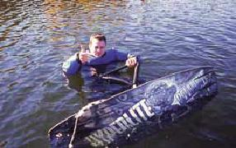
Obey the following when towing a water-skier - It’s the
law:
- A spotter must be in the boat at all times
- The towing vessel must be equipped with an extra seat for each person that is being towed in case emergency recovery is necessary. Only personal watercraft designed to carry 3 or more people, can be used for towing a waterskier.
- The person being towed must wear an approved flotation device. Keep in mind: A “ski belt” is not considered to be an approved flotation device.
- The towing vessel cannot be operated by remote control.
- Only tow skiers one hour after sunrise until one hour before sunset. It is a criminal offence, as governed by the Criminal Code of Canada, to tow a person after dark.
BACK TO TOP

Hand signals
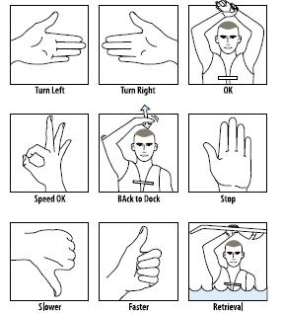
Both the spotter and the person being towed must understand and be able to communicate using standardized hand signals. Click on the image to the left to review standard hand signals and their definitions.

BACK TO TOP

SUMMARY

Summary
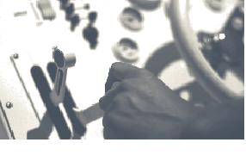
Operating in a safe and responsible manner is every boater’s obligation. Be sure that you understand how to properly control your craft and are aware of it’s unique handling characteristics.
After studying this module you should understand the proper procedures for casting off and returning to the Dock. You should also be aware of the effects of being on the water and how to adjust for them. Remember to always choose a safe speed when operating your craft, and minimize the effects of your wake and wash when operating close to shore and unpowered craft.
Knowing how to anchor your craft correctly is useful when stopping for an overnight stay or when swimming from the stern of you craft. It’s also a valuable technique that can be used in an emergency situation, such as during a storm or if a mechanical breakdown occurs.
Be sure that you understand the rules and regulations for towing water-skiers. Always use a spotter and operate with caution when towing a skier.
BACK TO TOP

RIGHT-OF-WAY

The collision regulations
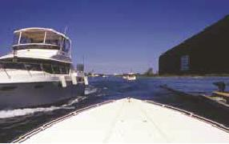
The Collision Regulations govern navigation rules on Canadian waterways and help boaters determine which craft has the right-of-way. These rules apply to all vessels and to all waters in Canada.
Your responsibilities
As a Canadian boater “you must use all available means, appropriate to prevailing circumstances and conditions, to make a full appraisal of navigation situations and determine if the risk of collision exists.” This means that you must know and understand
Canada’s navigation rules.
Safe Boating Tip
You are required to be knowledgeable of and abide by navigation rules, and take the proper actions when operating amongst other boat traffic. But that is not all; you must also be alert and use good judgement. The operators of other boats may or may not know the navigation rules, and he or she may not take the proper actions
- Don’t presume the actions of others and always proceed with caution.
BACK TO TOP

Determining right-of-way
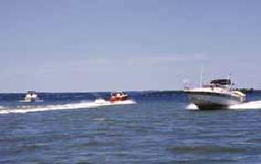
First, you should become familiar with right-of-way terminology:
Stand-on craft
Boats with the right-of-way are called “stand-on craft”. Stand-on craft are able to maintain their speed and Course when approaching another vessel.
Give-way craft
Boats that do not have the right-of-way are called “give-way craft”. Give-way craft must take early and substantial action to steer clear of the stand-on craft, altering their speed and direction to avoid a collision.
Several factors determine which craft has the right-of-way:
- The type of craft you’re operating
- The type(s) of craft(s) you’re approaching
- The position and direction from which other boat(s) are approaching
- The type of waterway on which you’re operating
BACK TO TOP

Type of craft
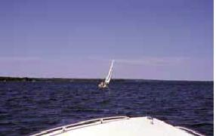
The types of craft approaching each other determine which operator has the right of way:
- Emergency craft always have the right-of-way. All pleasure craft operators should steer clear and yield to emergency craft.
- Non-powered craft including sailboats, canoes, paddleboats, sailboards and racing shells generally have the right-of-way over power-driven pleasure craft.
- All power boats and sailboats under 20 m in length must steer clear of larger less manoeuvrable vessels.
- Both power boats and sailboats must take early and substantial action to keep well clear of vessels engaged in fishing activities (those vessels operating with fishing nets and trawls).
- “Sport” fishing boats and waterski boats are considered manoeuvrable craft and operators of these craft must follow the same rules as all pleasure boats.
- Power-driven vessels must keep out of the way of any vessel that is not under command.
- Never pass between a tug and its tow (as it may be using a submerged towline) and keep clear of docked ferries, ferries in transit, or vessels in tow.
- Keep clear of docked ferries, ferries in transit and cable ferries which operate with a submerged tow cable from the bow and stern. Listen for large ship horns blasting one prolonged blast which indicates departing a dock.

RIGHT-OF-WAY

Approaching non-powered craft
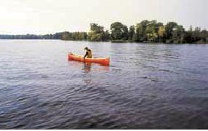
When approaching a non-powered craft, such as a sailboat or Canoe, you are the give-way craft and do not have the right-of-way.
You must take early and substantial action to keep well clear of non-powered craft. You should alter your speed and Course, and approach non-powered craft with caution.
BACK TO TOP

Position and Direction
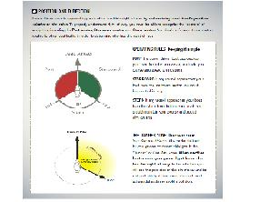
Power-driven vessels approaching each other establish right-of-way by determining each boat’s position relative to the other. To properly understand right-of-way, you must be able to recognize the “sectors” of navigation, including the Port sector, Starboard sector and Stern sector. You should reference these sectors relative to other boat traffic in order to determine who has the right-of-way.

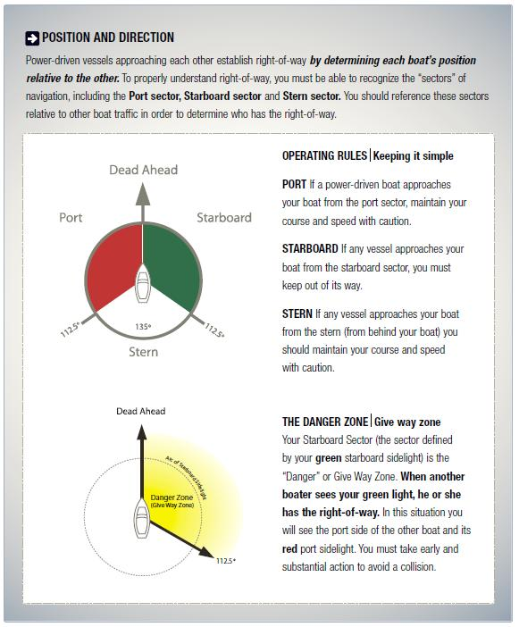POWERBOAT NAVIGATION

5.2.1 - Head on approach
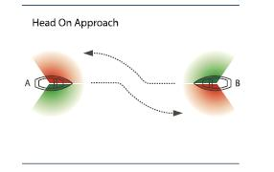
When power-driven vessels approach each other head on, neither craft has the right-of-way.
Both operators (A and B) must take early and substantial action to steer clear of each other. Each operator should give one short blast with a sound-signalling device and steer to starboard (to the right) as soon as possible in order to avoid a collision.
BACK TO TOP

Port (left) approach
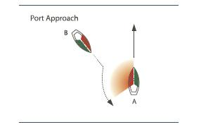
If a power-driven craft (B) is approaching from your port (left) sector you are the stand-on craft (A) and have the right-of-way. You should maintain your speed and
Course and be ready to take evasive action.
The approaching vessel (B) must take early and substantial action to avoid your vessel by reducing its speed and changing direction. When approaching from the Port side the operator indicated as Vessel B in the depiction above should give one short blast with a sound-signaling device.
BACK TO TOP

Starboard (right) approach
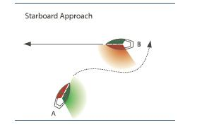
If a power-driven craft (B) is approaching from your starboard (right) sector you are the give-way craft and do not have the right-of-way.
You must take early and substantial action to keep well clear of the other vessel by altering your speed and Course. You should avoid passing in front of the oncoming vessel. When approaching from the Starboard side the operator indicated as Vessel A in the depiction above should give two short blasts with a soundsignaling device.

POWERBOAT NAVIGATION

Overtaking
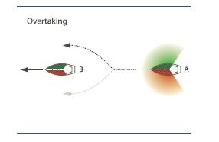
If you are overtaking another power-driven craft (B) from the stern (from behind) you are the give-way craft (A) and do not have the right-of-way.
You must take early and substantial action to keep well clear of the other vessel by altering your speed and Course. You should pass at a safe distance to the port (left) or starboard (right) side of the other vessel. However, if a safe route exists, you should always attempt to pass the boat on the starboard side.
Overtaking on port side
The operator of Vessel A should sound two short blasts to indicate “I want to pass on your port side”. Vessel B sounds two short blasts to accept and indicate “Proceed”. The operator of Vessel A should then sound two short blasts to indicate “I am altering my Course to Port”.
Overtaking on starboard side
The operator of Vessel A should sound one short blast to indicate “I want to pass on your starboard side”. Vessel B sounds one short blast to accept and indicate “Proceed”. The operator of Vessel A should then sound one short blast to indicate “I am altering my Course to Starboard”.
Sound-signaling devices and navigation
In addition to the sound signals covered in each of the proceeding navigation lessons, boaters should be aware of the sound signals that indicate various
navigational situations:
- Departing a dock: Power driven vessels of 12 m or longer in length should sound one prolonged blast when leaving a dock.
- Using astern propulsion: When operating astern, you should sound three short blasts.
- Failing to understand the intention of others: If you fail to understand the intentions (movements) of another vessel, or are in doubt whether sufficient action is being taken by the other vessel to avoid a collision, you should sound at least five short and rapid blasts.
- Vessel at anchor: If at anchor during periods of poor visibility, you should sound a signal rapidly for about five seconds in intervals of not more than one minute.
- Signals to be used in periods of poor visibility: Sailboats should sound one long blast, followed by two short blasts, every two minutes. A power boat
sounds one long blast every two minutes when underway and two long blasts every two minutes when stopped.

SAILBOAT NAVIGATION

Sailboats
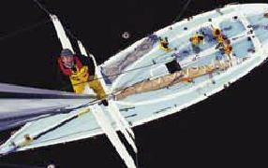
The Collision Regulations Rule 3 define a “sailing vessel” as a vessel that is under sail. If a sailboat is using a motor to propel itself, it is considered a power-driven vessel and must adhere to the rules for power-driven vessels.
Understanding sailboat navigation
Operators of pleasure sailing vessels (sailboats) are required to understand and obey right-of-way rules specific to their type of craft. However, operators of power-driven boats are also required to understand sailboat navigation rules. You are required to know and understand sailboat navigation in order to safely navigate around them.
BACK TO TOP

Sailboat navigation
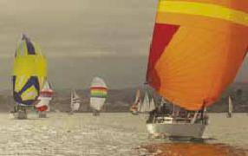
Sailboat right-of-way rules differ somewhat from those that apply to powerboats.
Right-of-way rules for vessels propelled by the wind are based on:
- The direction of the wind
- The position of the mainsail
- The position of the sailboat in relation to other boat traffic
BACK TO TOP

What is the windward side?
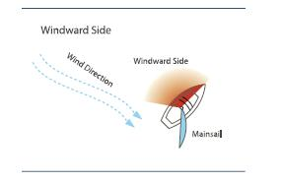
A sailboat moves when wind blows into the mainsail. The windward side is the direction from which the wind is blowing. One way to determine the windward side is to note the position of the sailboat’s “mainsail” (its large main sail). The windward side of the sailboat is opposite to the side on which the mainsail is being carried.
For example
If the mainsail is to the right side of the sailboat, then the left (port) side of the vessel is considered to be the windward side (as in the illustration shown above). In this example, the wind is blowing from the port (left) side into the mainsail and “pushing” the mainsail to the starboard (right) side.

SAILBOAT NAVIGATION

Wind on opposite sides
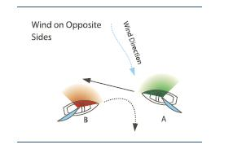
A pleasure sailing vessel with the wind on its port side is the give-way craft (B) and must take early and substantial action to steer clear of any sailing vessel with the wind on its starboard side (A).
What does this mean to you?
This means that a sailboat with the wind on the port side (port tack) should keep out of the way of a sailboat with the wind on the starboard side (starboard tack).If operating a power boat in the vicinity, you should anticipate that the sailboat with wind on its port side will alter its Course to starboard to avoid the other sailboat.
BACK TO TOP

Wind on the same side
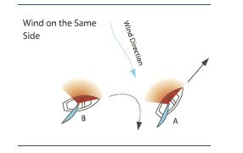
If two pleasure sailing vessels have the wind on the same side, the sailing vessel to the windward side is the give-way craft (B) and must take early and substantial action to keep well clear of the leeward vessel (A).
What does this mean to you?
This means a boat sailing Downwind (“behind” the other sailboat) must alter its Course to avoid a boat sailing upwind on the same tack. If operating a power boat in the vicinity, you should anticipate that the boat sailing Downwind will alter its Course to avoid the other sailing vessel.
BACK TO TOP

Wind on the port side
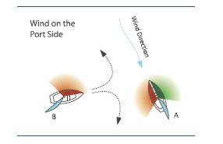
If a sailboat operating with wind on its port side (B) cannot determine with certainty where the wind is approaching another sailing vessel, it must take early and substantial action to change direction and keep well clear of the other vessel (A).

SAILBOAT NAVIGATION

Less manoeuvrable vessels
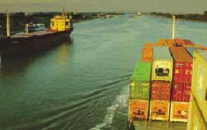
When operating in the vicinity of large commercial vessels, remember that these vessels have limited visibility, turning and stopping capabilities.
The Collision Regulations require that all smaller pleasure craft less than 20 m in length (including sailboats) must give right-of-way to larger, less manoeuvrable vessels. This is one of a few instances in which a powered vessel has the right-of-way over non-powered vessels.
Large vessels, those towing a barge, and those engaged in fishing activities with nets and trawls, always have the right-of-way and are considered to be the stand-on craft. Pleasure powerboats and sailboats must take early and substantial action to stay well clear of these types of vessels.
Remember
The Collision Regulations require that pleasure sailing craft and those power-driven vessels less than 20 m in length shall not hinder the passage of power-driven vessels which can safely navigate only in a narrow channel or those craft that are navigating in a traffic lane.
BACK TO TOP

Navigating at sea
Boaters are required to follow the International Regulations for preventing collisions at sea and the Canadian modifications upon the high seas and in all waters connected therewith and navigable by vessels as described in the Collision Regulations Rules 1 and 2 and the Canada Shipping Act Section 562. For more information visit www.tc.gc.ca.
When traveling to the United States by sea or inland waterway, Canadian citizens are required to present a single document that complies with the Western Hemisphere Travel Initiative (WHTI). These requirements came into effect on June 1, 2009. Boaters should check with the US Department of Homeland Security for up-to-date requirements.

OPERATING AT NIGHT OR DURING PERIODSOF RESTRICTED VISIBILITY

Safe operation in restricted visibility
Right-of-way and navigation rules are the same whether operating during the day or at night. However, while operating at night or during periods of restricted visibility (such as fog or heavy rain), you must determine the speed, position, and size of other boats according to the navigation lights they exhibit.
Sound signals should also be used when visibility is poor. Operators of sailboats should sound one long blast, followed by two short blasts, every two minutes. Power boat operators should sound one long blast every two minutes when underway and two long blasts every two minutes when stopped.
Remember: If you are operating a pleasure craft and you are not in sight of other vessels due to poor visibility, you are required to proceed at a safe speed that is appropriate for the prevailing circumstances and visibility conditions (as described in the Collision Regulations Rule 19).
BACK TO TOP

Navigating at night
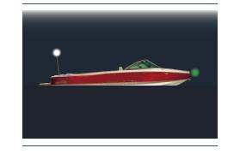
Right-of-way and navigation rules are the same whether operating during the day or at night. However, while operating at night or during periods of restricted visibility, you must determine the speed, position, and size of other boats according to the navigation lights they exhibit.
Navigation lights must be used on any pleasure craft that operates from sunset to sunrise or during periods of restricted visibility.
The navigation lights you are required to display depend
on the following:
- The size of your craft
- Whether it is sail-driven or power-driven
- Whether it is underway or at anchor
BACK TO TOP

Navigation lights
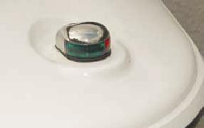
Power-driven pleasure crafts must exhibit a forward masthead light, sidelights and a sternlight.
Many small boats (such as bow riders and runabouts) typically have a white light affixed to the top of a light pole that can be placed at the stern of the craft. When underway, this all-round light functions as a combined masthead and sternlight, and must be visible in all directions, mounted higher than the boat structure, cockpit or any other obstruction.
Safe Boating Tip
Many boaters mistakenly exhibit all of their navigation lights, including their sidelights, when anchored. This is incorrect. Your green and red sidelights indicate to other boaters that you are underway. Your sidelights should NOT be displayed when anchored.
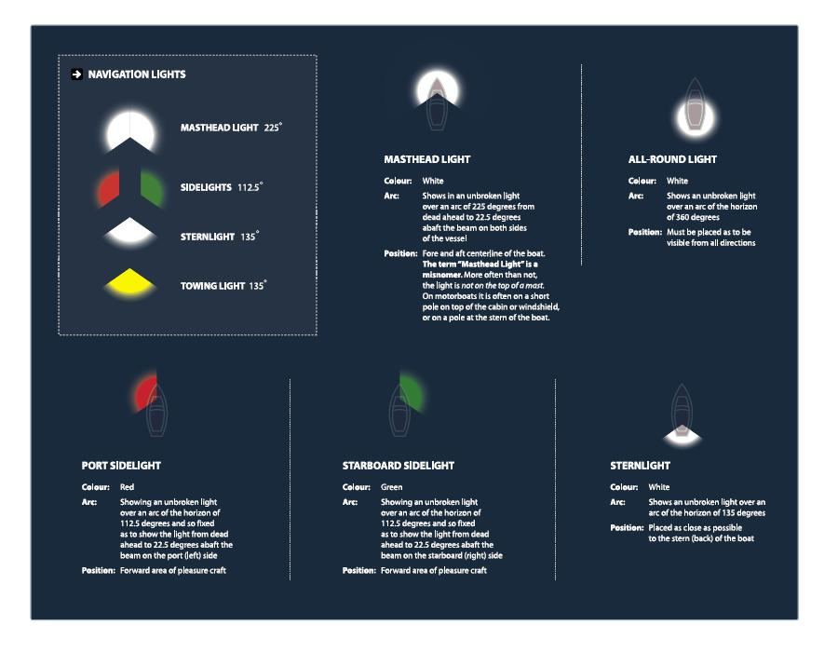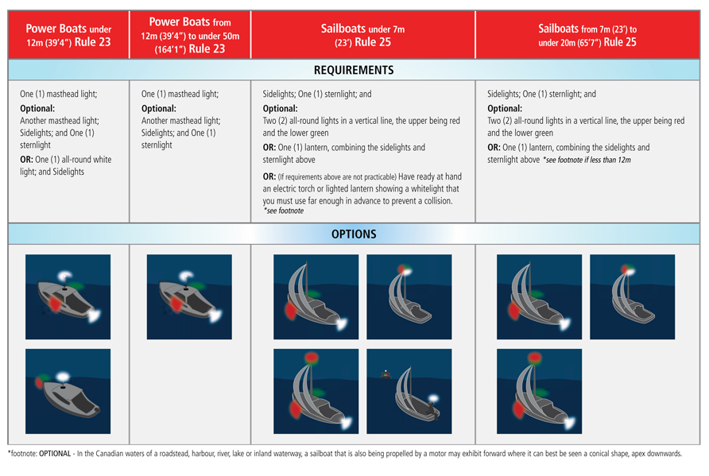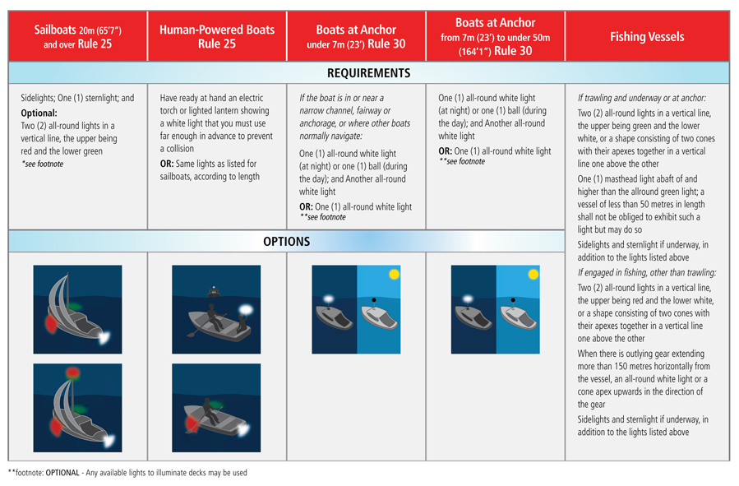Search and Rescue (SAR) Vessels
When responding to emergencies, search and rescue vessels as well as police and government vessels exhibit Aids to Navigation blue light(s). You should steer well clear of a
vessel with a Blue Flashing Light.
When towing
If towing another vessel from your stern you must show:
- Sidelights and a sternlight
- A yellow towing sternlight
- Two masthead lights in a vertical line
If being towed, you must exhibit:
- Sidelights and a sternlight
- A diamond shape
- If you do not have sidelights you must exhibit two Aids to Navigation, one each at Fore and Aft
In addition to the regular navigation lights, when a vessel not normally engaged in towing operations is engaged in towing another vessel in distress or otherwise in need of assistance, shall take all possible measures to indicate the nature of the
relationship between the towing vessel and the vessel being towed in particular by illuminating the towline.
Vessels being pushed
When using a power-driven vessel to push another vessel Ahead or tow alongside, you must exhibit:
- Two masthead lights in a vertical line, sidelights and a sternlight

NAVIGATING AT NIGHT

Head-on approach
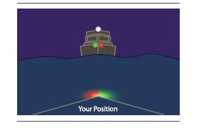
If you meet a vessel and see a green, red and white light, you are approaching another power-driven vessel head-on. In this situation neither vessel has the right-of-way. Both operators must take early and substantial action to steer well clear of the other vessel. Both operators should reduce their speed and steer to starboard.
If you meet a vessel and see a green and red light but no masthead (white) light, then you are approaching a sail-driven vessel. You are the give-way craft and must yield right-of-way to the sailing vessel.
BACK TO TOP

Port (left) approach
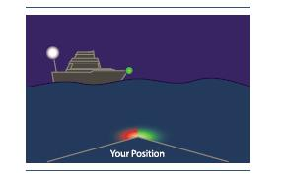
If a green and white light is visible, then another craft is approaching you from the port (left) side. In this situation, you are the stand-on craft and should maintain your speed and Course. The other craft should take early and substantial action to steer well clear of your craft.
BACK TO TOP

Starboard (right) approach
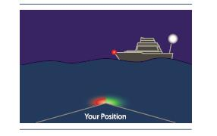
If a red and white light is visible, then another craft is approaching you from the starboard (right) side. In this situation you are the give-way craft and must yield right-of-way. You should take early and substantial action to steer well clear of the other craft. Reduce your speed, change direction and pass at safe distance behind the other boat.
Safe Boating Tip
A simple way to decipher power boat navigation lights is to remember the following:
If you see a green light you can “go”: Another boat is approaching from your port side
If you see a red light you should “stop”: Another boat is approaching from your starboard side

NAVIGATING AT NIGHT

Overtaking
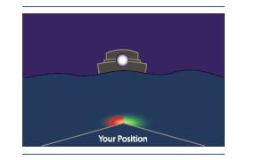
If only a white light is visible, you are approaching another craft from behind. You are the give-way-craft and must take early and substantial action to steer well clear by altering your Course and passing at a safe distance on the starboard (right) or port (left) side.
What else does a white light indicate?
If you see only a white light, it can generally indicate one of three things:
- You are approaching another craft from behind
- You are approaching a non-powered craft
- You are approaching a craft that is at anchor
Remember: In any of these situations, you do not have the right-of-way and must take early and substantial action to steer well clear and pass at a safe distance.
BACK TO TOP

Non power-driven craft
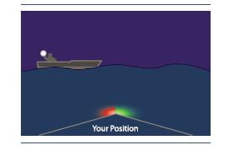
If you are approaching a non-powered craft, you are the give-way craft and must yield the right of way. You should take early and substantial action to stay well clear and pass at a safe speed and distance.
Safe Boating Tip
Any pleasure craft that is underway and using oars between sunset and sunrise must have ready for use an electric torch, flashlight or lighted lantern showing a white light (this rule applies if the boat cannot be equipped with standard navigation lights).
Anchoring at night
When anchored, you should exhibit your boat’s All-round light white light. This single white light indicates to other boaters that you are at anchor. Do not display your green and red sidelights as these indicate to other boaters that you are underway.

NAVIGATING UNIQUE WATERWAYS

Lock navigation
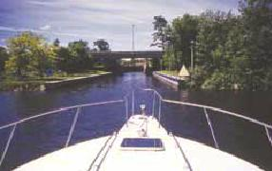
A lock is a physical structure of gates that enables vessels to travel between two bodies of water that are of different elevations.
Boats enter the lock from one body of water (vessels may enter from each end of the lock but from only one end at a time). Once the gates at the entrance of the lock are closed, the water level within the lock is increased or decreased to match the elevation of the adjoining body of water. When the correct water level has been reached within the lock, the gates are opened and boats are able to travel onwards.
A restricted speed zone is typically found at the entrance to each side of the lock. Obey posted speed limits and watch your wake when approaching a lock. Certain activities such as swimming, fishing, and water-skiing may also be restricted near locks.
BACK TO TOP

Entering and exiting a lock
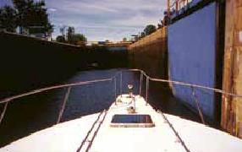
Operators should always control their speed when in the vicinity of a lock. When approaching a lock you should:
- Identify and adjust for water currents and other boat traffic
- Be aware of and operate according to any posted navigational aids (markers and buoys)
- Identify and adjust for adverse weather conditions such as high wind
- Be prepared for oncoming traffic as boats exit the lock
By mooring at the “blue line” area at the mouth of the lock, the lockmaster is made aware of your intention to enter the lock at the next opening. The lockmaster may provide specific instructions to your vessel including when to enter, in what order, and where to moor your vessel once inside the lock. Only tie up to the “blue line” if you wish passage through the lock.
BACK TO TOP

When entering a lock
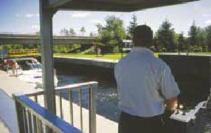
- Wait for any instruction from the lockmaster or waterway personnel.
- Proceed slowly (maximum speed limit is 10 km/h) and with caution into the lock. Have crew members posted at the Bow and stern of the boat with mooring lines ready to use.
- Use the vertical “drop cables” affixed to the walls of the lock to secure your Bow and stern. Your boat’s mooring lines should be wrapped loosely around the lock’s drop cables allowing for upward or downward movement of your craft. Never tie your vessel lines to the drop cables.
- Once positioned, turn off all engines, cease from using any fuel-burning appliances, and refrain from smoking. Turn on your engine ventilation system. Do not leave your mooring lines unattended.
- Once the water level within the lock has reached the proper elevation, the opposite end of the lock will open. The lockmaster will instruct you when to start your engine and when to proceed.
- Proceed with caution. Never block the entrance to the lock from other boats that may be entering or exiting.

NAVIGATING UNIQUE WATERWAYS

River navigation
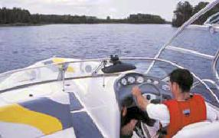
Operating a pleasure craft or PWC on a river is different than operating on an open waterway. A river presents its own unique hazards and conditions. Some rivers may exhibit strong currents which can affect your boat’s steering and the “predictability” of your craft. The water level in a river may also rise or lower more rapidly than an open waterway – exposing trees, rocks, sunken islands and other hazards. Always watch for
these types of hazards and the navigational aids that may indicate their position.
Remember
When approaching a blind turn always keep to the right side of a river. Power-driven craft and sailboats less than 20 m in length must give way to less manoeuvrable crafts while navigating on a river.
If two vessels approach each other in a narrow channel where tide, river flow, or underwater features create dangerous currents, then the vessel going downstream is automatically afforded the right-of-way
BACK TO TOP

Canal navigation
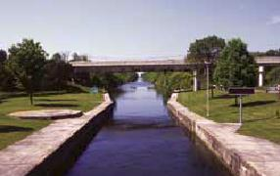
Canals are man-made waterways. A canal is typically narrower than a channel, and differs from a river as the depth of the water can be controlled.
You should always keep to the starboard (right) side of a channel, particularly when approaching oncoming traffic or entering a blind turn. Power-driven craft and sailboats less than 20 m in length must give way to less manoeuvrable crafts operating in a canal or shipping lane. Keep in mind that large vessels, such as commercial ships, are often restricted in their ability to manoeuvre in narrow channels, and pleasure craft operators should steer well clear.
There are a number of activities that are prohibited while in a canal:
- No excessive noise between 11 PM and 6 AM
- No mooring a vessel to a navigational aid
- No fishing within 10 m of a lock or from a bridge that passes over a navigation channel
- It is illegal to dive, jump, scuba-dive, swim or bathe within 40 m of a lock gate or dam
Safety around dams
Use caution when near canal dams where currents and undertows can be dangerous. Steer well clear of dams and adjust your Course to avoid strong currents near dams, especially when operating a small craft.
BACK TO TOP

Shipping lanes
The Collision Regulations require that boaters be aware of shipping lanes (traffic lanes) and use extreme caution when near vessel traffic lanes. Large commercial ships often cannot see small pleasure craft operating ahead of them from the bridge. You should always proceed in the appropriate traffic lane in the general direction of traffic flow for that lane. Boaters should join or leave a traffic lane at its termination, but when joining or leaving from either side you do so at as small an angle to the general direction of traffic flow as practicable.
You should avoid crossing traffic lanes but, if obliged to do so, cross at right angle to the general direction of traffic flow. If navigating near a shipping lane or near the termination of a shipping lane you should use caution, avoid the lane with as wide a margin as practicable. Always avoid anchoring in a shipping lane or near its termination. To increase your visibility to larger vessels in or near a shipping lane you should stay in groups with other small boats if possible.

SUMMARY

Summary
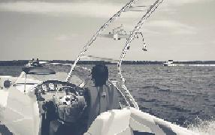
Understanding and abiding by navigation and right-of-way rules is essential for safe boating. Remember that certain types and sizes of craft are governed by different navigation rules under the Collision Regulations. Knowing what actions to take when approaching another craft will help you reduce the risk of collision and injury to yourself and others. Always keep a look out for other boat traffic, relative to your sectors of navigation.
You should be able to navigate with confidence during periods of restricted visibility, such as when operating at night or during poor weather conditions. Being able to recognize different types of craft by the configuration of their navigation lights is vital for safe operation during such conditions.
By completing this module, you should know the rules and regulations for operating on unique waterways such as canals, rivers, and locks. Remember that less manoeuvrable vessels have the right-of-way when operating in shipping lanes and confined waterways, such as rivers and canals.

AIDS TO NAVIGATION

Aids to navigation
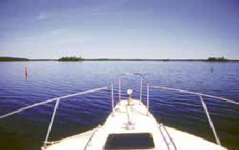
“Aids to Navigation” are the system of buoys and markers that assist a boater in determining his or her position and identifying potential dangers and waterway obstructions. External to pleasure craft, Aids to Navigation can be used to plot position and Course on nautical charts and other nautical publications. Aids to Navigation also assist the pleasure craft operator in choosing the most preferred and safest route.
It is prohibited under the Criminal Code of Canada to interfere with any aid to navigation. Operators should never tie up to a marker, buoy or any other aid to navigation. In addition, no person may willfully alter, remove or conceal a signal, buoy or other type of navigation marker.
Two main systems of navigation are used on Canadian Waterways: The Lateral System and The Cardinal System. All Aids to Navigation have identifying marks such as colours, lights and numbers.
BACK TO TOP

What is a buoy?
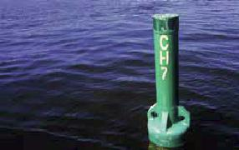
A buoy is a floating marker or signal which is affixed to the bottom of the waterway or mounted on a feature (such as an island) of the waterway.
Buoys serve four main functions:
- Provide Warnings
- Provide Information
- Mark underwater hazards
- Provide a system for navigation
BACK TO TOP

Floating buoys
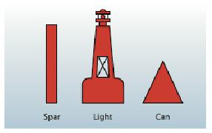
There are three styles of floating buoys used on Canadian waterways:
- Light Buoys: Light buoys are typically the largest of all floating buoys and have a light fixture affixed to the top of the buoy.
- Spar Buoys: Spar buoys are also called “pillars” and are common on smaller waterways. They have a cylinder shape and are typically smaller than light buoys.
- Cans: Cans are wider than spar buoys and are typically used as lateral system and bifurcation buoys.
All floating buoys are affixed to the bottom of the waterway using a structure of underwater cables and anchors.

AIDS TO NAVIGATION

Systems of buoys in canada
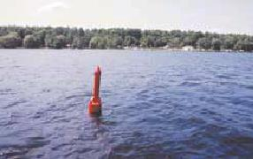
There are several systems of buoys and markers used on Canadian waterways to aid in navigation:
- The Lateral System is a system of red and green buoys used to mark preferred safe routes. The Lateral System also includes fairway buoys, isolated danger buoys and day beacons.
- The Cardinal System consists of yellow and black buoys that indicate safe routes by the cardinal compass points.
- A Range is a series of two buoys that, when aligned along a sight path, indicate the safest route for navigation.
- Special Purpose Buoys may be yellow or white in colour and are used to mark dangers such as (but not limited to) racecourses, underwater structures, pipelines, etc.

THE LATERAL SYSTEM

The lateral system
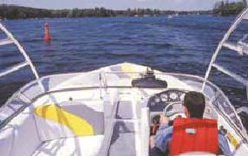
The lateral system is used to mark the most preferred and safest routes. Consisting of red and green buoys, this system marks the Course of deepest water and indicates on which side of the buoy boaters should safely pass.
In the Lateral System, buoys and beacons indicate the sides of the channel or route relative to a conventional direction of buoyage (usually upstream). They also mark junctions (a point where two channels meet) or bifurcations (the point where a channel divides). They can also mark a place where two tributaries meet.
Keep in mind: When navigating along the course of a channel or fairway you should be as near to the outer limit of the channel or fairway on the starboard side as is safely possible
There are two main types of Lateral System buoys which are most familiar to boaters:
- Green Port-hand buoys
- Red Starboard-hand buoys
In total, there are six types of lateral buoys including: port hand buoys, starboard hand buoys, port bifurcation buoys, starboard bifurcation buoys, fairway buoys, and isolated danger buoys. The Lateral System is standardized for international waterways.
BACK TO TOP

Port-hand buoys
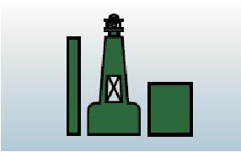
Port-hand buoys are green in colour and mark the left side of a channel or the location of a specific danger. Port-hand buoys must be kept on the left-hand side of your boat when upstream.
Port-hand buoys are identified by letter(s) and odd-digit number(s), and in standard configuration, are flat on the top. In some instances, a port-hand buoy may be fitted with a top-mark consisting of a single green cylinder.
Port-hand buoys may also be fitted with a green light that flashes in either a:
- F1 pattern (single flashes in 4 second intervals); or
- Q pattern (quick single flashes one second apart)
BACK TO TOP

Starboard-hand buoys
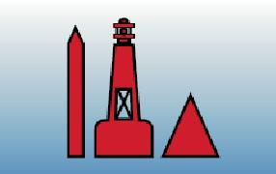
Starboard-hand buoys are red in colour and mark the right side of a channel or the location of a specific danger. Starboard-hand buoys must be kept on the right-hand side of your boat when upstream.
Starboard-hand buoys are identified by letter(s) and even-digit number(s) and in standard configuration, are pointed on the top. If they do not have a red light they will be conical on the top.
Starboard-hand buoys may also be fitted with a red light that flashes in either a:
- F1 pattern (single flashes in 4 second intervals); or
- Q pattern (quick single flashes one second apart)

THE LATERAL SYSTEM

Bifurcation buoys
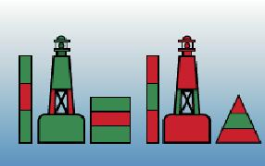
Part of the lateral system, bifurcation buoys indicate the junction of channels:
- Port-Junction bifurcation buoys are green in colour with a red horizontal band at the midsection. Port-junction buoys mark the junction of two channels and should be kept on the port (left) side of the vessel when navigating upstream.
- Starboard-Junction bifurcation buoys are red in colour with a green horizontal band at the midsection. Starboard-junction buoys mark the junction of two channels and should be kept on the starboard (right) side of the vessel when navigating upstream.
BACK TO TOP

Fairway buoys
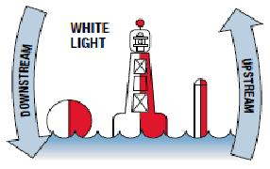
Fairway buoys are used to mark the entrance to a channel, the centre of a shipping channel, or a safe approach to land. Vessels should keep the fairway buoy on the left (port) side whether proceeding upstream or downstream.
Fairway buoys are identified by the following:
- Red and white in colour, divided vertically with one side red and the other side white
- Will have a ball shaped top-mark
- May be equipped with a white light that flashes in a Mo(A) sequence – One short flash, followed by one long flash repeated 10 times per minute
BACK TO TOP

Isolated danger buoys
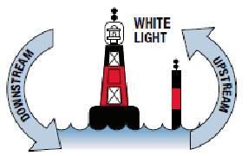
An isolated danger buoy is used to mark an isolated hazard or obstruction such as a rock, shoal, or sunken island. The buoy will be moored on, or above, an isolated danger that has navigable (i.e. safe) water all around it. You should refer to a marine Chart to determine the features of the isolated danger (i.e. size, depth, exact location etc.) and should navigate well clear of the marked danger.
Isolated danger buoys are identified by the following:
- Black in colour with a wide red band at the midpoint
- A top-mark consisting of two black balls
- May be equipped with a white light that flashes in a FL(2) sequence – a two flash sequence repeated every 4 seconds

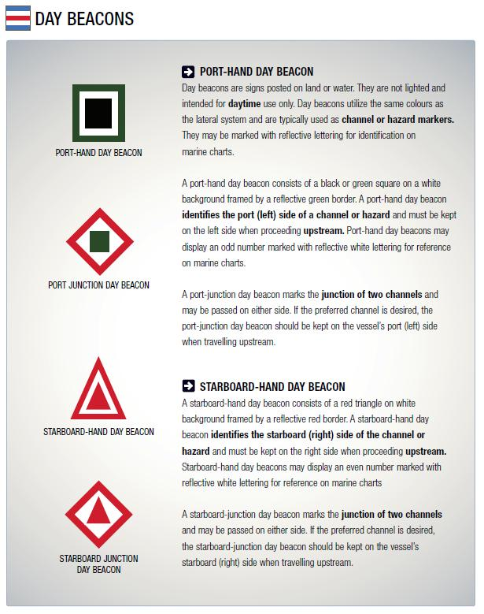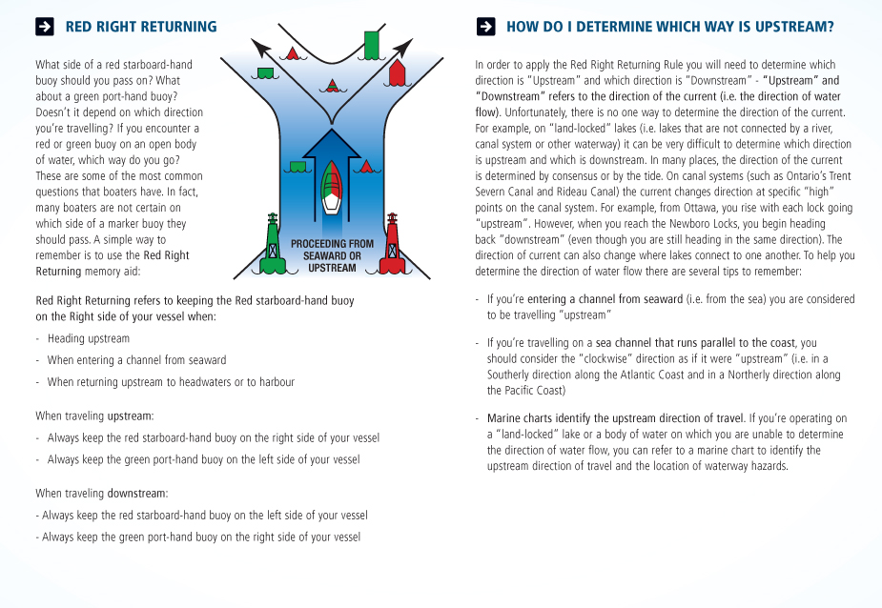THE CARDINAL SYSTEM

The Cardinal System
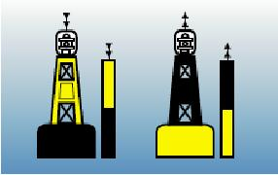
The cardinal buoy system consists of yellow and black buoys that are used to assist boaters in identifying the location of safe water. Safe water lies on the North, South, East or West side of the buoys. For example, a North Cardinal Buoy indicates that safe water lies to the North of the buoy. Cardinal buoys may be equipped with a light and/or letters for identification on a marine Chart. Remember: With cardinal buoys, safest water lies in the direction indicated by the buoy. Water in the opposite direction should be considered unsafe and avoided.
Cardinal markers are spar or pillar shaped (with a flat top). The position of the yellow and black colour bands indicates the cardinal Compass point of North, South, East or West and therefore the direction of the safest water. If so equipped, top-marks consisting of two cones indicate the direction of safe water.

SPECIAL BUOYS AND FLAGS

Range day beacons
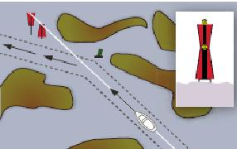
Ranges are typically used to guide larger vessels through a channel. Ranges consist of two or more markers, permanently affixed at a significant distance from each other. Ranges are constructed so that there is an upper marker and a lower marker. The lower marker is constructed near ground level at the shore while the upper marker is attached to a tower, located behind the lower marker.
One navigates through the channel by maintaining a Course that keeps one marker aligned top and bottom with the other. When the two markers are lined up vertically, the boater is on the recommended Course.
BACK TO TOP

Boating restriction signs
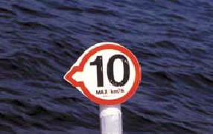
There are five shapes associated with boating restriction signs. Each boating restriction sign is framed in orange. The symbol on the sign indicates the type of restriction that applies. If the sign is arrow shaped, the restriction applies in the direction pointed by the arrow. Signs with a green border indicate that a special condition applies to the restriction.
Click on the image to the left to see examples of Boating Restriction signs.
BACK TO TOP

Special buoys and flags
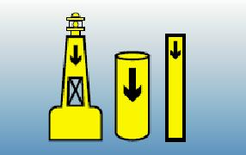
There are a variety of special buoys and flags that mark specific hazards and provide information to the operator. These markers may be equipped with lights and may be marked with letters or numbers for Chart identification. Operators must learn and be able to identify each special buoy and flag (refer to Appendix C at the beginning of the next page for a description of special buoys and flags).
Posted command signs
Operators may encounter additional Aids to Navigation including command signs and warning signs. These signs may be posted either on land or in the water and may signify:
- No-wake zones
- No-Anchorage areas
- Speed-limit zones
- Low-head dam hazards
- Pipeline hazards
- Power line hazards

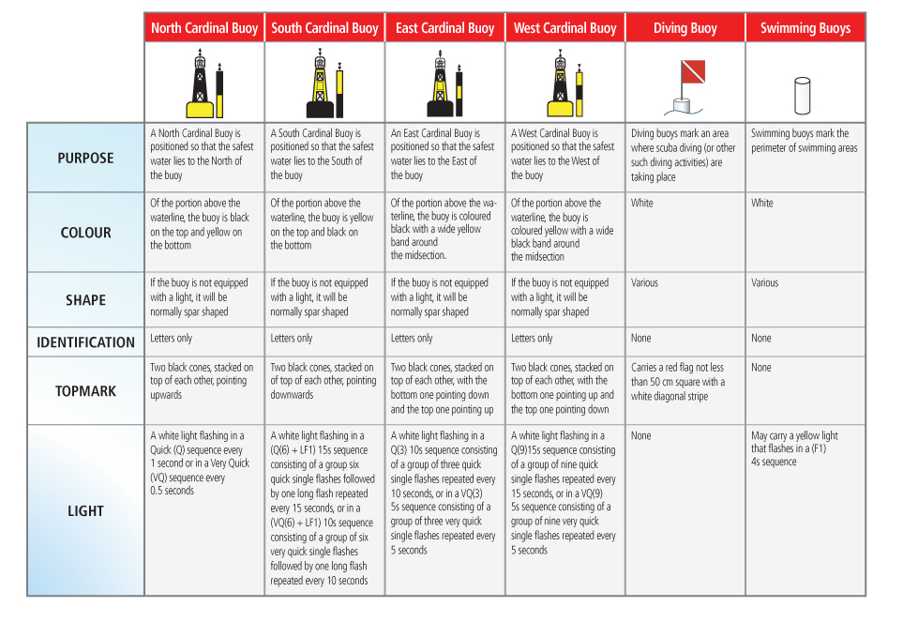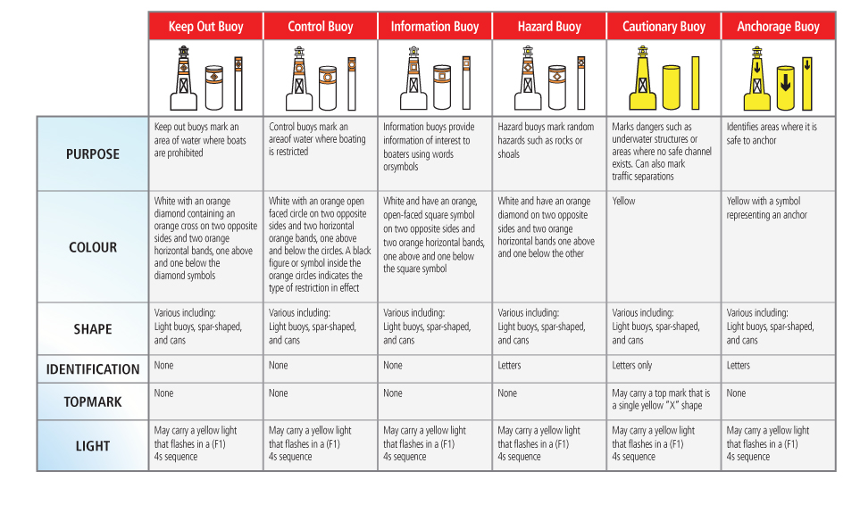SUMMARY

Summary
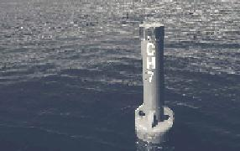
In this module you learned about Aids to Navigation and the different systems of markers and buoys in Canada. Markers and buoys indicate the most preferred and safest routes for navigation and also mark specific hazards and/or dangers. Keep in mind that you can reference markers and buoys on marine charts by their location and the numbers marked on them.
The Lateral System is the most common system of buoys in Canada and consists of green Port-Hand Buoys and red Starboard-Hand Buoys. Don't forget the Red Right Returning memory aid, which refers to keeping the Red Starboard-Hand Buoys on the right side when returning upstream into harbour or headwaters. You will need to determine upstream and downstream directions for the specific waterway on which you will be operating in order to navigate successfully using the Lateral System. You should be confident of these rules before out on any waterway.
The Cardinal System marks safe water according to the Compass points of North, South, East and West. You should be able to identify and navigate according to the Cardinal Buoy system.
Special buoys and flags mark specific hazards and/or provide important information to boaters. These include Hazard Buoys, Control Buoys, Information Buoys, Anchorage Buoys, Swimming Buoys, Diving Buoys and others. You should be able to recognize these buoys and operate accordingly in their vicinity

RESPONDING TO EMERGENCIES

Boating emergencies
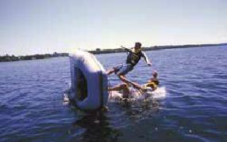
Boating emergencies can come in various forms and degrees of severity. The key to safe, enjoyable boating is being prepared and having the right knowledge. You may not be able to predict the unexpected - but you can prepare for it.
In a boating emergency you should:
- Remain calm
- Properly assess the situation and then take appropriate action
- Ensure your own safety and that of your passengers and crew
- If necessary, signal your need for help using a recognized distress signal
BACK TO TOP

What to do in an emergency
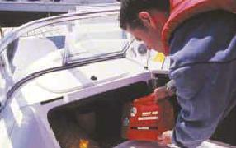
Remembering the following will help you respond effectively in an emergency:
- Always ensure that passengers and crew members are wearing a PFD or Lifejacket.
- The Small Vessel Regulations require that certain vessels carry an emergency kit. Keep the proper equipment and supplies onboard to stop hull leaks and make minor on-water repairs.
- Carry a first aid kit onboard at all times.
- If you or any of your passengers have been injured: Whoever is closest to the injured person should assess the victim’s breathing and administer first aid if necessary.
Safe Boating Tip
Would you know how to perform rescue breathing techniques in an emergency?
Have you ever treated a person suffering from hypothermia? If you don’t know how to handle these type of emergencies take a first aid Course. If an emergency arises, you’ll be able to respond quickly - You may even be able to prevent permanent injury or death.
BACK TO TOP

Rendering assistance
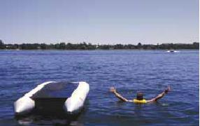
Remember: Always keep a look out for other boaters signalling distress and/or need of assistance. If you have witnessed a distress signal or an emergency situation, you are required by law to help other boaters as long as it is safe to do so.

RUNNING AGROUND

If your craft has run aground
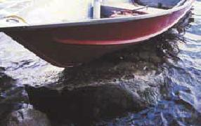
If your craft has run Aground:
1. Immediately shift the motor to neutral
2. Ensure that everyone is wearing a PFD or Lifejacket
3. Visually and/or verbally confirm that all passengers are present and accounted for
4. Determine if there are other craft in the vicinity that may offer assistance
5. Determine if there is any danger of being hit by other boat traffic
6. Inspect the hull and equipment for any damage. Check for rising or accumulating water in the hull
7. If the hull is undamaged, assess your Course of action:
- Is it possible to dislodge the craft from its
- obstruction?
- Is it necessary to lighten the craft by removing
- equipment and passengers?
- Is it possible that passengers may be able to
- push the craft off the obstruction?
- Is it possible to use the reverse thrust of the engine to free the craft from the obstruction?
8. If necessary, signal your need for help using a recognized distress signal
Safe Boating Tip
Your first reaction when running aground might be to gun the engine in reverse in an effort to dislodge your craft - this is the one thing you should not do. You could damage your boat’s rudder or propeller. You might also suck sand or mud into your engine’s cooling system. You should always assess the situation before attempting to dislodge your craft.
You should always consult a marine chart for the area in which you’ll be operating. Being aware of the water depth and the draft that your boat requires will ensure
you can avoid running aground and damaging your propeller.
BACK TO TOP

If your craft has capsized
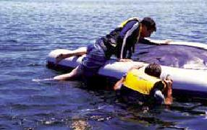
If your craft has capsized:
- Ensure that everyone is wearing a PFD or Lifejacket
- Visually and/or verbally confirm that all passengers are present and accounted for
- Determine if there are other craft in the vicinity that may offer assistance
- Determine if there is any danger of being hit by other boat traffic
- If you and your passengers are far from shore or unable to reach shore, stay with your craft. If your craft is not fully submerged, climb onto the overturned hull. This will help you retain energy, increase your survival time in cold weather/water conditions, and increase your visibility to other boaters. However, only re-board the capsized vessel if it is still afloat, seaworthy, and safe to do so. If it is appropriate to leave the craft, swim to shore and immediately get assistance once you’ve reached shore
- If necessary, signal your need for help using a recognized distress signal

SWAMPING AND SINKING

Hull leaks and flooding
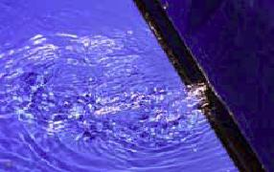
Striking underwater hazards such as a submerged rock, sunken island, shoal or deadhead may cause serious damage to your craft resulting in a breach of the hull. If the hull of your craft is breached, leaking and flooding will occur. Improper fitting of the craft’s drain plug or a worn or improperly installed exhaust/out-drive seal may
also result in flooding.
If you witness water accumulating in the hull of your boat, immediately take the following actions:
- If the craft is moving bring it to a complete stop (this will reduce water pressure against the hull and reduce the speed at which water is entering the boat). Turn on the bilge pump (if so equipped) and identify the source of the leak or flooding.
- Stop the hull leak if possible. The use of tapered wooden plugs, a hull patch kit, towel, rag or other malleable material may work.
- Attempt to remove accumulations of water. You can remove water by using a hand-held bailer, manual pump, or bilge pumping system. You should use a device that suits the circumstances and the type of craft. (Your craft should be equipped with appropriate bailing devices as stipulated by the Small Vessel Regulations.
- If necessary, signal your need for help using a recognized distress signal.
Remember
You should carry onboard the tools and materials needed to temporarily stop hull leaks or flooding.
These include:
- Tapered wooden plugs
- Hull patch kit
- Towels, rags, or other malleable material
BACK TO TOP

If your craft is swamped or is sinking
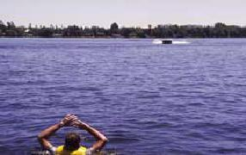
A boat is “swamped” when it fills with water from over the side. Swamping can be caused by large waves coming over the gunwales or transom of your boat if it has been overloaded. If your boat has been swamped or is sinking:
- Ensure that everyone is wearing a PFD or Lifejacket
- Visually and/or verbally confirm that all passengers are present and accounted for
- Determine if there are other craft in the vicinity that may offer assistance
- Determine if there is any danger of being hit by other boat traffic
- Attempt to stop any hull leaks or flooding if possible
- If you cannot stop your craft from sinking, immediately swim to safety
- Signal your need for help using a recognized distress signal

COLLISIONS AND ABANDONING SHIP

Collisions
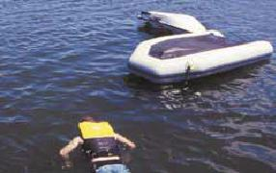
If your craft has been involved in a collision:
- Visually and/or verbally confirm that all passengers are present and accounted for. Ensure that everyone is wearing a PFD or Lifejacket.
- Determine if there are other craft in the vicinity that may offer assistance.
- Determine if there is any danger of being hit by another boat
- Inspect the hull and equipment for any damage - Check for rising or accumulating water in the hull
- If necessary, signal your need for assistance
BACK TO TOP

Reporting a collision
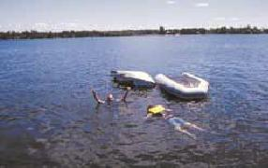
You are required to take certain actions if you have been involved in a collision:
- You are required to stop and identify yourself, your vessel, your home port, and your ports of origin and destination to the other craft
- You are required to assist the crew of the other vessel if it safe to do so
- If damage exceeding $1,000 has occurred, or the seaworthiness of either vessel has been compromised, you are required by law to file an accident report with the local authorities
- If serious injury or death has occurred, you are required by law to report the collision to the local law enforcement agency
BACK TO TOP

Abandoning ship
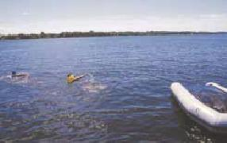
If circumstances (such as an onboard fire) dictate that you and your passengers need to abandon ship, do the following:
- Ensure that you and your passengers are wearing a PFD or Lifejacket
- If time permits, signal your need for assistance with a radio, Flare, horn, or flashlight
- If possible, jump to the windward side of the boat (the boat will drift away from you)
- Once in the water swim well clear of the boat
- Visually and/or verbally confirm that all passengers are present and accounted for

PERSON OVERBOARD

Person overboard emergency
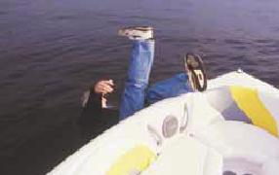
Over 40% of all boating fatalities are the result of people falling overboard (in addition to 40% of deaths involving alcohol as described in Module 1). You should be prepared with the right knowledge and equipment to rescue a person oveboard:
- Ensure that your emergency equipment is properly maintained and readily accessible
- Practice overboard rescue techniques with your passengers and make them aware of their responsibilities
- Practice manoeuvring your pleasure craft to properly position your boat so that you’re ready to perform an overboard rescue if an emergency arises
- You should be able to respond effectively, with water surface and weather conditions, as well as the condition of the person overboard, in mind
BACK TO TOP

Rescuing a person overboard
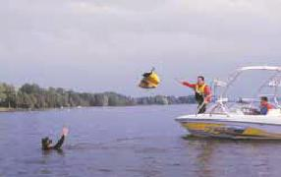
First, you should sound an alarm notifying your passengers and other boaters of the situation and call for help:
- Shout “Help - Person Overboard!”
- Assign another passenger to keep a visual contact of the person overboard and continuously point to the person’s location.
- Immediately throw the person a buoyant item such as a PFD or Lifejacket. This will help the person stay afloat and mark their position in the water (in the event that they become submerged or if attempting to rescue under reduced visibility).
Second, you should assess the situation and your readiness:
- Are you wearing a PFD or Lifejacket?
- Do you have the proper emergency equipment on hand and readily accessible?
- How panicked is the overboard person?
Third, you should remain calm and determine which overboard rescue technique to use:
- Reaching Assist (such as an oar, paddle, pole, or piece of clothing)
- Buoyant Heaving Line
- Life Buoy
BACK TO TOP

Overboard Rescue Techniques
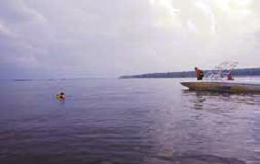
When rescuing a person overboard:
- Carefully manoeuvre the craft turning the bow into the wind.
- Once in position, shut down the engine to avoid injury (such as a propeller strike) or accidental movement.
- Once you have retrieved the person using one of the techniques described below, move to the side of the boat keeping your weight low and instruct the victim that you’re going help him/her out of the water.
- Use a re-boarding device (such as a portable ladder) to assist the victim up and over the side of the boat. In a small boat recover the victim over the stern as it is typically the lowest part of the craft. A heavy rope, chain or cable secured at both ends and draped over the side (almost touching the water) can also be used as a makeshift step if necessary.
Remember the following when rescuing a person who has fallen overboard:
- Position your craft downwind from the victim. He or she will drift towards your boat.
- Don’t panic. Keep a calm head and consider your course of action.
- Don’t jump into the water. If the victim is panicking and thrashing in the water he or she may grab hold of you and pull you under.
- Practice the emergency recovery techniques described in this section and ensure your passengers become familiar with the equipment, techniques and movement of the pleasure craft necessary to perform a successful rescue.
Using a Reaching Assist:
- Move to the side of the boat keeping your weight low and instruct the victim that you’re going to help him/her out of the water
- Using the reaching assist pull the victim to the side of the boat
- Using a re-boarding device assist the victim up and over the side of the boat
Using a Buoyant Heaving Line:
- Ensure the inboard end of the buoyant heaving line (the end without the float) is secured to the boat
- Throw the line so it lands behind the victim
- Slowly pull the line towards you so the victim is able to grab onto it
- Pull the victim to the side of the boat
Using a Life Buoy:
- Ensure the lifebuoy is secured to the boat with a line
- Throw the life buoy so it lands behind the victim
- Slowly pull the line towards you so the victim is able to grab onto it
- Pull the victim to the side of the boat

COLD WATER / COLD WEATHER SURVIVAL

Hypothermia
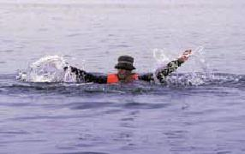
Hypothermia is a drop in core body temperature, caused by prolonged exposure toabnormally low temperatures. Hypothermia can be caused by:
- Immersion in cold water
- Exposure to cold air and wind while in water soaked clothing
- Prolonged exposure to low water and air temperatures
- Hypothermia sets in when core body tempurature drops below 35.0 degrees Celcius
BACK TO TOP

1-10-1
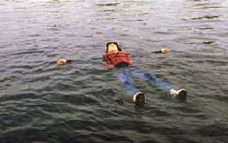
1-10-1 is a simple way to remember the first three phases of cold water immersion and the approximate time each phase takes.
1- Cold Shock: An initial deep and sudden gasp followed by hyperventilation. Cold Shock will pass in about 1 minute. During that time concentrate on avoiding panic and getting control of your breathing. Wearing a lifejacket during this phase is critically important to keep you afloat and breathing.
10 - Cold Incapacitation: Over approximately the next 10 minutes you will lose the effective use of your fingers, arms and legs for any meaningful movement. Swim failure will occur within these critical minutes and if you are in the water without a lifejacket, drowning will likely occur.
1- Hypothermia: Even in ice water it could take approximately 1 hour before becoming unconscious due to Hypothermia. You should understand the techniques of how to delay hypothermia, self rescue and calling for help in order to increase your chances of survival.
Cold water can also paralyze your muscles instantly - making it extremely difficult to put on a Lifejacket or PFD.
It is important to remember that cold water shock can occur throughout the year, even during warm summer months when water temperatures can remain lower than outside air temperatures.
BACK TO TOP

Stages of hypothermia
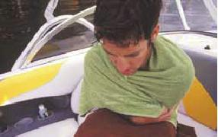
If suffering from hypothermia, the victim’s core body temperature drops Below normal levels resulting in weakened muscular functions, reduced co-ordination and slowing of mental functions.
A person suffering from hypothermia will exhibit progressive symptoms including:
1) Early Stage:
- The victim is still conscious
- Shivering
- Slurred speech
2) Intermediate Stage:
- The victim may be irrational, confused and sleepy and will exhibit a lack of co-ordination
- Slow and weak pulse
- Slow respiration
- Shivering exhibited in the early stage will now be slowed or absent
3) Final Stage:
- The victim may lose consciousness
- Weak, irregular or absent pulse
- Weak, irregular or absent respiration

COLD WATER / COLD WEATHER SURVIVAL

Cold water/weather survival gear
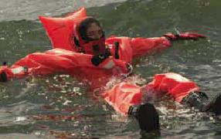
If you plan to operate in the early spring, late fall or in other cold environments, you and your passengers should always make use of cold weather and cold water protection gear. You can protect yourself by wearing a Lifejacket or PFD and multiple layers of dry, light clothing and a water or wind proof outer layer. Gear specifically designed for cold environments offer better protection from the elements and can delay the effects of hypothermia:
- Wet Suit: Traps and heats water against the body and should be used with a flotation device
- Dry Suit: Remains dry on the inside and should be used with a flotation device and thermal liner
- Survival Suit: Helps retain body heat and works as a full body flotation device
- Immersion Suit: To be used in extreme conditions when abandoning a vessel
- Exposure Coverall: A PFD with thermal protection
Be sure to choose cold weather protection gear that is appropriate to the temperature and your planned operating environment. Knowing how your equipment works in the water is also important. Test your equipment in a warm swimming pool or in calm water before you need it in an emergency.
BACK TO TOP

Rescuing a person with hypothermia
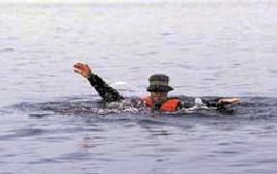
Immediate Action
1) Ensure that you are wearing an approved PFD or Lifejacket
2) Assess the victim's current condition: What stage of hypothermia is he exhibiting?
3) Clearly identify yourself to the person and ask him/her to respond
4) Assess what emergency and/or personal items you have onboard that may be used to warm the victim
5) Assess your ability to help the victim:
- - Do you have warm dry items to cover and wrap the person?
- - Will you be able to get the victim to safe harbour quickly?
6) Exhibit a distress signal indicating your need for
assistance if necessary
BACK TO TOP

Rescue Procedure
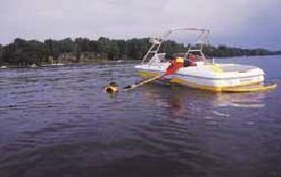
1) Remove the person from the source of cold exposure. (You should use the overboard rescue techniques described on pages 114 & 115 to remove the person from the water if necessary).
2) Provide dry shelter Below Deck if possible. Use a blanket, towel, or article of clothing to keep the victim warm.
3) Attempt to slowly increase the victim’s core body temperature by one or a combination of the following:
- Remove the victim from wet clothing as it can prolong cold exposure and worsen the symptoms of hypothermia - However, only remove wet clothing if you are able to provide a dry covering such as a blanket or a warm environment
- Cover the victim's head and neck
- Wrap the victim in dry blankets or towels
- Cover the victim with an insulating device (such as a reflective heat blanket) and vapour barrier
- Apply dry, warm objects (such as a hot water bottle) that have been heated to 40-45°C

COLD WATER / COLD WEATHER SURVIVAL

Remember
Remember
- If the victim asks for a warm liquid you may provide it to him. However, you should never give the victim alcohol or hot stimulants.
- Do not rub and/or massage the victim’s body or extremities in attempt to warm him up. Doing this may damage nerve endings at the skin and encourage cold blood from the extremities to move to the core of the body.
- You can use you own body to transfer heat to the victim.
- You should always carry a Safety Kit including equipment suitable for cold water and cold weather emergencies.
BACK TO TOP

Surviving cold water
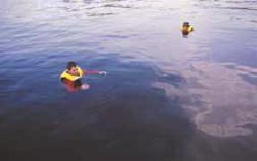
If you find yourself in cold water, do the following to increase your survival time:
Immediate Action
1) Assess the situation:
- Is everyone wearing a PFD or Lifejacket?
- Can you get to shore or safety?
- Are there any boaters who can assist you?
- Are you able to signal or call for help?
2) If you are within 50 m of shore and are able to swim to safety you should do so.
3) If you are injured, there is help close by, or you are farther than 50 m from shore, you should stay where you are.
4) If you are alone and close to a floating object, you should climb onto the object to remove yourself from the cold water and save energy. However, you should only do so if you are able to get most of your body out of and above the water.
5) Immediately signal or call for help if you are able to do so.
BACK TO TOP

Huddle position
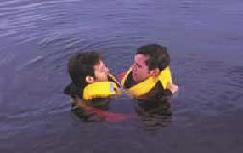
If you and your passengers find yourself exposed to cold water, and are unable to swim to shore or climb onto a floating object, you should assume the Huddle Position to increase your survival time:
- Place your arms around each other’s mid to lower back and pull together so your chests are close to each other’s sides
- Intertwine your legs
- Place any children in the middle of the huddle
- Keep unnecessary movements to a minimum in order to conserve energy
- COLD WATER / COLD WEATHER SURVIVAL

- Heat escape lessening position
- 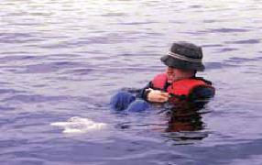
- If you find yourself alone and exposed to cold water, use the Heat Escape Lessening Position (H.E.L.P.) to reduce heat loss from your core body temperature and delay the effects of hypothermia.
- H.E.L.P is performed as follows:
- 1) Cross your arms tightly against your chest
- 2) Draw your knees up and against your chest
- 3) Keep your head and face out of the water

BREAKDOWN AND MECHANICAL FAILURE

Breakdown and mechanical failure
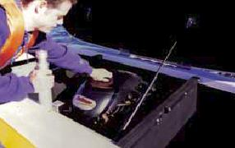
You are required by law to maintain your craft and safety equipment in proper working order. By regularly maintaining and inspecting your vessel, you’ll reduce the risk of an unexpected breakdown.
If your craft has broken down or is inoperable due to mechanical failure:
- Immediately alter your speed as appropriate to the situation.
- Use an anchor to secure your craft if necessary. If you are in a high traffic area, use a manual propelling device (such as a paddle or oars) to manoeuvre your craft to a safe area before anchoring. If you have lost all power and are drifting towards significant danger, set your anchor immediately.
- Investigate the cause of the breakdown or failure.
- If possible, correct the problem.
- If necessary, signal your need for assistance help using a recognized distress signal.
Remember
You should always carry a toolkit including:
- Spare bulbs (appropriate for your craft)
- Spare fuses
- Grease, penetrating oil and rags
- Spare Oil (4-Stroke or 2-Stroke depending on your type of engine)
- Spare safety lanyard (PWC operators)
- Spare spark plugs (appropriate for your engine)
- Basic toolset
- Common nuts and bolts
- Tie straps and duct tape
BACK TO TOP

Carbon monoxide
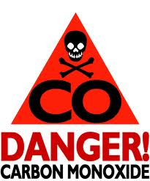
Carbon Monoxide (CO) is a deadly gas you can’t see, smell or taste. CO is produced by anything that burns carbon-based fuel (gasoline, propane, charcoal, oil, etc.), including engines, generators, cooking ranges and heaters. CO spreads evenly throughout an enclosed space and is undetectable. Be aware when swimming from a boat equipped with pontoons. CO buildup can occur between the pontoons of a houseboat or pontoon boats.
CO is inhaled through your lungs and cuts off the oxygen supply to your body and can kill in minutes. Be alert to flu-like symptoms which can include headaches, nausea and fatigue.
Operators of boats with fuel burning appliances such as cooking ranges in houseboats, should be aware of the increased risks of CO poisoning. Swimmers or people being towed closely behind a boat with engines operating are also at increased risk of CO poisoning.
BACK TO TOP

Protect yourself from co poisoning
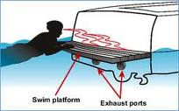
Be sure to protect yourself and others from CO poisoning:
- Use a marine grade CO detector and check its batteries before each trip
- Only idle your engine in well ventilated areas and recognize that winds from the stern can carry CO back on board
- Only heat you boat’s cabin or cook when in a well ventilated area
- Use only fuel-burning engines or appliances that are certified or designed for marine use
- Proper use of ventilation systems and blowers on your craft can reduce the risk of CO poisoning
Treating CO poisoning
- Move to fresh air away from the source of CO
- Seek medical/emergency help immediately

BREAKDOWN AND MECHANICAL FAILURE

Using fuel-burning appliances
Gas fumes, leaking propane and butane are heavier than air and will flow into the lower portions of your boat. These fumes are hard to remove and are highly explosive.
Be sure to follow these safety procedures when using butane and propane:
- Use fuel-burning appliances only in well-ventilated areas
- Secure gas cylinders, portable appliances and heaters so that unexpected movement doesn’t cause a leak
- Always attend to open-flame heating, cooking or refrigeration systems
- Install fuel burning equipment according to manufacturer’s instructions

FIGHTING A FIRE

Fighting a fire
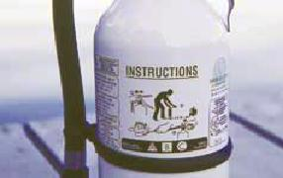
Although rare, fires can occur onboard a boat. Fires can be caused by a number of factors including engine malfunctions, a fire in the Galley, or other factors such as insufficient ventilation of an enclosed engine compartment. If a fire or explosion occurs, you can lessen the severity of the emergency by:
- Ensuring you have the mandatory fire-fighting equipment onboard
- Ensure fire-fighting equipment is in good working order and is readily accessible
- Ensuring you and your passengers respond with speed and effectiveness
When using a fire extinguisher:
- Ensure the extinguisher is suitable for the type of fire you are attempting to extinguish
- Stand at least 1 m from the source of the flame
- Pull the safety pin on the handle of the extinguisher
- Aim at the base of the flames and squeeze the trigger handle
- Spray the base of the fire with a left-to-right sweeping motion
BACK TO TOP

Important fire extinguisher tips
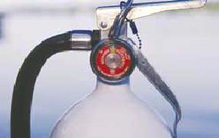
Always remember to:
- Use an extinguisher designed for marine use as it will be more corrosion resistant.
- Use an extinguisher with an external gauge (that indicates the condition of the charge).
- Ensure the extinguisher is inspected and maintained regularly.
- Remember that the fire-fighting material in dry chemical extinguishers can “cake” and lose effectiveness over time. The extinguisher should be turned upside down and shaken at least once per month. C02 type extinguishers should be weighed annually and re-filled when they have diminished to 90% capacity.
- Be aware that CO2 and Halon type extinguishers utilize colourless, odorless gases that displace oxygen. Proceed with caution if using or storing these type of extinguishers in an enclosed area.
BACK TO TOP

Tips and maintenance
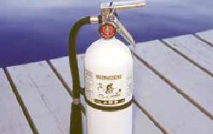
Water should never be applied to electrical (Class C) or flammable liquid (Class B) fires - Water will spread flammable liquid fires and will conduct electricity. Also, you should never use water on a grease fire. For marine uses, it is recommended that boaters use fire extinguishers that are approved to extinguish Class A, B and C fires.
Maintenance
A dead fire extinguisher is useless. Monthly inspections are required to keep fire extinguishers in proper working order. When inspecting a fire extinguisher you should:
- Check the gauge to ensure the fire extinguisher is fully charged
- Look at hoses (if so equipped) and replace any cracked or broken hoses
- Inspect the seals at the neck of the extinguisher to ensure they are not cracked or broken
- Weigh extinguishers to make sure they meet the minimum weight levels stated on the label - Have fire extinguishers recharged if they contain less than 90% of their rated capacity
- DISTRESS SIGNALS

- Understanding and using distress signals
- 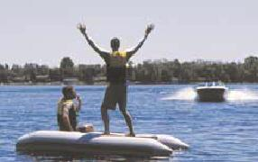
- Pleasure craft operators must be able to recognize, use and properly exhibit distress signals as required by the Small Vessel Regulations.
- Depending on the size of your craft, and whether you are operating a power or sail-driven vessel, you are required to carry certain types of distress signals. See
Appendix A for distress equipment requirements.
- Remember
It is an offence to make or report a fake distress signal. Sending false distress signals takes time away from Search and Rescue organizations, making them unavailable or farther away from real emergencies.
- Assisting vessels in distress
You are required to render assistance to any person, vessel or aircraft that signals distress. You are also required to offer assistance if you respond to a distress call and are asked by the vessel in distress to render assistance. If it is unreasonable (unsafe) to offer assistance, you are not required to help.
- BACK TO TOP

- Hand signal
- 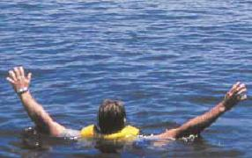
- You can use your hands to signal distress: Slowly raise and lower outstretched arms from above your head to each side of your body in repetition.
- BACK TO TOP

- Portable horn / whistle
- 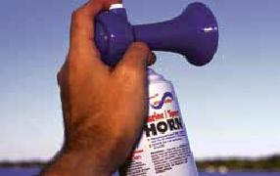
- You can use a portable horn or whistle to signal distress by continuously sounding in one minute intervals. You can also signal SOS by sounding three short blasts, then three long blasts, followed by three short blasts.
- Other sound signalling devices
You can signal distress by continuously sounding a fog-signalling device. You may also use a gunshot or other explosive sound-emitting device fired at one minute intervals.

DISTRESS SIGNALS

Watertight flashlight
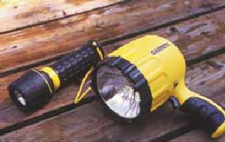
A watertight flashlight can serve as an effective distress signal at night or during periods of reduced visibility. To signal distress with a flashlight, flash SOS - Three short flashes, then three long flashes, followed by three short flashes.
BACK TO TOP

Flares
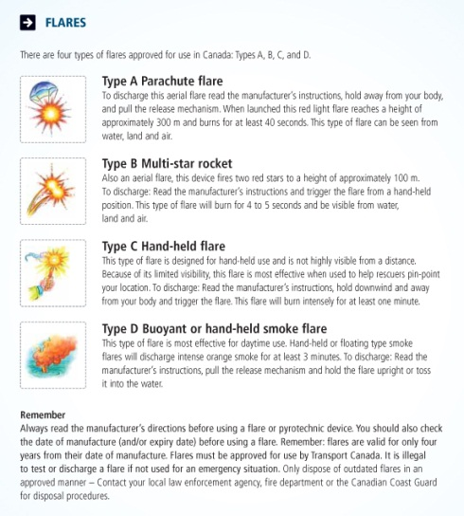
Click on the image to the left to view a description of Type A, B, C and D Flares.
Remember
Always read the manufacturer’s directions before using a flare or pyrotechnic device. You should also check the date of manufacture (and/or expiry date) before using a flare. Remember: flares are valid for only four years from their date of manufacture. Flares must be approved for use by Transport Canada. It is illegal to test or discharge a flare if not used for an emergency situation. Only dispose of outdated flares in an approved manner – Contact your local law enforcement agency, fire department, marine retailer or the Canadian Coast Guard for disposal procedures.
BACK TO TOP

Marine radio
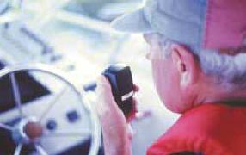
You can use a maritime VHF radio to signal distress:
- Use maritime VHF Channel 16 and repeat “Pan Pan” three times to signal the need for assistance
- Use Channel 16 and repeat “Mayday” three times to signal imminent danger and/or a life-threatening situation
- Once the appropriate distress signal is given, relay the following information:
- The name of your vessel
- Your position
- The nature of the emergency
- The type of assistance needed
Safe Boating Tip
If you have a cell phone onboard, call 911 to report your emergency. You can also call *16 to reach Canadian Coast Guard Marine Communications centres. You should provide the same information as above. Keep In Mind: A cellular phone should not be your only method of signalling distress. Making a cell phone call does not alert other boats on the water that you need help - and those boats could be the ones that help you first.
If you are buying a new maritime VHF radio, be sure it has the new Digital Selective Calling (DSC) feature on channel 70. This feature provides automatic digital distress alerts.
The Canadian Coast Guard provides DSC channel 70 service on the east and west coasts, as well as on the Great Lakes and St. Lawrence River.
Remember, maritime VHF radio channel 16 is used for emergency purposes only. Once you contact another vessel on channel 16, you should switch to another working frequency.
MCTS centres provide Vessel Traffic Services (VTS) which alert boaters to intended movements of larger vessels in certain areas. MCTS centres also continuously broadcast Notices to Shipping and weather and ice reports on marine radio frequencies. Boaters should also be aware that the Canadian Coast Guard and MCTS centres will issue Safety Calls via marine radio to mariners, transmitting navigational safety notices and meteorological warnings.
Limitations of Cell Phones
While you can obtain search and rescue assistance from the nearest Canadian Coast Guard Marine Communications and Traffic Services (MCTS) centre by dialing *16 or #16 on a cell phone, a cell phone is not a good substitute for a marine radio – a maritime VHF radio is generally the best way of sending a distress alert.
- Cell phones can lose reception or get wet and damaged
- Calling from your cell phone does not alert nearby vessels that you are in distress
- Some cell signals cannot be traced back to your location by rescuers
- Not all cell providers offer the *16 and #16 service
You must obtain a maritime VHF/ROC Certificate to transmit using a maritime VHF radio in Canada. Courses and exams are administered by the Canadian Power & Sail Squadrons.

DISTRESS SIGNALS

Code flags
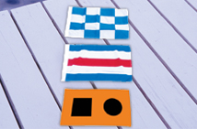
Code flags can be used to signal distress. Use either of
the following:
- The International Signal for Distress: Code flag “N” (November) flown above Code Flag “C” (Charlie)
- A square flag with a ball (or item resembling a ball) above or Below it
- A Distress cloth: a piece of orange-coloured material displaying a black square, identifiable from the air.
BACK TO TOP

Dye marker
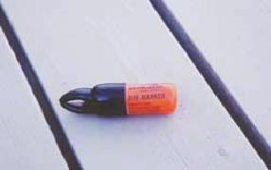
You can also discharge a dye marker in the water around your vessel. The dye marker will colour the water around your vessel signalling your need for assistance.
BACK TO TOP

EPIRB
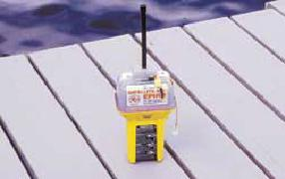
An Emergency Position Indicating Response Beacon (EPIRB) sends a distress signal via satellite to a monitoring center. The monitoring center can immediately dispatch assistance to the signal’s exact location. EPIRBs must be registered with the National Beacon Registry at 1-800-727-9414.

DISTRESS SIGNALS

Other distress signals
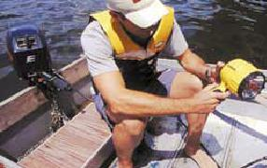
Other types of distress signals can be used to indicate the need for assistance. They are:
- A high intensity white light flashing 50 to 70 times per minute.
- A square shape (or arrangement of items resembling a square shape) positioned on your vessel or in the water near your vessel.
- Controlled flames showing onboard a vessel can also be used to signal distress. During daylight hours, choose a safe flammable substance (such as engine oil in a metal pan) to signal distress. Always use caution when using an open flame on board your craft.
- SUMMARY

- Summary
- 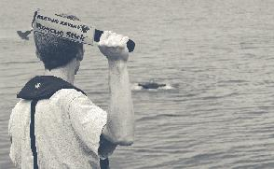
- Responding effectively in an emergency means that you need to be prepared with the right equipment and the right knowledge. You should know what to do if your craft capsizes, sinks, or is swamped by high waves. Always carry the right equipment so that you can respond to hull leaks or flooding of your craft.
- Be sure that you understand the correct techniques for rescuing a person overboard or a victim of hypothermia. People suffering from hypothermia exhibit progressive symptoms – you should be able to assess these symptoms and treat the victim accordingly. You should always be sure to carry appropriate cold water and cold weather survival gear when operating in harsh environments.
- Always have onboard the required distress equipment for your size and type of craft. You should be able to choose an appropriate distress signal according to the circumstances, and be able to use it correctly to signal your need for help. You should also be able to recognize and respond to distress signals from other craft.
- Remember: You may never be able to predict an emergency, but you can prepare for one.

