Tourism 12- Miss Ashley- Module 5-Navigation and Right of way rules
p.74-Right of Way
1. What regulations govern navigation rules on Canadian Waterways? Collision regulations
2. How do you avoid collisions?
make a full appraisal of navigation situations and determine if the risk of collision exists.
3. What are craft with right of way called? What are they able to do?
Stand on craft-able to maintain speed and course when approaching another vessel
4. What are give way craft? What must they do?
Crafts that do not have right of way- These craft must take early and substantial action to steer clear of the stand-on craft, altering their speed and direction to avoid a collision.
5. What 4 factors determine right of way?
- The type of craft you’re operating - The type(s) of craft(s) you’re approaching- The position and direction from which other craft are approaching- The type of waterway in which you’re operating
p.75-right of way cont.
6. What determines which operator has the right of way?
They type of craft
7. Describe each type of craft and the rules for right of way.
Emergency craft always have the right-of-way. All pleasure craft operators should steer clear and yield to emergency craft
- Non-powered craft including sailboats, canoes, paddleboats, sailboards and racing shells have the right-of-way over power-driven crafts
- Large vessels and those vessels engaged in fishing activities have the right-of-way. All power-driven craft under 20 m must steer clear of these less manoeuvrable vessels
8. How do power driven vessels approaching each other establish right of way?
By determining each boat’s position relative to the other
9. What 3 sectors of navigation must be recognized relative to your craft?
- Port sector- Starboard sector- Stern sector
10. What is the port side and the starboard side when referring to sectors of navigation?
- Port: To the left side of the pleasure craft when looking forward
- Starboard: To the right side of the pleasure craft when looking forward
11. When power driven vessels approach each other head on, who has the right of way? What must they do?
Neither vessel-Both operators (A + B) must take early and substantial action to steer clear each other. Each operator should give one short blast with a sound-signalling device and steer to the starboard (right) as soon as possible in order to avoid a collision.
p. 76-Right of way cont.
12. If a power driven craft approaches your port side, who is the stand on craft and has right of way? What should you do? What must they do?
Your vessel does- You should maintain your speed and course and be ready to take evasive action. The approaching craft must take early and substantial action to avoid your vessel by reducing its speed and changing direction.
13. If a power driven craft approaches your starboard side, who is the stand on craft and has right of way? What type of craft are you? What should you do? What must they do?
If a power-driven craft (B) is approaching from your starboard (right) sector they are the stand on craft and have right of way. You are the give-way craft (A) and do not have the right-of-way. You must take early and substantial action to keep well clear of the other vessel by altering your speed and course. You should avoid passing in front of the oncoming vessel.
14. Who has right of way if you are overtaking someone?
The vessel you are overtaking
15. What should you do if overtaking someone?
You must take early and substantial action to keep well clear of the other vessel by altering your speed and course. You should pass at a safe distance to the port (left) or starboard (right) side of the other vessel.
p. 77-Right of way cont.
16. When approaching non power crafts, who is the give way craft and does not have right of way? What should you do?
Your vessel-You must take early and substantial action to keep well clear of the on-powered craft. You should alter your speed and course and approach the other craft with caution.
17. What should you do when approaching fishing vessels?
Power-driven pleasure craft must take early and substantial action to keep well clear of vessels engaged in fishing activities.
18. What is a sailing vessel? When does that change?
a vessel that is under sail- changes if they are being powered by motor
19. If operating a sailing vessel what are you required to understand?
right-of-way rules specific to their type of craft.
20. How do sailboat right of way rules differ from those of power driven craft?
Right-of-way rules for vessels propelled by the wind are based on:
- The direction of the wind- The position of the mainsail- The position of the sailboat in relation to other traffic
p. 78 Right of way cont.
21. What is the windward side?
The windward side of a sailing vessel is defined as the side of the vessel opposite to the side on which the mainsail is being carried. If the sail is to the starboard (right) side then the port (left) side of the vessel is considered to be the wind-ward side. If the sail is to the port (left) side, then thestarboard (right) side of the vessel is considered to be
the windward side
22. What do both sailboat operators and operators of power driven craft have to be able to recognize in order to properly determine right of way?
Windward side of a sailing vessel
23. If the wind is on the port side of a sailing vessel does it have the right of way?- what must it do
No-A pleasure sailing vessel with the wind on its port side is the give-way craft (B) and must take early and
substantial action to steer clear of any sailing vessel with the wind on it’s starboard side (A).
24. If the wind is on the same side of two pleasure sailing vessels, which vessel is the give way craft and what must it do?
It two pleasure sailing vessels have the wind on the same side, the sailing vessel to the windward side is the give-way craft (B) and must take early and substantial action to keep well clear of the leeward vessel (A).
p. 78- right of way cont.
25. If the wind is on the port side of a sailing vessel and they cant determine with certainty where the wind is approaching another sailing vessel what must they do?
, it must take early and substantial action to change direction and keep well clear of the other vessel (A)
26. What types of vessels always have the right of way and are considered to be stand on craft?
The Collision Regulations require that less manoeuver-able vessels must be afforded the right-of-way. Large
vessels, those towing a barge, and those engaged in fishing activities with nets and trawls, always have the
right-of-way and are considered to be the stand-on craft. You must take early and substantial action to
stay well clear of these types of vessels.
27. What rule do pleasure sailing craft and power driven vessels have to follow regarding navigating narrow channels or traffic lanes?
shall not hinder the passage of power-driven vessels which can safely navigate only in a narrow channel or those craft that are navigating in a traffic lane.
28. What types of craft are not exempt from the Collision regulations?
“Sport” fishing boats and waterski boats are considered manoeuvrable craft and are not exempt from the Collision Regulations
29. Who has right of way if two vessels approach each other in a narrow channel where water features can create dangerous currents, who has right of way?
- If two vessels approach each other in a narrow channel where tide, river flow, or underwater features create dangerous currents, then the vessel going downstream is automatically afforded the right-of-way
p.80-Navigating and night or during periods of restricted visibility
30. What regulations apply for pleasure craft operators for preventing collisions at sea?
International regulations as described in the Collision Regulations Rules 1 and 2 and the Canada Shipping Act Section 562.
31. If you are out of sight of other vessels what are you supposed to do?
proceed at a safe speed that is appropriate for the prevailing circumstances and conditions of restricted visibility as described in the Collision Regulations Rule 19.
32. What are the right of way and navigations rules when operating during night time?
The same as during the day
33. What are additional factors you must do for navigation at night or restricted visibility?
you must determine the speed, position, and size of other boats according to the navigation lights they exhibit.
34. What standards determine what navigation lights your vessel requires?
Collision regulations
35. When must navigation lights be used?
Navigation lights must be used on any pleasure craft that operates from sunset to sunrise or during periods of restricted visibility.
36. What determines the types of navigation lights you are required to display?
- The size of your craft - Whether it is sail-driven or power-driven - Whether it is underway or at anchor
37. What are the 5 types of navigation lights? Where are they located? Describe each one.
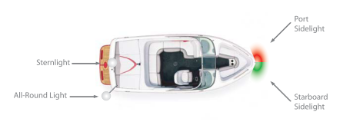
1) Starboard Sidelight
The Collision Regulations Rule 21 defines a starboard sidelight as a green light “showing an unbroken light over an arc of the horizon of 112.5 degrees and so fixed as to show the light from right ahead to 22.5 degrees abaft the beam” on the
starboard side.
2) Port Sidelight
The Collision Regulations Rule 21 defines a port sidelight as a red light “showing an unbroken light over an arc of the horizon of 112.5 degrees and so fixed as to show the light from right ahead to 22.5 degrees abaft the beam” on the port side.
3) Masthead Light
The Collision Regulations Rule 21 defines a masthead light as “a white light placed over the fore and aft centerline of the vessel showing an unbroken light over an arc of the horizon 225 degrees and so fixed as to show the light from right
ahead to 22.5 degrees abaft the beam on either side of the vessel.”
4) Sternlight
The Collision Regulations Rule 21 defines a sternlight as “a white light placed as nearly as practicable at the stern showing an unbroken light over an arc of the horizon of 135 degrees and so fixed as to show the light 67.5 degrees from right aft on each side of the vessel.”
5) All-Round
The Collision Regulations Rule 21 defines an all-round light as “a light showing an unbroken light over an arc of the horizon of 360 degrees.” An all-round light is used to signal that a pleasure craft is at anchor.
p. 82- Required navigation lights.
38 What are the requirements for navigations lights for different vessels?
 | Power-Driven Pleasure Craft | Sailing Craft | Non-Powered Pleasure Craft
General | Power-driven pleasure craft operating from sunset to sunrise or during periods of restricted visibility must exhibit a forward masthead light, sidelights and a sternlight. Other lights that may be mistaken as navigation lights are not permitted. | All operators of pleasure sailing craft must exhibit sidelights and a sternlight while underway from sunset to sunrise and during periods of restricted visibility, as prescribed in the Collision Regulations. Other lights that may be mistaken as navigation lights are not permitted. | If you are operating a pleasure craft under power of oars, you must display sidelights and a sternlight from sunset to sun-rise. If it is impracticable to exhibit side and stern navigation lights, you must have ready-for-use an electric torch or lighted lantern that displays a white light. The light must be exhibited in sufficient time to prevent a collision.

 | Power-Driven Pleasure Craft | Sailing Craft | Non-Powered Pleasure Craft
Less than 20 m  in Length | Powered-craft less than 20 m in length may exhibit sidelights combined in one lantern affixed on the fore and aft centre-  line of the vessel. | Sailboats less than 20 m in length may display combined  sidelights and sternlight in one lantern carried at or near  the top of the mast (in lieu of standard side and stern lights).
Less than 12 m  in Length | Powered-craft less than 20 m in length may exhibit an all-  round white light and sidelights in lieu of a masthead light and sternlights. The all-round light must be higher  than the sidelights.
Less than 7 m  in length | Powered-craft less than 7 m in length must display sidelights and a sternlight if practicable. If it is impracticable to exhibit side and stern lights, you must have ready-for-use an  electric torch or lighted lantern that displays a white light. The light must be displayed in sufficient time to prevent a collision. | Sailing craft less than 7 m in length and not equipped with  navigation lights must have an electric torch or lighted  lantern onboard. It must be displayed in sufficient time to pre-vent a collision.
When at Anchor | If anchored at any time from sunset to sunrise, crafts of any type less than 50 m in length must display an all-round white light towards the bow of the boat and the light should be visible from all directions. | If anchored at any time from sunset to sunrise, crafts of any  type less than 50 m in length must display an all-round  white light towards the bow of the boat and the light should  be visible from all directions. | If anchored at any time from sunset to sunrise, crafts of any  type less than 50 m in length must display an all-round  white light towards the bow of the boat and the light should  be visible from all directions.

p. 83- Navigating at night
39. What are special circumstances to be aware of when navigating at night?
Search and Rescue (SAR) Vessels-When responding to an emergency, search and rescue vessels exhibit an all-round blue light(s). You should always steer well clear of any vessel exhibiting a blue light
40. What are the requirements for lights when you are towing or being towed?
If towing another vessel from your stern you must show:
- Sidelights and a sternlight
- A yellow towing sternlight
- Two masthead lights in a vertical line
If being towed, you must exhibit:
- Sidelights and a sternlight
- A diamond shape
- If you do not have sidelights you must exhibit two all-round lights, one each at fore and aft
41. If you meet another vessel head on at night, and see a green and red light what does this mean?
In this situation neither vessel has the right-of-way. Both operators must take early and substantial action to
steer well clear of the other vessel. Both operators should reduce their speed and steer to starboard.
42. If a green and white light is visible what does this mean and what should you do?
another craft is approaching you from the port (left) side. In this situation, you are the stand-on craft and should
maintain your speed and course. The other craft should take early and substantial action to steer well clear of your craft.
p. 84-navigating at night cont.
43. If a red and white light is visible what does this mean and what should you do?
another craft is approaching you from the starboard (right) side. In this situation you are the give-way craft and must yield right-of-way. You should take early and substantial action to steer well clear of the other craft. Reduce
your speed, change direction and pass at safe distance behind the other boat.
44. If only a white light is visible, what does this mean and what should you do?
you are approaching another craft from behind (or a craft that is at anchor). You are the give-way-craft and must take early and substantial action to steer well clear by altering your course and passing at a safe distance on the starboard
(right) or port (left) side.
45. If you approach a non power driven craft what should you do?
you are the give-way craft and must yield the right of way. You should take early and substantial action to stay well
clear and pass at a safe speed and distance.
p. 85- Aids to navigation
46. What are aids to navigation? What are they used for?
a system of buoys and markers that assist the operator in determining position and identifying potential dangers and obstructions. External to pleasure craft, aids to navigation can be used to plot position and course on nautical charts and other nautical publications and assist the pleasure craft operator in choosing the most preferred and safest route.
47. What is prohibited under the Criminal code of Canada with regard to aids to navigation?
It is prohibited under the Criminal Code of Canada to interfere with any aid to navigation. Operators should never use a buoy for mooring and no person may willfully alter, remove or conceal a signal, buoy or other type of navigation marker.
48. What are the two main systems of navigation used on Canadian waterways?
The Lateral System and The Cardinal System. All aids to navigation have identifying marks such as colours, lights and numbers
49. What is a buoy and what 4 functions do they serve?
A buoy is a floating marker or signal which is affixed to the bottom of the waterway or mounted on a feature
(such as an island) of the waterway.
Buoys serve four main functions:
- Provide Warnings- Provide Information- Mark underwater hazards- Provide a system for navigation
50. What are the three styles of buoys on Canadian waterways? Describe each.
1) Light Buoys
Light buoys are the typically the largest of all floating buoys and have a light fixture affixed to the top of the buoy
2) Spar Buoys
Spar buoys are also called “pillars” and are common on smaller waterways. They have a cylinder shape and are typically smaller than light buoys.
3) Cans
Cans are wider than spar buoys and are typically used as lateral system and bifurcation buoys.
p.86-Aids to navigation cont.
51. What are the 4 systems of buoys used to aid in navigation? Describe each.
1) The Lateral System is a system of red and green buoys used to mark preferred safe routes
2) The Cardinal System consists of yellow and black buoys that indicate safe routes by the cardinal compass points
3) A Range is a series of two buoys that, when aligned along a sight path, indicate the safest route for navigation
4) Special Purpose Buoys may be yellow or white in color and are used to mark dangers such as (but not limited to) racecourses, underwater structures, pipelines, etc.
52. What is the lateral system used for?
to mark preferred safe routes.
53. What colours are lateral buoys?
Green and red
54. What are the two main types of lateral system buoys?
Port hand buoys and starboard hand buoys
55. What other types of buoys are included with the lateral system?
- Bifurcation Buoys- Standard Day Beacons- Fairway Buoys
56. What are port hand buoys and what do they do?
Port-hand buoys are green in colour and mark the left side of a channel or the location of a specific danger.
57. What side must port hand buoys be kept on when heading upstream? Left hand side
58. How are port hand buoys identified?
Port-hand buoys are identified by letter(s) and odd-digit number(s), and in standard configuration, are flat on
the top. In some instances, a port-hand buoy may be fitted with a top-mark consisting of a single green cylinder.
59. What else may a port hand buoy be fitted with?
A port-hand buoy may also be fitted with a green light that flashes in either a:
- F1 pattern (single flashes in 4 second intervals); or - Q pattern (quick single flashes one second apart)
p. 87-Aids to navigation cont.
60. What are starboard hand buoys and what do they do?
Starboard-hand buoys are red in color and mark the right side of a channel or the location of a specific danger.
61. What side must Starboard hand buoys be kept on when heading upstream? right hand side
62. How are Starboard hand buoys identified?
Starboard-hand buoys are identified by letter(s) and even-digit number(s) and in standard configuration, are
pointed on the top. In some instances, a starboard-hand buoy may be fitted with a top-mark consisting of a red cone.
63. What else may a port hand buoy be fitted with?
Starboard-hand buoys may also be fitted with a red light that flashes in either a:
- F1 pattern (single flashes in 4 second intervals); or - Q pattern (quick single flashes one second apart)
64. What do you need to remember when traveling upstream using lateral system navigation?
When traveling upstream:
- Always keep the green port-hand buoy on the left side of the vessel
- Always keep the red starboard-hand buoy on the right side of the vessel
65. What do you need to remember when traveling downstream using lateral system navigation?
When traveling downstream:
- Always keep the green port-hand buoy on the right side of the vessel
- Always keep the red starboard-hand buoy on the left side of the vessel
66. What is the Red right return memory aid?
Red Right Return refers to keeping the red starboard-hand buoys on the right side of your vessel when returning upstream to headwaters or to harbor
67. What do bifurcation buoys do?
, bifurcation buoys indicate the junction of channels:
68. What does a port junction look like and what does it mean for navigation?
Port-Junction bifurcation buoys are green in color with a red horizontal band at the midsection. Port-junction buoys mark the junction of two channels and should be kept on the port (left) side of the vessel when navigating upstream.
69. What does a starboard junction look like and what does it mean for navigation?
Starboard-Junction bifurcation buoys are red in color with a green horizontal band at the midsection. Starboard-junction buoys mark the junction of two channels and should be kept on the starboard (right) side of the vessel when
navigating upstream.
p.88- aids to navigation cont
70. What is a day beacon and what is it used for? How can they be identified on charts?
Day beacons are signs posted on land or water. They are not lighted and intended for daytime use only. Day beacons utilize the same colors as the lateral system and are typically used as channel or hazard markers. They may be marked with reflective lettering for identification on marine charts.
71. What is a port hand day beacon and what does it look like? What does it do?
A port-hand day beacon consists of a black or green square on a white background framed by a reflective green border. The port-hand day beacon identifies the port (left) side of the channel or hazard and must be kept on the left side when proceeding upstream.
72. What is a starboard hand day beacon and what does it look like? What does it do?
A starboard-hand day beacon consists of a red triangle on white background framed by a reflective red border. The starboard-hand day beacon identifies the starboard (right) side of the channel or hazard and must be kept on the right side when proceeding upstream.
p. 89 aids to navigation cont.
73. What are fairway buoys and what are they used to mark? What side should they be kept on when going upstream or into port?
Fairway buoys are used to mark the entrance to a channel, the centre of a shipping channel, or a safe approach to land. Vessels should keep the fairway buoy on the left (port) side when navigating upstream or into port.
74. How are Fairway buoys identified?
Red and white in color, divided vertically with one side red and the other side white- Will have a ball shaped top-mark- May be equipped with a white light that flashes in a Mo(A) sequence – One short flash, followed by one long flash repeated 10 times per minute
75. What is a range? What are they used for?
Ranges are typically used to guide larger vessels through a channel. Ranges consist of two or more fixed markers, permanently affixed at a significant distance from each other, and positioned at different elevations. The navigator is able to follow the recommended route by positioning his/her vessel on a visual sight-line so the marks are lined up. When aligned correctly, the navigator will see one marker in-line and on top of the other marker.
76. What is an isolated danger buoy? What do they look like and how are they identified?
An isolated danger buoy is used to mark an isolated hazard or obstruction such as a rock, shoal, or sunken island. Operators should refer to a marine chart to determine the features of the isolated danger (i.e. size, depth, exact location etc.) and should navigate well clear of the marked danger.
Isolated danger buoys are identified by the following:- Black in colour with a wide red band at the midpoint
- Will have a top-mark consisting of two black balls- May be equipped with a white light that flashes in a
FL(2) sequence – a two flash sequence repeated every 4 seconds
p. 90 navigation aids cont.
77. What is the cardinal system and what colour buoys does it use?
The cardinal system consists of yellow and black buoys that are used to assist boaters in identifying the location of safe water. Safe water lies on the north, south, east or west side of the buoy as indicated by the cardinal compass points. Cardinal buoys may be equipped with a light and/or letters for identification on a marine chart.
78. What do they look like and what do the position of yellow and black color bands indicate?
Cardinal markers are spar or pillar shaped (with a flat top). The position of the yellow and black color bands indicates the cardinal compass point of North, South, East or West and therefore the direction of the safest water. If so equipped, top-marks consisting of two cones indicate the direction of safe water
79. If a cardinal buoy if equipped with a flashing white light how do you tell the direction of safe water?
Cardinal buoys may also be equipped with a flashing white light. North flashes once; South flashes in a group six times followed by one long flash; East flashes in a group three times; and West flashes in a group nine times.
80. What are special buoys and flags?
here are a variety of special buoys and flags that mark specific hazards and provide information to the operator. These markers may be equipped with lights and may be marked with letters or numbers for chart identification. Operators must learn and be able to identify each special buoy and flag.
81. What are some other aids to navigation?
- No-wake zones- No-anchorage areas- Speed-limit zones- Low-head dam hazards- Pipeline hazards
- Power line hazards
p. 91/92- aids to navigation cont- fill out these charts

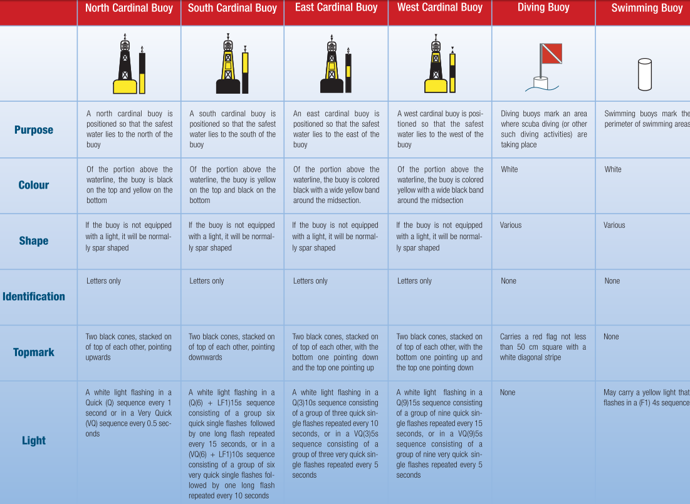

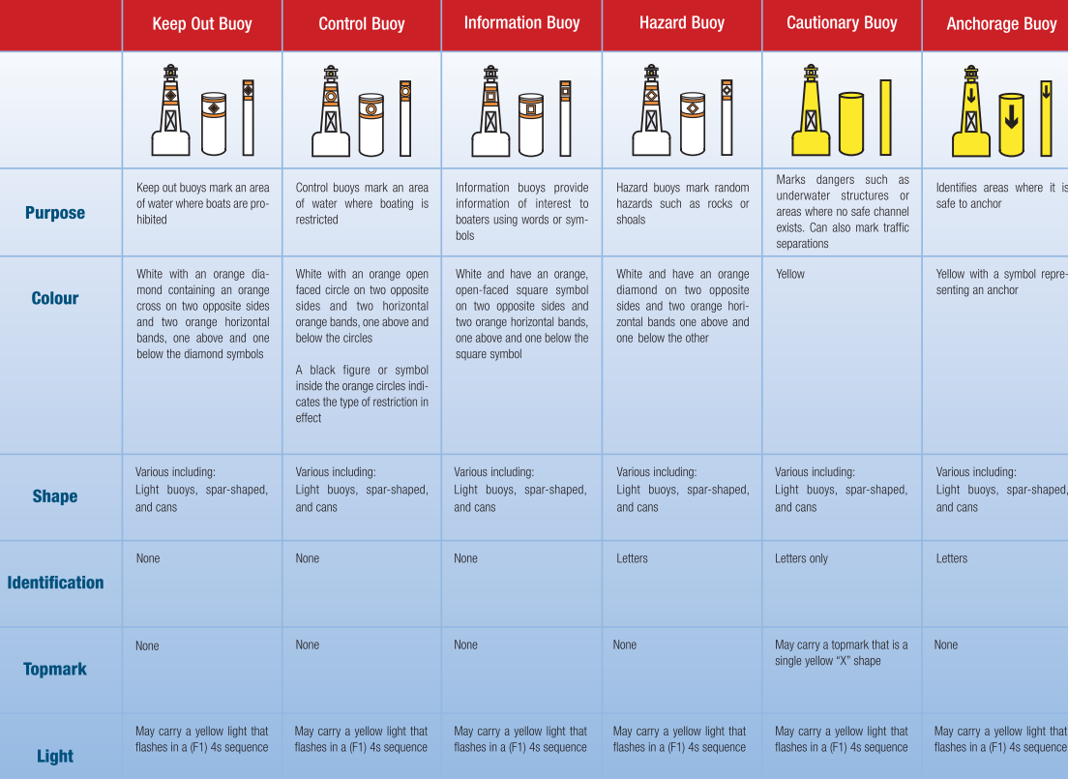

p. 93- Navigating Unique waterways
82. What is a lock? What is special about its navigation?
A lock is a physical structure of gates that enables vessels to travel between two bodies of water that are of different elevations. A restricted speed zone is typically found at the mouth of each side of the lock. Certain activities such as
swimming, fishing, and water-skiing may be restricted near locks.
83. What do you need to remember when entering and exiting a lock?
Operators should always control their speed when in the vicinity of a lock. When approaching a lock the operator should:
- Identify and adjust for water currents and other boat traffic
- Be aware of and operate according to any posted navigational aids
- Identify and adjust for adverse weather conditions such as high wind
- Be prepared for oncoming traffic as boats exit the lock
84. What does mooring at the blue line area at the mouth of the lock do?
the lockmaster is made aware of your intention to enter the lock at the next opening. The lockmaster may provide specific instructions to your vessel including when to enter, in what order, and where to moor your vessel once inside the lock.
85. What are the 6 steps for entering a lock?
1) Wait for any instruction from the lockmaster or waterway personnel
2) Proceed slowly and with caution into the lock
3) Use the vertical mooring lines affixed to the walls of the lock to secure your bow and stern. Your boat’s mooring lines should be wrapped loosely around the lock’s mooring lines allowing for upward or downward movement of your craft. You should never tie your boat to the lock’s mooring lines
4) Once positioned, turn off all engines, cease from using any fuel-burning appliances, and refrain from smoking. Turn on your engine ventilation system (blower)
5) Once the water level within the lock has reached the proper elevation, the opposite end of the lock will open. The lockmaster will instruct you when to start your engine and when to proceed
6) Proceed with caution. Never block the entrance to the lock from other boats that may be entering or exiting
p. 94 Navigating unique waterways cont
86. How is river navigation different than open waterways?
A river presents its own unique hazards and navigation conditions. Some rivers may exhibit strong currents which can affect steering and predictability of operation (which is not typical of an open waterway). The water level in a river may also rise or lower more rapidly than an open waterway – exposing trees, rocks, sunken islands and other hazards. Always watch for such hazards and/or navigation aids that may indicate their position.
87. What should you remember when approaching a blind turn on a river?
always keep to the right side of the river. Power-driven craft and sailboats under 20 m must give way to less manoeuvrable crafts while navigating a river.
88. What are canals? What do you need to remember when navigating a canal?
Canals are man-made waterways. A canal is typically narrower than a channel, and differs from a river as the
depth of the water can be controlled. Remember Operators should always keep to the right when approaching oncoming traffic or entering a blind turn. Power-driven craft and sailboats under 20 m must give way to less manoeuvrable crafts operating in a shipping lane or canal.

