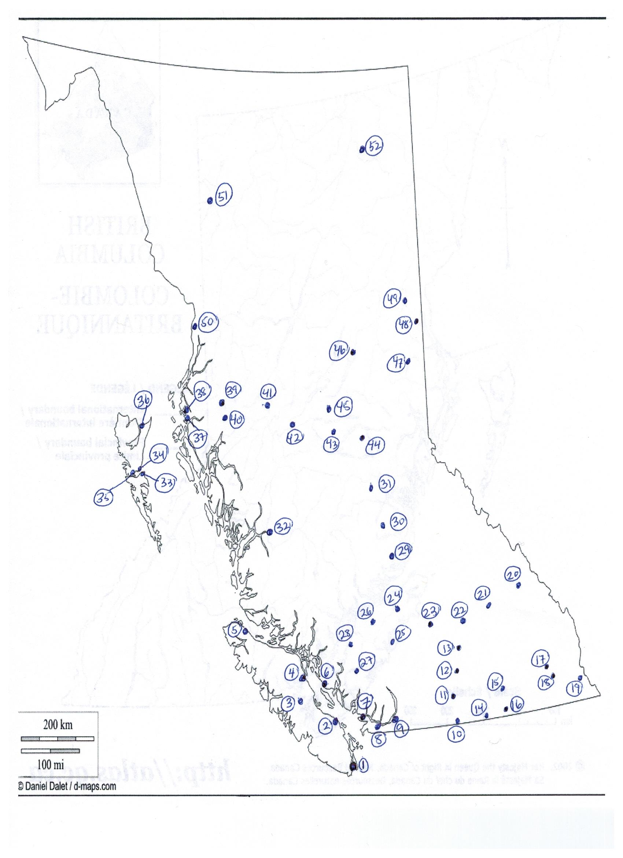

Names of cities
Prince George
Mackenzie
Tumbler Ridge
Dawson Creek
Fort St. John
Stewart
Dease Lake
Fort Nelson
Cache Creek
Lytton
Lillooet
Whistler
Pemberton
100 Mile House
Williams Lake
Kelowna
Vernon
Grand Forks
Nelson
Trail
Kimberley
Port Alberni
Campbell River
Port Hardy
Terrace
Kitimat
Smithers
Burns Lake
Vanderhoof
Fort St. James
Quesnel
Bella Coola
Sandspit
Skidegate
Queen Charlotte
Masset
Port Edward
Prince Rupert
Cranbrook
Fernie
Golden
Revelstoke
Victoria
Nanaimo
Powell River
Vancouver
Chilliwack
Hope
Osoyoos
Penticton
Salmon Arm
Kamloops

1.
2
3
4
5
6
7
8
9
10
11
12
13
14
15
16
17
18
19
20
21
22
23
24
25
26
27
28
29
30
31
32
33
34
35
36
37
38
39
40
41
42
43
44
45
46
47
48
49
50
51
52

