Writing a Persuasive Essay
A persuasive essay (also known as the argument essay) has one of two objectives:
- To convince your reader to adopt your point of view
- To convince your reader to take a specific course of action
A good persuasive essay argues one side of a very narrow topic. Although the persuasive essay only addresses one side of the issue, the topic must be debatable. Simply put, the persuasive essay recognizes that there are two sides to every question, but only presents one side to the reader. Still, it's important for you to understand both sides of the debate in order to promote your viewpoint effectively.
Choosing the Topic for a Persuasive Essay
The persuasive essay is an objective composition. In choosing your topic for a persuasive essay, although you should select one about which you feel strongly, be sure that you can find solid evidence that supports your position.
Refrain from choosing a topic where arguments are based on opinion or belief. Don't confuse facts with truths. A "truth" is a majority-held belief or opinion that is unproven and unsubstantiated by fact. Develop your argument using facts, logical reasoning, relevant examples, quotations from recognized experts, and/or statistics.
Avoid arguing indisputable facts. Start your essay draft by proving your thesis. Write the question, your position, and then write a thesis statement that directly opposes your viewpoint. This ensures that you have chosen a debatable question. Examine the other side of the argument and determine whether your evidence is strong enough to disprove the opposing viewpoint. Look for contrasting evidence, mistakes, and inconsistencies in logic.
Define Your Topic
In addition to a statement of the question, your persuasive essay title is also a statement of your position on the question. However, since your essay is objective, your title should be, too. For instance:
- Cable Internet vs. Fios Internet - This is unacceptable since it doesn't state your position.
- Why I Chose Cable Internet Over Fios Internet - This is also unacceptable since use of first person makes it subjective rather than objective and suggests personal choice rather than factual evidence.
- Reasons Why Cable Internet Rules Over Fios Internet - This is acceptable. It defines the topic, objectively states your position, and relates that your argument is based on evidence (reasons).
Introducing the Persuasive Essay
Use your thesis in your persuasive essay introduction. In addition to putting your topic and position into a sentence, the introduction to your persuasive essay should be a clear definition of the points that support your thesis. Present them in the same order that you'll use in the body of your essay to help the reader see that your position is supported in a way that comes to a logical conclusion.
Organizing the Persuasive Essay Body
The easiest way to organize the body of a persuasive essay is to think of your points as pointing towards your conclusion. Each sentence in the body should be closely related to your topic and to the sentence that precedes it.
- Begin each paragraph with a point from your introduction, following the same sequence you presented in the introduction. Support it with your evidence. As you finish each paragraph, examine it as you did the opposing point of view. Look for mistakes, inconsistencies in logic, and truths masquerading as facts.
- Be sure your evidence is specific. Stay away from using broad generalizations and personal opinions. Especially refrain from using words like all (as in all people), always, every, and never.
- Check to see that you have accurately cited any sources you used in examples and quotations.
- Help your reader see the logical progression of your argument by concluding each paragraph with a transitional sentence that leads to your next point.
Before you begin writing your conclusion, check all paragraphs of your essay body to ensure that
- Your evidence is strong and relevant to the point you addressed in the paragraph
- The essay progresses logically to your conclusion
- Both your points and supporting evidence are on topic and focussed towards the conclusion
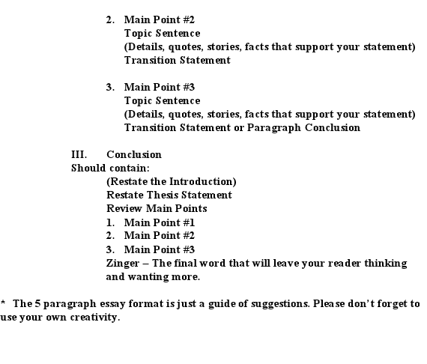
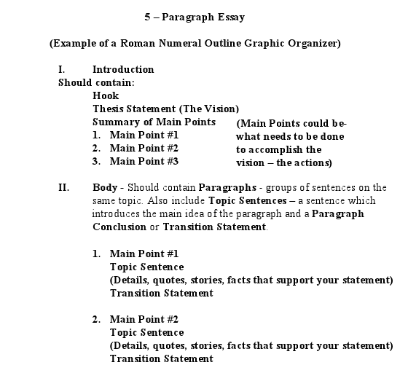
In Conclusion
Redefine your topic and summarize your essay by restating your most powerful evidence, again preserving the sequence of your presentation. The conclusion of your persuasive essay is your last chance to remind your readers of your position and persuade them to accept your point of view. 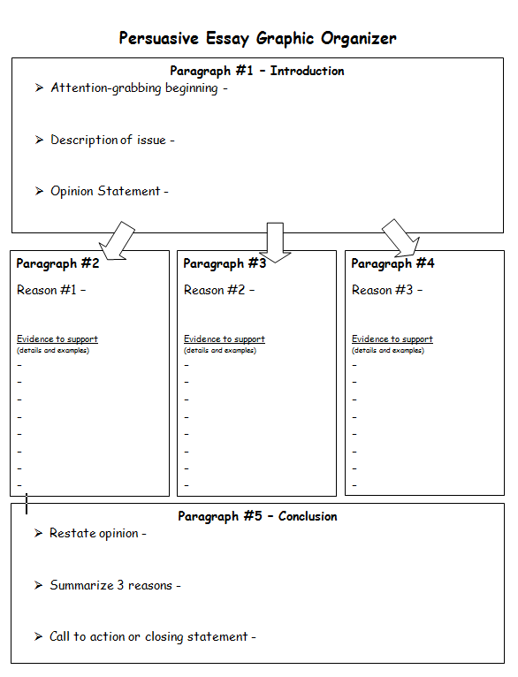

Argumentative and Persuasive Essays Hints and Tips

What is the difference?
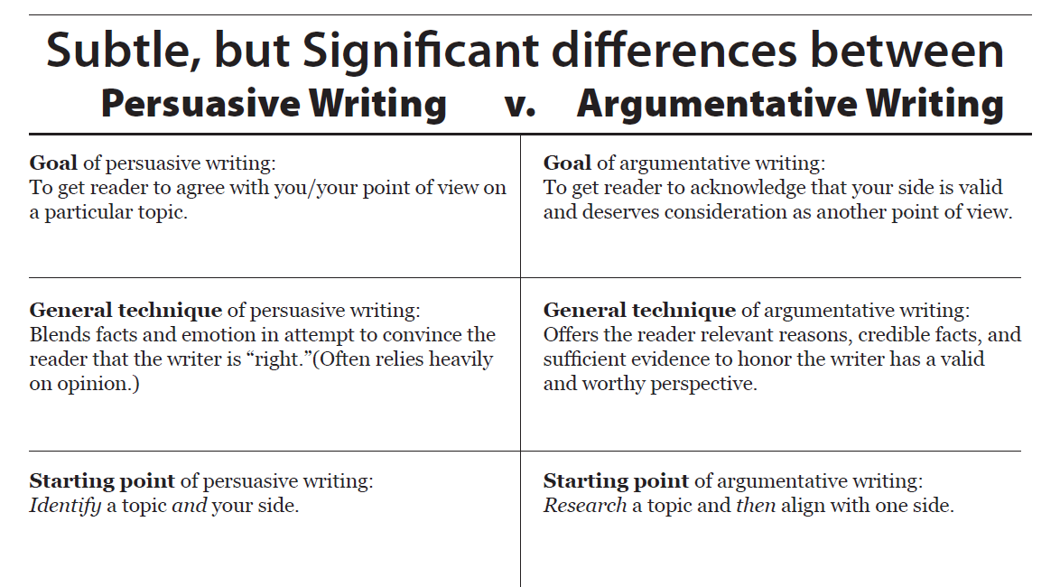
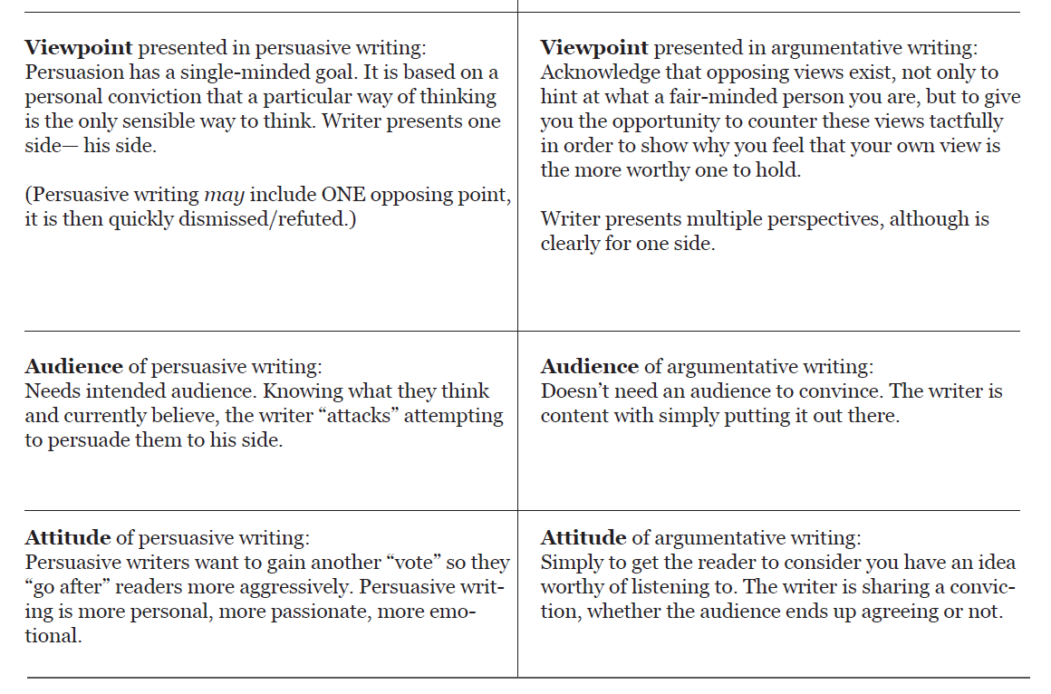

Students are used to aggressively convincing a reader to take their side in persuasive writing. However, argumentative writing is much more balanced. It requires the development of both sides of an issue, offering several claims for one side while acknowledging that there are valid counterclaims from the opposition. Argumentative writing is not about winning to "get" something, but rather giving the reader another perspective to consider on a debatable topic.
Argumentative writing is like a debate on paper--with both sides represented by facts, evidence, and relevant support. It's similar to the closing arguments at the end of a Law & Order episode. Students have to perform a similar role in their writing; they have to be both the prosecutor and the defense attorney. They have to roll out the key facts of the case, the issue, for both sides. Although they are definitely more for one side, their writing has to include valid points from the other side.

Types of Papers: Argument/Argumentative
You MUST choose one side or the other when you write an argument paper, even though you will come out in favour of one.
Do… | Don’t…
…use passionate language | …use weak qualifiers like “I believe,” “I feel,” or “I think”—just tell us!
…cite experts who agree with you | …claim to be an expert if you’re not one
…provide facts, evidence, and statistics to support your position | …use strictly moral or religious claims as support for your argument
…provide reasons to support your claim | …assume the audience will agree with you about any aspect of your argument
…address the opposing side’s argument and refute their claims | …attempt to make others look bad (i.e. Mr. Smith is ignorant—don’t listen to him!)

Why do I need to address the opposing side’s argument?
There is an old kung-fu saying which states, "The hand that strikes also blocks", meaning that when you argue it is to your advantage to anticipate your opposition and strike down their arguments within the body of your own paper. This sentiment is echoed in the popular saying, "The best defense is a good offense".
By addressing the opposition you achieve the following goals:
- illustrate a well-rounded understanding of the topic
- demonstrate a lack of bias
- enhance the level of trust that the reader has for both you and your opinion
- give yourself the opportunity to refute any arguments the opposition may have
- strengthen your argument by diminishing your opposition's argument
How do I accomplish this?
To address the other side of the argument you plan to make, you'll need to "put yourself in their shoes." In other words, you need to try to understand where they're coming from. If you're having trouble accomplishing this task, try following these steps:
- Jot down several good reasons why you support that particular side of the argument.
- Look at the reasons you provided and try to argue with yourself. Ask: Why would someone disagree with each of these points? What would his/her response be? (Sometimes it's helpful to imagine that you're having a verbal argument with someone who disagrees with you.)
- Think carefully about your audience; try to understand their background, their strongest influences, and the way that their minds work. Ask: What parts of this issue will concern my opposing audience the most?
- Find the necessary facts, evidence, quotes from experts, etc. to refute the points that your opposition might make.
- Carefully organize your paper so that it moves smoothly from defending your own points to sections where you argue against the opposition.

HOW TO WRITE AN ARGUMENTATIVE ESSAY

The following outline attempts to show you how to construct a good essay; it represents, in as simple a form as possible, the basic pattern to follow in putting together any “argument paper” whether this paper is a class essay, a dissertation, or an article designed for publication. An “argument paper” is best defined as a paper which states a thesis, or says something, and attempts to back it up or support this thesis with evidence which tends to convince the reader of the truth and validity of this thesis; this kind of paper is distinct from the kind of paper which merely presents information.

- Form a good, strong thesis sentence, stating what you propose to show.
This opinion or judgment is the stand you are taking on this particular topic and it will be the conclusion which your entire essay will to try to establish and support. This is your thesis sentence; and this is why the thesis sentence has to come first when you construct an essay.

- Build your argument to support this thesis sentence.
Return to your assembled material. Go through it again, and this time copy down every argument, every bit of evidence, or every reason you can find in it which will support your conclusion. After you have done this you should be able to tell whether your conclusion is valid or not. If you cannot find enough support to convince yourself of the validity of your own conclusion, you should discard your thesis sentence and form a new one. Never attempt to argue on behalf of something which you yourself do not believe, if you do, your paper will not be very good.

- Arrange your argument to produce the maximum effect on the reader.
Go through the evidence or separate arguments you have copied down and arrange them in the order of their strength. Usually it is best to arrange them in the order of their strength. It is often best to start with the weakest and end with the strongest; this arrangement is not always possible, but when it can be done your argument will accumulate more force as it progresses. If this type of arrangement cannot be use, merely arrange the arguments in the order in which they will appear in your paper. Along with each argument, list any contrary arguments. You must state these fully and fairly, but show that on balance your viewpoint is to be favoured. If you ignore them, your essay will be weak, one sided and unconvincing.

- Write your outline.
- Begin with a thesis sentence
- Always write complete sentences
- A brief introduction is needed if any questions or terms have to be defined before you start your argument; otherwise it is optional
- Roman numeral I will be the first argument or reason in support of your conclusion. Roman numeral II will be the second argument – and so on – as you have already arranged these arguments in order
- Just as the Roman numeral entries must support your conclusion, so must the sub-head entries under each roman numeral support that particular argument (usually by clarifying, explaining or the citing of examples).
- Copy your thesis sentence word for word as the conclusion at the end of your outline. (This may seem a bit of an insult to your intelligence, but if your outline has gone astray you will find that your thesis will no longer fit in the position it was originally created to occupy. Thus, by doing this you can sometimes save yourself time and wasted effort.
- Check your outline
- Are there any self-contradictory concepts in it?
- Is any of your material irrelevant?
- Does each argument follow logically from everything preceding it?
- Are there any gaps in your reasoning?
- Are there any terms which need to be defined?
- Are there any statements which are merely platitudes?
- Have you made any dogmatic statements?

- Write the paper itself
- Proofread you Paper.

Writing Persuasive Essays-To write a persuasive paper, you’ll need to use evidence and good reasons to convince others to agree with your point of view on a particular subject.
As you begin the research/brainstorm process, ask yourself:
- What type of information would I need to use in order to convince someone that I'm right?
- What facts, statistics, and evidence would an audience want to see?
- Are there any experts on this topic that I could quote in my essay?

What should my thesis statement look like?
A persuasive thesis statement is a one-sentence description of your topic AND the argument that you plan to make. For example, if I was arguing about the use of the death penalty in the U.S., my thesis statement would probably look like one of the following examples:
- The death penalty gives rights to humans that should only be given to God; therefore, the death penalty should be abolished in the United States.
- The death penalty forces murderers to give their own lives as a just punishment for taking someone else's life; therefore, we should continue to use this form of punishment in the United States. Please correct the error as it reduces your web site's credibility.
Notice that both thesis statements not only tell us WHAT the essay will be about, but also WHERE THE AUTHOR STANDS on that issue (his or her opinion) and briefly explain WHY. Make sure that your thesis statement includes these three elements too!
Here are some strategies to complete a persuasive writing assignment:
Write out the questions in your own words. Think of the questions posed in the assignment while you are reading and researching. Determine
- facts
- any sources that will help you determine their reliability
(as well as for further reference)
- what prejudices lie in the argument or values that color the facts or the issue
List out facts; consider their importance: prioritize, edit, sequence, discard, etc. Ask yourself "What's missing?"
What are the "hot buttons" of the issue?
List possible emotions/emotional reactions and recognize them for later use
Start writing a draft!(refer to: Writing essays, the basics)
Write your first paragraph
  - Introduce the topic
  - Inform the reader of your point of view!
  - Entice the reader to continue with the rest of the paper!
  - Focus on three main points to develop
- Establish flow from paragraph to paragraph
  - Keep your voice active
  - Quote sources
to establish authority
  - Stay focused
on your point of view throughout the essay
  - Focus on logical arguments
  - Don't lapse into summary
in the development--wait for the conclusion
- Conclusion
Summarize, then conclude, your argument
Refer to the first paragraph/opening statement as well as the main points
  - does the conclusion restate the main ideas?
  - reflect the succession and importance of the arguments
  - logically conclude their development?
- Edit
  - Ask yourself:
Does this make sense? Am I convinced? Will this convince a reader? Will they understand my values, and agree with my facts?
  - Have a friend read it and respond to your argument. Were they convinced?
  - Revise if necessary

Introductory Paragraphs
The introductory paragraph is the first-paragraph in the persuasive essay. Your introductory paragraphs should have three parts: an attention-catcher, a thesis, and a preview. It should clearly express the subject of the essay as well as the writer’s position. While it is generally not required, previewing the main points shows readers that the paper has been thoughtfully composed rather than free formed. Every introductory paragraph should begin with an attention catcher. (look in your essay opening examples for ideas)
A thesis is a clearly worded statement telling readers exactly what the writer intends to do in the essay. Good persuasive writing does not make the reader guess as to what the author’s intentions were. The writer’s intent should be made very clear. Every sentence in your paper should in some way connect to that central argument. Any sentence that is not furthering my thesis is distracting from it and should be removed. If your position changes during the course of your writing, don’t be afraid to go back and revise your thesis, but your thesis must align with the arguments in your essay.

Preview of Main Points
The preview briefly states the main points that will be argued in the essay.
Previewing and structuring main points in this manner is a good way to scaffold into a more personalized and sophisticated writing style, however, as you develop your own style this may prove to be formulaic.

Body Paragraphs
Each body paragraph should focus on one argument, called the main point.

Main Points
A main point is the purpose of the body paragraph. Each body paragraph should have one clearly stated main point that is expressed in the topic sentence of the paragraph. The main point should then be developed and supported with emotional or logical arguments. Each main point and paragraph should support the thesis of the essay.

Supporting Details
Supporting details are arguments, examples, or descriptions that justify, explain, and develop main points. Transitions that can be used to introduce those ideas are as follows:
- What I mean by this is… Another way to say this is… This connects to my argument because…
- The reason for this is that… To put it another way… This shows that… This is important because…For example…
Making the connection is when the last sentence in a body paragraph connects the support back to the main point. Writers need to explain what their evidence shows to make the connection. Don’t make the readers draw their own conclusions; that’s your job.

Concluding Paragraphs
The conclusion is the last paragraph in the persuasive essay. A good conclusion will not only restate the main points of the argument, it will bring something new to the table and end with strength and resolution. It’s been compellingly argued that readers or listeners best remember the first and last things stated. With this notion in mind, you should allot yourself an appropriate amount of time to craft a resonant introduction and conclusion. Summarize your main points in an interesting way. Attempt to leave a strong impression on the reader by ending on a clinching statement. (see examples of closings)
USE PERSUASIVE TECHNIQUES
To be persuasive, your argument must be solid and reasonable. In order to be convincing, you should appropriately apply the persuasive techniques of logos, ethos, and pathos.
􀁟Logos: Appeal to reason by using facts, statistics, research, logical arguments, etc.
􀁟Ethos: Appeal to the credibility or character of the author or of the people quoted. Use credible sources, and prove your own credibility with good academic writing and tone.
􀁟Pathos: Appeal to emotion, values, and beliefs to support your own feelings or passion about the issue. Include personal stories from yourself or others, and use appropriate word choice to emphasize emotion. In academic writing, this technique should be used with care.
UNDERSTANDING YOUR AUDIENCE
Supporting only your own viewpoint is not sufficient for writing a persuasive paper. You must also understand your audience, so you can find ways to support your thesis in a manner convincing to them.
Ask yourself the following questions to help you identify and persuade your audience more effectively:
􀁟What is the audience’s knowledge level about your topic?
􀁟What is their attitude towards the topic?
􀁟What are the audience’s values and beliefs?
These questions will help you identify the character of your audience and establish a tone for your paper that is both professional and reasonable. Assume your audience is intelligent—never sound condescending or know-it-all—but be sure to thoroughly explain concepts. Knowing your audience will also help you determine areas to research in order to effectively address counterarguments.
􀁟Use third person rather than first or second person point-of-view.
􀁟Use examples and vivid descriptions rather than telling your reader what to feel.
􀁟Avoid absolutes and hasty generalizations such as always, never, or all people.

􀁟Use evidence that is recent, relevant, and impartial. Have sufficient evidence to justify each point.
- Be clear in what you are claiming.
- Tell the reader which claims are based on facts and which on values.
- Provide good evidence in support of your claim.
- If a connection between the evidence and the claim is not obvious, tell the reader the connection.
- Discuss the opposing arguments and either provide a rebuttal or concession, whichever is appropriate given your evidence.

Criteria for Evidence to use when making your point
Last, some tips on what makes up solid evidence:
- Relevance: speak directly to the point.
- Representativeness: you cannot make a point for the whole U.S. population based on information about one state, for example. If information is only available for one state, present the evidence, but note the problems.
- Accuracy: try to find the same information in more than one place, if possible.
- Detail: provide as much as possible. If you know how many thousands of people smoke, tell us the exact number, don't just say "thousands smoke."
- Adequacy: Figure out which are the most important points in your arguments and support these in the most detail. Lesser points also need evidence, but don't get bogged down on debating a minor detail of the policy.

Tips for Using Evidence
- Distinguish facts from informed opinion or speculation.
- Use statistics carefully.
- Use examples to clarify meaning, demonstrate why, or to entertain.
- Use logic and reason to connect the evidence to the points.
- Use personal experience or anecdotal evidence sparingly.

Argument essay example -The Use of Landmines-by Alejandra Galindo
El Salvador, 6 April 1992--Three siblings died near the Guazapa volcano last weekend when they stepped on a mine planted during the period of civil warfare. Ironically, their parents had returned to the area only a few days earlier. The children were four, six and eight years old. Parts from the three children's bodies were found as far as 30 metres from the explosion site. (qtd. in Grant 25)
Antipersonnel landmines kill thousands of people every year. Antipersonnel landmines do not recognize a cease-fire; they continue killing or maiming for many years after the conflict is over. Antipersonnel landmines do not discriminate between soldiers or civilians. On the contrary, more and more they are being used in an indiscriminate way, terrorizing civilians and transforming agricultural fields into killing fields. In addition, de-mining is a very slow and very expensive process, and after a war most countries are not prepared to cope with the constant health care demands imposed by the number of injured by landmines. Finally, landmines make it very difficult for refugees to go back to their cities and villages. As response to the landmine problem, the international community has come up with a treaty to ban landmines. On March 1, 1999, the 1997 Mine Ban Treaty came into effect; so far 134 countries have signed the treaty. Unfortunately, the U. S. is not one of them.
The Encarta Encyclopedia defines a landmine as "an encased explosive device that is concealed below the surface of the ground." It can be made of "metal, plastic, glass, or wood" (n. p.). Probably the concept of landmines is almost as old as the existence of organized armies. Philip C. Winslow, in his book Sowing the Dragon's Teeth, describes how Roman soldiers, before the beginning of the first millennium, used a plant with spikes as a landmine in order "to delay pursuers" (126). The Chinese, according to Delbruck, used "ground mines" made out of explosives in the year 1232 (qtd. in Winslow 126). Six hundred years later, in 1840, the use of landmines was introduced in the United States; they were used "in large quantities" during the Civil War (Winslow 126, 127). In the course of the First World War the landmine technology was further developed, but it was "during the Second World War [that] hundreds of millions of mines were buried across Europe and North Africa" (Winslow 130). Thus began a massive use of this kind of weapon.
There are four main types of antipersonnel mines, explains James P. Grant, Executive Director of UNICEF. Blast mines, the kind more commonly used, are "normally detonated by the pressure of a foot and the resulting explosion will kill or severely injure [the] victims" (9). Fragmentation mines are normally triggered by tripwire and "jagged metal fragments are sprayed over a 100-metre radius. Anyone within a 25-metre radius is likely to be killed" (10). Directional mines, Grant continues, propel "steel balls forward in a 60-degree arc. These mines can kill at up to 50 metres and maim at up to 100 metres" (10). Bounding mines leap "45 centimeters into the air before shattering into more than 1,000 metal splinters. The lethal causality radius is at least 25 metres" (10). The end result in all the cases is either death (mostly in the case of children) or loss of body parts. In contrast with other armaments, landmines cannot be aimed to specific targets. Once deployed, they cannot be controlled. Even when the conflict is over, they cannot be stopped. They "can remain active for as long as 50 years. Land-mines placed today may still be killing and maiming . . . in the middle of the next century" (Grant 1). Landmines cause indiscriminate destruction and do not differentiate between soldiers, civilians, children, animals, or tractors. "It is estimated that land-mines have killed or injured more than one million persons since 1975, the vast majority of them civilians" (Grant 2). Furthermore, the United Nations reports that "every month over 2,000 people are killed or maimed by mine explosions" (1).
Nevertheless, according to Faulkner, in a war landmines are useful because they can "protect military establishments and other important installations." They also can "channel enemy forces" into specific areas and can "deny routes and strategic or tactical ground to the enemy" (3). Even if there is no war, landmines can help to protect specific areas or installations. Two examples can be found in South Korea and Cuba. In the event of an attack from North Korea, Heilbrunn explains, "millions of mines . . . have been laid by the U. S. and South Korea" in the border between the two countries (2). Cuba also uses landmines, "around the U. S. naval base at Guantanamo Bay," as protection from any American move (Canada-Mexico 11). However, it is hard to believe that in these days of sophisticated weapons and detailed satellite information another alternative to landmines cannot be found. Furthermore, even when landmines can have a specific and necessary function, they can very easily become a problem. For example, Hambric and Schneck reported that landmines caused "33% of all U. S. casualties" during the Vietnam War and "34% percent [sic} of all U. S. casualties" during the Gulf War (qtd. in Human Rights Watch, "The Global" 2).
Moreover, after the Second World War landmines have been used in agricultural lands, "villages, water sources, religious shrines," and also as "anti-morale, or terror weapons[s] targeting" civilian populations (Faulkner 3, 4). According to the United Nations, landmines can cost as little as $3.00 (1). Because they are cheap and effective, they are being used more and more in different conflicts around the world. "It is estimated that more than 110 million active mines are scattered in 70 countries" around the world (United Nations 1). However, the inexpensive cost of landmines is in great contrast with the expensive cost to remove them. According to Patrick Blagden, a United Nations de-mining expert, de-mining costs "between US $300 and US $1,000 per mine" (qtd. in Grant 3). Countries that have suffered a war in their own land encounter many rehabilitation tasks; landmines make these tasks very difficult and also put an extra economic burden on the country.
As is the case with the price of de-mining, the healthcare expenses imposed by the landmine injured are very high. Furthermore, most of the time, a war-torn country does not have the healthcare infrastructure necessary to cope with the demands imposed by this kind of injury. For example, the United Nations reports that "the number of units of blood required to operate on patients with mine injuries is between 2 and 6 times greater than that needed by other war casualties" (1). These expenses are only for physical injuries and are not taking under consideration any psychological damage. "Up to 1995, there are at least 250,000 landmine-disabled persons in the world" (Faulkner 1, 2). This number gives a clear picture of the magnitude of the healthcare problem confronted by the affected countries.
The indiscriminate use of landmines in rural areas has been devastating for these communities. Fertile agricultural lands are turned into "unusable and uninhabitable" landmine fields. And the grazing of livestock and domesticated animals becomes very dangerous for both the animals and the people taking care of them--a labor very often done by children (Faulkner 4). The economic and social consequences are impoverishment and malnutrition, accompanied by the feeling of despair and helplessness. In addition, the use of landmines make it very difficult for refugees to go back to their villages and towns, and, as just has been mentioned, to go back to their past activities.
Through the history of civilization, there have been a number of laws to "regulate conduct that is inherently brutal. . . . Societies have observed restrictions on the conduct of warfare for thousands of years. Just as there has long been a medical ethic, so there has been a warrior ethic" (Grant 15). There have been a number of attempts to regulate the use of landmines; but, for different reasons, they have failed to solve the problem. In October 1996, the Candian government sponsored a conference to discuss the strategy to achieve a total ban on antipersonnel landmines. This conference, explains Mary Wareham, a Senior Advocate for Human Rights Watch, led to a number of other conferences; and on December 1997, in Ottawa, "122 countries signed the Mine Ban Treaty" (3). It is also important to mention that in December 1997 the International Campaign to Ban Landmines and its coordinator Jody Williams were awarded the 1997 Nobel Peace Prize for "their role in making the treaty a reality" (3). The treaty, as Wareham explains,
prohibits the use, production, stockpiling, and transfer of antipersonnel landmines. It also requires that stockpiles be destroyed within four years of the treaty's entry into force, and that mines already in the ground be removed and destroyed within ten years. It also requires state parties to provide detailed information about antipersonnel mine stockpiles and minefields. It calls on states to provide assistance for care and rehabilitation of mine victims. (2)
Forty countries, Wareham continues, needed to ratify the treaty in order for it to become international law after six months had passed (3). In September 1998, the fortieth country ratified the treaty (Canada-Mexico 3). And six months later, on March 1, 1999, the treaty became binding international law. As of February 31, 1999, Human Rights Watch reports, "134 nations have signed the ban treaty (including all of NATO, except the U. S. and Turkey), and sixty-five nations have ratified." The U. S. has plans to sign the treaty in the year 2006, "but only if the Pentagon's search for alternatives to mines" is successful ("Historic" 1).
In a world that has many important problems--the war in Kosovo, the Ozone layer, AIDS--it is very difficult for people to keep informed. In a survey I conducted among eighteen students and two professors at Roane State Community College, only four people knew about the Landmine Ban Treaty. Nevertheless, thirteen thought the U. S. should sign it. The use of landmines constitutes a pressing problem for the world, but unfortunately, not many people are aware of it (see Appendix for a copy of the survey).
Landmines make the recovery process for countries that have suffered a war in their own land extremely difficult. Landmines put a tremendous economic burden along with psychological effects in the morale of the population; they may even perpetuate the conditions for a future conflict. The United States should sign the Mine Ban Treaty now, not in the year 2006. And also, the U. S. should put pressure on other countries to do the same. As it is, the advances made during this century in weapon technology are already impressive; the world does not need to wait for more new developments in order to ban the use of landmines. Human civilization should not begin a new millennium with the knowledge that new landmines are being produced and planted. The ban of the use of antipersonnel landmines should be in our "warrior ethic" for the next millennium; let us hope that the human race can achieve more than that in the next century.

Persuasive Essay example
The Failure of Abstinence-Only Programs
Sex education is important, but many students finish sex education classes with a distorted view of sexuality and without a good understanding of contraception and safe-sex practices. Instead, children only learn that they should not have sex until they are married. Abstinence-only programs in public schools have become popular because of a law giving millions of dollars to schools that teach the programs. These programs have the good intention of persuading young people to wait until marriage before having sex, but abstinence-only programs are not achieving this goal and are flawed by the distorted and biased perspective that they promote.
In 1996, the United States government passed a law giving funding to states that offered abstinence-only programs in public schools. Since this time, over half of a billion dollars has been given to states to promote abstinence-only programs (Brody). To receive the money, schools must agree to follow a set of rules. The rules indicate that a school’s abstinence-only program must have "as its exclusive purpose teaching the social, psychological, and health gains to be realized by abstaining from sexual activity" ("Impacts"). Students must be taught that they are likely to suffer harmful effects if they have sex before marriage. They also must be taught that the "expected standard" is for school-age children not to engage in sexual activity and for adults to engage in sexual relations only within marriage ("Impacts"). Schools receiving the funds must teach students that they should "just say no" to sex until they are married. The schools are not allowed to teach students about safe sex and "may not mention contraception except to point out the failure rates of various methods" (Brody). Some states have refused the federal funds so that their schools can determine their own ways to teach sex education, but 43 states participate in the program. With millions of dollars from the government every year, many schools now promote abstinence. They offer abstinence-only programs with encouraging titles such as "ReCapturing the Vision," "Teens in Control," and "My Choice, My Future!" ("Impacts"). They encourage students to sign virginity pledges vowing not to have sex until marriage, to proudly wear their "purity rings," and to carry their ATM ("abstinence till marriage") cards (Kelly). These programs encourage students to develop a strong sense of self and to avoid the negative consequences that might result from sexual activity, but there is a problem: abstinence-only programs do not work.
Studies show that abstinence-only programs do not reduce sexual activity by young people. In 2007, the United States Department of Health and Human Services released a study of abstinence programs. This government-funded study involved more than 2000 students. The authors discovered that "findings from this study provide no evidence that abstinence programs implemented in upper elementary and middle schools are effective in reducing the rate of teen sexual activity" ("Impacts"). The authors concluded that "findings indicate that youth in the [abstinence-only] programs were no more likely" than students not in the programs "to have abstained from sex" ("Impacts"). In addition, "among those who reported having had sex, they had similar numbers of sexual partners and had initiated sex at the same mean age" ("Impacts"). Apparently, students did not benefit from all of the effort and the millions of dollars that have gone into these programs. Another study by Peter Bearman of Columbia University shows that "88 percent of middle and high schoolers who pledge to stay virgins until marriage end up having premarital sex anyway" (Kelly). He adds that "the bad news is that they are less likely to use contraception the first time they have intercourse" (Kelly). Dr. S. Paige Hertweck, a doctor who contributed to an American Academy of Pediatrics report on teen sexual activity, states that "teaching abstinence but not birth control makes it more likely that once teenagers initiate sexual activity they will have unsafe sex and contract sexually transmitted diseases" ("Doctors Slam Abstinence"). In abstinence-only programs, students are taught to "just say no" to sex. They are not taught the information that they need to know about safe sex and contraception if they later choose to say "yes," as many of them are doing.
Abstinence-only programs also promote a distorted and biased view of sexuality. To receive funding, schools must follow the rules in the law for teaching abstinence-only programs. One of the rules is that students must be taught that the "expected standard of sexual activity" is a "monogamous relationship in the context of marriage" ("Impacts"). An estimated 88 to 99 percent of Americans have sex outside of marriage ("Many Who Pledge"), yet students must be taught that having sex only within marriage is "the expected standard." The rules also require that students be taught that having sex outside of marriage "is likely to have harmful psychological and physical effects" ("Impacts"). Approximately nine out of ten Americans have sexual relations outside of marriage. Do most of them suffer "harmful psychological and physical effects," as the government has determined that students must be taught? The law presents a distorted view of sexuality, along with a biased view. In 2006, the government updated the funding guidelines to state that, in abstinence-only programs, "the term 'marriage' must be defined as 'only a legal union between one man and one woman as husband and wife'" (Waxman 4). Promoting the government’s definition of marriage should not be a requirement for schools to receive funding for sex education programs. Senator Henry A. Waxman rightfully argues that "the benefits of abstinence from teenage sex should be taught in a way that does not further alienate gay and lesbian youth" (4). All students should benefit from sex education programs. Student Hunter Kincaid suggests how abstinence-only programs discriminate against gays and lesbians: "'As a gay student, I thought [the abstinence-only class] was ridiculous,' he says. 'Abstinence until marriage for people who can’t even get married'" (Kelly). A sex-education program should help all students make good decisions about sexual activity. It should not promote an unrealistic standard of behavior, should not promote a particular definition of marriage, and should not discriminate against some students.
Sexual activity by young people is an important concern. In an ideal world, maybe everyone would wait until marriage before having sex and would then remain in a single, monogamous relationship. But this is not the reality. It might be a good goal to try to convince young people to wait until marriage before having sex, but taking this approach alone to sex education is not working. After ten years and a half of a billion dollars in federal funding, abstinence-only programs have not had a positive impact on the sexual behavior of teenagers. The programs may even cause harm because of the distorted and biased views that they promote and because of the information about safe sex and contraception that they do not teach. It is time to put an end to abstinence-only programs and to give students more comprehensive sex-education programs that better prepare them for the future.
Works Cited
Brody, Jane E. "Abstinence-Only: Does it Work?" New York Times. New York Times, 1 June 2004. Web. 19 July 2009.
"Doctors Slam Abstinence-Only Sex Ed: Teens Need Access to Birth Control, Pediatrician Group Says." MSNBC. MSNBC, 5 July 2005. Web. 11 July 2009.
"Impacts of Four Title V, Section 510 Abstinence Education Programs: Executive Summary." Assistant Secretary for Planning and Evaluation, U.S. Department of Health and Human Services. U.S. Department of Health and Human Services, 13 April 2007. Web. 4 Aug. 2009.

