Bob Joseph notes
- Indian Act was an example of systemic racism
- Indian Act was a policy of assimilation
- 1969- white paper- government tried to get rid of Indian Act
- Countered by red paper- First nations concerned how first nations would take care of themselves without Indian Act
- Duncan Campbell Scott- early 1900’s –knew dying in residential schools- keeping policy anyways
- 1869- imposed the elected chief and council system- attempt to overthrow the hereditary system
- Denied women status- 1869 to 1985 if they married non indigenous
- Created reserves- 1869-don’t own the land legally- owned by federal government
- Encouraged voluntary and enforced enfranchisement (voting) -1876-1985
- John A Macdonald- felt they needed to assimilate First nations peoples
- Renamed individuals with European names- 1880- underdetermined time
- Trying to get the name off the list- make them a non-status indian
- Created a permit system to control Indian’s abiity to sell products from farms- 1881-2014- if they could sell- would lose motivation to get off the reserve
- Prohibited sale of ammunitions to Indians-1882-undetermined time
- Prohibited sale of alcohol
- Declared potlatch and other cultural ceremonies illegal- 1884-1951
- Restricted Indians from leaving their reserve without permission from Indian Agent 1885-1951
- Change from collecting material for individual to giving away wealth to gain rank
- Created residential schools-1886-1996
- Forbade indian students from speaking language
- Couldn’t wear traditional regalia
- Forbade Indians from forming political organizations
- Prohibited anyone from soliticing funds for Indians to hire legal counsel-1927-1951
- Prohibited pool hall owners from allowing Indians entrance 1927-1951
- Forbade students from practicing religion
- Denied Indians rights to vote until 1960-weren’t considered a person
- Indian act piece of legislation created under colonial rule for purpose of subjugation a group of people until 1960
- Racism is adaptable- whole system and individuals- ie instead of assimilation- now talk about equal- Example-people saying “why shouldn’t they have more rights than other people?”
- Melting pot philosophy- no individual cultures- all Canadians
- Not a melting pot in Canada we are a cultural fruitcake- better position to reconcile
- Are we a melting pot of a cultural fruitcake today?
- 94 calls to action under Truth and reconciliation Commission
- Need to challenge opinions that aren’t true or only partially based in fact
- Stanley Cup analogy- book about racism- systemic racism- curious about whether he felt there was systemic racism- honestly think if there was a Stanley Cup for systemic Racism Canada’s name would be all over the cup- no other places have legislation specifically designed to take away culture and assimilate
- Swimming in racist soup
- Land acknowledgement is a decolonizing action- acknowledge that the people that were here actually own it
- Ways to challenge systemic racism- educate people to see beyond the myths
- Question- why don’t you just get rid of the Indian act- not that easy- every group is distinct- need ways to prepare for that
- Question about readiness- Nisga’a nation was ready to get rid of Indian Act- now self governing- had a lot of growing pains
- Others are still struggling and healing from colonialism-beginning of healing process- haven’t dealt with impacts and trauma from residential schools (alcohol, violence, suicides- spillover from those experiences- effects intergenerational)
- Conservatives repealed part of Indian act where you couldn’t sell crops/livestocks- chiefs didn’t want it- the effect will probably extend the Indian act for another 100 years
- Only piecemeal- need a way to deal with it in totality
- Need to move to whatever’s nexts
- 3 selfs
- - self determination- nobody gets to tell us who our people are anymore
- - self government- whether hereditary or band chief- each community decides and learns about government- given opportunity to decide
- -self reliance- how do we get out of perpetual underfunded system and break free of Indian Act
Need to know how to figure out how to look after ourselves
- What people don’t understand- cost of change- $10 billion dollars over 20 years- however doesn’t talk about the cost of not changing- Indian Affairs- $11 billion dollars per year- tax payers spending 1 billion dollars a year to manage this per year- loss of economic opportunities
Jo Chrona notes
- Wants to provoke students into wanting to learn more about anti-racism
- Come with open hearts and minds
- Commit to taking one thing away to learn about
- Guiding questions
  - What is the difference between “not being racist” and being “anti-racist”?
  - In becoming anti-racist, how do we move from the fear zone to the learning zone to the growth one?
  - What is racial gaslighting and how do we avoid perpetuating this?
  - How do we understand the role of privilege and fragility in anti racism work?
  - How do we move from fragility?
- Racism
  - The belief that a group of people are “less than” or in some way inferior based on the colour of their skin, their culture (or their spirituality). It leads to discriminatory behaviours and policies
- Systemic or Structural racism
  - Power based
  - Racialized/indigenous, black, people of colour (IBPOC) peoples do not have equitable outcomes, or equitable opportunities, to non-IBPOC people and where acceptance of these discriminatory and prejudicial practices has become normalized across society and institutions
- Need to understand the difference between Equity and equality
- Document- In Plain Sight- investigation into systemic racism in Canada’s health care system
- Why focus on Anti-Racism
  - Thinking I am not racist is different than being anti racist
    - Lets us off the hook from doing something to make a change
  - We often create narrow definitions of racism that ignore the structures and process that perpetuate entrenched racism (systemic or structural racism)
  - Systemic racism exists in every part of this country, in every sector (education, policing, health, etc.)
  - It can have unique characteristics depending on who is being affected
- What does Systemic racism look/sound like?
  - Thinking that our current systems are culturally neutral
  - Thinking that we are bias free
  - Everyone has bias-need to be aware of those biases and how they are perpetuating or contributing to systemic racism
  - Absence of indigenous, black and people of colour in positions of authority and decision making- creates lack of voices and perspectives
  - Sitting in unexamined privilege
  - Ignoring contexts of diversity
  - Thinking that being blind to colour makes a difference- it is a negation of people and the cultural differences that exist between people-doesn’t make room for people to share who they are
  - Valuing indigenous and other non-western knowledge systems and perspectives as “less-than” (post industrial knowledge system in schools)
- Becoming Anti Racism- model- Andrew M Ibrahim MD MSC- helps us understand our roles
  - Fear zone- deny racism is a problem
  - Avoid discomfort
  - Learning zone- listen to others who challenge my ideas
  - Understand that they have biases
  - Growth zone-Understand how we benefit from systemic racism
  - Actively educating ourselves
- Sitting in unexamined privilege
  - How do we understand the role of privilege in anti racism work?
  - What are “white privilege” and “white fragility”?
  - How do we learn about these dynamics without retreating into defensive places?
- Privilege and Fragility
  - Systemic advantages that distribute power, benefits or advantages unequally amongst groups in society
  - Often difficult and hard to see for those people who have the privilege and the resources that go with it
  - Concept of “white privilege” coined in “White Privilege: Unpacking the Invisible Knapsack, 1988. “ by Peggy McIntosh
    - Refers to the advantages that automatically are conferred based on the colour of one’s skin
    - Does not mean that those who have “white privilege” do not face other disadvantages- means that those disadvantages were not because of the colour of their skin
- Examples of white privilege
  - I can turn on the tv or look at other media widely represented
  - I am never asked to speak for all people of my racial/cultural group
  - I can be late to a meeting without having the lateness reflect on my race/culture
  - I can be sure if I need legal/medical help my race/culture will not mean I receive a lower standard of service or care
- Google- In plain sight
- What is meant by “White fragility”?
  - Robin DiAngelo’s White Fragility: Why It’s so hard for white people to talk about Racism, 2018
  - Describes a defensive reaction to talking about white privilege
  - Surfaces in many different ways to diminish conversations about anti-racism
  - Book be a provocative beginning place for non-IBPOC people
- When thinking about privilege we can ask?
  - Whose voice has been valued? Why?
  - Whose knowledge has been valued? Why?
  - In education especially, what has been considered important to teach and learn
  - Quote- White privilege is your history being part of the core curriculum and mine being taught as an elective” Ozy Aloziem, MSW
- Building our own capacity and each other’s capacity
  - Disrupting narratives and processes that perpetuate deficit (less than) and “otherness”
  - Avoid racial gaslighting
  - Pay attention to diverse context of racism
    - Responding to diverse needs of people
- Racial gaslighting
  - A tactic in which people try to dismiss other’s knowledge/experience of racism by diminishing it or trying to make them question their reality
    - Examples
      - Just to play devils advocate..
      - In my opinion, I don’t think that was being racist..
      - There must have been another reason that happened
      - If you protested/said it more peacefully more people would listen to you
      - What I said/did was not racist
      - Racism does not exist anymore
      - ____ are racist too
      - Why is it always about race?
      - Are you sure that is what happened?
    - This dismisses peoples lived realities
- Additional contexts for addressing racism towards indigenous peoples
  - Unique nature of stereotyping, bias and prejudice about Indigenous peoples in Canada is rooted in the history of colonialism
    - Indigenous people were seen as weak
- Being first nations, metis or inuit in Canada
  - Distinct from multiculturalism
  - If not here, then where?
  - Needed increased indigenous perspectives in English language arts classes
Question-I understand if I have indigenous peoples – including them- but why do I need to if they don’t? why privileging indigenous history/culture and not other cultures?
- Think about where families have come from-are the languages of those places still being spoken? Is the knowledge still being taught? Is the literature connected to the land- still thriving there?-
- This is the only place where that knowledge comes from- if not here- they will be lost- they don’t exist anywhere else in the world.
- This is not about wedging indigenous knowledge into curriculum- honouring and valuing the knowledge and history of indigenous peoples in Canada
- If not here, then where?
- Changes happening
- 9th professional standing for BC teaching Certificate holders
  - Educators respect and value the history of First Nations, Inuit and Metis in Canada and the impact of the past on the present and the future. Educators contribute towards truth, reconciliation and healing. Educators foster a deeper understanding of knowing and being, histories and cultures of First Nations, Inuit and Metis.
- Educators critically examine their own biases, attitudes , belief, values and practices to facilitate change. Educators value and respect the languages, heritages, cultures and ways of knowing and being of First Nations, Inuit and Metis.
- What it mean to critically examine our biases, attitudes, beliefs, values and practices to facilitate change?
  - Be really open to hearing
  - Be okay with moving into places of discomfort
  - Be wiling to make mistakes and learn from them
  - Acknowledge that there is always more to learn and understand
  - Be patient with our own and each other’s learning but not complacent
  - Advocating for IBPOC in positions of decision making in all sectors
  - Understanding distinctiveness and diversity of Indigenous peoples
  - Examine the implications of who knowledge systems are valued
  - Creating and holding space for voices of Indigenous, black and people of colour
  - Think about the role that we have and our sphere of influence
- Recommended reading list
  - Braiding sweetgrass
  - Indigenous story work:educating heart, mind body and spirit
  - Indigenous writes: a guide to first nations, metis and inuit issues
  - Moon of the crusted snow
  - The inconvenient indian
  - The truth about stories
  - This place-150 years retold
  - Fnesc bc first nations land
  - Unreserved podcast
- Creating safe spaces- don’t allow stereotyped and damaging thinking that will harm or perpetuate racism (write down instead of say out loud- do in a way that doesn’t let statement out in the air)
  - Acknowledging that we focus on ideas and thinking- not the individual person
  - If someone has beliefs that are racist- talk about the belief as racist- not the person- try to avoid putting people on the defensive
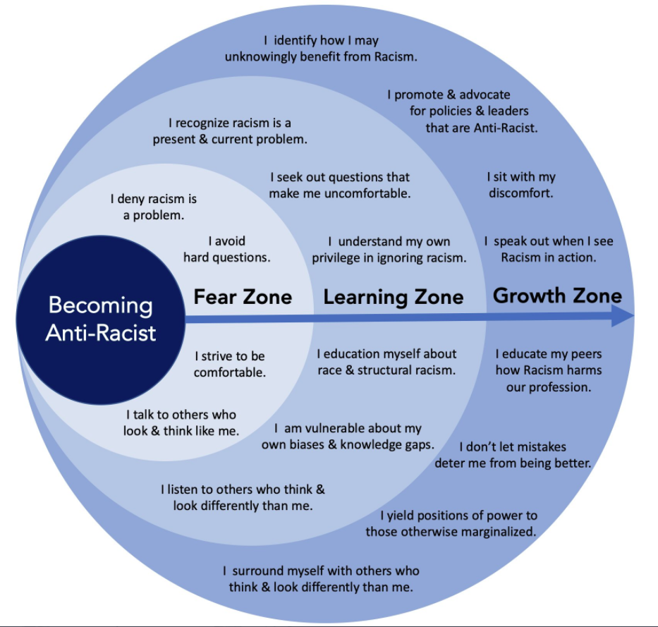
Linda Gray notes
- Author of First Nations 101
- Ts’msyen
- Important to understand shared history and understand the strengths, as well as to empower indigenous peoples
- All individual nations
- Similarities with new-comers
  - Family and community oriented
  - Respect for the land
  - Culture and traditions
  - Displacement from homelands
  - Loss of connection to homelands, family, culture, medicines, food
  - Racism-primarily based on differences. Is especially severe when there is competition for resources (jobs, fish, land, lobsters, money)
- Traditions have evolved and adapted over thousands of years
- Racism and Unique FN history
  - FN were strong, healthy, independent and self-governing in our own land
  - Colonization through the negation, minimizing, dismissing of FN people, culture, land ownership, rights, treateies through laws policies propaganda, media
  - Externally imposed actions, laws, policies that led to:
    - Dismantling of governance and social systems
    - Dependence- food education jobs money
    - Loss of cultural knowledge traditions, roles and respect
    - Inter-generational trauma (lots unresolved)
    - Poor health and wellness (physical, emotional, spiritual and mentally)
- Racism affect on social determinants of health
  - The following became challenges due to colonization:
    - Gender (women), heritage, physical ability, age
    - Social support/belonging due to break up of communities
    - Culture and community connection that is sense of belonging and support
    - Childcare-education, training and employment
    - ECD, trauma- re; education- not prepared for school, being pushed out
    - Income- housing, food access, transportation, childcare
    - Meaningful access to health care, justice system, child welfare, education
- How to be an Ally
  - Never speak for FN or share their stories without permission
  - Don’t make FN responsible for helping you work through your feelings
  - Be aware of aggressions, micro-aggressions and micro-assaults
  - Ask questions in your circles. Seek out full truthful answers. Then act
    - In your home, family, social circles, workplace, schools, social settings
    - Reconciliation, who’s territory, input, FN access/participation/retention
  - Safely challenge stereotypes, exclusion and other forms of racism
  - Equally as important when FN not in the room
  - Don’t capitalize on work, connections, or actions that you helped with, instead recommend a FN person that was involved
  - Allies can be helpful in many ways from volunteering-to advocacy-to contributing resources needed to support FN peoples working on issues important to them
  - Allyship, action, and support are more productive than justifications and apologies for past wrongs
  - 2nd ed will have more information on how to be a great ally
  - Free online pdf with many more ideas (funds, actions, volunteering, and specific ideas for introvert/extrovert, preferences, skills)
  - firstnations101.com
- What can you do?
  - Listen to, watch and read First Nations’ messages
  - Volunteer or donate funds, equipment, supplies, space, skills
  - Attend events with family, co-workers, peers
  - Co-host, co-sponsor, or co-promote events
  - Share what you learn with at least one person
  - FN child and family caring society’s 7 ways to make a difference
  - Read the Truth and Reconciliation Commissions 94 calls to action
  - Read first nations 101
- Continued learning
  - www.friendshiphouse.ca
  - www.metlakatla.ca
  - www.laxkwalaams.ca
  - www.yellowheadinstitute.org
  - www.reconciliationcanada.ca
  - www.nctr.ca
  - www.firstnations101.com

