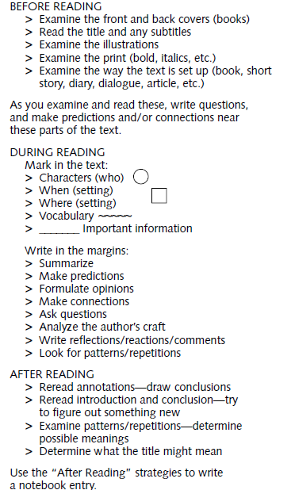
ACTIVE READING AND ANNOTATING WHILE READING

