Procedures to Book A Role Model ( with more details)
PLEASE DO NOT BOOK A ROLE MODEL/KNOWLEDGE KEEPER WITHOUT GETTING PRIOR APPROVAL AS NOT ALL REQUESTS ARE APPROVED.

- Teacher completes the top portion of the Role Model Request Form and gives or emails it to their principal to sign. See more on how to fill this out at the end of this information sheet.

- Once the role model request is signed please scan it and email to:
Anna Ashley- (Indigenous Education Teacher Mentor) anna.ashley@cmsd.bc.ca
And
Lindsay Harder (Executive Assistant to Robert Clifton) Lindsay.harder@cmsd.bc.ca

- Once you have emailed it the request will be forwarded to the head of the Indigenous Education Department for approval. Please keep in mind that there is a limited budget and not all requests will be approved. As well, we might not have a role model available or on our list that can meet the needs of the request.

- Once you have received the ok to go ahead with the role model request then either it will be arranged through the Indigenous Education department, or in certain cases the person asking for the role model can make the arrangements.

- Once the Role model has been booked please make sure of the following:

- Verify the date and time with the role model and arrange for a reminder.
- Determine the materials required & costs, as well as the prep work required (if any)
- If materials are required determine who is responsible for purchasing and payment
- Keep all receipts (make sure you have approval to purchase materials)
- Find out if the Role Model has transportation to the school

- If you have any questions or concerns please contact the Indigenous Education department for assistance.

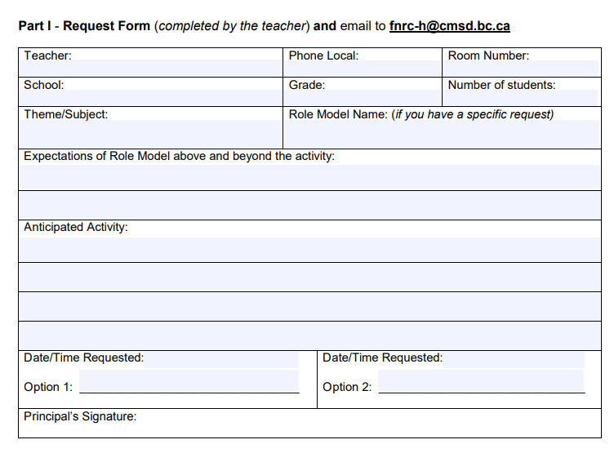
If you have a specific person you want to come in and aren’t sure if they are on the role model list please check with the Indigenous Education Department as there are certain steps that we need to follow when adding role models to the list.
Please be as specific as possible with regards to the expectations for the Role Model and the type of activity you would like to do. For example, if you want someone to come in and talk about Contemporary Indigenous issues, this topic is too broad. Instead please add as much detail as possible so we can try and find someone that best suits your needs. If you are unsure then send an email to the Indigenous Education Teacher Mentor for assistance. If there is not enough room in the space please add information on an additional sheet.
Get the principal’s signature before sending in the role model request.
If you know the dates and times you would like the role model to come in please specify. If you want someone during a specific time period but are flexible about when please specify. Please keep in mind that we may not be able to accommodate some requested dates and times because role models may not be available. Also, please note that the earlier you put in a request the more likelihood there is of finding a suitable role model for the dates requested.

