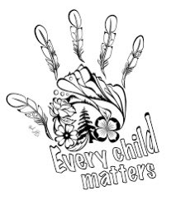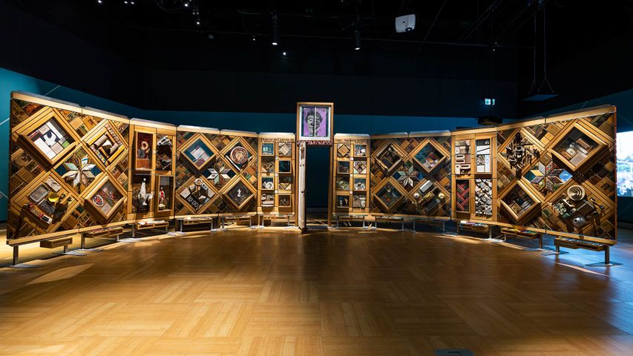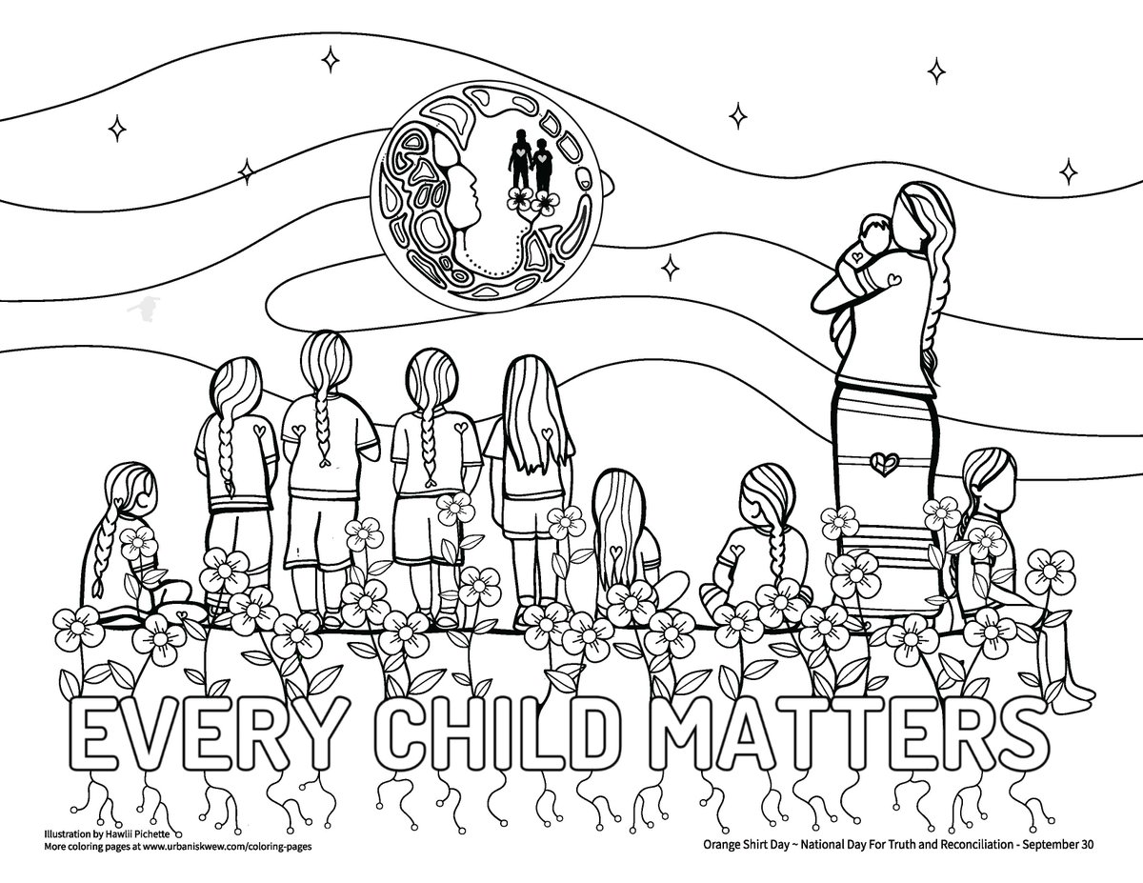

ARTWORK BY MICHELLE STONEY

ARTWORK BY MICHELLE STONEY

ARTWORK BY HAWLII PICHETTE

**What is the Witness Blanket and what was used to make it?**

**Who is the artist that created the Witness Blanket? Why did he use a blanket as metaphor for his artwork?**

**How do the pieces help us witness what happened to children at residential school and how the experience affected them?**

**What did you learn from viewing the Witness Blanket?**

**Why is the Witness Blanket an important part of the Truth and Reconciliation Process?**

**Where can people go to learn more about details about the Witness Blanket and/or the Truth and Reconciliation Calls to Action?**

**THE WITNESS BLANKET**

**TRUTH AND RECONCILIATION IN ACTION**