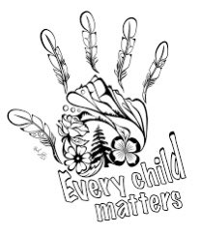

**THE WITNESS BLANKET**

**TRUTH AND RECONCILIATION IN ACTION**

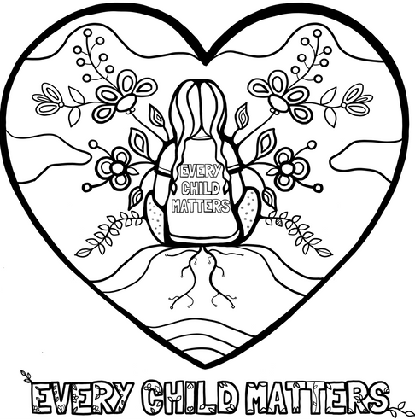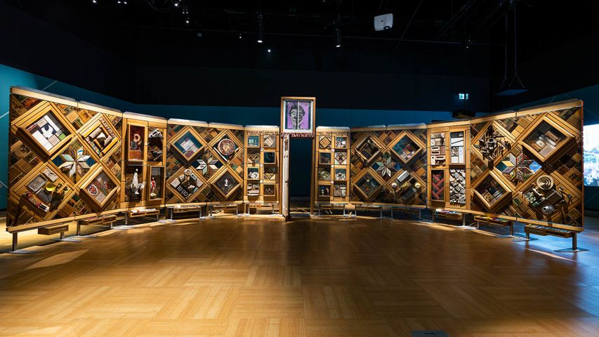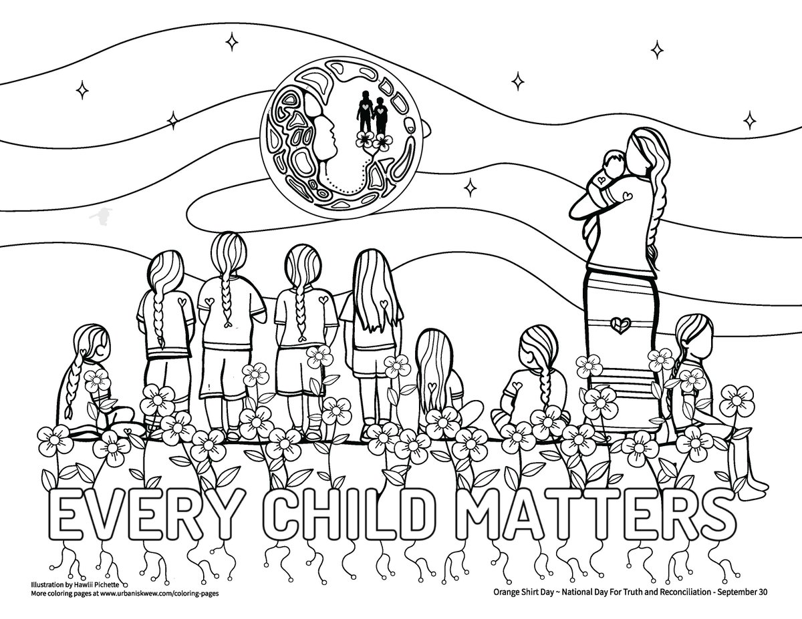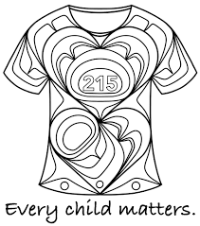

ARTWORK BY

HAWLII PICHETTE

ARTWORK BY

HAWLII PICHETTE

ARTWORK BY MICHELLE STONEY

ARTWORK BY MICHELLE STONEY

ARTWORK BY

YASAKW YAKGUJANAAS

ARTWORK BY

YASAKW YAKGUJANAAS

ARTWORK BY HAWLII PICHETTE