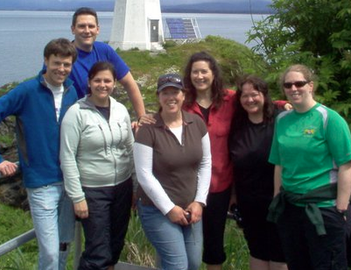

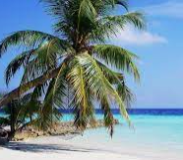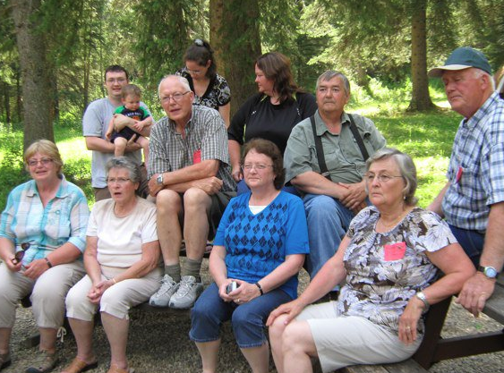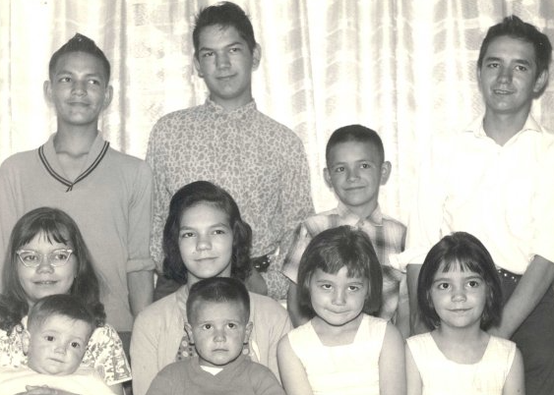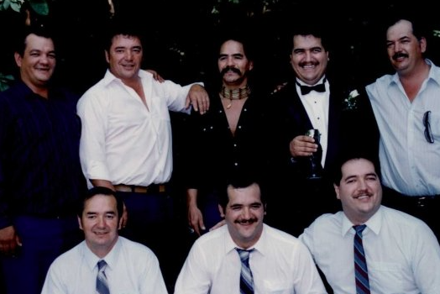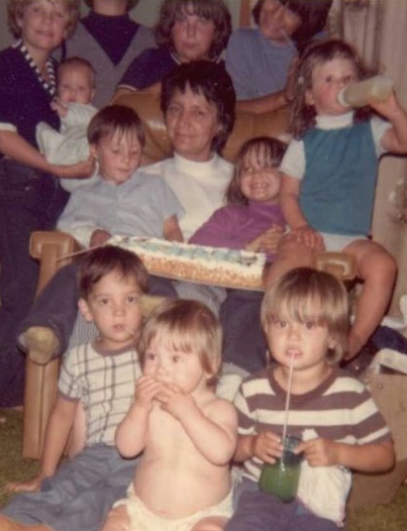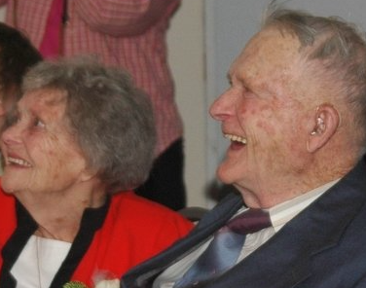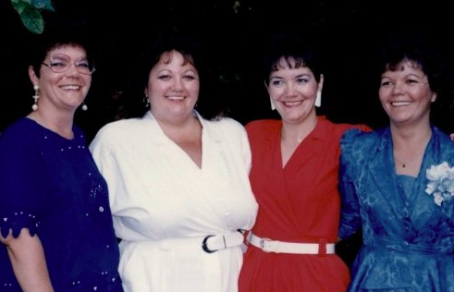 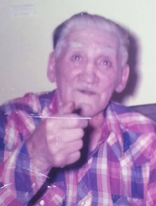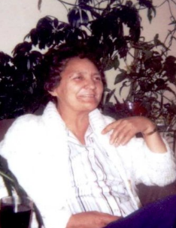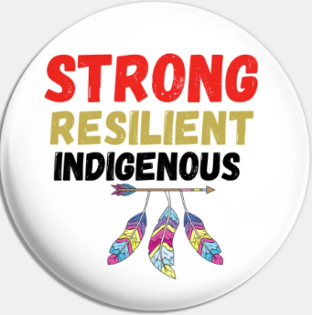 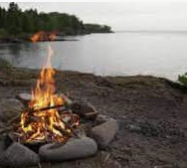 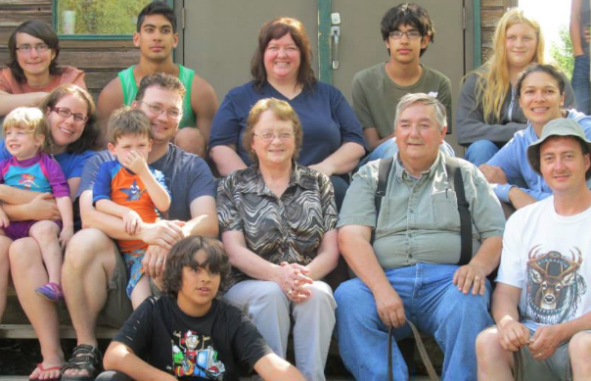 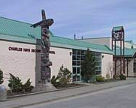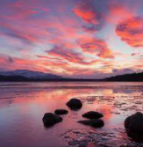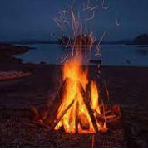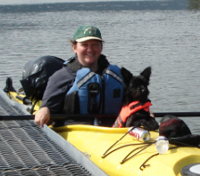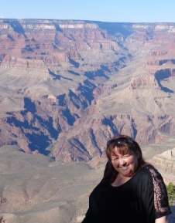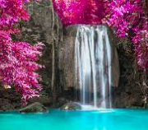 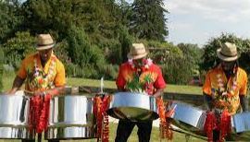

MY FAVOURITE THINGS AND THINGS THAT MAKE ME HAPPY

THINGS THAT REPRESENT ME

MY HOPES AND DREAMS

MY INTERESTS

MY CULTURE/HERITAGE

FACTS ABOUT ME

THINGS I’M PROUD OF

THINGS I’M PROUD OF

* I AM PROUD OF BEING THE FIRST GRANDCHILD ON MY DAD’S SIDE OF THE FAMILY TO GRADUATE FROM UNIVERSITY.
* I AM PROUD OF BEING A TEACHER.
* I AM PROUD OF BEING A COACH.
* I AM PROUD OF BEING A GOOD FRIEND.
* I AM PROUD OF CARING ABOUT OTHERS.
* I AM PROUD OF BEING INDIGENOUS.
* I AM PROUD OF HELPING OTHERS.
* I AM PROUD OF BEING A GOOD PERSON.
* I AM PROUD TO BE A RAINMAKER.

THINGS THAT REPRESENT ME

* CAMPFIRE- BECAUSE I LOVE CAMPING
* BASKETBALL- BECAUSE IT IS MY FAVOURITE SPORT
* HEART- BECAUSE I CARE ABOUT A LOT OF THINGS, ESPECIALLY MY FAMILY AND FRIENDS
* DIPLOMA- BECAUSE I’M PROUD OF MY EDUCATION
* SCHOOL- BECAUSE I LOVE BEING A TEACHER
* PLANE-BECAUSE I LOVE TO TRAVEL
* CAR- BECAUSE I LOVE ROAD TRIPS
* WATERFALL- BECAUSE I LOVE NATURE
* IPOD- BECAUSE I LOVE LISTENING TO MUSIC

MY INTERESTS

* I ENJOY THE OUTDOORS AND LIKE TO GO CAMPING AND FISHING
* I LIKE COACHING SPORTS LIKE BASKETBALL
* I LIKE GOING OUT FOR DINNER AND HANGING OUT WITH FRIENDS
* I LIKE GOING TO THE MOVIES
* I LOVE CAMPFIRES
* I ENJOY SPENDING TIME WITH FAMILY
* I ENJOY TEACHING AND GETTING TO KNOW MY STUDENTS
* I LIKE ROAD TRIPS
* I REALLY ENJOY TRAVELING AND SEEING DIFFERENT PARTS OF THE WORLD
* I LOVE TROPICAL VACATION SPOTS
* I LIKE PLAYING A VARIETY OF GAMES, INCLUDING BOARD GAMES, DICE, CARDS AND SOME VIDEO GAMES

MY FAVOURITE THINGS AND THINGS THAT MAKE ME HAPPY

* MY FAVOURITE COLOUR IS BLUE
* MY FAVOURITE NUMBER IS 10
* LISTENING TO MUSIC MAKES ME HAPPY
* SITTING AROUND A CAMPFIRE MAKES ME HAPPY
* MY FAVOURITE MEAL IN THE SUMMER IS BBQ STEAK
* HAVING FUN WITH MY FRIENDS MAKES ME HAPPY
* SPENDING TIME WITH FAMILY AND FRIENDS MAKES ME HAPPY
* BEING CRAFTY MAKES ME HAPPY
* MOVIES THAT HAVE HAPPY ENDINGS MAKE ME HAPPY

MY HOPES AND DREAMS

* I REALLY WANT TO TRAVEL TO EUROPE ONE DAY AND SEE THE THINGS I’VE ONLY READ ABOUT
* I WANT TO TRAVEL TO AFRICA AND GO ON A SAFARI
* I WANT TO GO TO THE CARIBBEAN AND ESPECIALLY JAMAICA TO HEAR THE STEEL DRUMS
* I REALLY WANT TO SEE ALL OF MY STUDENTS GRADUATE AND FULFILL THEIR HOPES AND DREAMS
* I WANT ALL MY FAMILY AND FRIENDS TO BE HEALTHY AND HAPPY

MY CULTURE/HERITAGE

* I HAVE INDIGENOUS (SECWEMPEC0 AND SETTLER ANCESTRY.
* I HAVE LINKS TO ENGLAND, SCOTLAND, IRELAND, SPAIN, FRANCE, PRUSSIA, AND GERMANY,
* I DON’T KNOW MUCH ABOUT MY INDIGENOUS ANCESTRY.
* I AM AN ASSOCIATE MEMBER OF THE WILLIAMS LAKE INDIAN BAND.

FACTS ABOUT ME

* I AM A TEACHER AND I LIVE IN PRINCE RUPERT.
* I GREW UP IN WILLIAMS LAKE.
* I WENT TO UNIVERSITY IN VICTORIA.
* I HAVE BEEN TEACHING FOR 31 YEARS (SINCE SEPT 1991)
* MY PARENTS ARE MARVIN AND BONNIE ASHLEY.
* I HAVE THREE YOUNGER BROTHERS NAMED CHESTER, SAM AND DOUG.
* I HAVE 10 NIECES AND NEPHEWS.
* I HAVE A VERY LARGE EXTENDED FAMILY WITH 16 AUNTS AND UNCLES, 3 1 FURST COUSINS AND NUMEROUS 2ND AND 3RD COUSINS.
* I HAVE A DOG NAMED MONKEY.

Anna Ashley