What worked for us:

Universal adaptations are made available to assist all students to achieve the learning outcomes of these courses and to demonstrate their learning during class including:
- additional time;
- one-to-one support from educational assistants,
- learning assistance teachers and the classroom teacher;
- access to electronic devices for speech-to-text, text-to-speech, and written output;
- audio books, dictated assignments and transcription help;
- graphic organizers, framed paragraphs, sentence stems, and similar;
- pairing verbal instructions with visual or written supports
- shortened, simplified, and/or chunked assignments;
- writing templates; use of separate settings when needed and,
- opportunities to display competence and learning outcomes in a variety of ways.
- flexible timelines to demonstrate skill acquisition and conceptual understanding.
- intentionally exploring areas of student interest to enhance engagement
- utilizing game format and cooperative social learning strategies for peer-to-peer support
Students are also provided many opportunities to explore personal and cultural identities, written and oral histories, stories and connections to land/place.
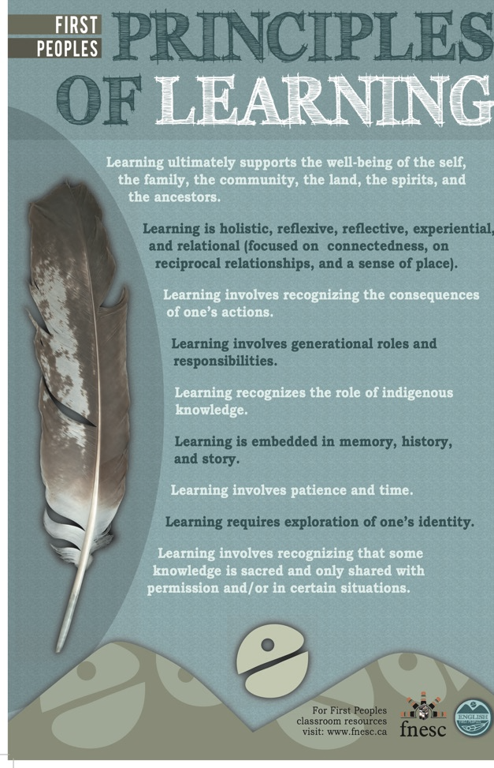
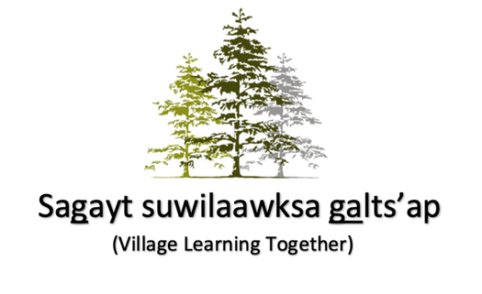
Indigenous worldviews and perspectives are integral to this learning. Students access authentic resources such as books, literature, texts, and film. As often as possible we invite community to visit our classrooms or meet with Role Models, Elders, and other knowledge keepers on the land or at their place of work.

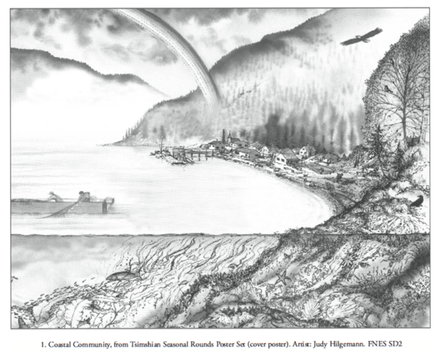

Communicating Student Learning:
- The learning environment was fairly structured with very clear expectations, often using rubrics, or co-constructed criteria. We allowed the students more time to get things right, to continue to build their expertise on curricular content and skills.
- Aimed to ensure feedback was clear/concise/oral/immediate.
- Students demonstrated conceptual understanding and skills mastery often through project-based assessments. This helped inform us if they were developing (C- to C), proficient (C+ to B), or Extending (B+ to A) based on the curricular competencies.
- Completion mark/skills practice marks = we both learned that these students needed to know everything they do in class counts (skills practices mark, build work ethic needed to succeed. Even down to marks for active listening and questions with a presenter).
- As a group, there was a tendency to discount the inherent value of the learning activities leading up to skills/content mastery. We found they needed to recognize that every step in the learning process held value for them.
- So, we’ve discovered that providing daily or weekly marks, not exactly a participation or attendance mark, but every day their key skills they had demonstrate proficiency in, over time was directly translated into success in the curricular items.
- It didn’t seem to be a practice they were accustomed to or understood implicitly. They appreciated the sense of success from receiving some marks each day.
- This connects to the strategy of ‘chunking’ larger academic goals into smaller attainable ones.

