"Transition" refers to the process of changing from defense to offense (transition offense), or offense to defense (transition defense). Transition defense can be as simple as having one guard protecting back after a score, rebound or steal, with the rest of the team hustling back on defense. Or, if the opponent is a fast-breaking team, it may require two guards (see below). Or transition defense may employ a full court pressing defense, which can be simple full-court man-to-man pressure, or one of various zone presses.

Preventing the fast break
Our goal is to prevent the opponent from scoring easy lay-ups on the break. When your team shoots, at least one guard should not attack the offensive board, and should remain "back" beyond the three-point lane, in the center of the floor. This should be assigned to a certain player and be his/her responsibility.
When a substitute comes in for this player, the sub must know that this is now his/her responsibility. If this player drives to the hoop, there must be communication and understanding that a second guard will now have this responsibility. If this fundamental is not kept, the opponent will get easy transition, fast-break lay-ups.
As the guard retreats to stop the break, the other four teammates must hustle down quickly to defend. Players who fail to sprint back on defense usually find themselves on the bench. There is no excuse for not hustling and sprinting back on defense, unless it is fatigue and you need a rest.
We teach our players that in sprinting back, it's the first two steps that really make the difference. Often players hesistate, look and then go. They should be taught to react NOW, with two quick first steps. Game film is a great tool here. Players often think they are sprinting back, until you show them on film. The film doesn't lie.

Two-guards back
Some teams are very proficient at the fast-break, and break every time they get the ball. To stop this team, try this defensive approach (diagram A).
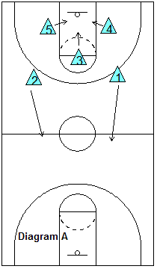
Assign two guards to stay back on defense. When the shot goes up, the three "big-men" crash the offensive boards, while two guards retreat to the mid-court line, one on each side of the center circle. The guard on the ball-side will pick up the dribbler and try to stop the ball. The other guard retreats back to the opponent's paint area to prevent the lay-up.
When the opponent gets the rebound, one of our re-bounders should try to "jam" and pressure the re-bounder in order to prevent, or slow down, the outlet pass. The other two players should sprint back on defense.

Defending the paint area.
Again, we want to prevent the easy lay-up. All players should sprint back on defense and run straight to the paint area to protect the basket. One player should stop the ball, to avoid dribble penetration. Once the fast break is stopped and the "big-men" are back in defensive position, then the defenders can move out of the paint to pick up their man assignment, or zone position.

Defending against 2-on-1 and 3-on-2 fast break attacks.
If the opponent is successful in running a fast-break, your transition defense may be confronted with a 2-on-1, or 3-on-2 situation. In these situations, your defense should be taught to first prevent the lay-up. We have a standard rule... "get as low as the lowest offensive player." This means that if the offense has a player under the basket, a defender must be down low.
If the opponent chooses to shoot the outside jumper, give it to them. It is a lower percentage shot than the lay-up, and you avoid getting a foul, and you may get the rebound, or delay the offense long enough for your teammates to arrive on defense. Often I see high school players make the mistake of coming up away from the basket and challenging the ball, only to get beaten by an easy pass to another player under the basket for a lay-up (see diagram). Again, the defender must stay back and "gap" the offensive players, that is, try to straddle and cut off the passing lanes to the easy lay-up.
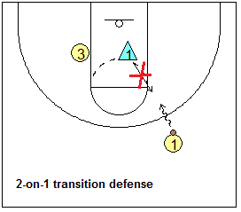

3-on-2 defense
See the diagrams below. When we have a 3-on-2 situation, we stack the two defenders as shown. The top defender should stop the ball and yell "ball, ball, ball!" The bottom defender should sprint out and take whoever gets the first pass. As the pass is made, the top defender should then immediately drop back in the paint, following the rule "get as low as the lowest offensive player".
If you can make them pass a couple times and delay the break, the rest of your team should be able to sprint up the floor in time to help. We drill the 3-on-2 defense when running the 11-man or 7-man drills, and the 4-on-4-on-4 drill.
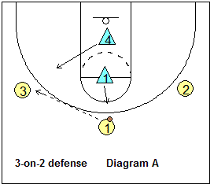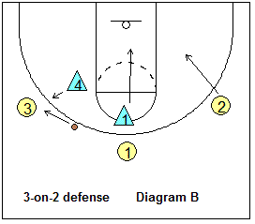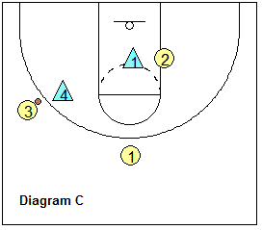
With the above strategy and understanding of transition defensive assignments, and with good team hustle, you go a long way in stopping, or slowing down the fast-break.

Full-Court Press Defense
Transition defense can be even more sophisticated with full-court pressing defense. First, the disadvantages of a press defense are that is takes a lot of practice time to develop a good, cohesive press. Also, remember that the full-court press is a gamble (especially trapping zone defenses). You risk giving up the easy transition lay-up. Good offensive teams with good ball handlers and passers can break the press and turn it into their advantage with an easy score.
If you press the entire game, your players may become fatigued, may get into foul trouble, and the offense often "figures it out" with time. So you might want to press only in certain situations (e.g. after a made basket), or certain times of the game. You may want to use the press as a "surprise" tactic.
The advantages are that it can quickly produce back-court turnovers, and easy steals and scores for your team. So it is an offensive weapon as such, and a way to come from behind, or a way to break open a close game. The press keeps the opponent off-balance, changes the tempo of the game, and often has the opponent doing things they don't normally like to do.
It often forces the opposing coach to use valuable time-outs. It favors a well-conditioned team with a deep bench, and with more substitutions, allows more of your players to get playing time. There is a saying, "To error is human, and pressure causes error."

Some basic principles apply to all presses.

1. Have a safety back.
Always have one player back in prevent mode to prevent the easy lay-up.

2. Sprint back.
Sprint back to the paint when you are beaten. But don't be lazy and give up too soon on the press.

3. Avoid back-court fouls.
When trying to stop the dribbler, don't reach in! Rather, you must move your feet to get into position and force to (but deny penetration along) the sideline. The referee is watching closely for the reach-in foul. Back-court fouls are usually "stupid" fouls, created when the opponent was not even in position to score. It's especially "stupid" if the opponent is in the two-shot bonus, or if it is committed with only seconds remaining in a period.

4. Trapping
In trapping, one defender should first stop the dribbler, often along the sideline or baseline, or in one of the "trapping zones" (see below). Trapping zones are those areas where the offensive player definitely does not want to get caught losing his dribble. It's like getting caught in a corner.
Once the ball is stopped, the second defender sprints over and double-teams the ball carrier. They cut off the ball-handler's view, and get into the passing lane. The position of their hands should be at the same height as the ball. If the offensive player holds the ball high to "throw over the top", the hands should be high. If the ball is low, the hands should be low to prevent the bounce pass.
The defensive players should be close together ("knee-to-knee") so the offensive player cannot split the trap with a dribble.
Do not reach in! This only transforms a good situation into a bad one (now the player goes to the free throw line). Instead, the trapping players should deny the player from getting the pass off and get the 5-second call, or force a bad pass, which is intercepted by one of your teammates.

5. Gapping
The other defenders who are not actively trapping, try to get into the gaps between the ball-handler and his/her teammates. They play the passing lanes and deny and intercept passes from the trapped player.
The yellow zones catch the player in the corner.
The red zones are excellent trapping zones, since the offensive player cannot retreat across the 10 second line.
The blue zones are good trapping zones because the offense has to worry about the 10-second count.
