Runner: Tom Charles Longboat
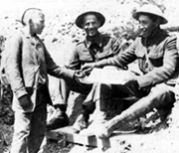
Longboat was wounded twice and once was wrongly reported killed. He would survive the war. Here he is shown buying a newspaper from a French newsboy in 1917. (Department of National Defence / Library and Archives Canada / PA-1479)
Thomas Charles Longboat did not receive any awards for bravery. He was not killed in the thick of battle while performing a daring feat above and beyond the call of duty. Rather, he is an example of the selfless response of Canadians to the chaos spreading throughout Europe.
An Onondaga from the Six Nations Grand River Reserve, Longboat had a compelling reason not to enlist: he was a world champion long-distance runner. In 1907, he won the Boston Marathon (a distance of approximately 40 kilometres) in record time, leaving his closest competitor four-fifths of a kilometre behind.⁴⁷ His status as a racing celebrity was solidified in 1909, when he won the world professional marathon championships at Madison Square Garden in New York City.
His running had earned him thousands of dollars by February 1916 when, at the age of 29, he set aside his athletic career to enlist. Though the rewards were substantially less, he did not quit racing. As a dispatch carrier with the 107th Pioneer Battalion in France, Longboat ran messages and orders between units. He also kept in competitive form by racing in inter-battalion sporting contests, many of which he won. At the 1918 Canadian Corps Dominion Day competitions, Longboat won the eight-mile [13-kilometre] race.⁴⁸
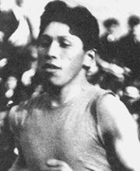
Tom Longboat continued to run after joining the Canadian Expeditionary Force. The famous Six Nations' distance runner became a dispatch carrier with the 107th Battalion. As well, he competed in army sporting contests, and won the Dominion Day Competition's eight-mile race in 1918. (Canada's Sports Hall of Fame / Library and Archives Canada / PA-49901)
The famous runner was wounded twice during his time of service. Once he was declared dead, but he survived the war and returned to Canada in 1919. Tom Longboat died in 1949 at the age of 62. He is a member of the Canadian Sports Hall of Fame and the Indian Hall of Fame.
Two Brave "Van Doos"Table of ContentsNurse Overseas

