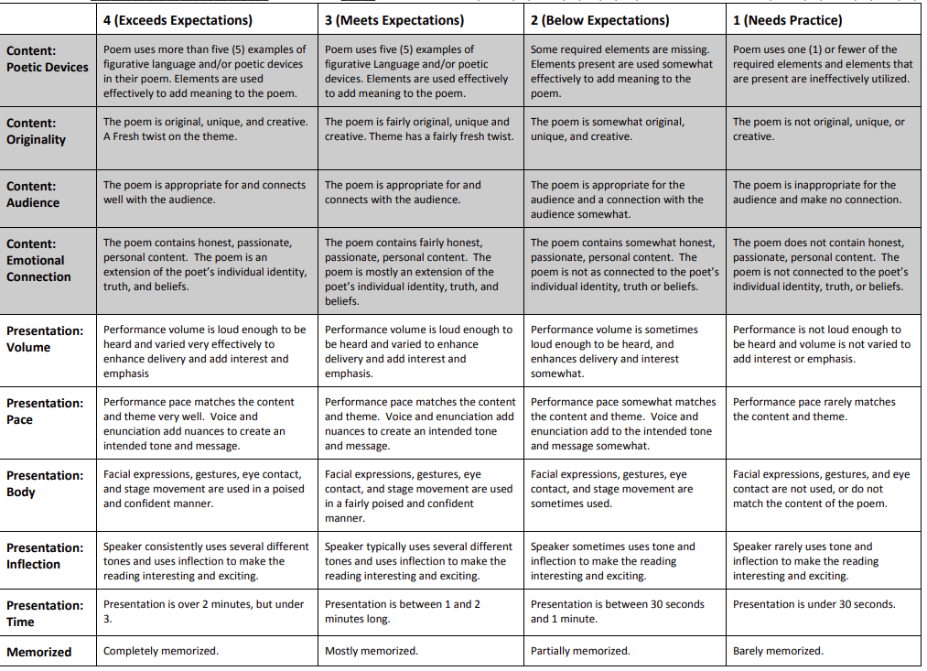
Slam Poetry Rubric Name: ________________________________

