Shannen’s Dream Background Information and Writing Assignment
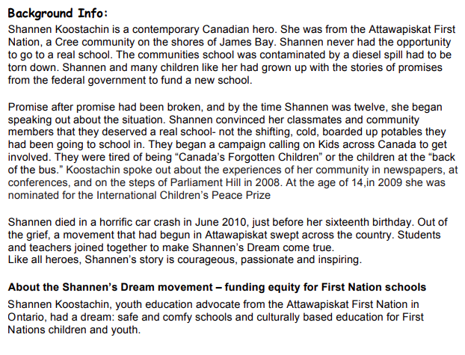
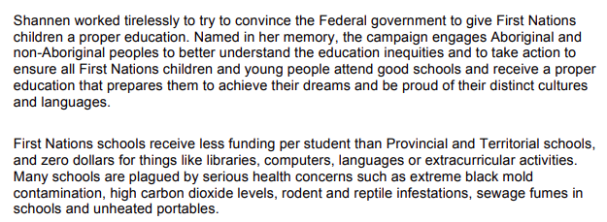
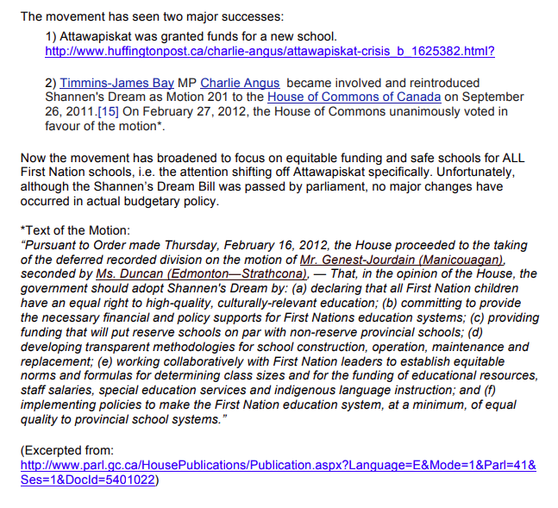

While you are watching the youtube video Heartspeak and Shannen’s Dream and the movie Hi Ho Mistahey write down things that you learn about Shannen’s situation, and how you feel about it.
After the movie choose one of the following assignments to write about your thoughts.
Assignment Choices:
- Write 1-2 pages describing Shannen’s journey and what her dream was. Talk about what she accomplished and what still needs to be done. Write about what you think the government should do to fix the situation and why.
- Write a 1-2 page letter to the Prime Minister Justin Trudeau explaining what you have learned about in the movie and reminding him about Shannen’s dream. Ask him why he has not followed through on the government promises. Explain to him what still needs to be done and why the government should be doing it. Try to persuade him to fulfill Shannen’s dream using your personal feelings about what is happening.

