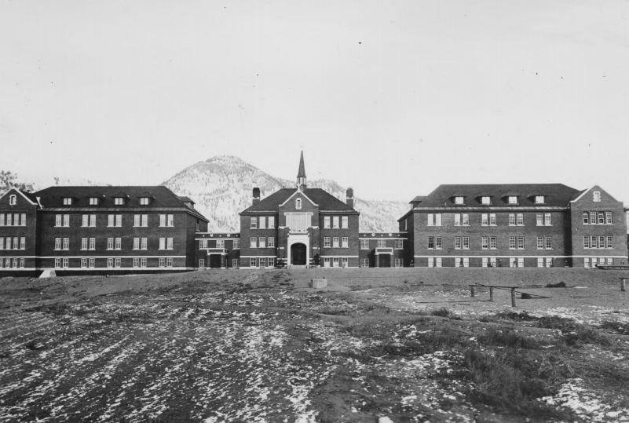https://news.ubc.ca/wp-content/uploads/2021/06/Screen-Shot-2021-06-02-at-10.51.20-AM.png
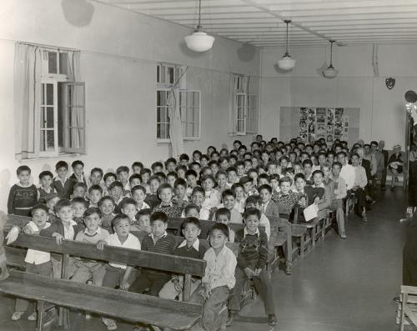https://www.google.com/url?sa=i&url=https%3A%2F%2Findigenousfoundations.arts.ubc.ca%2Fthe_residential_school_system%2F&psig=AOvVaw1qT2ssUbxdOCjqf2iFuaNM&ust=1663866820225000&source=images&cd=vfe&ved=0CAwQjRxqFwoTCOjXlouxpvoCFQAAAAAdAAAAABAH
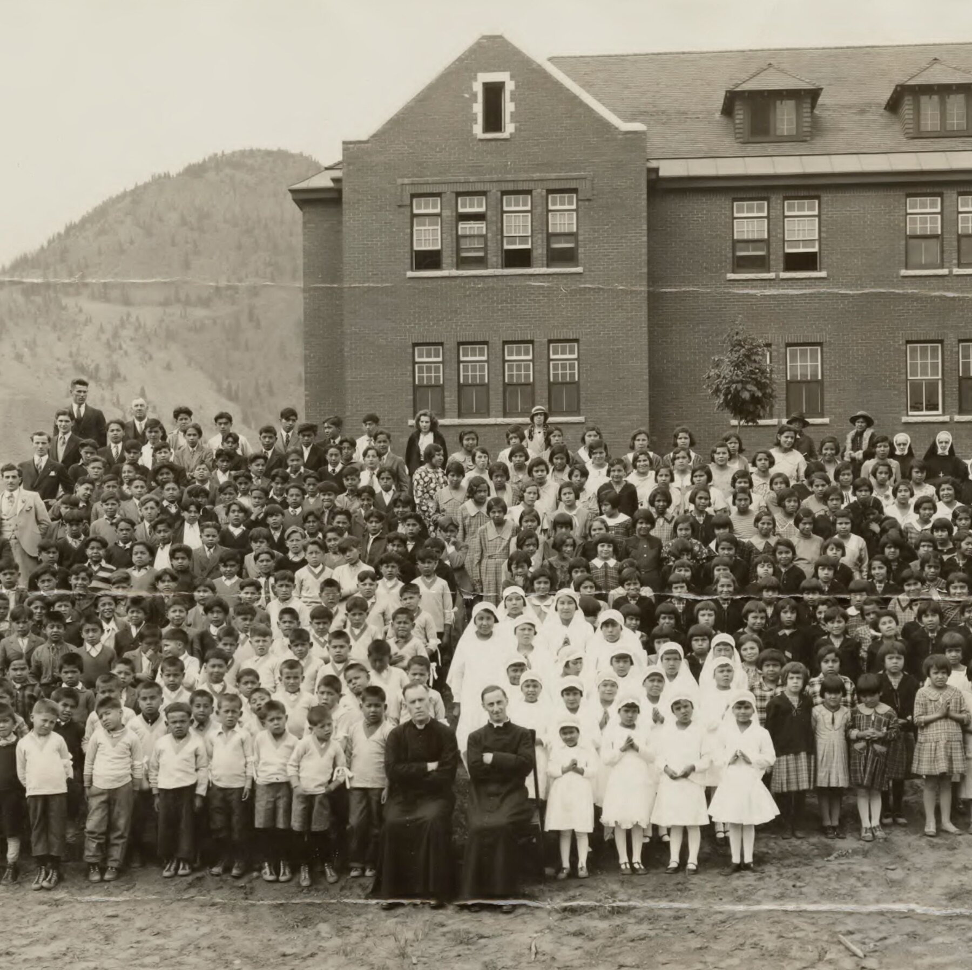https://static01.nyt.com/images/2021/06/28/world/00INDIGENOUS-SCHOOLS1/00INDIGENOUS-SCHOOLS1-mobileMasterAt3x.jpg
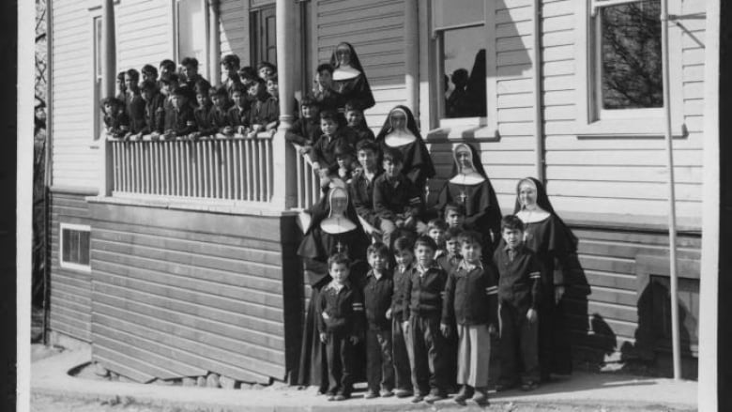https://i.cbc.ca/1.6136271.1628617527!/fileImage/httpImage/image.jpg_gen/derivatives/16x9_780/st-pauls-residential-school.jpg
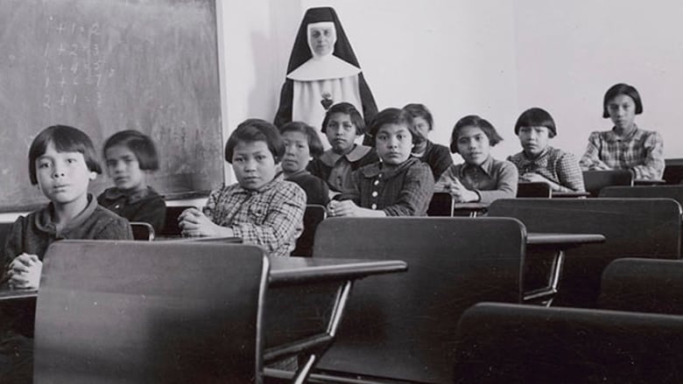https://i.cbc.ca/1.3562292.1625023411!/fileImage/httpImage/image.jpg_gen/derivatives/16x9_780/canada-residential-schools.jpg
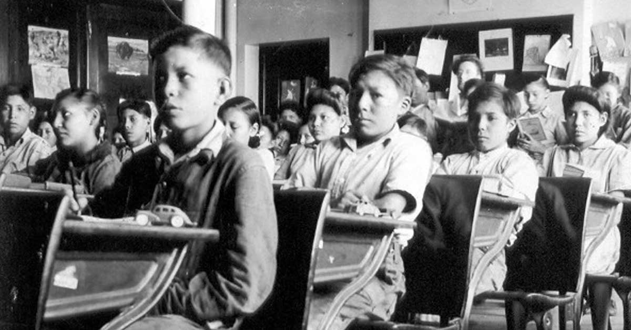https://www.anglican.ca/wp-content/uploads/P75-103-S7-184.jpg
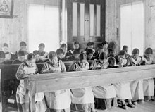https://upload.wikimedia.org/wikipedia/commons/thumb/d/d0/Study_period_at_Roman_Catholic_Indian_Residential_School%2C_Fort_Resolution%2C_NWT_%2814112957392%29.jpg/220px-Study_period_at_Roman_Catholic_Indian_Residential_School%2C_Fort_Resolution%2C_NWT_%2814112957392%29.jpg
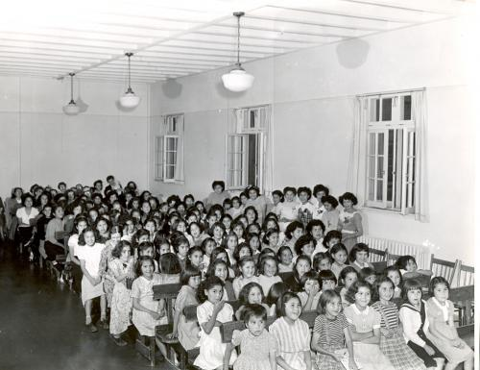https://indigenousfoundations.arts.ubc.ca/wp-content/blogs.dir/56/files/sites/8/2015/09/UnitedChurch_433.jpg
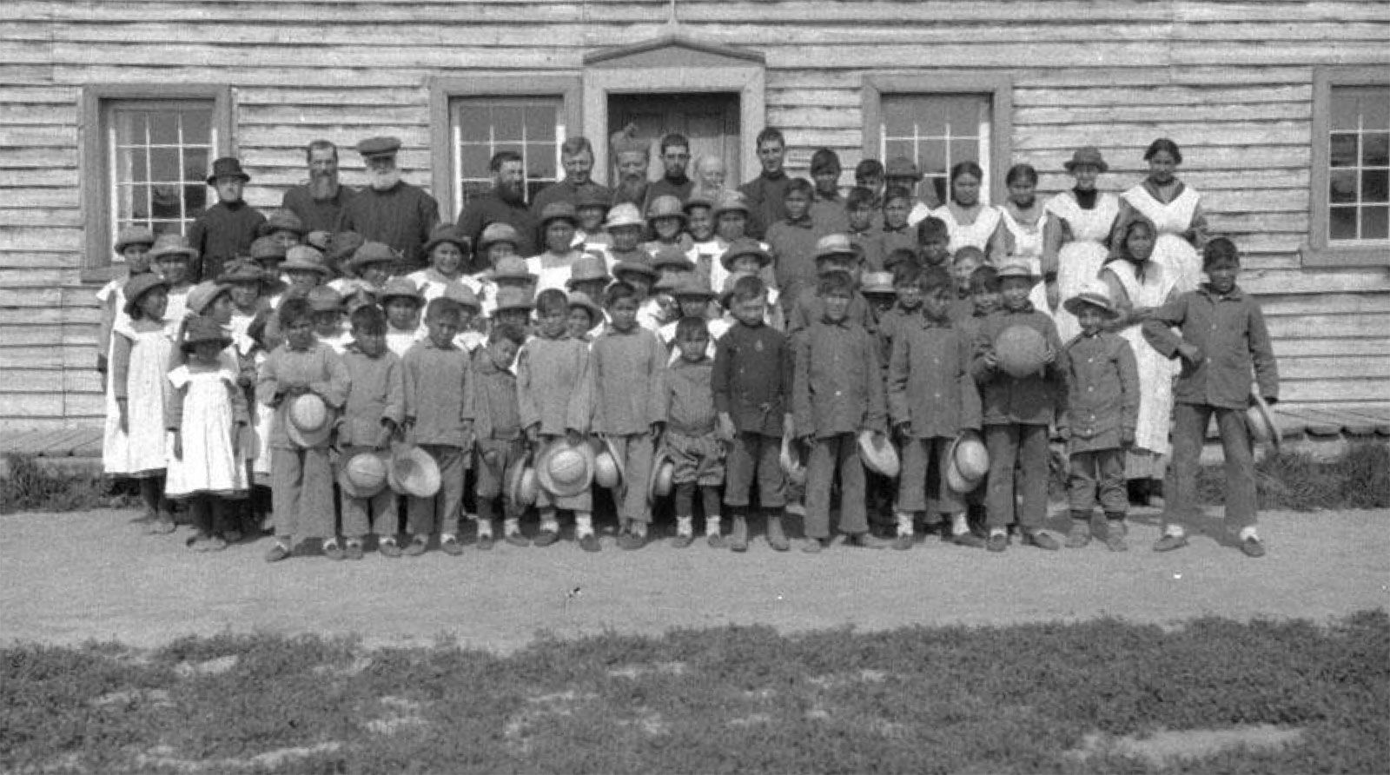https://cdn.britannica.com/17/232117-050-6F15A315/Canadian-Indian-Residential-School.jpg
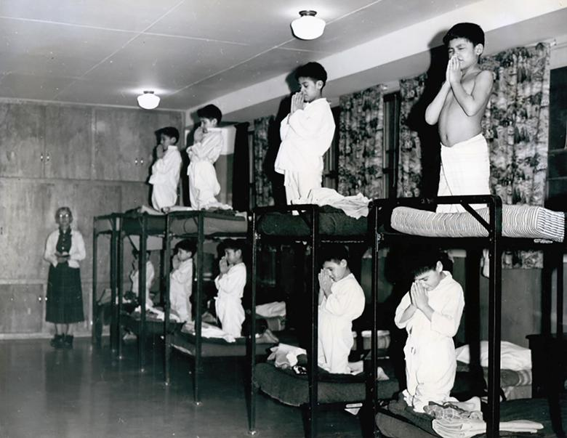https://s4.reutersmedia.net/resources/r/?m=02&d=20210604&t=2&i=1564542034&w=780&fh=&fw=&ll=&pl=&sq=&r=2021-06-04T192412Z_40521_MRPRC23TN9SE6BD_RTRMADP_0_CANADA-INDIGENOUS-RESIDENTIAL-SCHOOLS
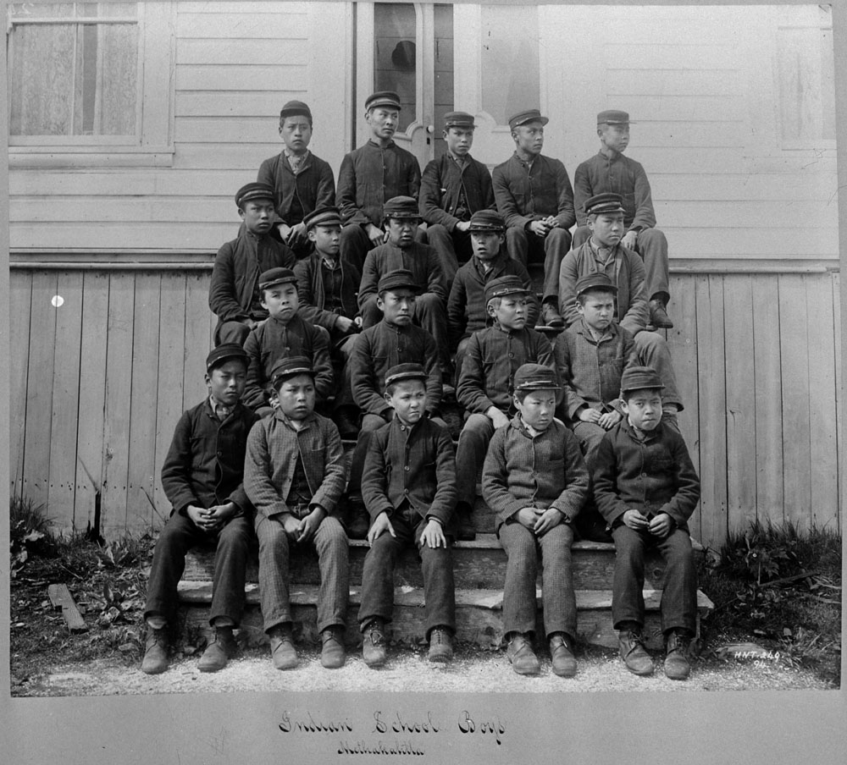
https://d3d0lqu00lnqvz.cloudfront.net/media/media/c015037-v8.jpg
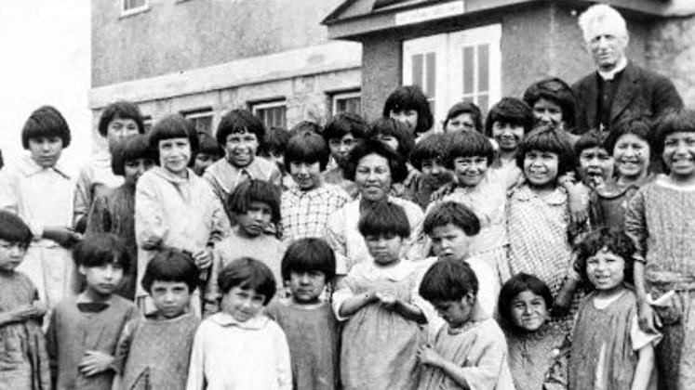https://www.vmcdn.ca/f/files/newmarkettoday/images/historical-images/indigenous-residential-school-class-photo-(1).jpeg;w=747;h=420;mode=crop
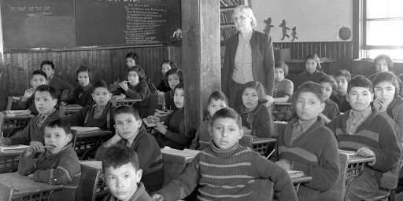
https://lh3.googleusercontent.com/7z-P6WOqoukhELdeMzrVMBdrEbpCMA7XRKCMj6jRL8msDp6pMRn4oHP4SOOdG5kK7g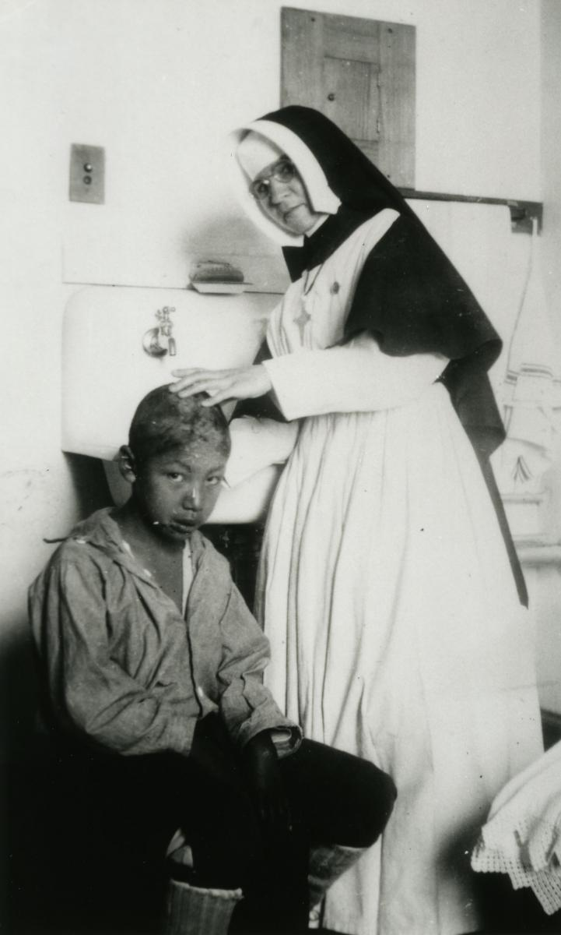https://saskarchives.com/sites/default/files/gm-ph-1384-5.jpg
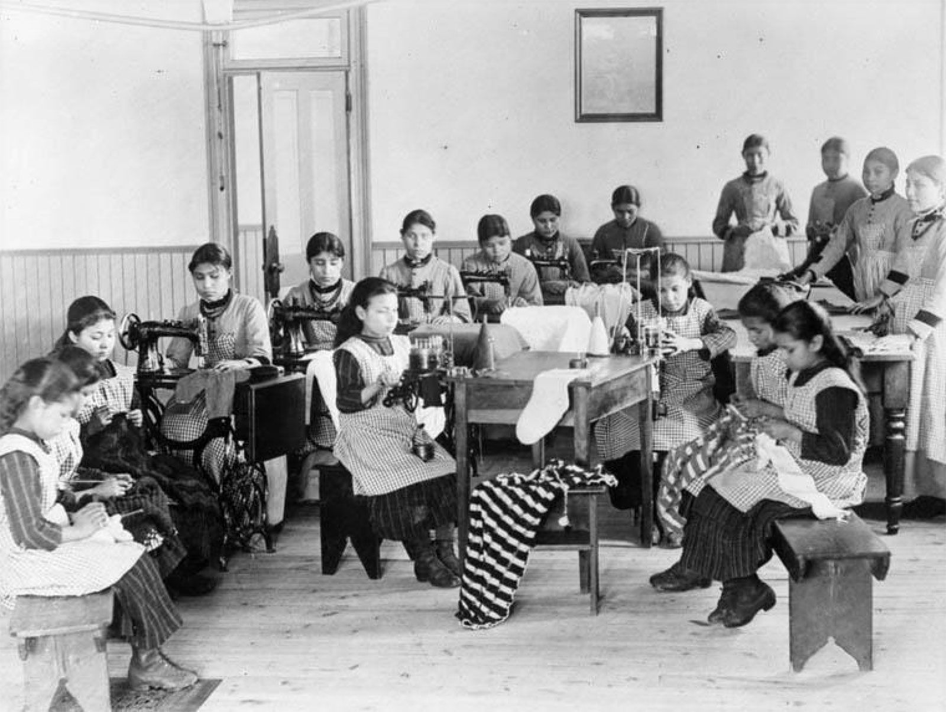https://cdn.britannica.com/14/232114-050-27021052/Canadian-Indian-Residential-School.jpg
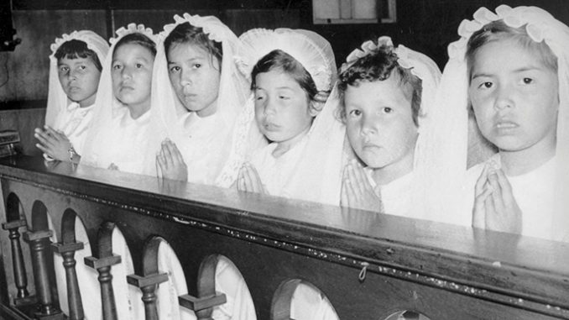
https://s3.us-west-2.amazonaws.com/files.catholicworldreport.com/2021/07/20210701T1245-US-INTERIOR-INQUIRY-BOARDING-SCHOOLS-1251224-678x381.jpg
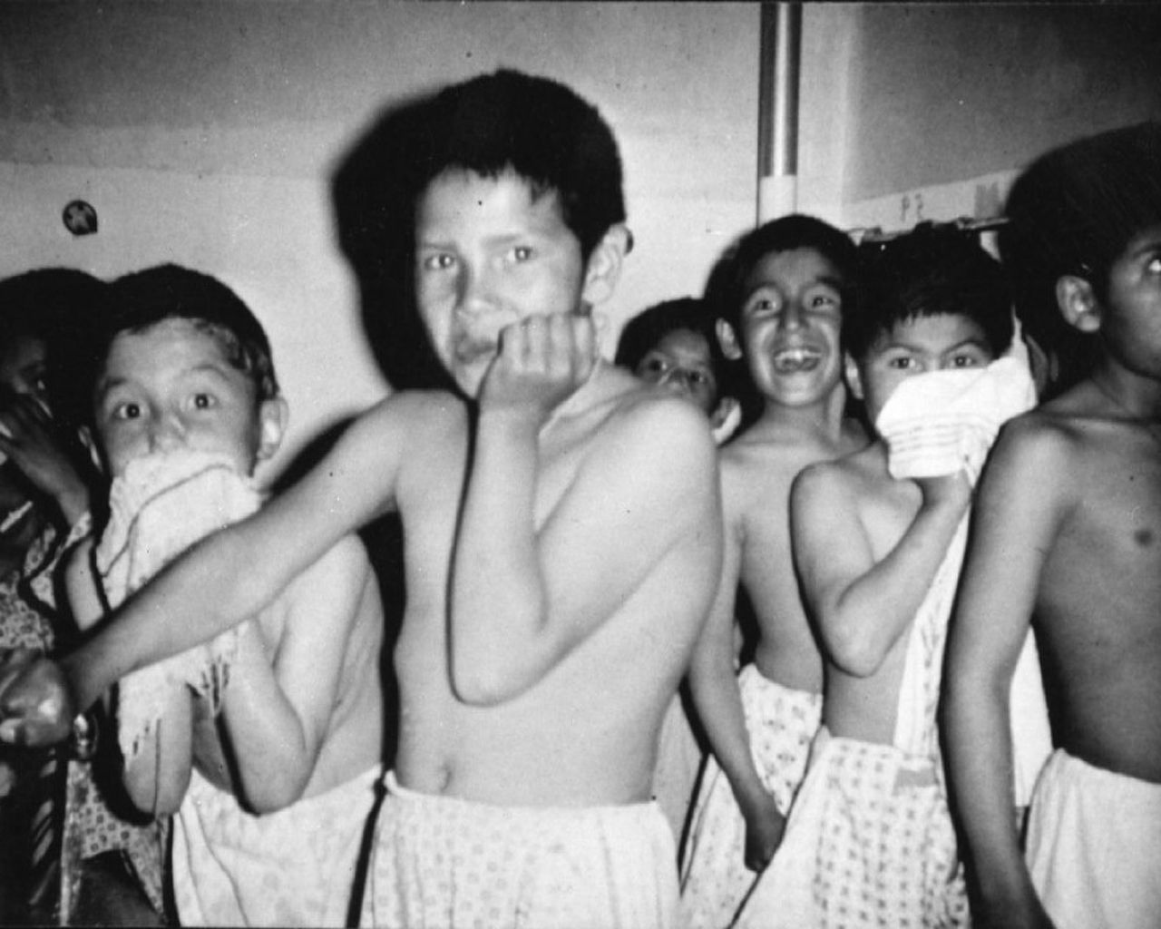https://images.thestar.com/8ZKcQDI-MBVurN6ju7Yf-Rk61M0=/1280x1024/smart/filters:cb(1529628724836)/https://www.thestar.com/content/dam/thestar/news/canada/2014/01/14/government_ordered_to_hand_over_documents_about_infamous_residential_school/residential_school.jpg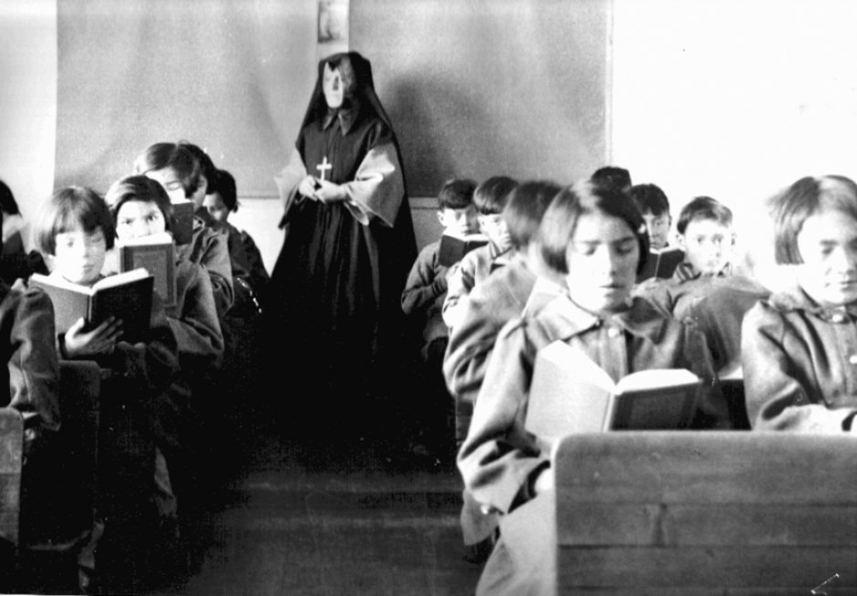https://newsinteractives.cbc.ca/craft-assets/images/lead/_medium/st.-annes-rs-2012-001_001_023.jpg
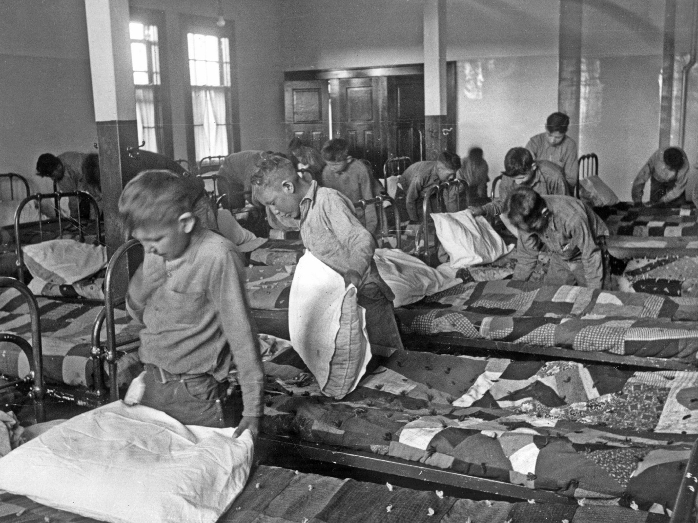
https://static01.nyt.com/images/2017/07/01/opinion/01scrimshaw-inyt/01scrimshaw-inyt-superJumbo.jpg
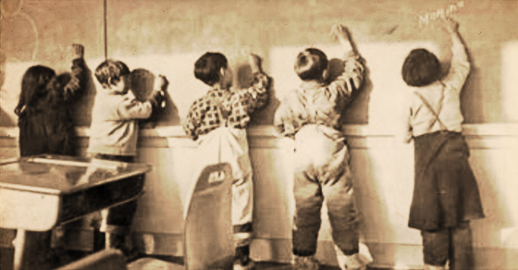https://pressprogress.ca/wp-content/uploads/2017/09/trc_thumb-1.png
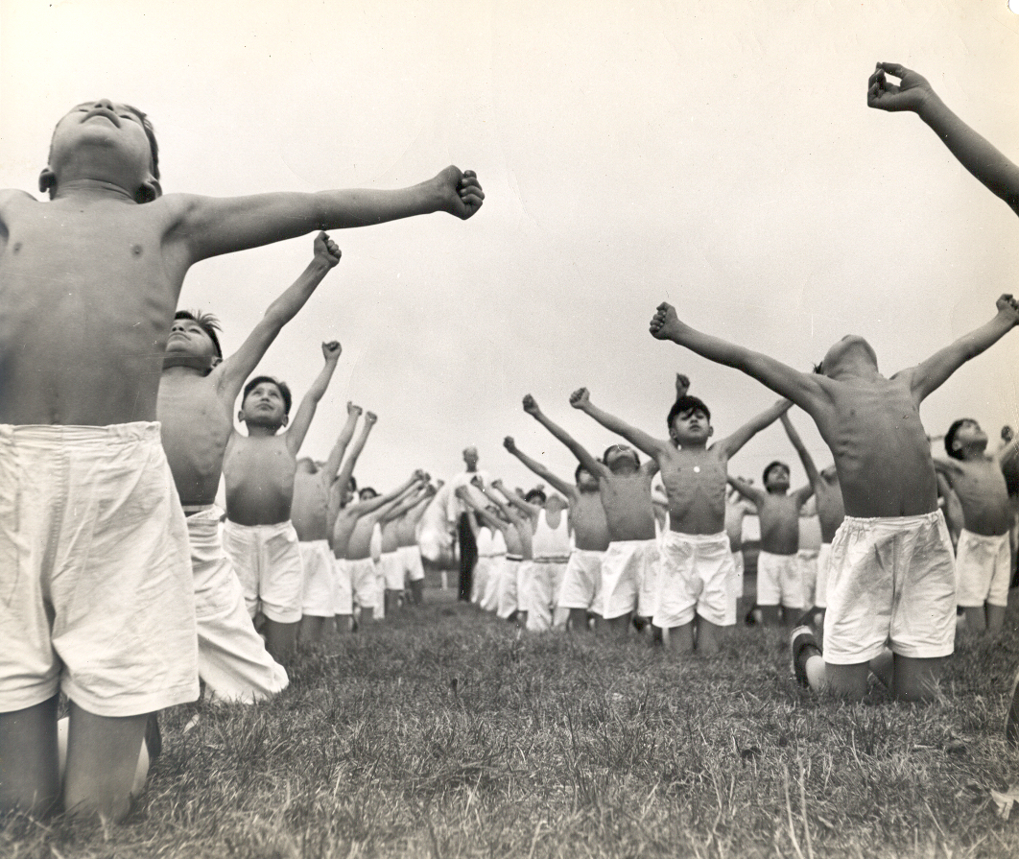https://windspeaker.com/sites/default/files/news/image/2020-08/Image1.png
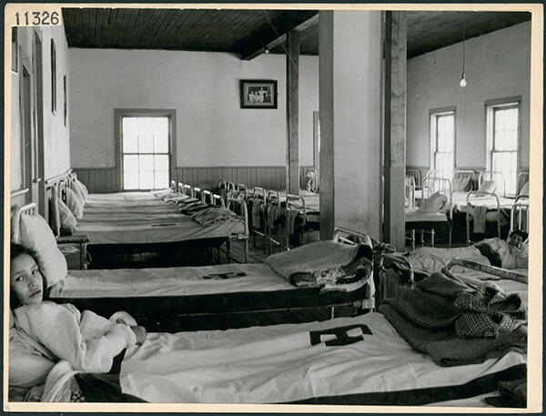http://static.hwpi.harvard.edu/files/styles/os_files_large/public/rpl/files/cs_violencepeace_christianity_residentialschools2.jpg?m=1597342295&itok=R9UpQi_D
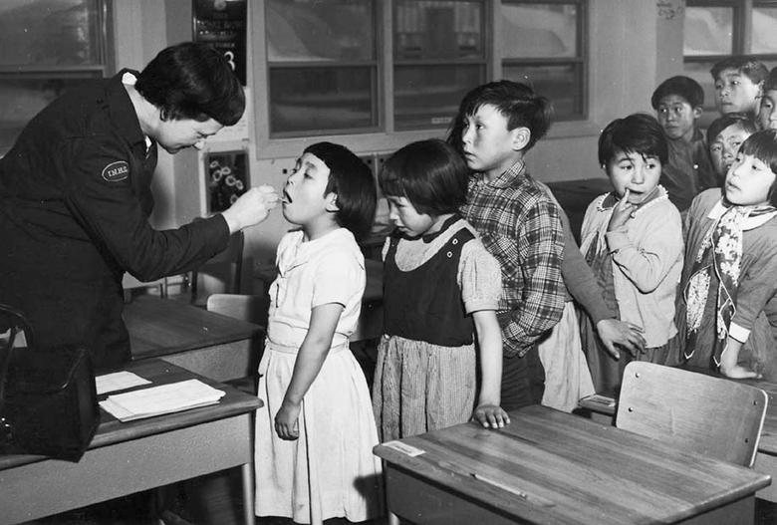https://s4.reutersmedia.net/resources/r/?m=02&d=20210930&t=2&i=1576434545&w=780&fh=&fw=&ll=&pl=&sq=&r=2021-09-30T135506Z_42007_MRPTM3EB62107101_RTRMADP_0_CANADA-ABORIGINALS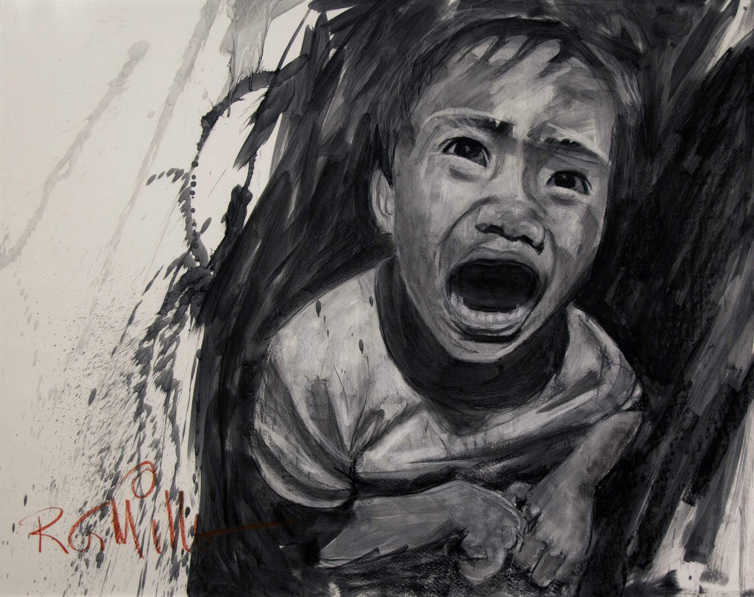https://intercontinentalcry.org/wp-content/uploads/2018/09/ScreamingChild_RGMiller-w1900.jpg
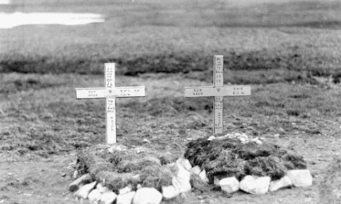https://lh3.googleusercontent.com/xydE90P25P-0tkEKpcFi0-JRCSvHQJ9yMd6rPgVo1xg2Wn4kJSo92J_C___JByQ=w480-h288-n-rj
https://www.abbynews.com/wp-content/uploads/2018/09/13648624_web1_180427-SAA-Indian-Horse.jpg
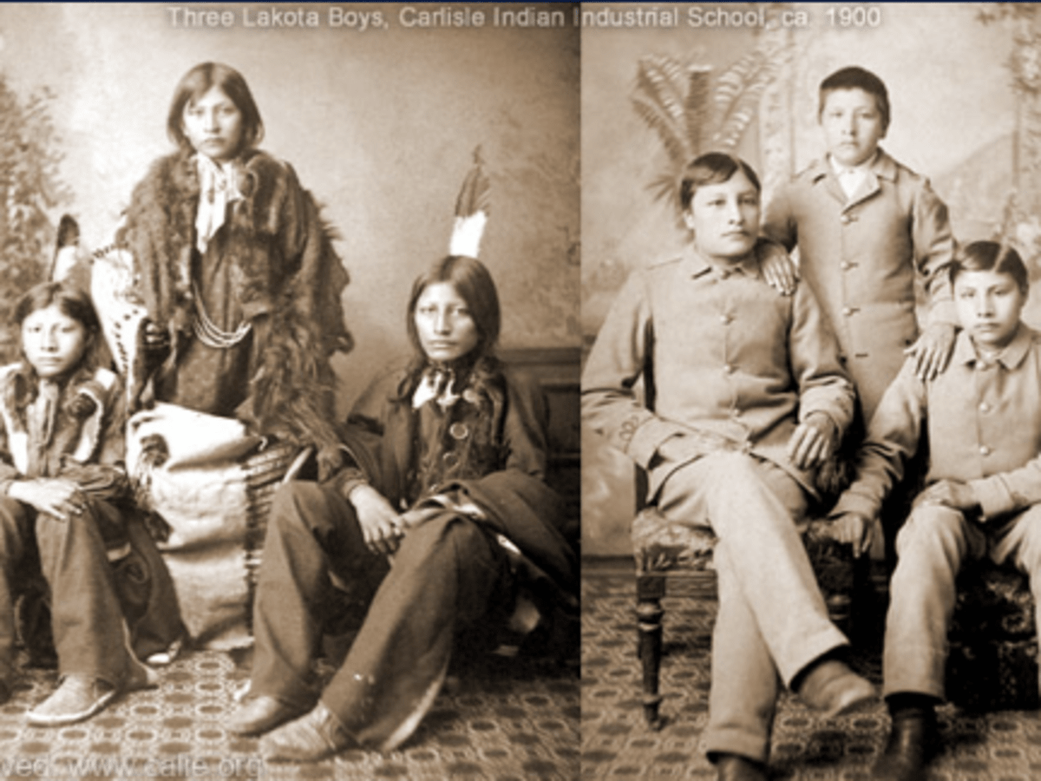https://indiancountrytoday.com/.image/ar_4:3%2Cc_fill%2Ccs_srgb%2Cq_auto:good%2Cw_1200/MTU4NDEyMzY3MDE3MTU4MTAx/kill-the-indian-save-the-man-boarding-school.png
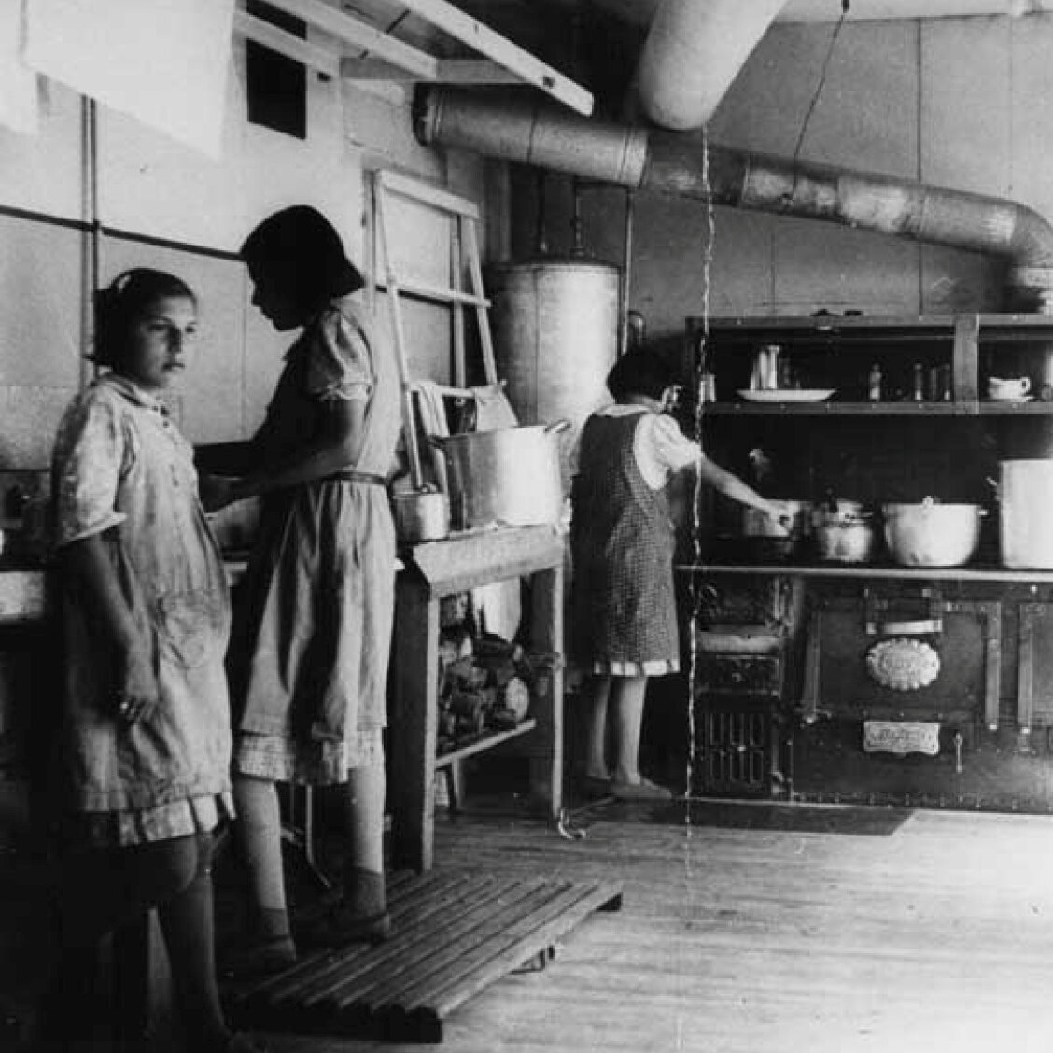https://static01.nyt.com/images/2021/06/28/world/00INDIGENOUS-SCHOOLS9/00INDIGENOUS-SCHOOLS9-mobileMasterAt3x.jpg
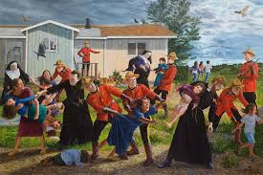https://encrypted-tbn0.gstatic.com/images?q=tbn:ANd9GcSNQHvWqkGsLazeVuc8J4JqiAqNLIYAKEarWw&usqp=CAU
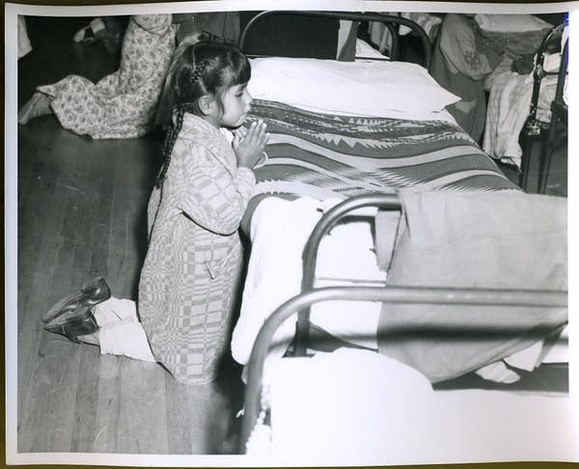
https://img.apmcdn.org/75fad7cbf4445e55e369f56d0240ce1e7b8aa103/uncropped/d191b3-20190924-stringingrosaries-02.jpg
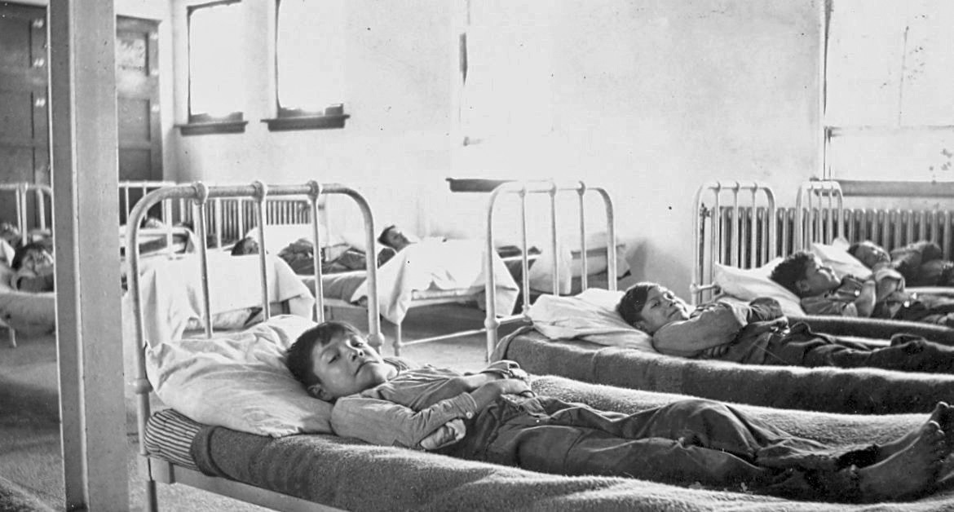
https://ecampusontario.pressbooks.pub/app/uploads/sites/176/h5p/content/10/images/file-5b847fdc7ebc4.jpg
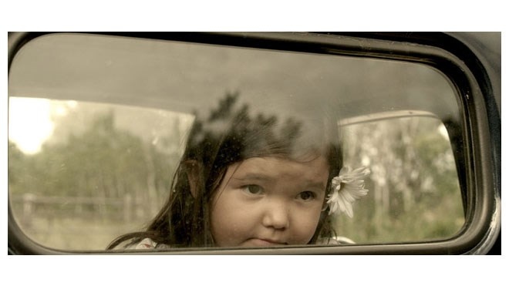
https://www.vmcdn.ca/f/files/sudbury/images/LifestyleImages/wewerechildrensized.jpg;w=960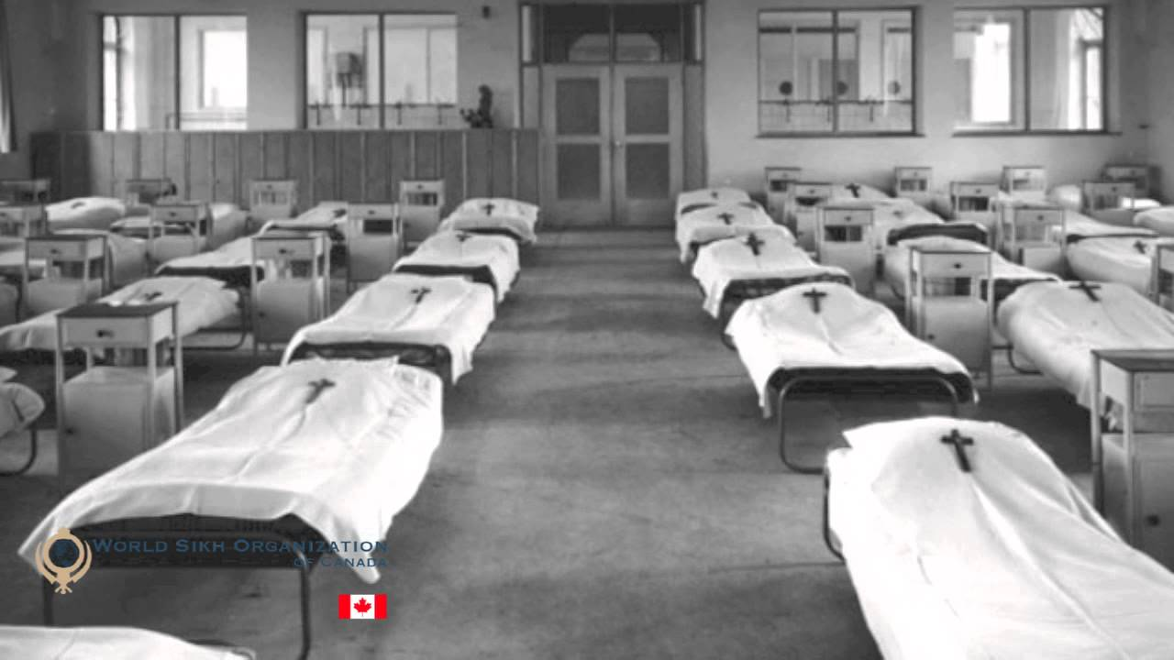https://i.ytimg.com/vi/rxGtnKUT0ms/maxresdefault.jpg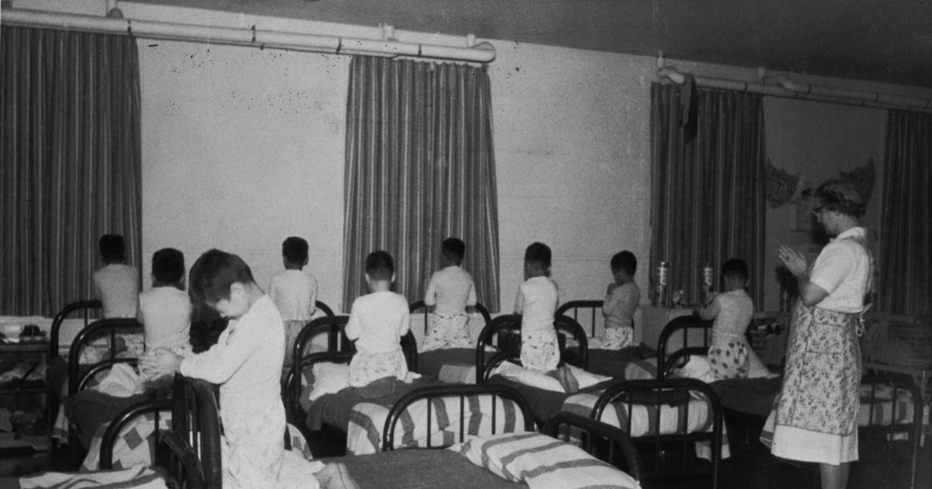https://humanrights.ca/sites/prod/files/styles/content_share/public/2018-09/g03241%20L2Z3-03-mt01%20Yukon%20Archives%2086_61_678-DP-A.jpg?h=f23bfe6f&itok=ZFHHDT4M
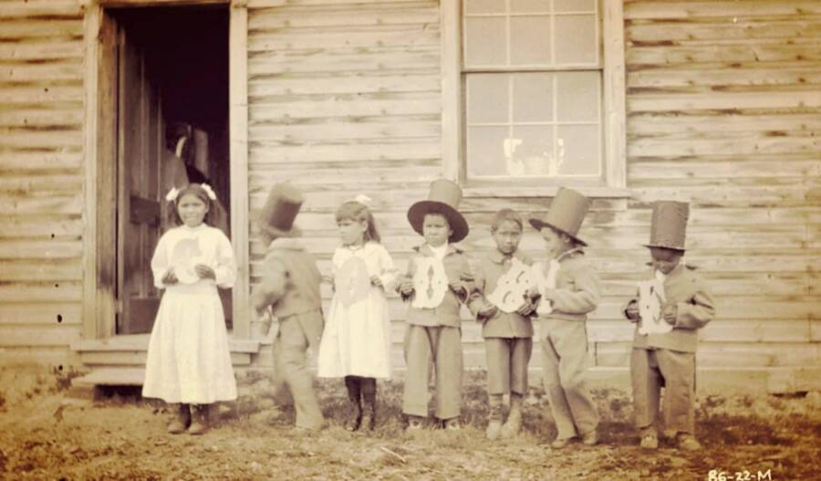https://allthatsinteresting.com/wordpress/wp-content/uploads/2021/10/canadian-indian-residential-schools-1.jpeg
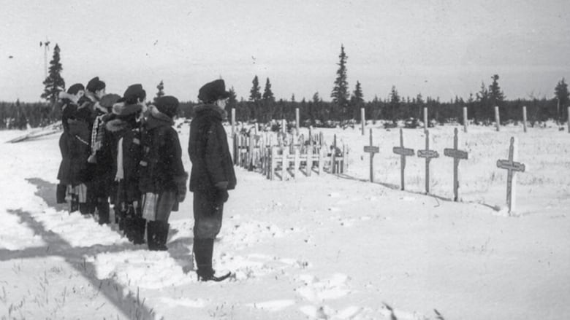https://i.cbc.ca/1.6053559.1622829639!/fileImage/httpImage/image.jpg_gen/derivatives/16x9_780/fort-george.jpg
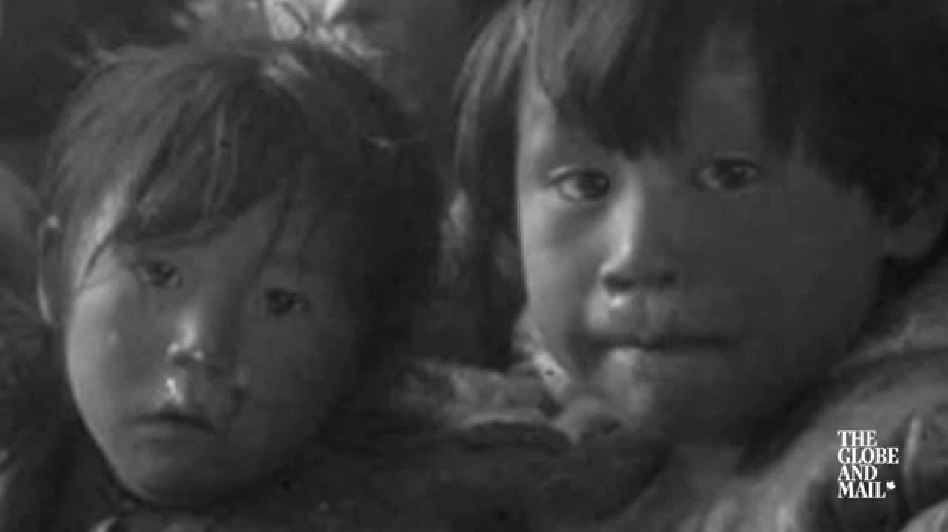https://i.ytimg.com/vi/zgJgQXPbOVU/maxresdefault.jpg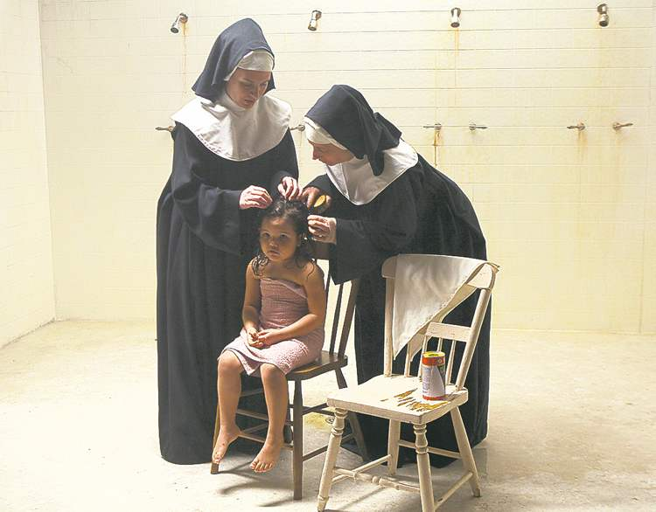https://thelinkpaper.ca/wp-content/uploads/2021/06/WCCAR-Indigenous-People10.jpg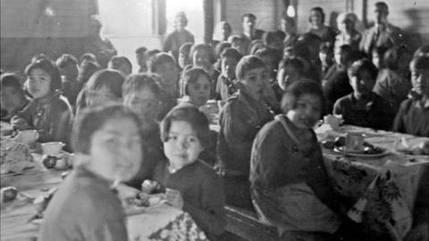http://foodsecurecanada.org/sites/foodsecurecanada.org/files/styles/large/public/ahousaht_british_columbia_students_in_the_school_cafeteria._british_columbia_archives_pn-15589.jpg?itok=MGxFqJO7
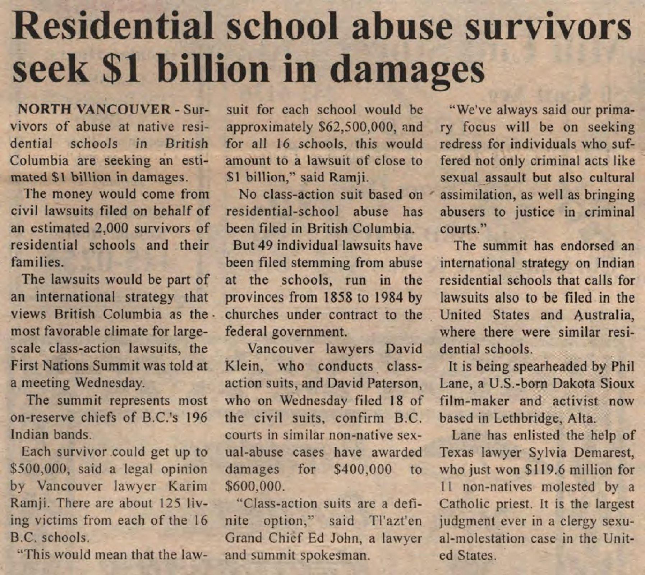https://images.ourontario.ca/Partners/SixNPL/SixNPL003238447f.jpg
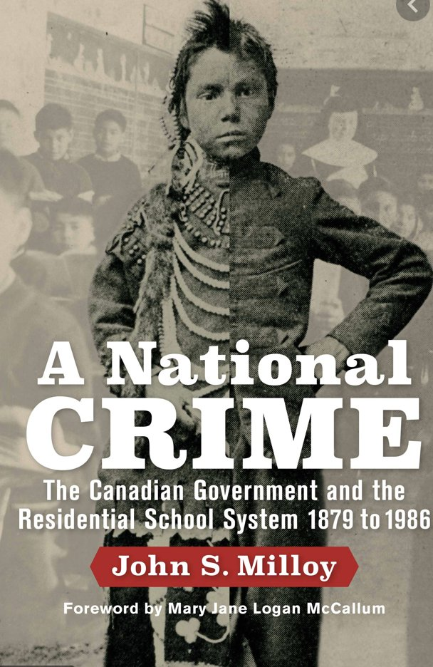https://pbs.twimg.com/media/E2gRGJRWEAExl_o.jpg
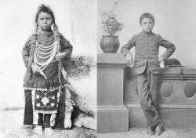https://encrypted-tbn0.gstatic.com/images?q=tbn:ANd9GcS-GCzcNIogxloU0hkQQaaClqM58e0yuK6hXQ&usqp=CAU
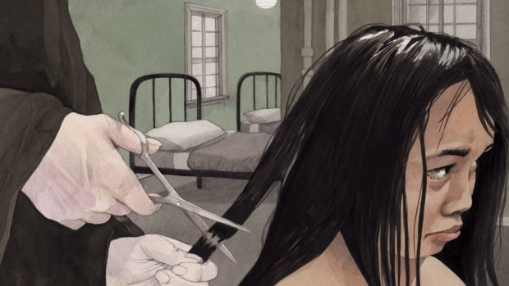https://i.cbc.ca/1.4543449.1519150186!/fileImage/httpImage/image.jpg_gen/derivatives/16x9_620/book-cover-i-am-not-a-number-by-jenny-kay-dupuis-kathy-kacer-illustrated-by-gillian-newland.jpg

