TSONOQUA-CANNIBAL WOMAN
Who was Tsonoqua?
- Tsonoqua was a half-mad cannibal woman who hunts for naughty or careless children to eat.
- When she caught them she would carry them off in an enormous back basket.
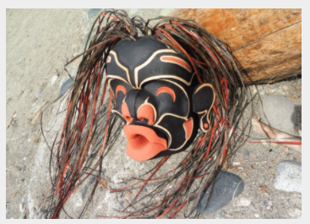
- She is the bogey woman of the Northwest Coast
- She was used as a threat for misbehaving children.
- She was not very smart and her prey usually escaped.
- She was greatly feared by children.
What nations had stories about Tsonoqua?
- Many nations had stories about Tsonoqua including the Kwak’waka’wakwa,
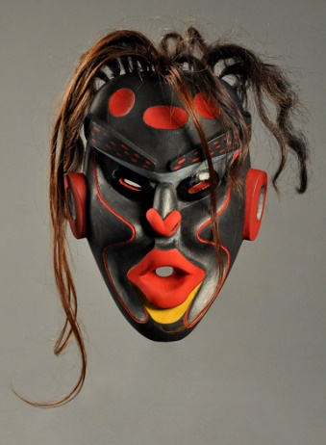
the Haisla, and many nations along the Pacific Northwest Coast.
Is she known by any other names?
- Tsonoqua is also known by names such as Dzunukwa (Wild Woman),
and Tsonokwa.
What are some characteristics associated with her?
- Tsonoqua had bright red big pooched lips.
- She was ugly.
- Her features were very sculptured and deep.
- Some stories say she was a giant.
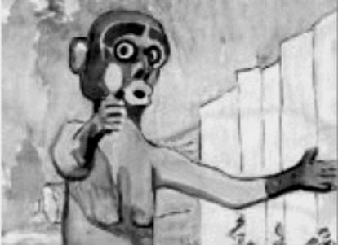
- She is usually naked and black (as soot) in colour.
- She has long pendulous breasts.
- She had bedraggled hair.
- She had very bad eyesight and could be easily avoided because she
could barely see.
- She was drowsy and dimwitted.
- She has deep set eyes which are rimmed with red.
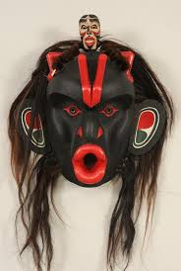
- She has grabbing eyes.
- She smelled awful.
Did she have any special abilities?
- Tsonoqua was believed to be able to bring herself back from the dead
and regenerate wounds.
- She controls the magical Water of Life, and clumsill spills it around.

What were the purpose of her stories in their cultures?
- Her stories were used to make children behave.
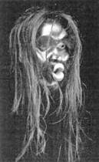
- Her stories were used to show obsessive desires like greed or the hunger felt for children by Tsonoqua are not a laughing matter.
What are some other interesting facts about Tsonoqua?
- In one of the stories about her she was jealous of the beauty of a local
young woman and befriended her because she knew she could never
be so beautiful.
- She ran through the woods crying “hoo hoo” when she hunted for naughty
children which sounded like the wind blowing or whistling through the trees.
- Most children managed to escape from her in the stories that were told.
- Many masks of here had the dark look of a death mask, alive and horrifying.
- One of the myths about Tsonoqua is related to how mosquitos were created.
- She is rich and many try to steal from her, but their quest for wealth
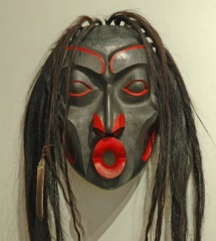
and power leads to unhappiness.
- Parents used the Tsonoqua story as a warning to keep their children
safe and discourage them from venturing too far into the forest by telling
them she might eat them.
- Many artists have created masks about Tsonoqua to share her stories.
What are some cultural traditions related to Tsonoqua?
- At the end of some potlatch ceremonies the host chief wears a mask of Dzunukwa
which is a sign the ceremony is over.
- During the Winter Ceremony (Hamatsa) Tsonoqua is represented by an oversized
mask worn by a master dancer who moves clumsily to represent the monster’s confusion.

REFERENCES:
https://stoningtongallery.com/artwork/tsonoqua-in-love/#:~:text=People%20of%20the%20Northwest%20Coast,for%20naughty%20children%20to%20eat.&text=Tsonoqua%20comes%20in%20many%20forms,the%20imagination%20of%20an%20artist.
http://www.native-languages.org/basket-ogress.htm
https://www.mymondotrading.com/native-meanings-symbology-myths-legends
https://en.wikipedia.org/wiki/Dzunukwa
http://richardtylman.atspace.com/tsonoqua.html
https://sjima.org/legends/
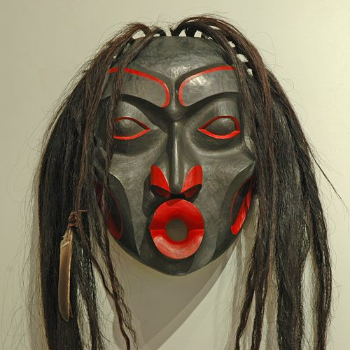
https://masksoftheworld.com/how-masks-help-tell-the-legend-of-the-wild-woman/

