Oolichan Harvesting and Processing Scavenger Hunt Name: ________________________________
During the lesson look for the following items and put a check above the box when you see them or hear me talk about them. At the end of the lesson prizes will be given.
PRESENTATION SCAVENGER HUNT
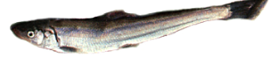  Oolichan | 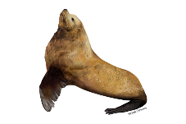  Sea Lion | 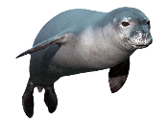  Seal | 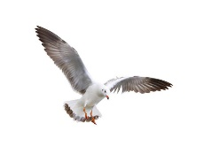  Seagull
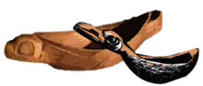  Feast Dish | 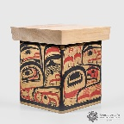  Bentwood Box | 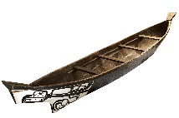  Dugout Canoe | 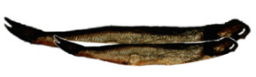  Dried Oolichan
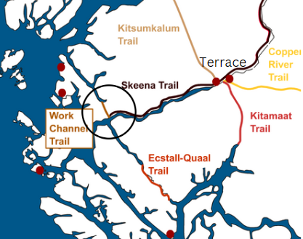  Grease trail | 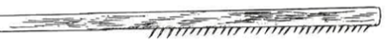  Oolichan Rake | 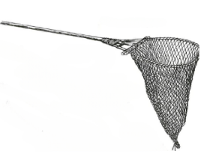  Oolichan Dip net | 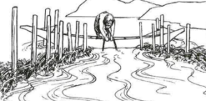  Oolichan Weir
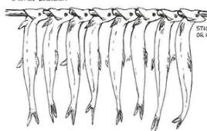  Smoked oolichan | 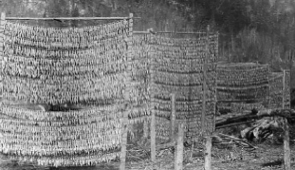  Oolichan drying racks | 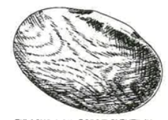  Oolichan oil scoop | 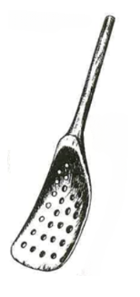  Scoop to remove stones
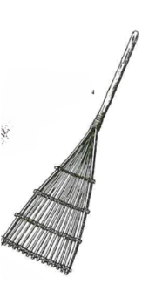  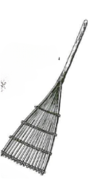  Oolichan oil strainer | 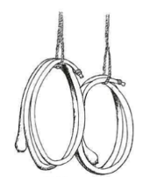  Kelp bottles to store oolichan oil | 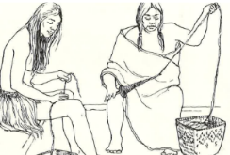  Stinging nettle being made into twine | 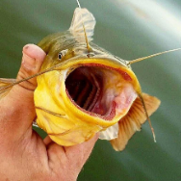  Bullhead
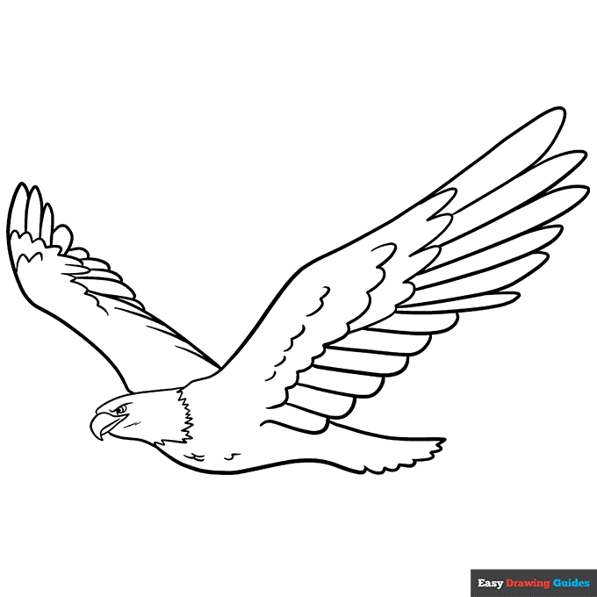  Eagle | 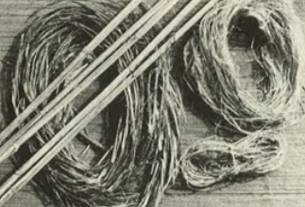  Stinging Nettle Fibre | 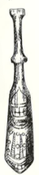  Nettle Fibre Beater | 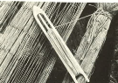  Net Gauge

Trivia questions
Which of the following was a way that oolichan were used?
- Trading with other nations
- Making into grease
- Eating with berries
- All of the above
- None of the above
What type of fish does an oolichan net look like?
- Salmon
- Bullhead
- Trout
- Oolichan
Which of the following rivers does not have oolichan?
- Nass River
- Skeena River
- Kitlope River
- Fraser River
Which of the following nations did not fish for oolichan themselves?
- Nisga’a
- Gitxsan
- Haisla
- Ts’msyen
Which of the following animals did not follow the oolichan run?
- Seals
- Sea Lions
- Sea gulls
- All of the above
- None of the above
Which of the following ways were used to process oolichans?
- Smoking
- Drying
- Roasting
- All of the above
- None of the above

What is an adawx?
- A true telling/teaching narrative
- A small fish that preys on oolichan
- What oil is called in Sm’algyax
- The Ts’msyen name for an oolichan net
What is the reason oolichan and oolichan grease were served at feasts and potlatches?
- Because it was very nutritious
- Because sharing it increased the chief’s status
- Because it was the only food available
- Because it was a ceremonial food
Which of the following was traded by the T’smsyen people when they travelled inland to Gitxsan territory?
- Oolichan grease
- Clams
- Abalone
- All of the above
- None of the above
Which of the following was not traded by the Gitxsan to the Ts’msyen?
- Soapberries
- Dried meat
- Moccasins
- Oolichan grease
What were the Grease Trails?
- Trails they followed to find the oolichan
- Trails they used to trade grease with other nations
- Trails they used to get to the oolichan camps
- Trails they were very slippery
Which of the following was not the name of a grease trail?
- Nass Trail
- Skeena Trail
- Copper River Trail
- Kitimaat Trail
What did the Ts’msyen use to make nets from?
- Bullrushes
- Alder bark
- Devils club
- Stinging Nettle
Why do they have to make sure the strands in the net are the right distance apart?
- So the net would be big enough to catch the fish
- So the net would be strong enough to catch the fish
- So the net would be the right size to catch the fish
- So the net would not break from the weight of the fish
Which of the following techniques was used to catch oolichan?
- Raking
- Weirs
- Dip netting
- All of the above
- None of the above
How did they attach the oolichan to the racks for drying?
- By tying the tail fin of the oolichan to the racks
- By putting the oolichan onto the racks through their gills
- By slicing the oolichan open and laying them on the sticks
- All of the above
- None of the above
Why were Weirs, dip nets and rakes not the best way to catch oolichan?
- Because they broke too easily
- Because the oolichan escaped too easily
- Because they caught too many other fish
- Because they didn’t catch enough oolichan at once
Why were oolichan called the saviour fish?
- Because they saved the people from starving after winter
- Because they provided food for the salmon, seals and sea lions
- Because they helped create the grease trails
- Because they were so valuable as a trade item
What did they traditionally heat the oolichan to boiling in the canoe or other pits?
- By cooking the oolichan over the fire
- By adding hot stones to the oolichan
- By heating water and pouring it on the oolichan
- By stirring the oolichan very fast in the water
How did the oolichan net work?
What was the name of oolichan in Sm’algyax?
Why was the oolichan known as the saviour fish?

