Match up zone rules-Based on the split line and who takes the first pass.
At beginning of defensive set
- Point should pressure the ball handler coming up
- Point takes the ball- match ups depend on what side ball is on when point takes the ball
- Ball side post- outside the paint-low
- Weakside post one foot in lane in deny position for post- calls hi post cut
General rules
- When ball goes to side- post cuts to elbow-top covers hi post cut
- If doubling- only do so if they cannot shoot (only off bad shooter)
- Keep hands up high- helps deny easy pass and makes zone look bigger
- Force ball to corner
- Don’t allow middle penetration
First pass rules- if pass is above second peg- match ups based on what side of split line the point is on
- First pass- above 2nd peg- point has first pass- force it to corner
- Second guard has ball side elbow- hi post responsibility on high post cut- matches up with top guard
- Middle person matches up with weak side post
- Ball side post takes ball side post
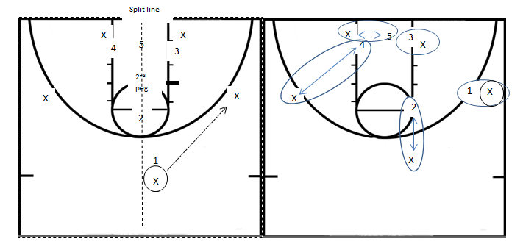
- Weakside post calls high post cut and has weakside split line- matches up with weakside wing

First pass rules- if pass is below second peg
- If wing pass is below second peg ball side post takes pass-point drops to top of key
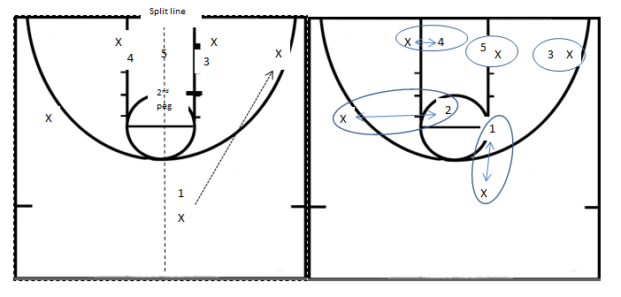
- If they flash to high post weakside post calls high post cutter and point covers hi post-comes up to middle on bump denying cutter
4
5
3
X
1
3
4
5
X
X
X
2nd peg
Split line
X
2
1
X
X
X
X

Skip pass- Rule
- skip pass- close out- taken by weakside post- kicked down by guard- all rest of zone moves to help/deny positions according to man to man principles
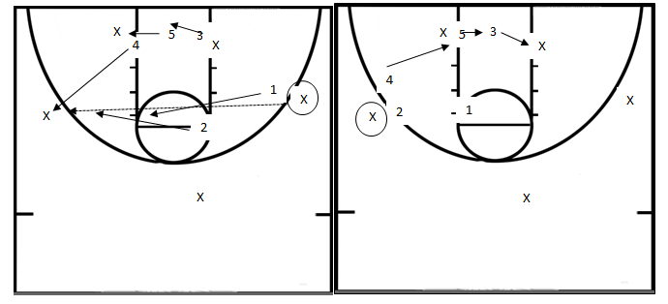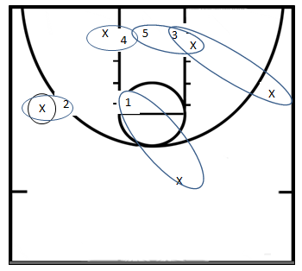

Ball in corner rule
- Ball in corner- rule if beaten on corner- ball side post and middle trap ball- (or middle and weakside post trap ball) deny reversal pass- weakside top player drops down into help to stop cross over pass to weakside
Box out response
Ball shot at point
- If ball is shot at point- box out blocks on both sides and the shooter
Ball shot at wing
- If ball is shot at wing- box out shooter- middle blocks out ball side post- weakside post blocks out weakside post on offense- top defensive player not on the ball goes to block out at weakside post
Ball shot at corner
- Shot corner
- Middle Boxout ballside post- weakside top goes to weakside glass-

