Literature circle example for all discussion circle roles
Example story:
Morris and his wife Esther went to the Grand Canyon every year, and every year Morris would say, 'Esther, I'd like to ride in a helicopter over the Grand Canyon so we can see the sights. I really want to look at the lands of the Navajo nation and where they lived from the air. 'Esther always replied, 'I know Morris, but that helicopter ride is 50 dollars and 50 dollars is 50 dollars.'
One year Esther and Morris went to the fair, and Morris said, 'Esther I'm 85 years old. if I don't ride that helicopter, I might never get another chance. They say you can see the ancient Hopi houses of the Hopi people as well as the lands of the Navajo. Both nations have lived here for thousands of years and shared the resources of this area. ' Esther replied, 'Morris that helicopter is 50 dollars and 50 dollars is 50 dollars.'
The pilot over heard the couple and said, 'folks I'll make you a deal. I'll take the both of you for a ride; if you can stay quiet for the entire ride and not say a word I won't charge you! but if you say one word, it's 50 dollars.'
Morris and Esther agreed and up they went. The pilot did all kinds of fancy manoeuvres, but not a word was heard. He did his dare devil tricks over and over again, but still not a word. When they landed, the pilot turned to Morris and said, 'by golly, I did everything I could to get you to yell out, but you didn't . I'm impressed!'
Morris replied, 'well I almost said something when Esther fell out, but, you know, 50 dollars is 50 dollars!'

Discussion Director- Sample questions
- What do you think about Esther telling Morris not to ride every year because it costs $50?
  - Because she is only thinking short term
Reason- Because she is cheap
Example-She always points out the helicopter ride will cost $50
Explanation-Since she points out the cost, instead of focussing on the experience, it shows she is cheap and only thinking about short term money issues

- Would you have listened to Esther? Why or why not?
  - It depends- but if we were well off I wouldn’t because I wanted to go
Reason-I wouldn’t listen to her because I wanted to go on the ride
Example-If we had lots of money
Explanation-because we could afford it and I would want to have the experience
- Did you think the story was funny? Why or why not?
  - Yes- even though I don’t think it’s funny that someone would be let to fall out of the helicopter I imagined her with a bungee- ironic- teach her a lesson about being so stingy
Reason- Because it is such a ridiculous turn of events
Example-he lets his wife fall out of the helicopter without saying anything just to save money
Explanation-since this shows the absurdity of only being focussed on money without considering all the aspects of what a decision would mean- ie. Helicopter ride= memories not just money Falling out of helicopter = death/injury- not just money

Literary Luminary –Example of quote with summary, pg # and paragraph # on page, and two reasons, examples and explanations for choosing it

Quote chosen:-'well I almost said something when Esther fell out, but, you know, 50 dollars is 50 dollars’
-Summary of quote - this is the part where he explains that even though his wife fell out he was worried about the loss of money-'well I almost said something when Esther fell out, but, you know, 50 dollars is 50 dollars’
Pg # and Paragraph #: Pg. 1, last paragraph
Why did I pick it?

-Reason 1- because its ironic- he learned the lesson but not the way she wanted him to
Example-lets his wife fall out of the helicopter’
Explanation- if he hadn’t been so focussed on money- he never would have done that

-Reason 2-because it helps us understand the meaning of the story- that money isn’t everything
Example-his wife died or was seriously injured
Explanation- since he let his wife die for a measly $50 this shows how absurd it is to be so focussed on money alone

Artful Adventurer (example of description of art, and 2 reasons for choosing it with examples and explanations)
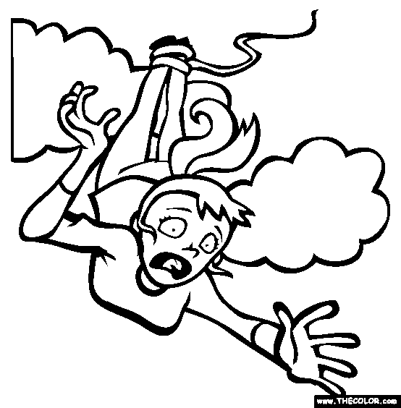
I chose this picture because I think Esther would be scared falling out of the helicopter. I picked a picture where she was tied to a bungee cord because I don’t think the pilot or Morris would have intentionally hurt her- but Morris might have wanted to get even and the pilot was trying to make his money

Description of art- I chose a picture of a person falling through the sky attached to a bungy cord
Why did I choose it?
-Reason 1-because I imagined that if he let his wife fall out he wouldn’t really want her to be hurt but just to learn her lesson
Example-so I imagined her attached to a bungy cord
Explanation- since being attached to a bungy cord would save her but still let her learn a lesson I thought this picture helped show the meaning of the story without such a disastrous ending
Reason 2-because I wanted to show her reaction to what had happened to her
Example- shocked and scared reaction
Explanation- Since the picture shows a shocked and scared reaction it illustrates how she would feel falling out.

Connector (description of connection with 1 reason, example, and explanation)
Description of connection- In the story when the husband says to his wife- 'Esther I'm 85 years old. if I don't ride that helicopter, I might never get another chance.'- A lot of people in life don’t take chances or miss opportunities just like the man who always avoids the helicopter ride to save money
Page #: Pg. 1
Reason for choosing this connection-because the lesson of the story is that life is about more than just money
Example-the helicopter ride
Explanation-since life is short people need to take advantage of opportunities like the helicopter ride so they don’t miss out.

Character Captain (example of three adjectives that describe a character with example from the story and explanation
Character: Esther- Adjective: cheap- Example- $50 comment Explanation- isn’t willing to spend $50 on something her husband wants to do Pg #: Pg 1
Character: Esther- Adjective: bossy-Example-$50 comment Explanation- forces her husband to always not do what he wants to do Pg #: Pg 1
Character: Morris Adjective:-weak- Example- not willing to stand up to his wife Explanation-if he wanted to do something he should have just done it Pg #: Pg 1

Indigenous Culture (example of 2 indigenous themes or topics from story with example)
Indigenousl theme/topic-connection to the land
Example from the story-Morris wants to see the lands of the Navajo people
Indigenousl theme/topic-connection to the land
Example from the story-Morris mentions that the nations of the Hopi and the Navajo have shared resources and lived in the area for thousands of years.

