Keeper N' Me
Chapter 1 Plot Outline
- Garnet is taken by child services at age two, separated from his family and leaves the White Dog Reserve. He lives in countless foster care families throughout his childhood.
-He runs away at age sixteen, hitchikes and roams the country, pretending to be other people, anything but aboriginal.
-He settles in Toronto, discovering his love for the blues music. Garnet meets Lonnie Flowers and his family, eventually moving in with them. Lonni influences Garnet to dress and act more like Lonnie.
-Garnet starts dealing drugs, gets arrested and is sentenced for five years in jail. Two years into his sentence, his brother Stanley makes contact with him and they begin communicating.
- A year later he is released and makes his way to his original home, White Dog. He reunites with his siblings and his mother and moves into his mother's house.
Keeper N' Me
Chapter 2
-Keeper invites Garnet over to his cabin and begins to tell him stories about their history.
- Garnet learns more about his family, specifically his grandpa's best friend and how he used to be one of the last traditional people.
- Garnet finds out that Jackie doesn't talk to him because he feels like he didn't save Garnet when he was taken away by the social workers.
-Garnet and Jackie play hockey together, and Jackie expresses how he felt when Garnet was taken away, and how much he missed him.
- Keeper tells Garnet about Beedahbun, how it is the first light and how it connects to your life.
- Keeper gives Garnet words of wisdom.
-They talk about their culture.
Chapter 3
- Wilbert Fish smashes the shortwave radio against the wall, Bert Otter's radio. This cause Garnet to talk to Wally Red Sky about bringing a radio to White Dog.
- Everybody was "cranky" after the radio was smashed, which motivated the community to support the new radio station.
- Red Sky One Radio is announced.
- Keeper tells Garnet how "people are gonna bump up against the outside world" warning him about the coming radios influence on White Dog.
- A Pow-Wow is held at White Dog.
Chapter 4
- Garnet decides to go into the forest on his own for a few days to live on the land on his own. He does this to meditate on the land and to experience the silence of the land.
- Keeper helps Garnet get ready for his four day spiritual journey and tells him to pray for all he's thankful for while smudging tobacco.
- While Garnet was canoeing and day dreaming oneday he saw two eagles watching him and moving in mysterious ways. He later had a dream of a young man and women dancing who he later realizes are symbols of the eagles.
- Garnet returns home and tells Keeper about the eagles he saw and asked about what it could have meant. Keeper gives him two eagles feathers to signify his pride and honor in Garnet.
- Everyone began calling Garnet "Jake" which was an honorable term meaning he way cool and hip.
- Garnet's mother decided to organize a celebration to celebrate his achievements since he arrived in White Dog. Everyone was very proud of him and he recieved many gifts of recognition and Garnet truly felt like he belonged.

Keeper ‘N Me Chapter 1 (“Bih’kee’-yan”) Summary
(Definition of “Bih’kee’-Yan” at the bottom of the chart)
List 8-10 key events that happen in Chapter 1 (in order) | List 5 themes that apply to this chapter and (in point form) connect them to the main events
The reader is introduced to the character of “Keeper” who will serve as a philosophical voice throughout the novel. Keeper speaks about how “we are all tourists” looking for someone to guide us. He comments how Garnet is like a tourist who is caught between the two worlds when he (Keeper) first meets him on the White Dog reserve. He also mentions how Aboriginal youth are often caught between the shiny attraction of fast modern, Westernized life, and the teachings of an older, traditional history.  Narrator switches and the reader is introduced to the protagonist Garnet who describes life on the White Dog reserve. He describes how the reserve is like a completely different world from modern society with no running water or electricity, but he also highlights that “even though we’re poor we still got spirit and heart and we look out for each other”  Flashback: Garnet describes how he was taken from his family when he was three and spent the next 12 years getting moved from foster home to foster home with no idea about his family or cultural heritage. He mentions stereotypes of Indians (term used in the novel-preferred term now Aboriginal) in movies and how Aboriginal history was ignored in schools. He then describes how the negative stereotypes of Aboriginal people led him to a desperate attempt to hide his background. He pretends to be Hawaiian, Mexican… anything except Aboriginal.  When he is older, Garnet discovers a love of Blues music which eventually leads him to an African American man named Lonnie Flowers. Lonnie and his family become the closest thing to family that Garnet has ever had to family and they spend significant time together living the fast life in Toronto. Lonnie and his family are good and generous people who love and support Garnet.  Garnet gets caught for possession and attempt to traffic drugs and ends up with a 5 year prison sentence.  While in prison he receives a letter his brother Stanley Raven letting Garnet know that he has an entire family living on the White Dog reserve who have been waiting for 20 years to see him again.  Once out of prison, Garnet goes to White Dog and is immediately overwhelmed by the incredible contrast with his former life.  Narration switches back to Keeper who describes how lost and foreign Garnet is when he first comes home. Keeper describes how Garnet will need help and love and guidance to reconnect with his culture. Keeper mentions how he has seen this situation many times before with other youth who were taken away and no longer know who they are.  Garnet makes a comment about laughter and how humour is an ingrained part of Aboriginal culture, and something that has allowed them to survive constant negative historical experiences.  Garnet is introduced to his brother Stanley and his sister Jane. He has a second brother Jackie who he does not meet at this time. He learns his father John Mukwa never really got over his children being taken away and he became a recluse and eventually died (it is speculated that he fell off a bridge during a night of drinking).  Stanley and Jane tell Garnet stories of their childhood before Garnet disappeared.  At the end of the chapter Garnet is reunited with his mother Alice Raven. The chapter ends with Alice singing the song Bik’hee’-yan to Garnet and explains that it means “Come Home” and that she has been singing it all through the years as she hoped and prayed for her lost son to one day be returned to her. | Tradition vs. Modernity  Personal and Cultural Identity (and loss of that identity)  History and colonization (impact of historical legislation such as the “Indian Act” relocating Aboriginals to reserves and creating cycles of poverty)  Resilience and healing (though there is a lot of poverty on the reserve, the community bonds are strong and the people are resilient)  Grief & Loss  Racism, stereotypes, negative labelling  Personal and Cultural Identity  Family and extended family and support provided by others  Sharing and generosity  Transitions (with loss and gain)  Responsibility and decision making  Family and extended family  Concept of “home”  Tradition vs. Modernity  Importance of Culture, Tradition and Ceremony  Learning (how to learn, and roles of teacher and learner)  Importance of nurturing  Roles, inclusivity, belonging  Humour and its importance in Aboriginal society (often a very effective coping mechanism)  Importance of family and cultural heritage and support  Re-claiming identity  Concept of “home”  Resilience and healing  Love of family  Wisdom from family and elders  Family and belonging and identity  Conflict resolution

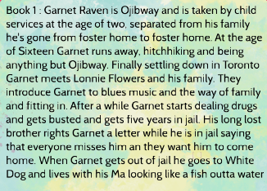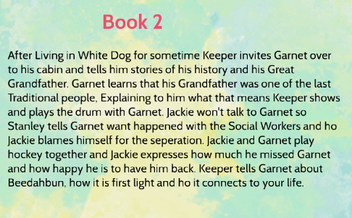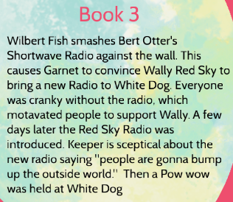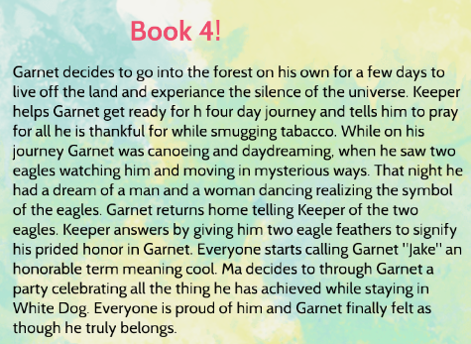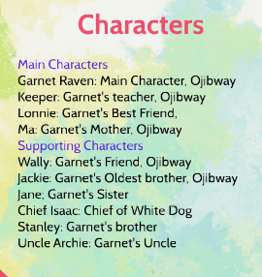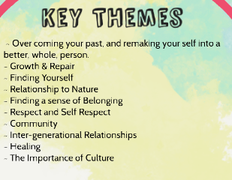

BIH’KEE’-YAN meaning

Bih’kee’-Yan means “come home”. It is the one word in a single-word-song that Garnet’s mother sang to herself when she didn’t know where he was. It captures the main themes of the first part of the novel of displacement and loss of identity which resulted when Garnet was taken involuntarily from his family and completely stripped of his culture. His entire journey so far has revolved around him trying to regain his own identity and discover who he truly is. While he has finally “come home”, his task of discovering his true heritage and becoming comfortable with himself has only just begun. The song “Bih’kee’-Yan” also proves that the entire time that Garnet was lost and searching for his family, his family never forgot him or gave up hope that he would someday return to them.

During Reading
1. Keep the following chart nearby and take notes on it as you read, or place sticky-notes on the page whenever the following themes come up:

According to Keeper, what does it mean to be Indian? | What does Garnet learn about what it means to be Indian? | What does is mean to be Indian according to society?

2. Before reading you can look at topographical and aerial maps of Northern Ontario, and pictures of Northern Ontario Indian reserves, and keep a running list of descriptions that the author includes of the reserve and the land surrounding it. At the end you could create an illustration, model, or written description of the land in the novel.
3. The relationships between people is an ongoing theme throughout the novel. For example, the novel explores the relationship between men and women, the relationship between teacher and learner, and the inter-generational roles within communities. You may want to keep notes as you go along on the different roles that people have in Anishnabe culture.
Bih’kee-yan (First Chapter)
1. Contrast rural life and urban life as you know it in Canada.
2. Describe Garnet’s experience of urban life.
3. Describe Garnet’s return to a rural area on pages 4-5. Predict how this urban-raised person will fit into rural life.
4. What is Ma’s description of what it means to be Anishnabe? (p8)
5. How did cultural differences in terms of an understanding of what makes a good upbringing for children factor into Garnet’s apprehension by the social worker? (p10-11)
6. One of the major themes of this book is what it means to be Indian. Up until this point, how had the world defined Indian-ness for Garnet? (p13)
7. List some reasons that people try to be things that they are not. Why do you think that Garnet tries to be things that he is not? (p18-19)
8. According to Lonnie and his family, why is family important? (p22)
9. What might Garnet learn from hanging around Lonnie’s family? (p23)
10. Explain the quote “see us, we know you can’t make a beaver from a bear” as it applies to Garnet’s life. (p36-37)
11. Many cultures adapt their lifestyle to suit the modern world, while keeping their values and beliefs the same. Keeper says “If you got the spirit of the old way in you, well, you can handle most anything this new world got to throw around.” Apply this concept of holding onto old spiritual or moral ways of being in modern society to other cultures or to your own life. How many examples can you think of? (p36-37)
12. According to Keeper, what is the process of learning to become Indian? (p39)
13. Explain the metaphor of the jigsaw puzzle with missing pieces. How do you think Garnet will go about finding the missing pieces?
14. Describe the role of children in Ojibway marriage. What might the impact of losing children have on a marriage centered on children?
15. Compare and contrast the Ojibway role of children in a marriage with that of the role of children in marriage in your community.
16. Compare and contrast the Ojibway role of children in the marriage with that of the role of children in a popular television drama or reality show that you regularly watch.
17. What does bih’kee-yan mean? Why did the author choose to use this word as the name of the chapter?
18. Explain how the entire community was effected by the apprehension of children from the community.
Beedahbun (Second Chapter)
19. What was Keeper’s life like before Garnet returned? (p64-65)
20. Research the pipe ceremonies, sacred tobacco offerings, the sweat lodge practice, and sacred sweet grass smudging.
21. What does midewewin mean? (p67-69)
22. Using the metaphor of spiritual hunger, explain why Garnet had been starving. (p68-69)
23. Explain the symbol of the drum. Are there any lessons that you can learn from the drum and apply to your own life? (p71)
24. What does Beedahbun mean? Why do you think the author used it as the title of this chapter? (74)
25. According to Keeper, once a person faces the truth that they are an Indian, a three step process of learning how to be a good Indian. What are the three stages?
26. Look up some rounddance songs on the internet! You can use the search term ‘round dance,’ ‘round dance contest,’ or ‘rounddance pow wow’ (My personal faves are Leo Charlie’s ‘One of these days’ which is on Youtube, and Tribute to Lester by Lard Thomas, also on Youtube) (p92-93)
27. List the metaphorical horses that Stanley says the Anishnabe should steal? Compare Stanley’s metaphor of stealing horses on pages 94-95 with Chief Dan George’s Lament to Confederation (easily found online). (p94-95)
28. Using the internet, define lateral violence and internal racism. How do these terms apply to some of the issues brought up in the novel, but especially in pages 106-107?
29. What does S’Beedahbun mean? How is it related to Beedahbun? How does this relate to Garnet’s journey so far? (110-111)
Soo-Wanee-Quay (Third Chapter)
30. Keeper says that respect is at the center of everything. When someone learns respect, what other things are they able to do? (116)
31. On page 120 it says that the story of the radio happens in a circle. Draw a circle on a piece of paper, and document the story of the radio. Where does it end where it began? How is it different than where it began?
32. Apply the metaphor of the eagle finding balance to Garnet’s life. (128-129)
33. Apply the metaphor of the eagle finding balance to something that you’ve been through in your life. (128-129)
34. What does Keeper think about the metaphor of stealing horses? (136-137)
35. Explain how the radio taught Garnet about balancing two worlds. (137)
36. How does Keeper see the role of First Nations teachings in contemporary life? (138)
37. No meaning is given for Soo-Wanee-Quay. What does it mean to Garnet? (149)
38. If stories provide lessons about what people value, what do Anishnabe value based on the story of the man who wanted a powerful animal? What does mainstream society value today? How are they different? Are there any similarities?

