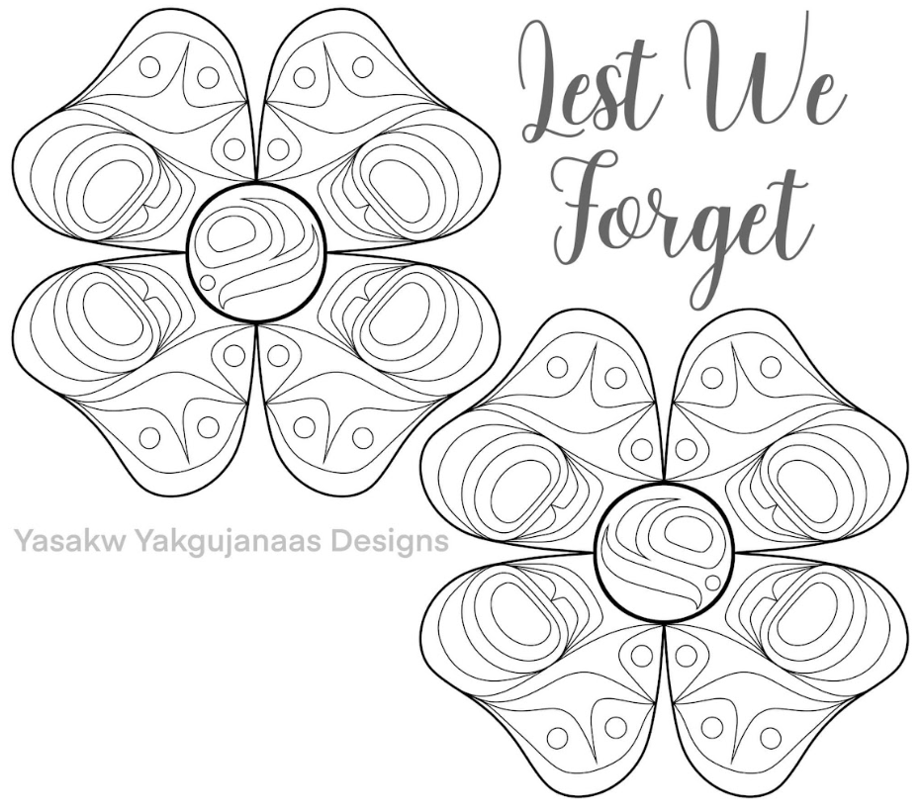
Design Created and shared by Yasakw Yakgujanaas Designs
Haida Artist From Haida Gwaii

Please use one of the maps to show where the artist comes from
https://native-land.ca/
https://fpcc.ca/stories/first-peoples-map/

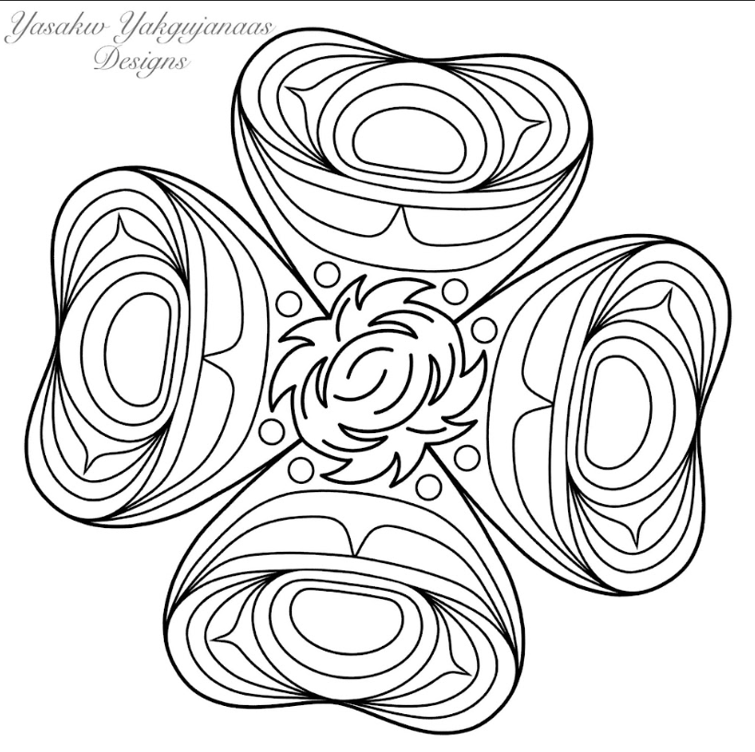

Design Created and shared by Yasakw Yakgujanaas Designs
Haida Artist From Haida Gwaii

Please use one of the maps to show where the artist comes from
https://native-land.ca/
https://fpcc.ca/stories/first-peoples-map/

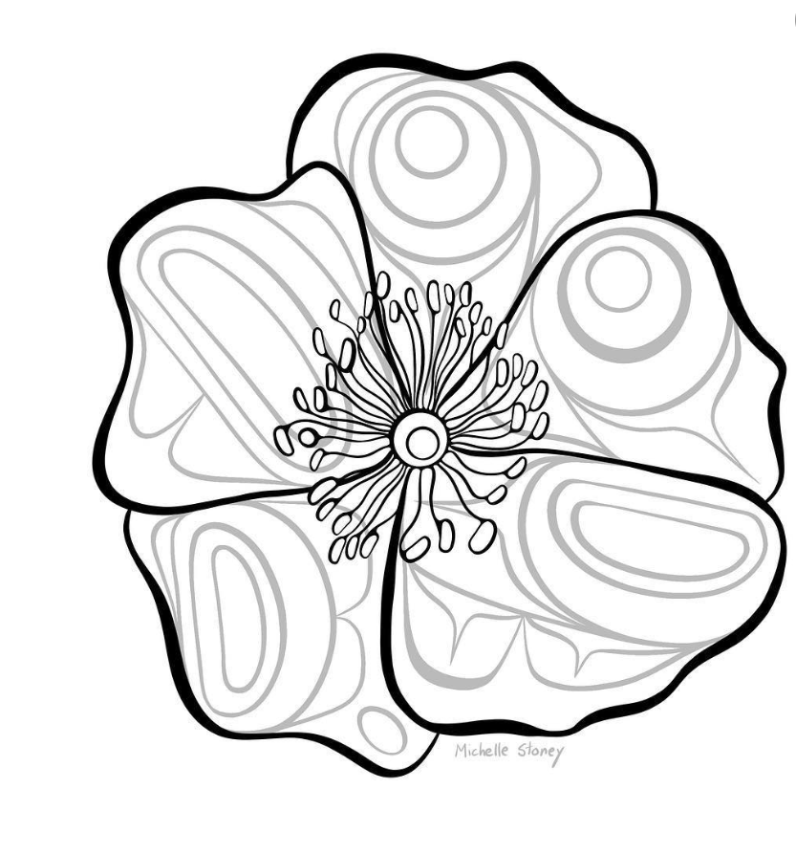
Artwork by Michelle Stoney- Gitxsan artist

